DELEGATED APPLICATION REPORT - Application No.: 160765
Address: 172 Southampton Street
Case officer: Ralph Chakadya

Site Description and Surrounding Area:
The site is a three storey end of terraced property on Southampton Street. The existing use of the property is a C2 use (children’s care home).

Proposal: The change of use from a C2 (Residential Institution) to Sui-Generis House in Multiple Occupation with seven (7) bedrooms.

The ground floor would comprise a single bedroom, lounge/dining and a kitchen, with the remaining bedrooms at first, second and third floors levels.

There are no external alterations proposed.

Plans considered:
Amended Unnumbered Location and Block Plan received 2nd August 2016
Existing Floor Plans No.SS:003 received 25th April 2016
Proposed Floor Plans No.SS:004 received 25th April 2016

Relevant Planning History:
080849 - Change of use from a residential dwelling to a residential care home C2 use, incorporating retrospectively the erection of a rear-facing dormer. Permitted

080616 - Certificate of Lawfulness for existing use of property as HMO (House in Multiple Occupation) – Determination declined.

080513 - Retrospective rear dormer window and change of use from dwellinghouse to a residential care home – Withdrawn.

021358 - Retrospective planning application for a pitched roof rear dormer - Withdrawn.

The property was previously licensed as an HMO before change of use to a children’s care home.

Neighbour Consultation Responses
170 and 176 Southampton Street were consulted. No responses were received.

Non-statutory consultees

RBC Transport - The site is located within the Zone 2, the primary core area but on the periphery of the central core area which lies at the heart of Reading Borough, consisting primarily of retail and commercial office developments with good transport hubs.
Plans submitted indicate the development will consist of 7 Bedrooms therefore in accordance with the adopted Parking Standards and Design SPD; the development would be required to provide a parking provision of 0.25 parking spaces per bedroom.

Plans submitted illustrate that there is parking for 2 cars at the rear of the development accessed via Short Street. Dimensions provided indicate that parking would be accommodated in tandem formation, however as previously advised, the nature of the development is changing from a C2 to a HMO, therefore parking spaces would need to be independently accessible.

In recent communication the applicant’s agent has advised that there has always been a shortfall of one parking space on this site with only two spaces available. I am happy to accept the provision of one parking space given the historical shortfall of one parking space but the proposed tandem arrangement is not acceptable and not conducive to this type of development for the reasons stated above. Plans have now been resubmitted illustrating the revised parking provision for one space. This is now deemed acceptable.

The development site is located in an area designated as a Residents Parking Permit Area; Zone 10R. Under the Borough’s current parking standards, this proposal would generate additional pressure for parking in the area. Therefore if this application is approved there should be an assumption that any future occupants of the proposed dwelling will not be issued with a resident parking permit which should be covered by condition and an informative applied.

Bin storage area is indicated in the submitted plans at the front of the property. This should be located no further than 15m from the access point of the site to avoid the stationing of service vehicles on the carriageway for excessive periods.

Cycle storage is illustrated on submitted plans. In accordance with the adopted Parking SPD, the development is required to provide a minimum of 0.5 cycle parking spaces per unit which should be in a conveniently located, lockable, covered store. Clarification is required on this point and a plan submitted illustrating the proposed provision. I am happy to deal with this by condition.

In the circumstances, there are no transport objections to the proposal subject to the recommended conditions.

RBC Environmental Health (HMO Team)

Licensing of Houses in Multiple Occupation
Under the Housing Act 2004, HMOs of 3 or more storeys and with five (5) or more occupants require a licence, and indeed this property has been licensed in previous years when in HMO use. More information is available at www.reading.gov.uk

HMOs: Fire Safety
An adequate fire alarm system and fire doors will be required. Further information on fire safety standards in HMOs is available in:
LACORS guidance document ‘Housing – Fire Safety’ is available at: www.gov.uk/workplace-fire-safety-your-responsibilities/fire-safety-advice-documents

Conclusion
I have no objection to the proposal.

RBC Environmental Protection
No objection subject to informatives on control on noise transmission between dwellings and during construction and demolition phases.

Relevant Planning Policy and Guidance:
Section 38(6) of the Planning and Compulsory Purchase Act 2004 requires that proposals be determined in accordance with the development plan unless material considerations indicate otherwise. Material considerations include relevant policies in the National Planning Policy framework (NPPF) - among them the 'presumption in favour of sustainable development'.

The following local and national planning policy and guidance is relevant to these applications:

National Planning Policy Framework:
Part 6 – Delivering a wide choice of high quality homes
Reading Borough Local Development Framework Core Strategy (2008):
CS18 (Residential Conversions)
CS24 (Car/ Cycle Parking)
CS31 (Additional and Existing Community Facilities)

Reading Borough Local Development Framework Sites and Detailed Policies Document (2012):
DM4 (Safeguarding Amenity)
DM8 (Residential Conversions)
DM10 (Private and Communal Outdoor Space)

Supplementary Planning Documents:
Residential Conversions SPD (2013)
Revised Parking Standards and Design SPD (2011)

Appraisal:

The main issues are considered to be:

(a) Principle of the development - loss of an existing care home that is a community facility;
- Whether the conversion of the property to a large HMO use has resulted in unduly diluting or harming a mixed and sustainable community;
- The impact on amenity of nearby properties and future occupants;
- Effect on car/ cycle parking; and
- Other matters raised through consultation

(a) Principle of the development
Core Strategy policy CS31 among other things seeks to protect existing community facilities, ‘unless it can be clearly demonstrated that there is no longer a need to retain that facility’. The proposal would involve the change of use of an existing children’s care home that is considered a community facility. The applicant submits that the property was run by a bespoke provider as a children’s care home. The bespoke provider outgrew the premises and moved on in September 2015. The property has been vacant ever since. The applicant argues that the property on 4 floors is not suitable for a more general care home and residents making up the local community have not objected to the proposal. Given the bespoke nature of the care home operated on the site, the unfavourable layout of the property in relation to general care home use, the vacancy period and the fact that local residents have not objected to the change of use, it is officers’ view that on balance it has been demonstrated that there is no longer a need to retain the care home facility. The principle for the change of use is therefore considered to accord with Core Strategy policy CS31.

(b) Whether the conversion of the property to a large HMO use has resulted in unduly diluting or harming a mixed and sustainable community

Whilst it is acknowledged the residential use of the property as a family dwelling was lost by the change of use to a children’s care home, the Adopted Residential Conversions SPD (2013) that provides assessment criteria for mainly residential (C3) conversions to HMOs or flats is considered relevant to the current proposal in relation to the overall concentration of HMOs in a locality that might ‘unduly dilute or harm a mixed and sustainable community. The SPD identifies that the ‘tipping point is when the concentration of HMOs becomes over dominant and the community is no longer considered to be mixed and sustainable.’ The SPD defines that “planning permission will not normally be granted where the proportion of HMOs will result in HMOs representing 25% or more or the residential properties within a circle of 50m radius measured from the application site” (para. 5.43). Below is the 50m radius.

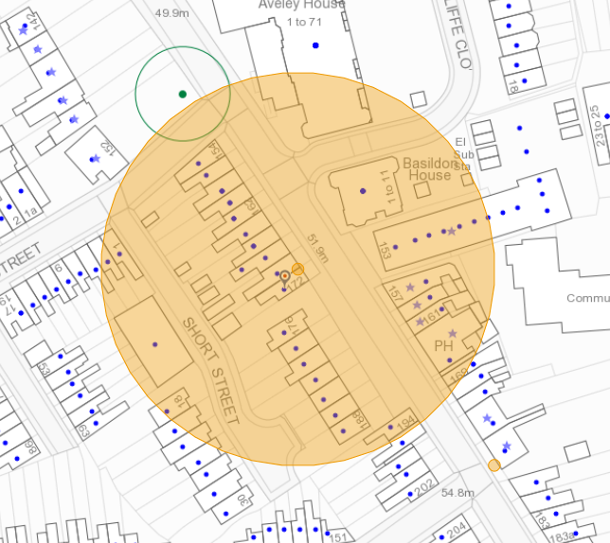

The concentration of HMOs in the area surrounding the application site has been calculated as a percentage of the total estimated number of existing HMOs (C4 or sui generis) against the total number of residential properties, i.e. those falling with C3, C4 or sui generis HMO use. Available data from Environmental Health, Council Tax, granted permissions for HMOs, and data held by the Enforcement Team, has been used. The total number of residential properties within the 50m radius, including the application site, has been calculated as 31. The total number of properties in HMO use, using the above sources of data, including the application site is 7, which equates to 22.6%, is below the threshold maximum of 25%. Therefore, in this regard, the principle of the conversion of the application property to a large HMO is considered acceptable.

(c) The impact on amenity of nearby properties and future occupants
There are no external alterations proposed to the property and therefore the impact of the property on the physical character of the area and neighbouring properties would remain unchanged.

As outlined in the submitted planning statement, the proposal does not seek to intensify the existing use of internal areas when compared to the existing C2 that had 5 bedrooms for children in care and an additional 2 for staff. The current proposal that is for a 7 bedroom HMO is therefore not considered to introduce unacceptable levels of noise and disturbance to neighbouring properties compared to the existing use. In addition, it should be noted that prior to the change of use to a care home, available records from RBC Environmental Health show that the property was licensed as an HMO. RBC Environmental Health has not objected to the proposal.

The property to be converted is more than 120sqm in gross floor space that is considered to be of adequate size for conversion of properties into sui generis HMOs.

There is a rear garden shared with a single parking space, which is considered sufficient for sitting out and for drying clothes.

All of the bedrooms would meet the minimum internal floorspace standards (as set out in Appendix 1 of the SPD). At ground floor there is a kitchen and a lounge room for communal use. Guidance is provided within local policy that layouts should avoid locating bedrooms next to living rooms. The layout is largely as the property was built, and the only change is the use of the ground floor front room as a bedroom. It is not considered that this is so significant as to warrant refusal on this basis.

All proposed habitable rooms benefit from an external window.

Bins will be stored to the front of the property, a similar situation to other properties on this part of Southampton Street.

(d) Affect car/cycle parking provision
Transport has advised that the proposed use would generate a parking requirement of 2 on-site car parking spaces (0.25 parking spaces per bedroom) in accordance with the adopted SPD. Plans submitted illustrate that there is parking for 2 cars at the rear of the development accessed via Short Street. Dimensions provided indicate that parking would be accommodated in tandem formation, however as previously advised, the nature of the development is changing from a C2 to a HMO, therefore parking spaces would need to be independently accessible. Following discussions between the applicant and RBC Transport officer it was agreed that there has always been a shortfall of one parking space on this site and therefore the amended plans showing a single parking space is therefore considered acceptable in this instance.

Cycle storage is illustrated on submitted plans and a condition has been requested requiring that details of the storage type be provided.

(e) Other matters raised through consultation
A sui generis HMO does require a licence from RBC Environmental Health.

(f) Equality Act 2010:
In determining this application the Council is required to have regard to its obligations under the Equality Act 2010. However, there is no indication or evidence (including from consultation on the application) that the protected groups identified by the Act have or will have different needs, experiences, issues and priorities in relation to this particular planning application. Therefore in terms of the key equalities protected characteristics it is considered there would be no significant adverse impacts as a result of the development.

RECOMMENDATION:

APPROVE

