Dischagre of Conditions

99 St peters av

9)

- Finished ground levels etc. Attached
- Drainage drawing attached.
- To follow.

d )

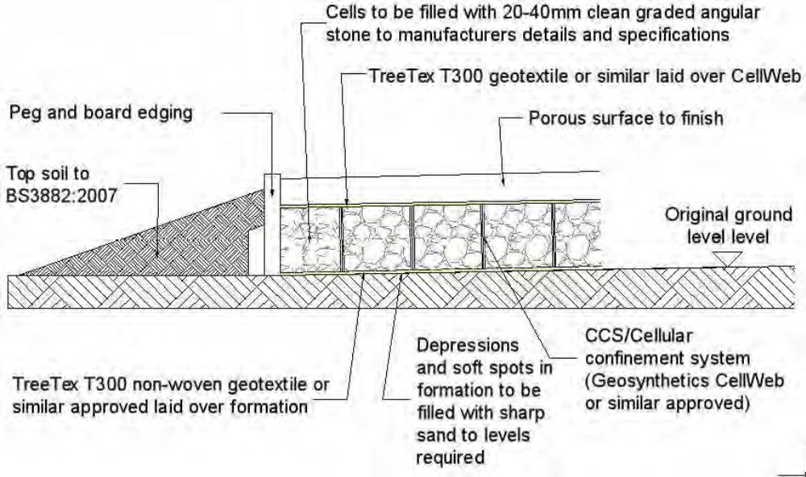
Stages for Installation of the cellular confinement surface:
1) Contact project arboriculturist to hold pre-start site meeting and ‘toolbox’ talk before
starting work
2) Dismantle TPF and re-erect in secondary location as shown on TPP
3) Remove existing vegetation by using a specific herbicide (as advised by a specialist)
or manual removal with hand tools only. Agreed removal of shrubs, saplings or
trees, within the protected areas of retained trees are to be cut, or ground out to just
below ground level rather than grubbed or winched out, which can damage roots of
retained trees.
4) Retain all original ground levels after vegetation removal. No excavation
whatsoever.
5) Remove any existing hard surfaces (paving, tarmac etc.) Hand tools should be used
if possible. If machinery is required for this operation, it must be used only on
existing surfaces or outside the protection areas and tree canopies (approval from
project arboriculturist must be sought before using machinery). The sub base of
existing surfaces or foundations should be left in situ where possible to avoid
unnecessary root disturbance and provide a base for the new surface.
6) Install a non-woven Geotextile (such as TreeTex T300) directly over soil grade level
(levelled where necessary, by non-compacted washed sand) and fix in place.
7) Lay the cellular system over the Geotextile, which is secured open under tension
during the infill process with steel staples or wooden pegs.
8) Install kerbs and edgings directly on top of existing soil grade level. For light
structures, a treated peg and board may be acceptable. For more substantial
structures, railway sleepers, haunched concrete with road pins, drilled kerbstones,
gabions or cast in situ kerbs will be appropriate.
9) Fill the cellular system ensuring any machinery works only on already filled areas.
Typical infill consists of no fines angular granular material 20-40mm, which will
remain un-compacted.
10) Cover with a non-woven Geotextile (such as TreeTex T300).
11) Install porous wearing surface.
• Small Block Paving
• Washed Gravel
• Porous

