Heritage / Design and Access Statement – 68 Broad Street, Reading, RG1 7QE

- Assessment of Heritage Significance

Premises

The unit is Grade II listed three storey building with attic and basement built in a Norman Shaw manner style. The property was built in 1890’s or Circa 1900’s and consists of ground floor retail shop with converted storage to the upper floors.

Listing

1890s or circa 1900. In a Norman Shaw manner. 3 storeys and attic. Grey brick with red brick quoins and terracotta decorative band with dentil strips over 2nd floor. 2 storey recessed bay of 5-lights to left with stucco decoration, small pane upper windows and pediment to centre windows. Similar treatment to right, 2nd floor only (1st floor lopped off for slightly later shop window with carved pairs of fascia brackets). Carved stucco scroll brackets to cornice, entablature with stucco acanthus decoration. Central rainwater head. Mansard tile roof with dentil purlin and 2 corniced dormers of 2 lights (glazing bar sashes) flanking panel. Crested ridge, end chimneys, coped verge. Modern ground floor shops. Included as interesting examples of the Norman Shaw style.

Front Elevation:
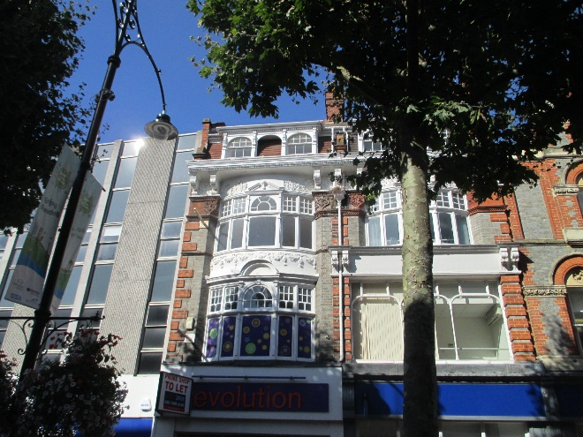

Location

The unit is located towards the west end of Broad Street in Reading Town Centre, which is one of the city’s main shopping streets. The street is in the pedestrianized part of the town.
- Assessment of Impact:

The application for the works to this unit includes the items detailed below and the anticipated impact is referenced:

Note: All reference to elevations are orientated as facing the front elevation from Broad Street.

An outbreak of Dry Rot has occurred to the second floor following historic leaking of a downpipe and the subsequent saturation of the brickwork and internal finishes to the front right elevation. The Dry Rot has affected predominately the second floor with the outbreak radiating from the floor void and spreading to the first and third floors through the plastered finishes. Remedial treatment to prevent the spread of Dry Rot requires that all affected timber and that within a radius of one meter of the last visible signs of fungal growth is removed. And that all other surfaces are sanitised and treated with an appropriate fungicide. Further details on

- Repair works to Floor Joists.

  - Due to the extent of the outbreak of Dry Rot it is not possible to salvage the affected timbers. Following an inspection by Nick Hibberd (Structural Engineer), splicing / splinting the existing joists is not possible due to the extent of timber requiring removal. Accordingly, the works require the removal of the existing joists and replacement with new treated joists supported on joist hangers with the timber ends treated with an appropriate bitumen paint, as identified in the Structural Engineers detail – (H732 CALCS FLOOR JOISTS Feb 2016) and damp survey – (68 Broad Street, Reading JB 16 075)
IMPACT LOW

See Photo Schedule – Photographs 1 - 3

- Repair works to Associated Timber.

  - Timber skirting board and trim to the windows have also been affected by Dry Rot and in places are rotten beyond repair. It is proposed than new profile matched trim and skirting boarding will be used to replace the damaged timber following appropriate treatment of the Dry Rot.
IMPACT LOW

See Photo Schedule – Photographs 4 - 7

  - The spread of the Dry Rot is such that the timber laths to first floor ceiling have also been affected. In addition the removal of the rotten joists will require the removal of the ceiling to allow for appropriate replacement and treatment of the affected areas. It is proposed that the new ceiling will be made good with plasterboard and a skim finish to reduce the possibility of Dry Rot returning.
IMPACT MODERATE

See Photo Schedule – Photograph 8

- Repair works to Dry Rot affected Window Frame.

  - Due to the extent of the outbreak of Dry Rot it is not possible to salvage the infected timbers. The framing sill / horn and the framing jamb to the right hand side of the second floor window bracing has become rotten and is beyond salvage. It is proposed that the affected timber be removed and new profile matching timber installed.
IMPACT LOW

See Photo Schedule – Photographs 6 - 7

- Repair works to Internal Plastered Walls.

  - The spread of the Dry Rot is such that the plaster to the first, second and third floors locally to the source require removal and treatment with an appropriate fungicide. The brickwork will require holes to be drilled to the surface to allow for effective treatment and warranty. The plaster is proposed to be replaced with either a renovating render or a john Newton 800 membrane and dry lined plasterboard.
IMPACT LOW

See Photo Schedule – Photographs 9 - 12

- Assessment of Impact:

There are no plans for structural changes and the only element of removal of the any of the historic elements is for the safe and proper repair and treatment of Dry Rot. The repair and replacement of the affected materials will resemble the original finishes as close as possible to maintain the character of the property. The proposed work will protect the building fabric from further damage caused by the water ingress and outbreak of Dry Rot.

