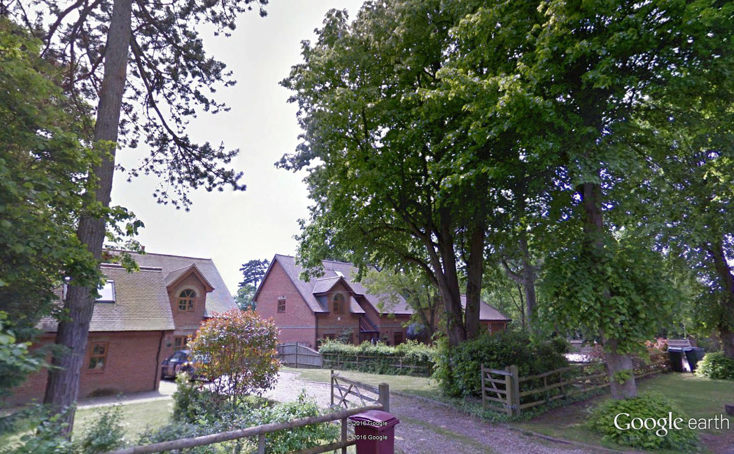
1 x mature Lime
Deanays House, Upper Warren Avenue, Caversham RG4 7EB

