DELEGATED APPLICATION REPORT - Application No.: 160755
Address: 126 Wykeham Road
Proposal: Change of use from C3 to C4 (HMO) within an Article 4 area.
Case officer: Ralph Chakadya

Site Description and Surrounding Area:
The site is a two storey terraced house on the west side of Wykeham Road. At the time of site visit the property was being renovated internally. There is on-street parking.
To the rear is a small garden.

Proposal: The change of use from a C3 dwellinghouse to a C4 small HMO would create four bedrooms – one at ground floor (front room) and three at first floor. There is a ground floor kitchen and communal dining area/lounge. There are ground and first floor bathroom/toilets.

The application site is within the Article 4 Direction Area, which restricts the permitted change of use from C3 dwellinghouse to C4 small House in Multiple Occupation (HMO).

Plans considered:
Unnumbered Location Plan - received 25th April 2016
Unnumbered Existing/Proposed Floor Plans, received 23rd May 2016

Relevant Planning History:
None.

Consultation Responses: Nos. 122, 124 and 128 Wykeham Road as well as 121 St Peters Road were consulted, and two responses were received.

Objections raised were:

- Too many HMOs in this area and with a number of student households
- Will cause parking problems with limited parking in this stretch of road. These roads cannot cope with the extra parking.
- Area now feels like part of the University/Student Campus
- Noise and disturbance.
- HMOs will put off families who want to live in the area
- Need to clarify the number of houses which are allowed within the 25% limit to be HMO.
Further information was provided by a few residents in terms of what use, i.e. C3, family rented or small HMO, they considered each property within the assessment radius to be in. Some were unknown.

RBC Transport - This site is located on the west side of Wykeham Road which is a residential street serving predominantly terraced properties which have limited off street parking facilities. There is no Resident’s permit scheme in operation on Wykeham Road.

The site is located in Zone 2, Primary Core Area, of the Revised Parking Standards and Design SPD and the required parking standard for the proposal is 0.25 spaces per bedroom equivalent to 1 parking space for a 4-bedroom HMO or 0.75 spaces for a 3-bedroom HMO. Whereas a 3-4 bedroom family dwelling would generate a requirement for 2 parking spaces.

The provision of 0.25 spaces per bedroom is lower than a self-contained dwelling due to fact that their economic position makes it less likely for them to have the disposable income to own and run a motor vehicle.

The site is currently not provided with any car parking and none is being proposed as part of this development. It is noted that there is concern from local residents that the proposed change of use will increase demand for on-street in the area. However, given that the proposal will not increase the demand for on-site parking over and above the residential permitted use as per the adopted standards, I am unable to object on parking grounds for the change of use.

There is no indication of any secure cycle provision on site. Cycle storage should be provided at a ratio of 0.5 spaces per letting room in the form of ‘Sheffield’ type stands within a lockable covered store. This can be provided within a communal facility within the rear garden as space is limited at the front of the site. The proposed 3/4 bedroom HMO would require 1 ‘Sheffield’ type stand to meet this standard. I am however happy for this to be dealt with by way of a condition.

In the circumstances, there are no transport objections to the proposal subject to the conditions attached.

RBC Environmental Health (HMO Team) – No objection subject to an informative advising that the first floor rear room, which, at 6.48m2 is under the minimum size of 6.5m2 considered acceptable for sleeping accommodation and should therefore not be used as such.

Relevant Planning Policy and Guidance:
Section 38(6) of the Planning and Compulsory Purchase Act 2004 requires that proposals be determined in accordance with the development plan unless material considerations indicate otherwise. Material considerations include relevant policies in the National Planning Policy framework (NPPF) - among them the 'presumption in favour of sustainable development'.

The following local and national planning policy and guidance is relevant to these applications:

National Planning Policy Framework:
Part 6 – Delivering a wide choice of high quality homes
Reading Borough Local Development Framework Core Strategy (2008):
CS18 (Residential Conversions)
CS24 (Car/ Cycle Parking)

Reading Borough Local Development Framework Sites and Detailed Policies Document (2012):
DM4 (Safeguarding Amenity)
DM8 (Residential Conversions)
DM10 (Private and Communal Outdoor Space)

Supplementary Planning Documents:
Residential Conversions SPD (2013)
Revised Parking Standards and Design SPD (2011)

Legal context:
Reading Borough Council made an Article 4 Direction in May 2012, which came into force on 16th May 2013, which removes permitted development rights to convert from a dwellinghouse (C3 use) to a house in multiple occupation (C4 – small HMO for 3-6 unrelated persons sharing at least one basic amenity) in parts of Redlands, Katesgrove and Park Wards. The application site is within the Article 4 Direction Area.

Appraisal:

Main Issues: The main issues are considered to be:

(a) Whether the conversion of the property to C4 use has resulted in unduly diluting or harming a mixed and sustainable community;
- The impact on amenity of existing residents of the property and those of nearby properties;
- Effect on car/ cycle parking; and
- Other matters raised through consultation

Along with the adopted local planning polices the assessment has mainly been based on the Adopted Residential Conversions SPD (2013). Section A of the SPD, deals with the ‘General Assessment of all Conversions’ (i.e. from C3 dwellinghouses to flats or HMOs (both small C4 use and sui generis HMOs). Section B specifically covers the assessment of applications for HMOs within the area covered by the Article 4 Direction. This application has been considered against both sections. The SPD sets out 26 no. checklist items; the relevant ones of these are used to form the basis of the assessment within this report.

(a) Whether the conversion of the property to C4 use has resulted in unduly diluting or harming a mixed and sustainable community

The SPD identifies that the ‘tipping point is when the concentration of HMOs becomes over dominant and the community is no longer considered to be mixed and sustainable.’ The SPD defines that “planning permission will not normally be granted where the proportion of HMOs will result in HMOs representing 25% or more or the residential properties within a circle of 50m radius measured from the application site” (para. 5.43). Below is the 50m radius.

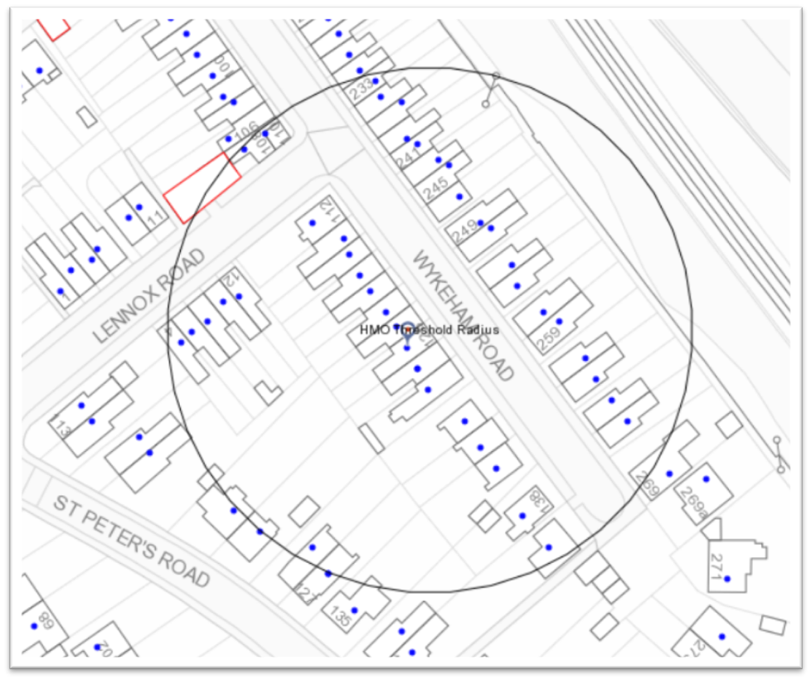
The concentration of HMOs in the area surrounding the application site has been calculated as a percentage of the total estimated number of existing HMOs (C4 or sui generis) against the total number of residential properties, i.e. those falling with C3, C4 or sui generis HMO use. Available data from Environmental Health, Council Tax, granted permissions for HMOs, and data held by the Enforcement Team, has been used. In addition data provided by residents objecting to the proposal that has been verified by officers has also been taken into account. It should be noted that data provided by residents was checked using a desk based exercise and on-site observation, however, the Residential Conversions SPD makes it clear that “Where there is significant doubt as to whether a property is an HMO, it will not be counted towards the threshold.” The total number of residential properties within the 50m radius, including the application site, has been calculated as 51. The total number of properties in HMO use, using the above sources of data, including the application site is 9, which equates to 17.6%, is below the threshold maximum of 25%. Therefore, in this regard, the principle of the conversion of the application property to a C4 small HMO is considered acceptable.

(b) The impact on amenity of existing residents of the property and those of nearby properties

There is a small rear garden, which is considered sufficient for sitting out and for drying clothes, and there are public areas of open space within a short walking distance of the property.

There are no new windows proposed, so there would be no effect on overlooking.

Whilst the property was being internally renovated at the time of site visit, there is no evidence that specific sound insulation has been used in this case. However, there is no evidence to suggest that an HMO for up to six individuals would create significantly greater levels of noise than a fully occupied three bedroom family house, and in this case, due to the overall size of the property, it is more likely that the house would primarily be let to four individuals at any one time. In terms of Building Regulations requirements specific sound insulation would only be required where independent units were being created. Issues were raised through consultation regarding noise and disturbance created by students specifically. A small HMO could be occupied by a range of individuals and not solely students. Noise from activities such as parties would not be sufficient reason to warrant refusal. Such matters would need to be addressed through Environmental Health under separate legislation.

There is no evidence to suggest that the proposal would have implications for crime or safety.

Apart from the rear first floor room, all of the rooms would meet the minimum internal floorspace standards (as set out in Appendix 1 of the SPD, and although not a specific requirement there is a large kitchen and a lounge room for communal use. Whilst the Council’s Environmental Health Officer has objected to the use of the rear first floor room as sleeping accommodation due to its size (6.48m2), it is considered that a difference of 0.02m2 to the minimum size requirement is 6.5m2 would not result in such harm to the amenities of the future occupier of the rear first floor room not to warrant its use.

Guidance is provided within local policy that layouts should avoid locating bedrooms next to living rooms. The layout is largely as the house was built, and the only change is the use of the ground floor front room as a bedroom. It is not considered that this is so significant as to warrant refusal on this basis.

All proposed habitable rooms benefit from an external window.

Bins will be stored to the front of the property, although not ideal from an aesthetic point of view, as a terraced property there is no other viable option, without having to carry bins through the house.

(c) Affect car/cycle parking provision

Transport has advised that the dwelling as a C3 use would generate a parking requirement of 2 on-site car parking spaces in accordance with the adopted SPD, although there are currently no off-street parking spaces resulting in a shortfall of two spaces. In accordance with the SPD, the required parking standard for the proposal is 0.25 spaces per bedroom equivalent to 1 parking space for a 4-bedroom HMO or 0.75 spaces for a 3-bedroom HMO. The proposed development would require 1 car parking spaces (i.e. 0.25 per room); therefore the shortfall of on-site parking remains unchanged.

No cycle storage is shown on the proposed plans and a condition has been requested requiring that this is provided. However the property is a mid terraced property with no access to the garden other than by going through the house in a not very straight route. Officers therefore feel that such a condition might fail some of the tests for a condition being acceptable or reasonable given that it has been acknowledged that the parking situation would remain unchanged by virtue of the change to C4 use; this could arguably be applied to cycle storage. Even if a store was provided given the awkwardness of access it is likely that it would not be used. The applicant could instead be advised by an informative that this facility should be considered.

(d) Other matters raised through consultation

A small HMO does not require a licence from Environmental Health, unless it is over 3 floors.

This application has been assessed as would any application and has been found to be acceptable in this case.

(e) Equality Act 2010:
In determining this application the Council is required to have regard to its obligations under the Equality Act 2010. However, there is no indication or evidence (including from consultation on the application) that the protected groups identified by the Act have or will have different needs, experiences, issues and priorities in relation to this particular planning application. Therefore in terms of the key equalities protected characteristics it is considered there would be no significant adverse impacts as a result of the development.

RECOMMENDATION:

APPROVE

CONDITIONS

1. This permission relates to the layout shown on the unnumbered drawing received on 23rd May 2016. This change of use from a C3 dwellinghouse to a C4 small HMO shall be restricted to the four bedrooms – one at ground floor (front room) and three at first floor with ground floor kitchen and communal dining area/lounge as shown on the approved plans.
Reason: as it is on this basis that the planning application has been considered and found to be acceptable and in the interests of the amenities of neighbours and occupants of the property.

Core Strategy (2008):
CS18 (Residential Conversions)

Sites and Detailed Policies Document (2012):
DM4 (Safeguarding Amenity)
DM8 (Residential Conversions)

Supplementary Planning Documents:
Residential Conversions SPD (2013)

Informatives:
- Your attention is drawn to the terms and conditions of this permission. Any development which is carried out but which differs materially from the approved plans and details, or does not comply with any condition(s) or planning obligation(s) attached to the permission may result in the Council taking action to remedy the breach of planning control. If you are in any doubt please contact the Council.

- It should be noted that should an on-street car parking permit scheme be introduced then occupiers of letting rooms would not be entitled to an on-street car parking permit in the interests of the proper management of parking, and to ensure that the development does not harm the existing amenities of the occupiers of neighbouring residential properties by adding to the already high level of on street car parking in the area in accordance with adopted Sites and Detailed Polices Document (2012) Policy DM12: Access, Traffic and Highway-related Matters. The site is located close to local facilities, with frequent public transport services on nearby roads.

- The applicant is advised of the need to provide for cycle storage at a ratio of 0.5 spaces per letting room in the form of ‘Sheffield’ type stands within a lockable covered store. This can be provided within a communal facility within the rear garden as space is limited at the front of the site. The proposed 3/4 bedroom HMO would require 1 ‘Sheffield’ type stand to meet this standard.

- The decision to grant planning permission follows the positive and proactive consideration of the issues raised by this planning application.

