Discharge of Conditions St Peters avenue RG4 7DP
Application No. 150172
CMS

No.5

No development shall take place inc demolition works until a construction method statement has been submitted.

- Parking of vehicles and site operatives and visitors
99 St. Peters Road is on the corner and access will be via the entrance on Woodcote Road. The access point will be secured at all times when not in use and manned when open. Parking will be on St peters avenue in the unrestricted areas highlighted below
Parking for site operatives will be in the Mapleduram playing fields carpark just up the Woodcote road. , trades man will up load tool etc on site in the loading area and park their vehicles of site ( unless possible to be on site ) 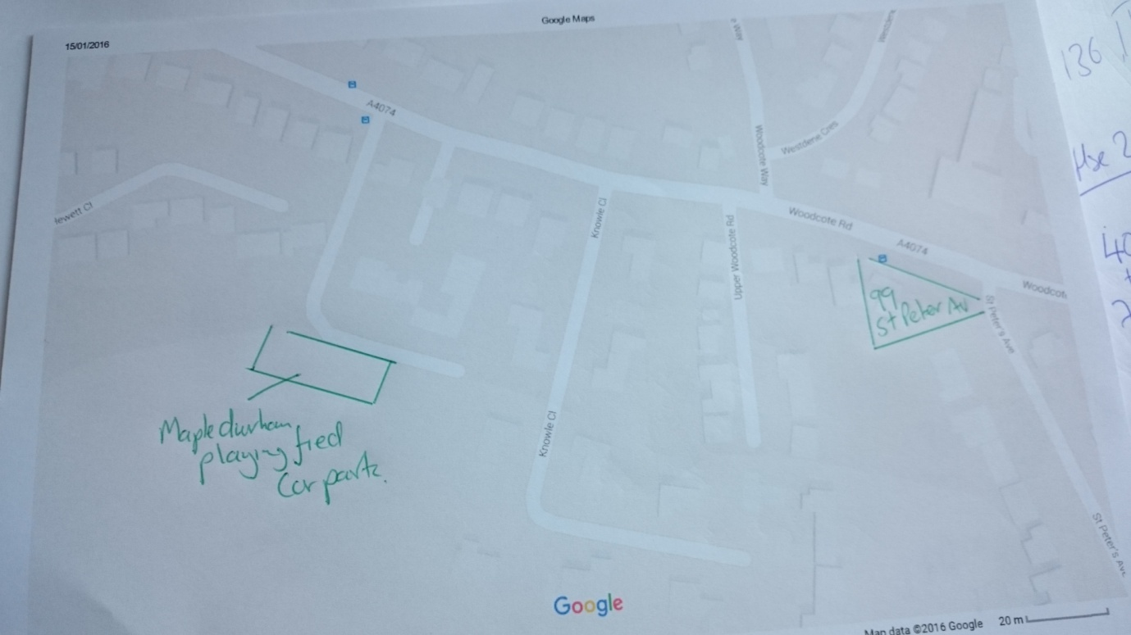

- Loading and unloading of materials

All unloading and loading of materials will take place on site and off road. Banks man will be used for traffic in and out of the site. Deliveries will be where possible kept outside of the peak 7.30 -8.30 am morning rush hour. Shown below. As per below all Care will be taken when working around all remaining trees, flora and fauna.

- Storage of plant and Materials
As highlight in the drawing below in Orange , as per below storage of plant and materials will take place on site . Care will be taken when working around all remaining trees, flora and fauna.

- 99 St peters avenue already has a 6 foot fence surrounding the property. A Haras fence gate will be used to secure the main entrance
- Wheel washing in the Blue area will limit the dirt on to the highway. This will be manned on every delivery and collection.
- Measures to control dirt on to public highways, prior to demolition hard standing will be created within the site from Crushed concrete or similar, for vehicles to drive on. Banks man to sweep entrance and exit to public highway during the working day,
- Footpath/road closures > Will not be required
- Traffic management during construction. Will not be required. A banks man will be present to assist larger vehicles leaving and entering the site. Delivery times/routes. Deliveries Will not be made to site between 7:30 -9:00am and 4:30-6:00pm, Monday to Friday within peak hours. Vehicular traffic to inc waste and deliveries will enter the site from woodcote road and park on site , in the areas mentioned on hard standing.
N.B the construction of the buildings will be of timber frame construction with off site exterior finishes, so onsite works will mostly be internal.
Tree and root protection.
Care will be taken when working around all remaining trees, flora and fauna , tre protection scheme already submitted. No. Dig area with cellular confinement system will be in place prior to construction to allow ease of movement around the site. ( all demolition will happen clear of the tree protection area and waste removal at the other end of the site. ) See Page 30 of doc PRI19866 attached

