Our Ref: 35678/AJF

FAO: Jo Hearn
MITIE Landscapes Limited
30 North Luton Industrial Estates
Sedgwick Road
Luton Beds
LU4 9DT

Date – 25th August 2016

Re: Premier Inn Reading (Caversham Bridge) Richfield Avenue Reading Berkshire RG1 8EQ

Further to your request I have pleasure in forwarding our costs to carry out the works at the above site.

Specification

T1, 2, 3, 4, 5, 6, 7, 8, 9, 10, 11 & 12 (See area highlighted on Google Earth)

Raise crowns over public road to 5.5m from ground level.
Raise crowns over public footpath and parking areas to 2.75m from ground level.
Clear all signs and lamp columns of branches by 1 – 2m

Group of shrubs at end of car park encroaching on 3rd on public footpath

Cut back all encroaching vegetation back to fence line to create good clearance

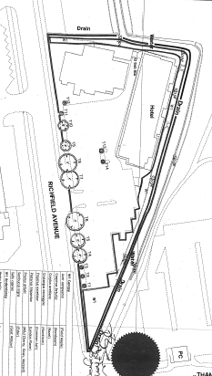

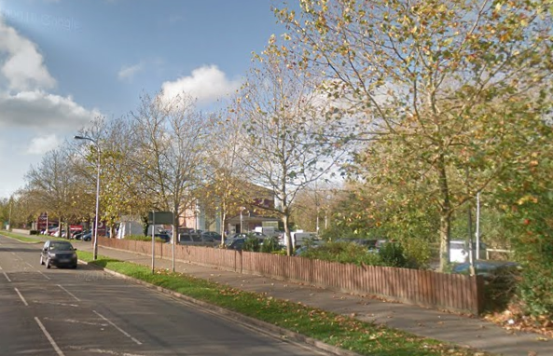

Please note: 1. Costs exclude additional parking charges incurred
2. Access arrangements to site are the responsibilities of others
3. Adjacent parking bays need to be cleared by others prior to the commencement
of work
4. Incurred costs will be charged in the event of works not being able to proceed due to no
access to work site being provided in accordance with the approved works ‘method
statement’.

All works shall be undertaken in line with British Standard 3998:2010 ‘Recommendations for tree works’ where applicable.

Cost

The cost of completing the work as detailed above is:

Work cost: £788.75
VAT @ 20%: £157.75
Total: £946.50

The total cost is nine hundred and forty six pounds and fifty pence including VAT.

Arising Waste

All arising waste will be removed from site.

Commencement of Works

Planning of works can commence upon our receipt of your written instructions by way of a purchase order.

When planning works we must consider whether the trees have any TPO restrictions or whether they are located within a conservation area. These are to be checked prior to a date being arranged for works to be carried out.

Please Note: When checking with the local authority, if it is found that the trees are subject to TPO restrictions, (we cannot proceed without permission) – an application will need to be raised with the local authority, which can take up to 8 weeks from the date of receipt, for permission to be granted. If the trees are located within a conservation area, permission can take up to 6 weeks from the date of application.

Should you wish to discuss this or any other matter please do not hesitate to contact me.

Yours sincerely

Director

