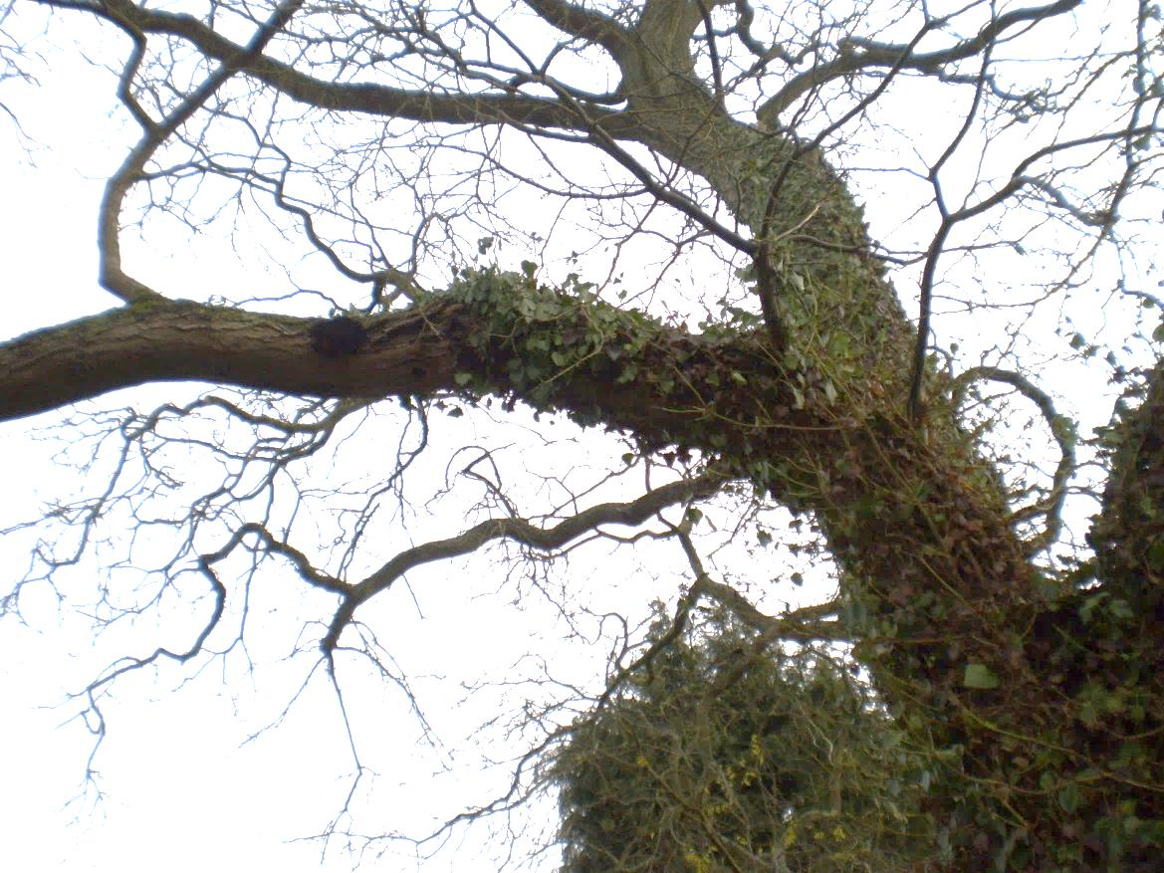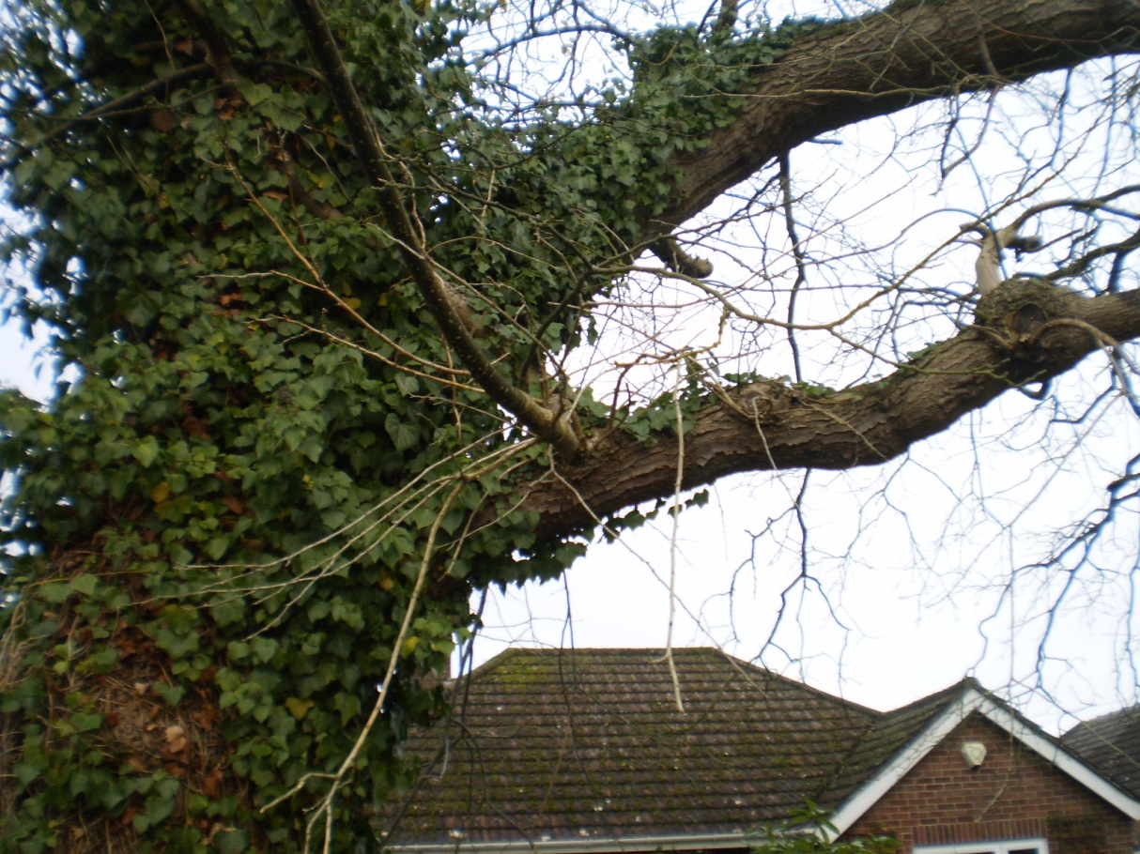
T2 Reduction of low limb over the driveway of No. 32 past the fungal growth and hole, i.e. not back to the trunk
T1 Removal of low limb on Council tree to be cut back within the region indicated, i.e. not back to the trunk

