COMMITTEE REPORT

BY THE DIRECTOR OF ENVIRONMENT AND NEIGHBOURHOOD SERVICES
READING BOROUGH COUNCIL ITEM NO.
PLANNING APPLICATIONS COMMITTEE: 26 April 2017

Ward: Katesgrove
App No.: 170195
Address: 21 South Street
Proposal: Proposed new signage.
Applicant: South Street Arts Centre (RBC)
Date validated: 21st March 2017
Application target decision date: 16th May 2017
26 week date: 19th September 2017

RECOMMENDATION

GRANT advertisement consent

Conditions to include:
- Approved Plans
- Maximum luminance – 250 cd/m²
- Standard Advertisement Conditions

Informatives:
- Terms and Conditions

- INTRODUCTION

  - The application site relates to a one/two storey building serving the Arts Centre located on the corner of South Street and East Street. The arts centre is a red brick building with tiled pitch roof, timber sash windows and stone cills with a stone portico to the main entrance.

  - Originally there were two courtyard areas fronting South Street. Under previous application 160495-FUL the courtyard to the eastern side of the South Street frontage was filled in by a new bar extension of a contemporary design. Under that same application a new timber shelter for waste and recycling container was constructed to the front of the western courtyard.

  - South Street is a mixed street with offices, residential uses and other uses close by, with the street scene representing various types of styles and designs. No.23, to the east of the site, is a chapel and opposite, is a three storey building which has recently been converted into residential use. There are no other examples of building mounted signage in the surrounding area.

  - The site is not within a designated shopping or office core. However, it is adjacent to the Market Place/ London Street Conservation Area.

  - This minor application is reported to Planning Applications Committee for a decision as the applicant is part of Reading Borough Council

Location Plan:

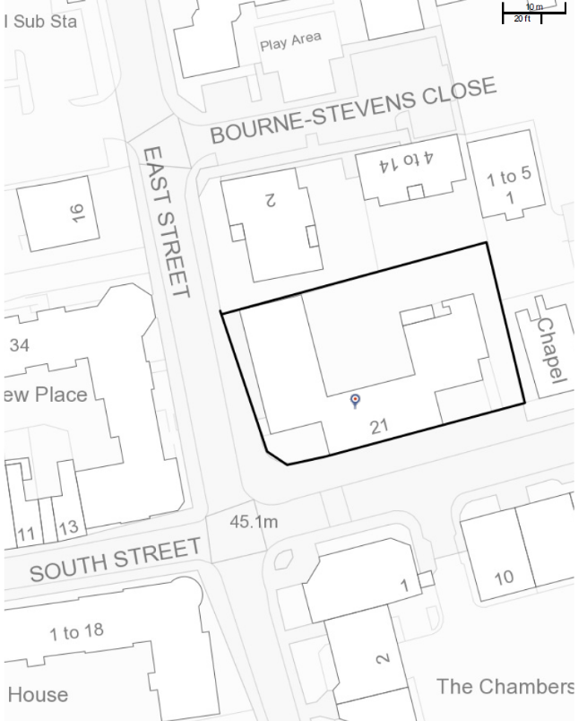

- PROPOSAL

  - This is an application for advertisement consent for two fascia signs, one to be mounted above the main entrance of the arts centre, fronting South Street, and the other to be mounted on the western elevation of the two storey element of the arts centre, fronting the junction of South Street and East Street.

  - The South Street facing fascia is located above the main entrance to the arts centre and below the first floor windows. It will be no wider than the existing entrance and associated detailing. The letters and logo of this fascia will have a depth of 20mm.

  - The west facing fascia is to read vertically and is to be set 3.5m above ground level, between the first floor west facing windows and the corner with the front façade of the building. The letters and logo of this fascia will have a depth of 30mm.

  - Both fascia are to consist of individual letters mounted directly to the face of the building. There is to be no fascia board. The lettering and logos on both signs will be internally illuminated with halo illumination and an illuminance level of 250 cd/m². The letters and logo will be constructed from black powder coated metal.

- PLANNING HISTORY

  - 160495-FUL - 15.5m2 floor area lean-to circulation extension to rear courtyard, 46m2 floor area bar extension to east recess fronting the highway. Remove 1nos door to west elevation and 3nos window to east courtyard elevation and infill opening. Permitted 13/05/2016

3.2 02-01045-REG3 Improved disabled access to building and courtyard - Permitted 11/10/2002

3.3 91-00820-ADV - Four vertical banners mounted on brackets at 90 to facade of building 2 metres long x 60 mm wide. Permitted 03/10/1991

- CONSULTATIONS

  - Internal: No internal consultations were undertaken

4.2 Public consultation:

Two site notices were displayed on the 31st March 2017. No neighbour letters of representation have been received at the time of writing this report.

- RELEVANT PLANNING POLICY AND GUIDANCE
5.1 Section 38(6) of the Planning and Compulsory Purchase Act 2004 requires that proposals be determined in accordance with the development plan unless material considerations indicate otherwise. Material considerations include relevant policies in the National Planning Policy framework (NPPF) - among them the 'presumption in favour of sustainable development'.

5.2 The following local and national planning policy and guidance is relevant to this application:

National
National Planning Policy Framework (2012)
National Planning Policy Guidance

Reading Borough Core Strategy (January 2008) (Altered 2015):
CS7 Design and the Public Realm
CS20 Implementation of the Reading Transport Strategy
CS31 Additional and Existing Community Facilities
CS33 Protection and Enhancement of the Historic Environment

Reading Borough Sites and Detailed Policies Document (2012)(Altered 2015):
DM4 Safeguarding Amenity
DM12 Access, Traffic and Highway-Related Matters
DM22 Advertisements

- APPRAISAL

Legal context

6.1 Regulation 3 of the Town and Country Planning (Control of Advertisements)
(England) Regulations 2007 requires the Local Planning Authority to exercise its
powers under these regulations in the interests of amenity and public safety taking
into account the provisions of the development plan, so far as they are material;
and any other relevant factors. Regulation 3 states that factors relevant to amenity
include the general characteristics of the locality, including the presence of any
feature of historic, architectural, cultural, or similar interest.

6.2 Factors relevant to public safety include highway safety and whether the advert
would hinder security or surveillance devices, including speed cameras.

Main Issues

6.3 The main issues are considered to be:
(i) Impact on the visual amenity of the street scene and character of the area
(ii) Impact on public safety

- Visual amenity of the street scene and character of the area

6.4 Although DM22 (Advertisements) of the Sites and Detailed Policies Document (2012) states that advertisements above ground floor level are likely to have detrimental effects on visual amenity, and are therefore discouraged, it is considered that, in this case, the higher level signage on the western elevation would not cause unacceptable harm to visual amenity. It is considered that, given the simple design and relatively small scale of the proposed advertisements and that the building in question is a key cultural venue in the town, the signage on the western elevation would be acceptable at first floor level.

6.5 It is considered that the size, design and materials of the signage proposed are acceptable and in keeping with the newly extended application property.

(ii) Public Safety

6.6 The proposed signage is located in a position that would not cause a physical obstruction to members of the public using the highway. The illuminated elements to the fascia will not exceed a level of luminance of 250 cd/m², which is unlikely to cause a distraction to users of the highway. As such the proposal is considered to be acceptable in public safety terms in accordance with DM12: Access, Traffic and Highway-Related Matters of the Sites and Detailed Policies Document (2012).

Equality Act

6.7 In determining this application the Council is required to have regard to its obligations under the Equality Act 2010. The key equalities protected characteristics include age, disability, gender, gender reassignment, marriage and civil partnership, pregnancy and maternity, race, religion or belief, sexual orientation. There is no indication or evidence (including from consultation on the application) that the protected groups have or will have different needs, experiences, issues and priorities in relation to the particular planning application.

7. CONCLUSION

7.1 The application is considered acceptable in planning terms and is recommended for approval for the reasons given above.

Plans:
Drawing No: 2320 (P) 001 - Location Plan, received 8th March 2017
Drawing No: 2320 (P) 006 - Proposed Elevations, received 11th April 2017

Other Supporting Documents:
Main Entrance Visual, received 2nd March 2017
Building left end Visual, received 2nd March 2019
Email specifying illuminance levels, received 21st March 2017, 13:14
Email confirming depth of signage, received 11th April 2017, 15:33

Case Officer: Heather Banks

