UPDATE REPORT
BY THE DIRECTOR OF ENVIRONMENT & NEIGHBOURHOOD SERVICES
READING BOROUGH COUNCIL ITEM NO. 8
PLANNING APPLICATIONS COMMITTEE: 26/04/2017 Page: 41

Ward: Katesgrove
App No.: 170195/ADV
Address: 21 South Street
Proposal: Proposed new signage
Applicant: South Street Arts Centre (RBC)
Date validated: 21/03/2017
8 week target decision date: 16/05/2017

RECOMMENDATION:

As per recommendation in main report but with the additional condition:

The signage hereby permitted shall not be illuminated between the hours of 2300 and 0700 each day.

Reason: to protect the amenity of neighbouring properties of the proposed development in accordance with Policy DM4 of the Sites and Detailed Policies Document

- ADDITIONAL INFORMATION

Context
The main report states that the application site is bounded to the east by a Chapel at 23 South Street. This building has now been demolished as per Demolition Prior Approval application, 161075, which was granted in August 2016.

Proposed advertising
The agent has provided further information regarding the proposed advertisements stating that the illumination will be linked to a timer set to come on at dusk and turn off at 11pm.

Public responses
Two neighbour letters of representation have been received since the submission of the main report. Both letters object to the proposal. The following issues were raised by the objections:
- Lack of information included in the application especially in relation to brightness of illumination.
- Concerns regarding the impact of the illumination on surrounding residential properties, given previous poor experiences with building mounted lamps on west elevation of the application property.
- Lack of information regarding what hours the signage will be illuminated. Preference expressed for illumination to be only for agreed time periods to limit disturbance
- Concerns that no assessment has been undertaken to determine the impact of light levels on residents.

Officer response:
Although not originally submitted with the application the agent has since confirmed that the internal illumination will have an illuminance level of 250cd/m². This information has been visible to the public online, under the documents for this application, since the 21st March. The agent also stated on the application form that the internal illumination would be halo illumination. Halo illumination is LED internal illumination where the face of the lettering or logo remains opaque resulting in the lighting creating a ‘halo’ effect around each element. See example below, provided by the agent, of one of the proposed halo illuminated letters:

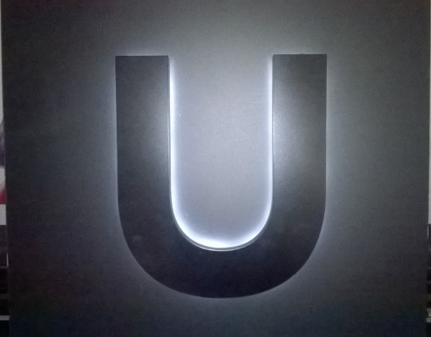
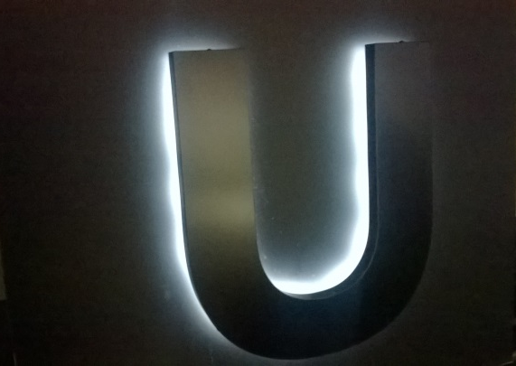

With regard to the impact of the illuminance level of the advertisements on the surrounding residential properties, whilst applicants are not required to submit a report regarding the impact of light levels, officers consider the guidance provided in the publication produced by the Institute of Lighting Engineers ‘Brightness of Illuminated Advertisements’, is helpful when making a decision as to whether the illuminance level is appropriate. This publication recommends that the following values be used as a guide for maximum luminance levels (these values differ based on the environment in which the host property is located):

Illuminated Area (m²) | Illuminance level (cd/m²) Zone E1 | Illuminance level (cd/m²) Zone E2 | Illuminance level (cd/m²) Zone E3 | Illuminance level (cd/m²) Zone E4
Up to 10.00 | 100 | 600 | 800 | 1000
Over 10.00 | n/a | 300 | 600 | 600

E1: Intrinsically dark areas (e.g. National Parks, Area of Outstanding Natural Beauty or other dark landscapes)
E2: Low district brightness areas (e.g. rural or small village locations)
E3: Medium district brightness areas (e.g. small town centres, urban locations)
E4: High district brightness areas (e.g city and town centres with high levels of night time activity)

It is considered that the application property falls within Zone E3, and as the proposed advertisements have an illuminated area of less than 10m² it is recommended that the advertisement should have an illuminance level of no greater than 800cd/m². The illuminance level of the proposed advertisements will be significantly lower than this, at 250cd/m², and therefore it has been concluded that this would be unlikely to have a detrimental effect on the amenity of neighbouring properties. The implementation of the proposed level of illuminance, 250cd/m² is to be secured by the illuminance condition included in the main report, and controlled by an hours of illuminance condition recommended in this update report.

With regard to the concerns expressed in relation to what hours the advertisements will be illuminated, the agent has now confirmed that the illumination will be set to come on at dusk and turn off at 11pm. Given that the premises has a licence to operate until 12pm during the week, and 1pm at weekends, the proposed hours of operation of the signage are considered acceptable. A condition securing compliance with these hours of illuminance is therefore suggested.

Case Officer: Heather Banks

