DELEGATED HOUSEHOLDER APPLICATION REPORT

Ward: Tilehurst
App Ref: 171947/HOU
Address: 12 Elmstone Drive, Tilehurst, Reading, RG31 5NU
Proposals: Two storey & single storey side extension – resubmission of 171401.
Case Officer: Julie Williams
Applicant: Paul Winter
Date received (valid from): 2 November 2017
Target Decision date: 28 December 2017

1. INTRODUCTION
The application property is a semi-detached house set back from the road with a steep change of level from pavement to front door and the house sits almost at the crest of the hill rising from the west. This gives the house prominence when seen from this approach. The house, like others nearby, has stone cladding on the ground floor and brick above.

2. PROPOSAL AND SUPPORTING INFORMATION
Two storey & single storey side extension. The ground floor of the two storey side extension element would sit on the same position as the existing garage, which is to be demolished, matching the main front of the existing house. The first floor is proposed to be set back from the front of the original house by 330mm with a small tiled roof feature.

The ground floor would comprise a store with a garage door, wc with small side facing window and kitchen extension with rear facing window. The store element would measure 2930mm wide x 3618mm deep and the rear kitchen extension 2449mm wide x 3682mm deep. At first floor the 3rd bedroom would be extended by 2930mm x 3288mm. One window facing front at first floor level and a side facing window is shown.

The roof has a gable end with tiled pitched roof. Height from ground to eaves 5.5 metres and 6.8 metres to the ridge. Mono-pitched roof over kitchen extension rising to 3 metres high to the eaves and 4.3 metres high where it meets the rear wall of the front part of the side extension.

Plans considered
07 17 7606 Rev A – Existing Survey
07 17 7606A Rev C – Proposed two storey & single storey side extension

- RELEVANT PLANNING HISTORY
171401/HOU - same as current – Refused. 16/10/17. Reason being failure to set 1st floor of extension back and blank appearance of the side elevation would lead to an unacceptable design and appearance in a prominent location.

4. CONSULTATIONS
4.1 The following addresses were consulted by letter and a site notice was displayed. Deadline for comments 1st December.
6 Elmstone Drive, Tilehurst, Reading, RG31 5NU
10 Elmstone Drive, Tilehurst, Reading
14 Elmstone Drive, Tilehurst, Reading

4.2 No comments received.

4.3 No objections from ecologist or transport. Transport requested parking provided but there is space on street and on forecourt.

- LEGAL AND PLANNING POLICY CONTEXT

Section 38(6) of the Planning and Compulsory Purchase Act 2004 requires that proposals be determined in accordance with the development plan unless material considerations indicate otherwise. Material considerations include relevant policies in the National Planning Policy framework (NPPF) - among them the 'presumption in favour of sustainable development'.

The following local and national planning policy and guidance is relevant to this application:

National Policy

National Planning Policy Framework
National Planning Practice Guidance

Reading Borough Local Development Framework Core Strategy (2008)
CS7 (Design and the Public Realm)

Sites and Detailed Policies Document (2012)
DM4 (Safeguarding Amenity)
DM9 (House Extensions and Ancillary Accommodation)

SPG/SPD
- A Design Guide to House Extensions SPG

Equality Act
In determining this application the Council is required to have regard to its obligations under the Equality Act 2010. The key equalities protected characteristics include age, disability, gender, gender reassignment, marriage and civil partnership, pregnancy and maternity, race, religion or belief, sexual orientation. It is considered that there is no indication or evidence (including from consultation on the current applications) that the protected groups have or will have different needs, experiences, issues and priorities in relation to this particular planning application.

6. APPRAISAL

6.1 The main issues are:

- Design and impact on the character and appearance of the original house
- Design and impact on the character and appearance of the surrounding area
- Impact on neighbours

6.2 Policy DM9: House Extensions and Ancillary Accommodation of the Sites and Detailed Policies Document (2012) states that an extension to a house should respect the character of the house in terms of scale, location, materials and design, and respect the character and pattern of neighbouring properties and the street as a whole in terms of scale, location, materials and design, and any important existing building line. Policy CS7 (Design and the Public Realm) of the Core Strategy also states that all development must be of high design quality that maintains and enhances the character and appearance of the area. The Council’s Supplementary Planning Guidance – A Design Guide to House Extensions advices that side extensions should be smaller in scale than the original house, achieved by setting the extension back from the front of the original house.

6.3 The proposed extension has been redesigned from that refused to avoid the proposed 2 storey side extension appearing unusually tall and dominant in comparison with the main house.

6.4 The first floor of the extension has been set back from the front of the house so that with the relative site levels and the use of a tiled pitched roof the side extension would not appear too tall.

6.5 Policy DM9 seeks development that respects the character and appearance of the street and discourages design that would present a large blank façade to public areas. The elevated position of the house means that it is very prominent when seen from the street, particularly from the western side, which is the side where the proposed extension would go. The proposed high side elevation will now be slightly narrower and with a first floor window will present a better proportioned and more interesting façade to the public street.

6.6 The extension is not considered to be harmful to the amenity of neighbours (Policy DM4) in terms of reducing the amount of daylight and sunlight enjoyed by neighbouring properties or through invading the privacy of neighbouring properties through overlooking from windows or balconies. The applicants explained with their previous application that they had not placed a window in the side elevation out of concern for overlooking the neighbour lower down the hill at No.10 Elmstone Drive. However, the case officer advised that due to the orientation of the houses a side facing window would only overlook the forecourt serving their neighbours garage (see image below) and therefore would not lead to a loss of privacy.

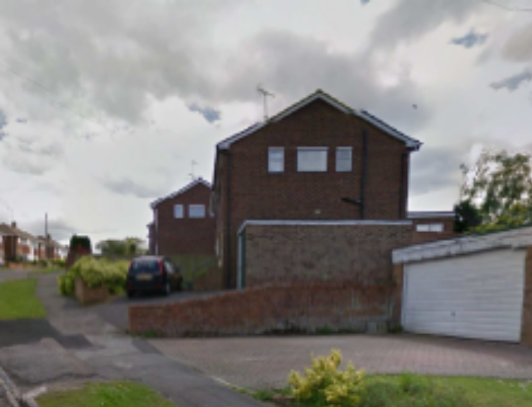

- CONCLUSION
The proposed development is now considered to be acceptable in terms of the character and appearance of the site and its surroundings and would not have a detrimental impact on the appearance of the original building. As such the proposed side extension is considered to be in accordance with Core Strategy Policy CS7 (Design and the Public Realm) and Policy DM9: House Extensions and Ancillary Accommodation of the Sites and Detailed Policies Document and the Council’s Supplementary Planning Guidance – A Design Guide to House Extensions.

Grant – standard conditions

