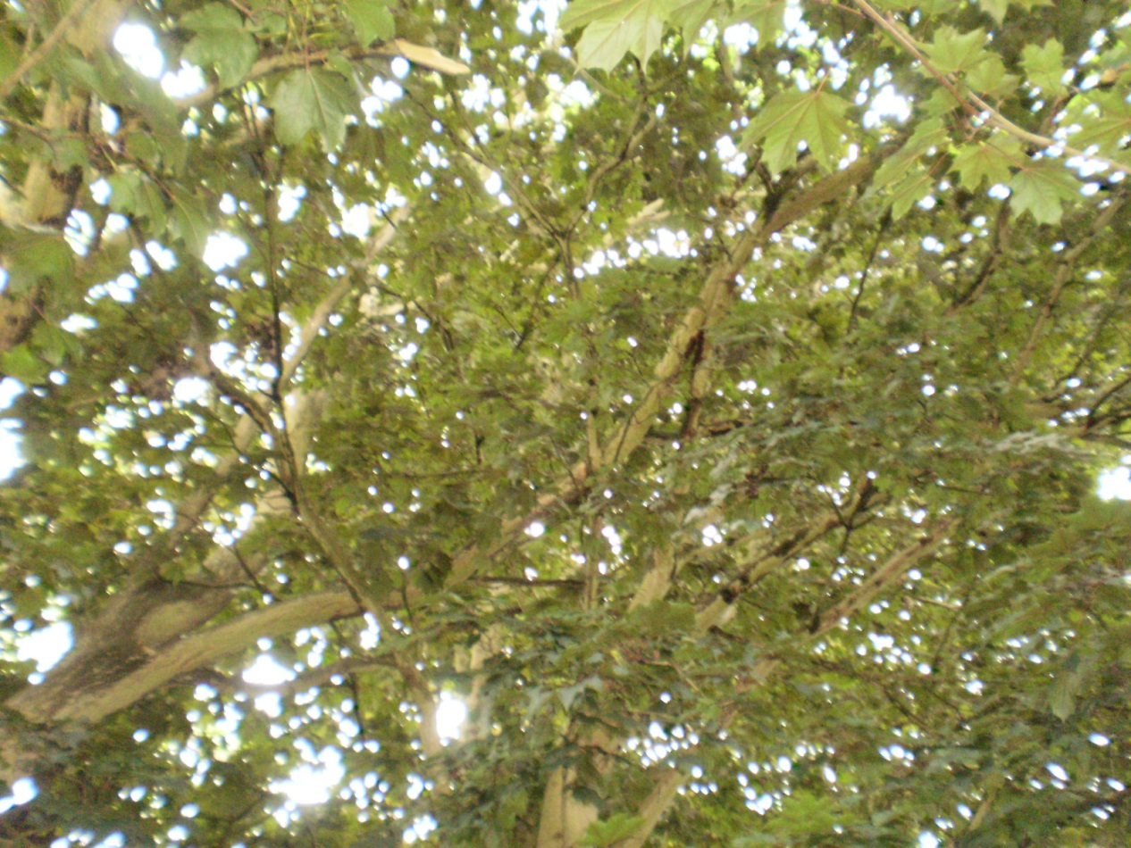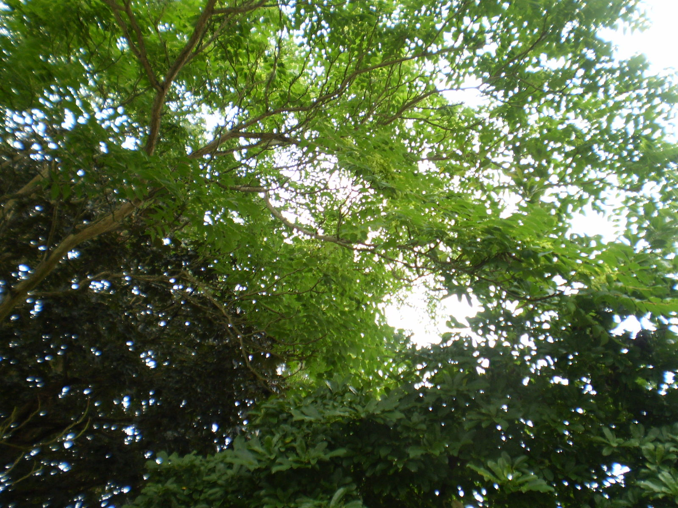
Crossing/rubbing branches to be reduce/removed (indicative pruning points in red) – refer also to application photo
Two minor branches from Tree of Heaven to be removed

9 Conisboro Avenue
24/7/17

