15 Gun Street, Reading , RG1 2JR
Proposed flank wall signage –Heritage Statement
The building is listed Grade II, list entry number 1113492 (as La Corbiere Restaurant), it was listed in 1978. It also sits within the St. Mary’s Butts/Castle Street Conservation Area.
Previous signage for the Gurkha Square Tandoori Restaurant has been removed and any fabric disturbed made good.
The new signage is hand painted onto the rendered flank wall and has been designed to be fully removable without damage to the fabric of the building, protecting the existing historic elements of the building.
It is now proposed to retain the lower part of the flank wall sign, ie. the graphic and that is the subject of this application.
The setting of the building has been somewhat compromised by the Oracle development and the siting of the walkway through with its modern canopy and, more recently the permanent coffee stand.
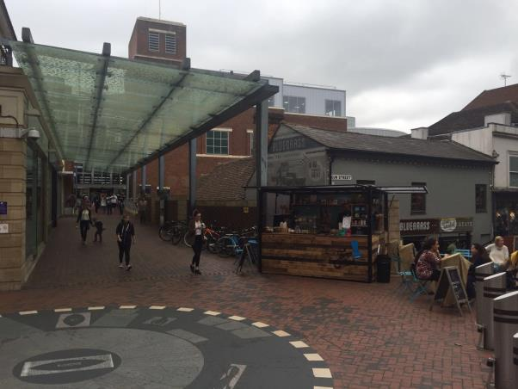
The current flank sign, seen in the context of the canopy, coffee stall and proliferation of cycles appears quite muted, particularly in contrast to other local shopfront signage.
Examples such as the signage for the Purple Turtle, below, also a listed building and the recent Smash frontage in the same terrace, along with Subway, are all much more prominent and contemporary, not at all in keeping with the appearance of the heritage assets.
We submit, therefore, that we have avoided the garish styles of building display advertising that has clearly established itself within the Gun Street frontages and have adopted a long standing and , now somewhat forgotten, form of display advert in the painted gable wall.
This form is much lamented by many architectural historians as the following link refers in Ghostsigns.
http://www.hatads.org.uk/catalogue/search.aspx?titleType=Ghostsigns
The style of the sign, the subject of this application, is very much in keeping with this old tradition and enhances the building, attempting to detract from the visual vandalism that the modern Oracle entrance and recently erected coffee stall has created.
As previously mentioned the painted sign is easily erased and has not impaired or damaged the listed structure with any mechanical fixings. It has also, already commenced to age and fade.
We therefore request that consent should be granted for the retention of the flank wall sign which is the subject of this application.

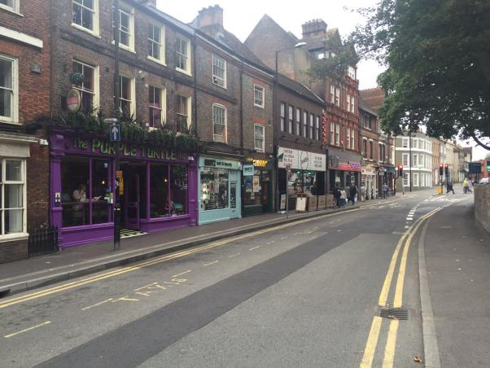

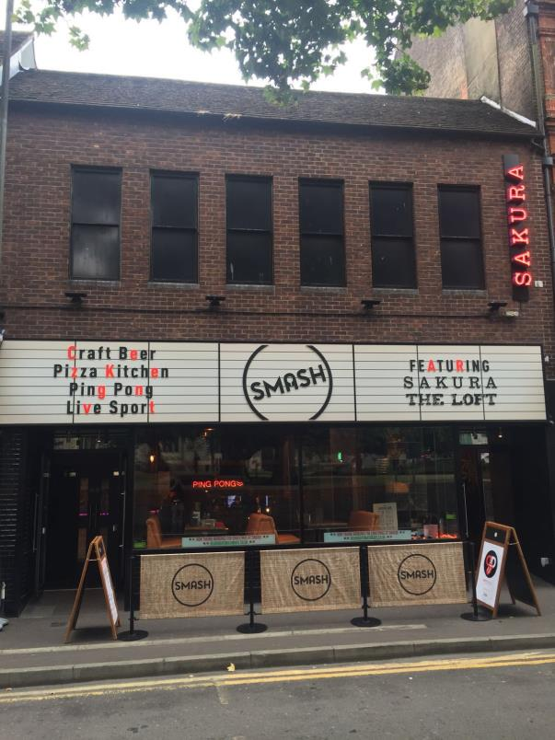
Farrow Silverton 12/16

