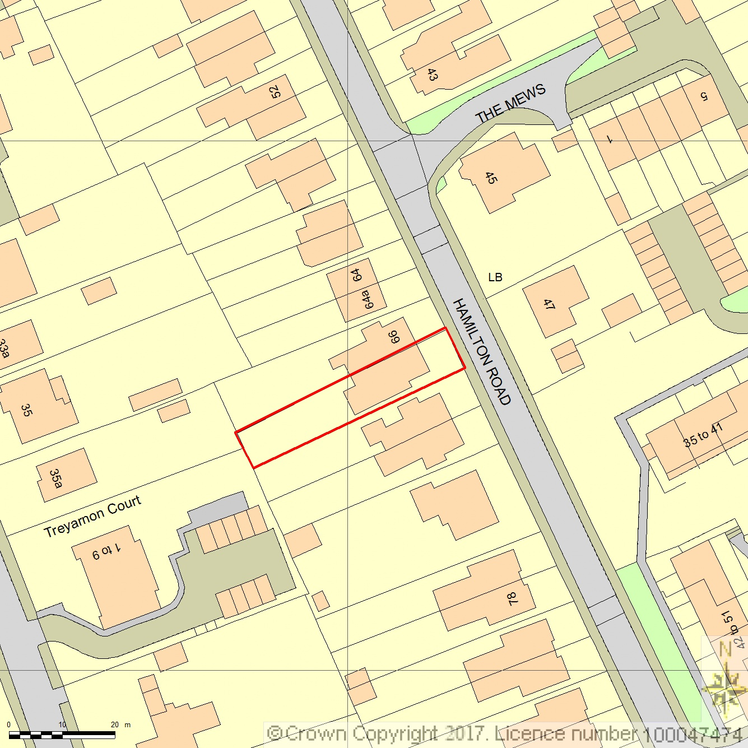SITE LOCATION PLAN
AREA 2 HA
SCALE 1:1250 on A4
CENTRE COORDINATES: 473405, 172856



Supplied by Streetwise Maps Ltd
www.streetwise.net
Licence No: 100047474
22/05/2017 15:13

