PLANNING STATEMENT

ADDITION OF A 3 BEDROOM ATTACHED DWELLING ON EXISTING SITE.

28 Eskin Close,
Tilehurst,
Reading,
RG30 4DU

PLANNING Sept 2017

1. INTRODUCTION
1.1. The planning application seeks full planning permission for the addition of a 3 bedroom end terrace property built adjoining the proposer’s property.
1.2. This Planning Statement consists of three parts:
• Introduction and the policy context
• The merits of the application
• Conclusions
1.3. It assesses the planning considerations associated with the proposed change of use and considers the change of use in the context of the Reading Revised local planning policy and guidance.

2. THE SITE
2.1. The site is occupied by an existing 3 bedroomed dwelling to the side of the property there is a large garden currently seating area. The Plot size totals xxxm2.
2.2. Tilehurst is a suburb of the town of Reading in the English county of Berkshire. It lies to the west of the centre of Reading, and extends from the River Thames in the north to the A4 road in the south. Eskin Close is a large residential road with several terraced matching properties set along pedestrianised footways.

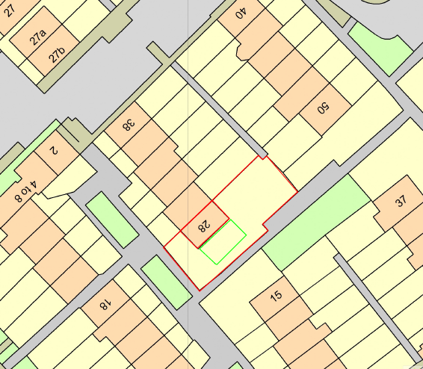

3. THE POLICY CONTEXT
3.1. This section sets out and examines the legislative and policy context relevant to the proposal. It comprises an assessment of the following:
• PART 2 - Local List of Information Requirements.
- Item 1 - Affordable Housing Statement and Item 27 – Viability Appraisal – Client has acknowledged this and is willing to make a contribution to the affordable housing policy.
- 2. Item 4 – Contaminated Land Survey and Report – Acknowledged, survey to be carried out before work starts.
- 3. Item 11 – Heads of Terms Proposals – S106 – Acknowledged, Certificate of ownership available on request.
- 4. Item 13 - Landscape Principles – Exiting landscaping to be untouched and unaffected.
- 5. Item 25 – Vehicle (including cycle) parking and waste collection details – Waste collection and storage to be as existing. There is no off road parking at all at the property however there are designated on street bays located on Eskin Close and surrounding roads.

4. CONCLUSION
4.1. The Application would greatly improve the existing use of the plot and would provide a beautiful family home.
4.2. The proposed new dwelling will follow the building line and ridge line of the existing property which would keep everything neat and with minimal impact.

