Design and Access Statement

This Design and Access Statement has been produced to accompany and support a Householder Planning Application for the addition of a single storey Glass Canopy to the rear elevation of the Property.

The existing residential property is located at 1009 Oxford Road¸ Tilehurst, Reading, Berkshire, RG31 6TL. The detached property is mainly two storeys, with a single storey rear extension. There have been multiple extensions and alteration to the property. The proposed Glass Canopy will be attached to the single storey rear extension.

Access to the site is via Oxford Road. The driveway allows access for parking and routes around the site. The main point of access into the property is via the front elevation, the site of the proposal is on the rear elevation, situated on the patio in the rear garden. The garden is accessible through the property or via the side gate.

The purpose of the design is to provide a sheltered area within the garden. The Glass Canopy will provide the applicant with a space, which can be used throughout the year. The non-insulated Glass Canopy is an enhancement of the garden area; as opposed to an extension of the house as it is an open structure.

The design of the Glass Canopy has a gutter system built into the supporting posts. This is an elegant design, which does not detract from the existing building and is both functional and sleek. The 5° pitch of the roof enables rainwater to roll down and into the gutter, rather than lying flat on the roof and therefore is essential to the design. The rainwater can then be redirected to the existing drainage points within the garden.

The floor space of the Glass Canopy will be 27m², which comprises RAL 9007 ‘Grey Aluminium’ posts and profiles, and a clear glazed roof.

The character of the existing dwelling is preserved, through the addition of the clear glass. The original building is unharmed as the construction of the proposal is demountable and is not classed as a permanent structure, unlike a conservatory or extension. The proposal is aesthetically pleasing with the colour choice. The ‘openness’ of the Glass Canopy allows the garden area to be utilised in all weather conditions. This discreet design is both elegant and fitting for the function and site.
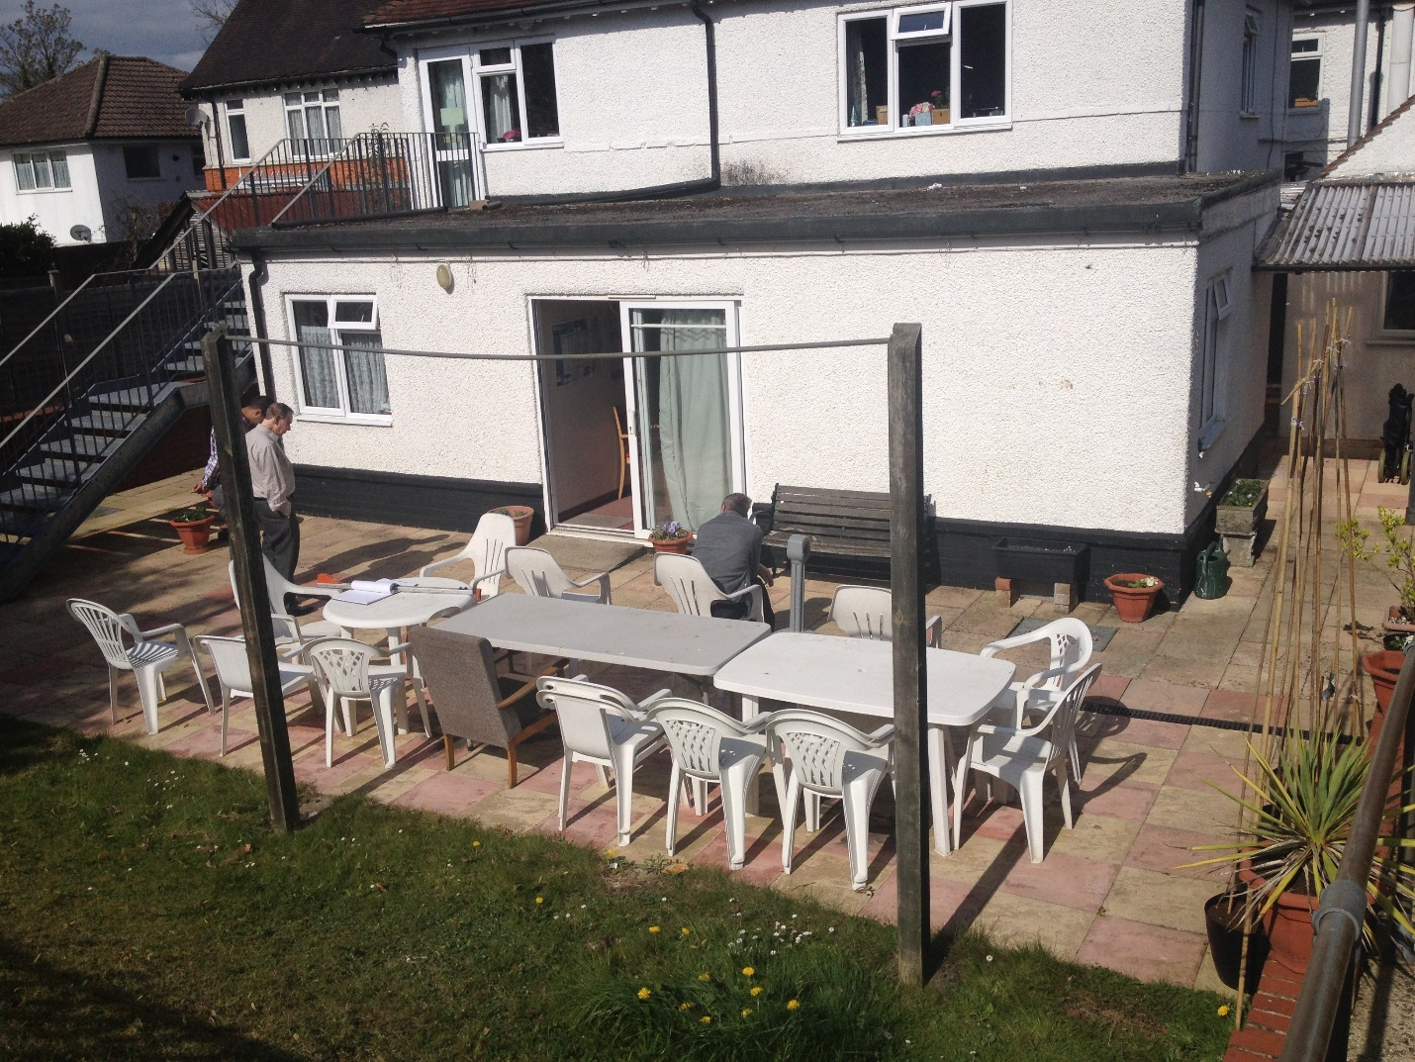
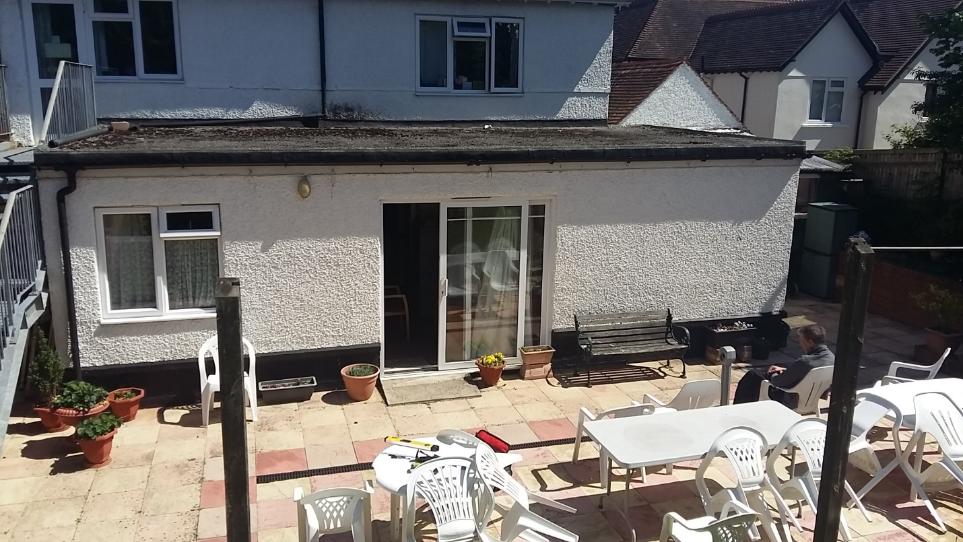
Photographs of site of the proposal at the rear of the Property.

