DELEGATED APPLICATION REPORT - CERTIFICATE OF LAWFULNESS

APPLICATION NUMBER: 17980/CLE
SITE ADDRESS: 328 Oxford Road, Reading
PROPOSAL: Certificate of lawfulness for existing use of property as 3 self-contained flats.
CASE OFFICER: Ralph Chakadya

SITE DESCRIPTION & PROPOSAL
The site is an end-terrace building on a classified road adjoining a Mosque. At ground floor the building is part of a shopping parade with retail use.

The flats are at rear ground floor, first floor and roofspace.

PLANS SUBMITTED
The agent provided the following drawings:
Unnumbered Location Plan received 14th June2017
No. OFR.328.RG.EX Existing Floor Plans received 14th June 2017

RELEVANT PLANNING HISTORY OF THE SITE
07/00535/COU – Enforcement investigation following alleged Change of use from residential (C3) and commercial storage to three self-contained flats. October 2009

RELEVANT PLANNING POLICY AND GUIDANCE
Section 10 of the Planning and Compensation Act 1991 established a procedure that enables anyone who wishes to do so, to apply to the local planning authority to determine whether a proposed use or operation, or an existing operational development or an existing use of land, or any other matter constituting a failure to comply with any condition or limitation subject to which planning permission has been granted, is lawful, and if so, be granted a certificate to that effect.

A Lawful Development Certificate is a legal document stating the lawfulness of past, present or future development. If granted by the local planning authority, the certificate means that enforcement action cannot be carried out to the development referred to in the certificate. However, the certificate will not protect from enforcement action by the planning authority if the specified use or development is then changed 'materially' without a planning application for it.

The certificate is not a planning permission. The planning merits of the use, operation or activity in the application are not relevant. The issue of a certificate depends entirely on factual evidence about the history and planning status of the building or other land and the interpretation of any relevant planning law or judicial authority. The responsibility is on the applicant to provide evidence to support the application.

The NPPG states that “In the case of applications for proposed development, an applicant needs to describe the proposal with sufficient clarity and precision to enable a local planning authority to understand exactly what is involved. In determining an application for a prospective development under section 192 of the Town & Country Planning Act a local planning authority needs to ask “if this proposed change of use had occurred, or if this proposed operation had commenced, on the application date, would it have been lawful for planning purposes."

RESPONSE TO CONSULTATIONS

RBC Enforcement – An enforcement investigation in 2009 established that unauthorised change of use from residential (C3) and commercial storage to three self-contained flats had taken place.

RBC Legal – No objection

RBC Electoral Services – The Electoral Services Department have supplied details of the Electoral Register for this property showing the property as 3 flats from 2012.

RBC Council Tax - Council tax records show there are 3 separate flats registered at this property and these flats have been banded for council tax purposes since February 2012.

RBC Environmental Health – No comments received.

EVIDENCE SUBMITTED
The following documents were submitted:
Location Plan
Existing Floor plans
Tenancy Agreements
Letter from the Council’s Environmental Health HMO Department
Supporting letter by applicant
Statutory Declaration by the letting agent
Valuation Office Listings for the 3 flats

ANALYSIS OF EVIDENCE (ASSESSMENT)
The applicant has submitted a signed Statutory Declaration by the manager of the letting agency confirming that the property has been let as 3 flats since 2008 and has remained as such to present day. This is collaborated by the Council’s Enforcement investigation in 2009 that confirmed the property had been changed into 3 flats. Council tax records show there are 3 separate flats registered at this property and the Council Tax department has confirmed that these 3 flats have been banded for council tax purposes since February 2012 to present. In addition submitted screenshots from the Valuation Office Listings by the applicant confirms the 3 flats were registered for council tax since 2012. In the same file there is also a letter from the Council’s HMO department of Reading Council detailing an inspection and drawings from that period, also showing it as 3 separate flats.

The submitted existing floor plans (No. OFR.328.RG.EX) show the property as 3 flats, a situation confirmed by officers upon site visit on 28/07/2017. All 3 flats are currently occupied. The applicant has provided part-tenancy agreements dating from 2009 to present.

Having reviewed the information submitted as outlined above, it has been concluded that on the balance of probability, the property known as 328 Oxford Road Reading, RG30 1AF has been in use as 3 flats for a period in excess of 4 years with no enforcement action having been taken on the property in connection with the use. In these circumstances, it is considered appropriate to grant a certificate of Lawfulness to that effect.

Conclusion
Sufficient evidence has been provided to demonstrate that a Certificate of Lawfulness for the use of 328 Oxford Road Reading as 3 flats should be granted on the basis that a period of 4 years has lapsed since the conversion of the property and is now therefore immune to enforcement action and is now lawful.

Submitted drawings:
Unnumbered Location Plan received 14th June2017
No. OFR.328.RG.EX Existing Floor Plans received 14th June 2017
Therefore the Local Planning Authority will, on this occasion, issue the applicant with a Certificate of Lawfulness for the existing 3 flats.

Recommendation:
GRANT Certificate
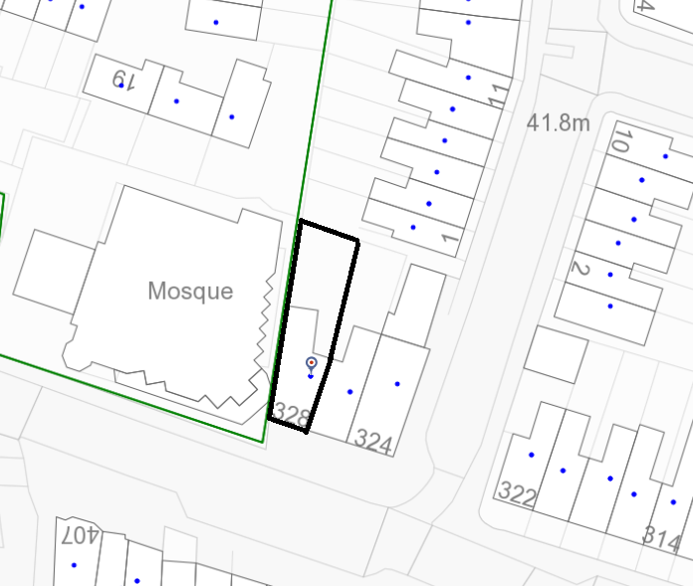
Location/Block Plan

