This Design and Access Statement is supporting documentation for the application at:

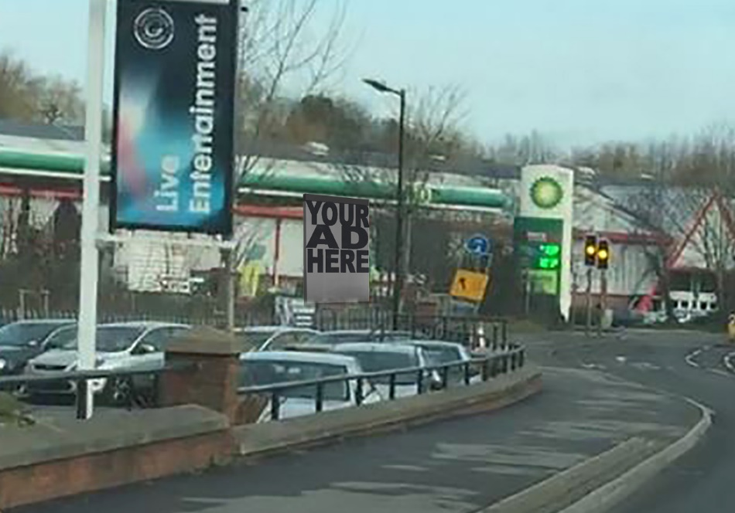

A33 Relief Road, Reading, RG2 0SN

1. Introduction
1.1 This statement seeks to cover the previous history of the site including previous applications and addresses their refusal.
1.2 The statement seeks to cover the history of the site and provide information to support the decision made by Reading Borough Council. We believe this application addresses previous issues that led to the refusal of the previous application.
1.3 This statement is supported by the following documents:
PL-01 Location Plan -3
PL-02 Existing Block Plan -3
PL-03 Proposed Provisional Access Track
PL-04 Electronic advertising details

1.4 Payment of the £385 planning application fee will be paid by the client following submission of the application.
1.5 The device itself would feature a screen advertising display sized as a 48-sheet advertising board, or 6096mm height by 3048mm width – a surface area of approximately 18 m². There will be only 1 advertisement display, facing drivers going into Reading on the A33.

2. Site Location
2.1 The A33 Dual Carriageway is one of the main routes in and out of Reading town centre from the M4 Junction 11 located to the south.
2.2 The application site is located along the west side of the A33, approximately 1.5km from Reading town. To the south of the site lies the Grosvenor Casino, to the north a retail shopping park and petrol station, and opposite are sited the dealerships of Reading Honda and Audi.
2.3 The site is not in a restricted advertisement area such as an Area of Special Control.
2.4 The surrounding area is industrial / retail and features advertisements for the likes of Grosvenor Casino along this road.
2.5 The access gate exists. The track is proposed (crushed concrete).

3. Assessment of Policy

3.1 Reading Borough’s development plan consists of the Core Strategy (2015) and the sites and details policy document (2015). National guidance in the National Planning Policy Framework (NPPF) and National Planning Policy Guidance (NPPG) also applies, along with the Institution of Lighting Engineers technical Report number 5.
3.2 National Planning Policy Framework - The overarching policy change applicable to the proposed development is the presumption in favour of sustainable development. This presumption in favour of sustainable development sets out the tone of the Government’s overall stance and operates with and through the other policies of the NPPF. Its purpose is to send a strong signal to all those involved in the planning process about the need to plan positively for appropriate new development; so that both plan making and development management are proactive and driven by search for opportunities to deliver sustainable development, rather than barriers.
3.3 Paragraph 14 of the NPPF specifically states at the heart of the National Planning Policy Framework is a presumption in favour of sustainable development, which should be seen as a golden thread running through both plan-making and decision-taking. For decision-taking this means approving development proposals that accord with the development plan without delay.
Principle of Development
3.4 The application site is located within the settlement boundary as defined by Core Strategy policy CS6, where new development is considered appropriate.
Character and amenity of the area
3.5 The NPPG states at Paragraph 079 Reference ID: 18b-079-20140306 dated 06/03/14 that the consideration of amenity includes aural and visual, such as whether the “locality where the advertisement is to be displayed has important scenic, historic, architectural or cultural features” and if the advertisement is “in scale and in keeping with these features”.
3.6 The proposed adverts will not make any noise and as such would result in no aural effects on amenity.
3.7 The site lies in a busy, urban, commercial area where surrounding businesses have displayed a number of adverts, including internally illuminated adverts at the Casino site immediately to the south of the proposed advert location. The surrounding buildings are also large in scale and mass and height, and commercial in nature. The proposed development scale and design would therefore be in keeping and appropriate when viewed against the backdrop of surrounding commercial development and illuminated advertisements. The site is not located within an area designated for its scenic, historic or architectural features.
3.8 Policy DM22: ADVERTISEMENTS identifies the following application requirements, which are assessed in turn; a) Advertisements will not obstruct windows any other sign already located on the building, or significant architectural features such as cornices or scrolls; Not applicable to this application
b) Where a shop or business occupies more than one adjacent unit, the advertisement will not run between the shopfronts; Not applicable to this application
c) Advertisements on listed buildings or in Conservation Areas will respect or enhance the building or area, and will respect the key features of the historic asset;
Not applicable to this application
d) Advertisements will not reduce visibility for users of the highway or accesses onto the highway; See following section of this statement
e) Illumination should not detract from the amenity of the area or pose a safety hazard to users of the highway; and See following section of this statement
f) Advertisements should not obscure the sight lines of cameras installed for public safety. The proposed advertisement would not obstruct the site lines of any security cameras installed on adjoining land uses.
3.10 Finally, the site would have no adverse effect on residential properties, in accordance with policy DM4. For the above reasons, the proposal is considered to have an acceptable effect on the character and amenity of the surrounding area.
Highway Safety 3.11 In addition to points d and e of policy DM22 reference above, NPPG paragraph 067 Reference ID: 18b-067-20140306 dated 06/03/14 states that “There are less likely to be road safety problems if the advertisement is on a site within a commercial or industrial locality, if it is a shop fascia sign, name-board, trade or business sign, or a normal poster panel…and if the advertisement is not on the skyline”.
3.12 The proposed advertisement application is within a commercial area and the 5m proposed height is such that the development would not be upon the skyline.
3.13 An accompanying transport statement has been prepared, which concludes at paragraph 4.7 that the adverts are “positioned at a location to which safe highway access can be gained and where it would present no material adverse effects to road safety.” The proposal is therefore considered to be appropriate in terms of its effect on highway users.
3.14 With regard to illumination levels, the maximum illumination capacity of the technology is 6500 NITS or CANDALAS. Typical operating outdoor LED Screen luminance (c/m2) are as follows:
• Bright sun Daytime 2500c/m2 ‐ 4800c/m2
• Hazy Day Daytime 1500c/m2 ‐ 3000c/m2
• Cloudy Bright Daytime 800c/m2 ‐ 1500c/m2
• Cloudy Dull Daytime & Evening Sunset 300c/m2 ‐ 800c/m2
• Twilight 300c/m2
3.15 Thus, whilst the maximum capacity is 6500c/m2, most suppliers fully advocate reducing the illumination values of the screen wherever possible as this has a direct reduction in the power consumption of the LED Screen and additionally aids the longevity of the screen. The maximum levels as indicated above would therefore be utilised for the proposed development. Additionally RBC imposes a daylight limit of 600 cd/m², and 300 cd/m².
3.16 The access to be utilised for construction and maintenance is existing, and so does not require separate consent. Maintenance visits would amount to only once a year, as the monitoring and display changes can all be managed remotely.
Flood Risk
3.17 The site lies within Flood Zone 2; defined as land having between a 1 in 100 and 1 in 1,000 annual probability of river flooding. Standing advice from the Environment Agency confirms that advertisement applications do not fall within the definition of ‘minor developments’ requiring a Flood Risk Assessment, nor is the advert a vulnerable use.
3.18 As the access and track is also existing, the use of this for the yearly maintenance check would also not worsen the drainage situation.
3.19 Consequently, it is not considered the proposal would have any adverse effect with regard to vulnerability to flood events, nor would increase the risk of flooding elsewhere.
Air Quality Management Area
3.20 Policy DM19 seeks to protect sensitive areas from development which would adversely affect local air quality. As this application is for advertisements, the proposal would not detrimentally affect local air quality and therefore would not conflict with this policy.
Community Infrastructure Levy (CIL) 3.21 The Council’s adopted CIL schedule seeks to mitigate against the effect of development upon Borough infrastructure. As this application is for advertisements, it does not form one of the CIL liable uses, and the payment of CIL is not required.

4.Previous Application
The previous application on this site was refused on a number of grounds, however an approval has been suggested as likely if these terms were rectified.
- We are willing to submit a secondary planning application for the access road which shall be used mainly for agriculture, and maintenance to the digital sign generally once or twice a year as they can be updated / controlled remotely.
- The control shed has been removed.
- The sign facing traffic going out of Reading has been removed – there is now only one sign facing traffic entering Reading.
Responding to Claire Ringwood’s Comments 04 Oct 2016 Consultation:
The advertisement brightness will be within Reading Borough Council Zone standards, 600 cd/m² during daylight hours and 300 cd/m² between dawn and dusk – these measures are in place to prevent sign illuminance from potentially distracting road users.
The siting is such that those closest to the traffic lights do not have any view of the digital billboard, as seen in PL-04. Therefor they will not be distracted and will move off in a prompt fashion – this will cause consequent traffic to move off in good time as well. Approximately cars from 4 cars back will have a view of the billboard.
The reduced surface area of the advertisement board from 35m² to 18m² also reduces any chance of dazzling or distracting road users. The transport Statement goes into further detail concerning this.
Concerning visual amenity, the proposed digital billboard is smaller than the previous application, and as it is narrower the aspect of visual provided by the view of hedging and trees is still present. When viewed exiting Reading via the A33, it is viewed either side on, or from the back, meaning it’s visual impact is minimally distracting.
At no point will traffic approaching Reading from the South will see this sign at the same eye level as the traffic light as requested by Darren Cook.

5. CONCLUSION
4.1 This statement has demonstrated the proposed development can be implemented without adverse harm to the character of the local area and amenity of neighbouring land uses.
4.2 The proposal would also not result in any material harm to the safety of local highway users and would be without detriment to the local environment.
4.3 It is therefore respectfully requested that advertisement consent be granted for the proposed development together with the proposed track.

