DELEGATED HOUSEHOLDER APPLICATION REPORT

Ward: Tilehurst
App Ref: 171401/HOU
Address: 12 Elmstone Drive, Tilehurst, Reading, RG31 5NU
Proposals: Two storey & single storey side extension
Case Officer: Julie Williams
Applicant: Paul Winter
Date received (valid from): 21 August 2017
Target Decision date: 16 October 2017

1. INTRODUCTION
The application property is a semi-detached house set back from the road with a steep change of level from pavement to front door and the house sits almost at the crest of the hill rising from the west. This gives the house prominence when seen from this approach. The house, like others nearby, has stone cladding on the ground floor and brick above.

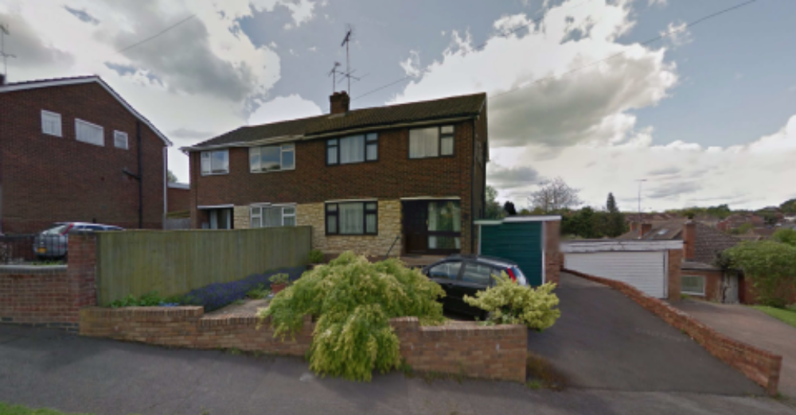

2. PROPOSAL AND SUPPORTING INFORMATION
Two storey & single storey side extension. The two storey side extension element is proposed to be set flush with the front of the original house (in the place of the garage which is to be demolished) with a store and WC at ground floor and extension to bedroom 3 on the first floor. External measurements are 2930mm x 3618mm. One window facing front at first floor level is shown and a garage door to the store. The roof has a gable end with tiled pitched roof. Height from ground to eaves 5.5 metres and 6.8 metres to the ridge.

The store has steps up to the single storey element, which would enlarge the kitchen by 3682mm x 2449mm. This has a mono-pitched roof design 3 metres high to the eaves and 4.3 metres high where it meets the rear wall of the front part of the side extension.

Plans considered
07 17 7606 Rev A – Existing Survey
07 17 7606A Rev B – Proposed two storey & single storey side extension

- RELEVANT PLANNING HISTORY
None

4. CONSULTATIONS
4.1 The following addresses were consulted by letter and a site notice was displayed.

6 Elmstone Drive, Tilehurst, Reading, RG31 5NU
10 Elmstone Drive, Tilehurst, Reading
14 Elmstone Drive, Tilehurst, Reading

4.2 One representation was received with observations that “due to differences in the floor and site levels, the submitted design creates large plain panels of brickwork, particularly between the garage door and first floor window. As the proposed extension is aligned with the existing East (front) elevation, the large areas of brickwork and roof-line give an unbalanced appearance to the original semi-detached properties of Nos. 12 & 14. This effect could be lessened by adopting a similar approach to that of other two storey side extensions in Elmstone Drive, where the upper floor is stepped back from the front elevation”.

- LEGAL AND PLANNING POLICY CONTEXT

Section 38(6) of the Planning and Compulsory Purchase Act 2004 requires that proposals be determined in accordance with the development plan unless material considerations indicate otherwise. Material considerations include relevant policies in the National Planning Policy framework (NPPF) - among them the 'presumption in favour of sustainable development'.

The following local and national planning policy and guidance is relevant to this application:

National Policy

National Planning Policy Framework
National Planning Practice Guidance

Reading Borough Local Development Framework Core Strategy (2008)
CS7 (Design and the Public Realm)

Sites and Detailed Policies Document (2012)
DM4 (Safeguarding Amenity)
DM9 (House Extensions and Ancillary Accommodation)

SPG/SPD

- A Design Guide to House Extensions SPG

Equality Act

In determining this application the Council is required to have regard to its obligations under the Equality Act 2010. The key equalities protected characteristics include age, disability, gender, gender reassignment, marriage and civil partnership, pregnancy and maternity, race, religion or belief, sexual orientation. It is considered that there is no indication or evidence (including from consultation on the current applications) that the protected groups have or will have different needs, experiences, issues and priorities in relation to this particular planning application.

6. APPRAISAL

6.1 The main issues are:

- Design and impact on the character and appearance of the original house
- Design and impact on the character and appearance of the surrounding area
- Impact on neighbours

a) Design and impact on the character and appearance of the house

6.2 Policy DM9: House Extensions and Ancillary Accommodation of the Sites and Detailed Policies Document (2012) states that an extension to a house should respect the character of the house in terms of scale, location, materials and design, and respect the character and pattern of neighbouring properties and the street as a whole in terms of scale, location, materials and design, and any important existing building line. Policy CS7 (Design and the Public Realm) of the Core Strategy also states that all development must be of high design quality that maintains and enhances the character and appearance of the area. The Council’s Supplementary Planning Guidance – A Design Guide to House Extensions advices that side extensions should be smaller in scale than the original house, achieved by setting the extension back from the front of the original house.

6.3 The proposed extension would fail to respect the character of the house in terms of scale due to the change in ground levels on the site and the elevation of the site when seen from the street. This would result in the proposed 2 storey side extension appearing unusually tall and dominant in comparison with the main house.

6.4 A common device to achieve a comfortable relationship between side extensions and the original house (as advised in our SPG) is to set the extension back from the front of the house and to drop the ridge height. In this case the ridge is significantly lowered but the relative site levels means that without a set back from the front the side extension would still appear too tall. During the course of assessing the application the applicant was advised to set the front at first floor level back by a small amount (275mm) to allow a horizontal break to be introduced to help break up the expanse of brick work on the front. This suggestion was not taken up and therefore it is considered that the proposed extension would detract from the appearance of the original house by not fitting in with the scale and proportions of the original building.

b) Design and impact on the character and appearance of the surrounding area

6.5 Policy DM9 seeks development that respects the character and appearance of the street and discourages design that would present a large blank façade to public areas. The elevated position of the house means that it is very prominent when seen from the street, particularly from the western side, which is the side where the proposed extension would go. The proposed high side elevation has been designed to have no features (apart from a small window at ground floor level) and therefore will present a large blank façade to the public street. The applicant was asked to consider a first floor window to the bedroom on this elevation to add interest to this wall (and to provide a better view from the bedroom) but this suggestion has not been accepted. Therefore it is considered that the proposed side extension is not well designed and would have a harmful impact on the appearance and character of the area.

c) Impact on neighbours

6.6 The extension is not considered to be harmful to the amenity of neighbours (Policy DM4) in terms of reducing the amount of daylight and sunlight enjoyed by neighbouring properties or through invading the privacy of neighbouring properties through overlooking from windows or balconies. The applicants explained that they had not placed a window in the side elevation out of concern for overlooking the neighbour lower down the hill at No.10 Elmstone Drive. However, the case officer advised that due to the orientation of the houses a side facing window would only overlook the forecourt serving their neighbours garage (see image below) and therefore would not lead to a loss of privacy.

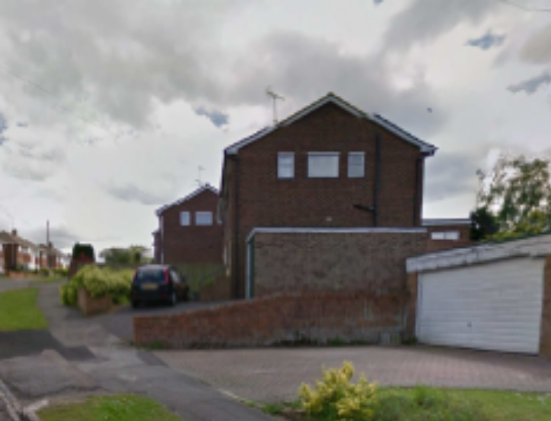

- CONCLUSION
The proposed development would be harmful to the character or appearance of the site and its surroundings and would have a detrimental impact on the appearance of the original building. As such the proposed side extension is considered to not be in accordance with Core Strategy Policy CS7 (Design and the Public Realm) and Policy DM9: House Extensions and Ancillary Accommodation of the Sites and Detailed Policies Document and the Council’s Supplementary Planning Guidance – A Design Guide to House Extensions.

8.0 RECOMMENDATION
Application Refused

1. By virtue of the prominent siting of the house above street level the proposed side extension will present a large blank façade when viewed from the public area. The side elevation uses no design detail or device, such as a first floor window, to soften this bland impression. Therefore the proposed extension would detract from the character and appearance of the house and the local area contrary to Policy CS7 of the Local Development Framework Core Strategy 2008 (amended 2015) and Policy DM9 of the Sites and Detailed Policies Document 2012 (amended 2015) and A Design Guide to House Extensions SPG.
2
2. There is a change in ground levels on the site and by virtue of a lack of any set back from the front elevation of the main house the front of the proposed side extension will present an unattractive extent of blank façade between the top of the garage door and the bottom of the first floor window sill when viewed from the public area. The design uses no device to soften this impression. Therefore the proposed extension would detract from the appearance of the house and the local area contrary to Policy CS7 of the Local Development Framework Core Strategy 2008 (amended 2015), Policy DM9 of the Sites and Detailed Policies Document 2012 (amended 2015) and A Design Guide to House Extensions SPG.

