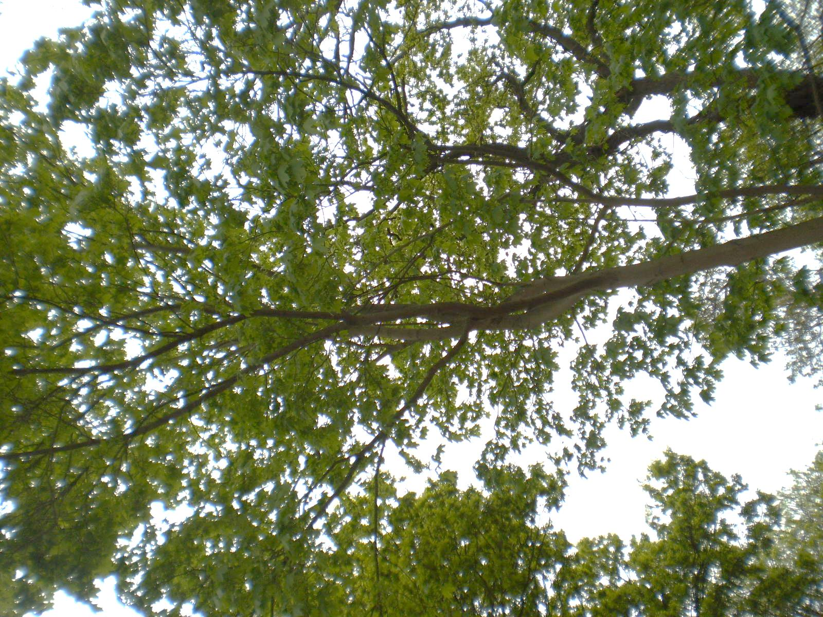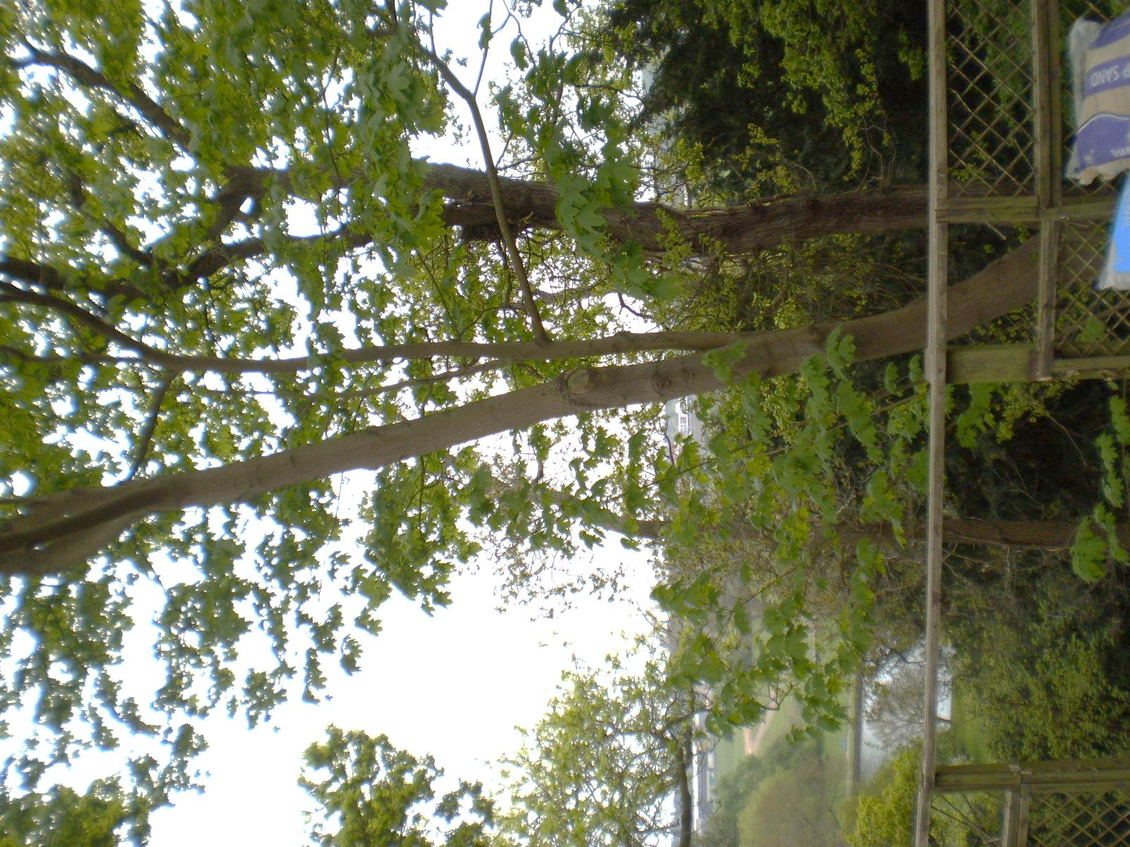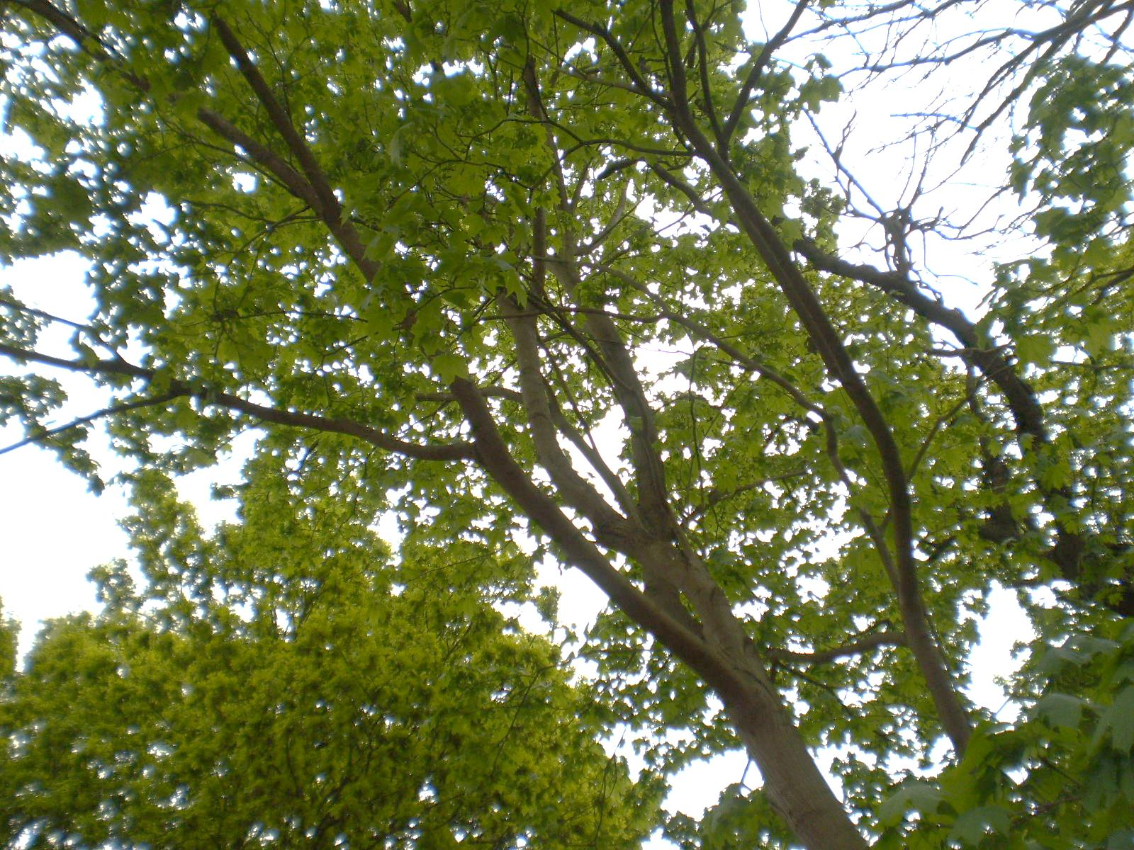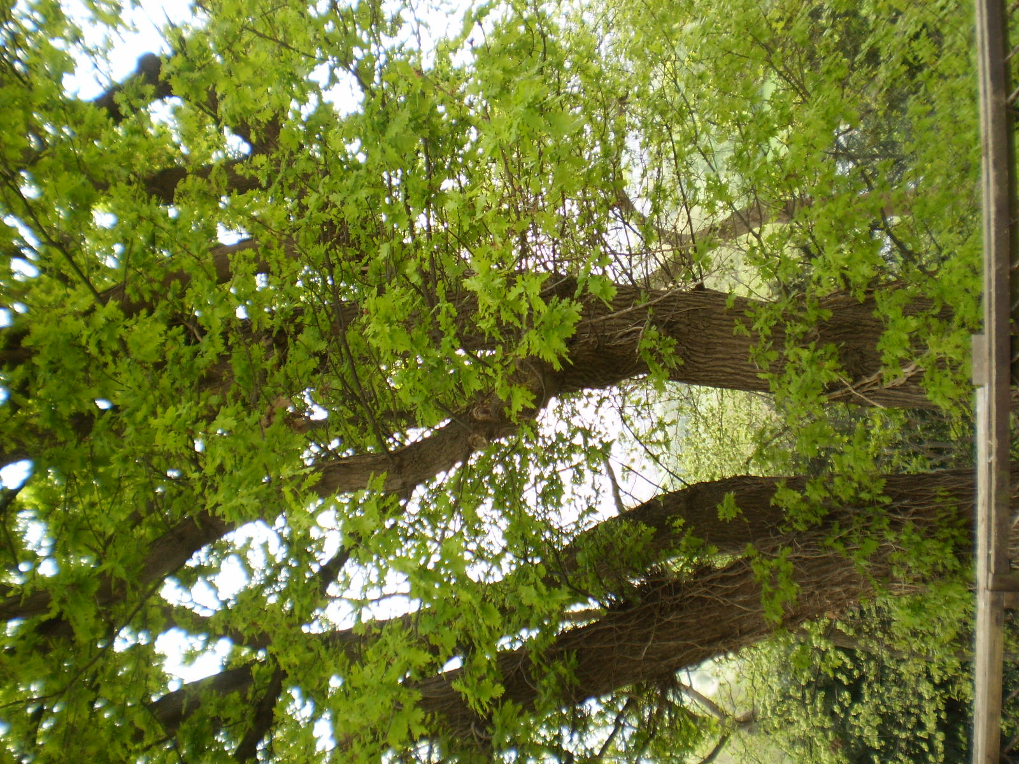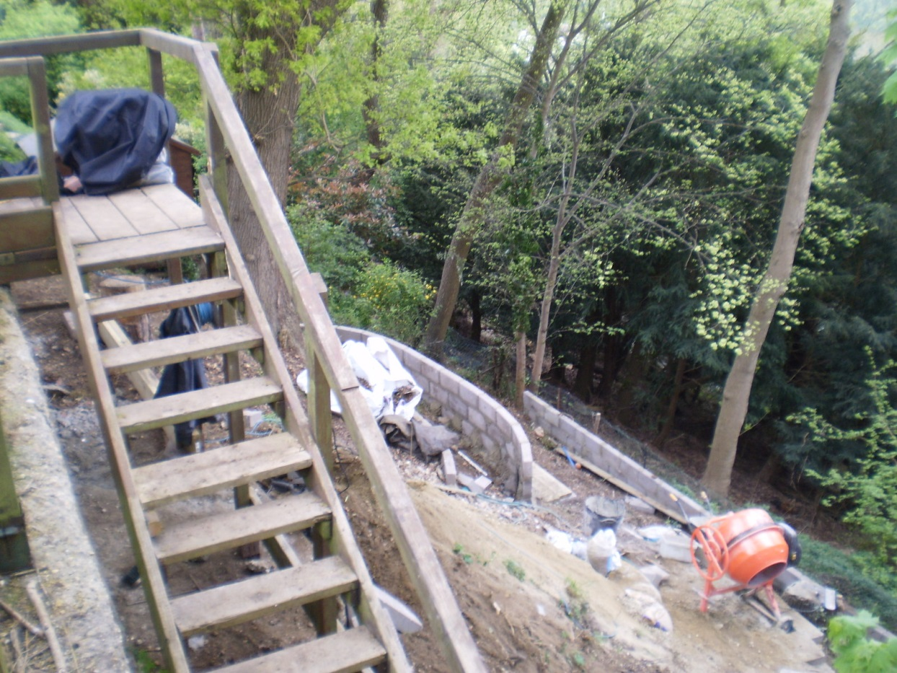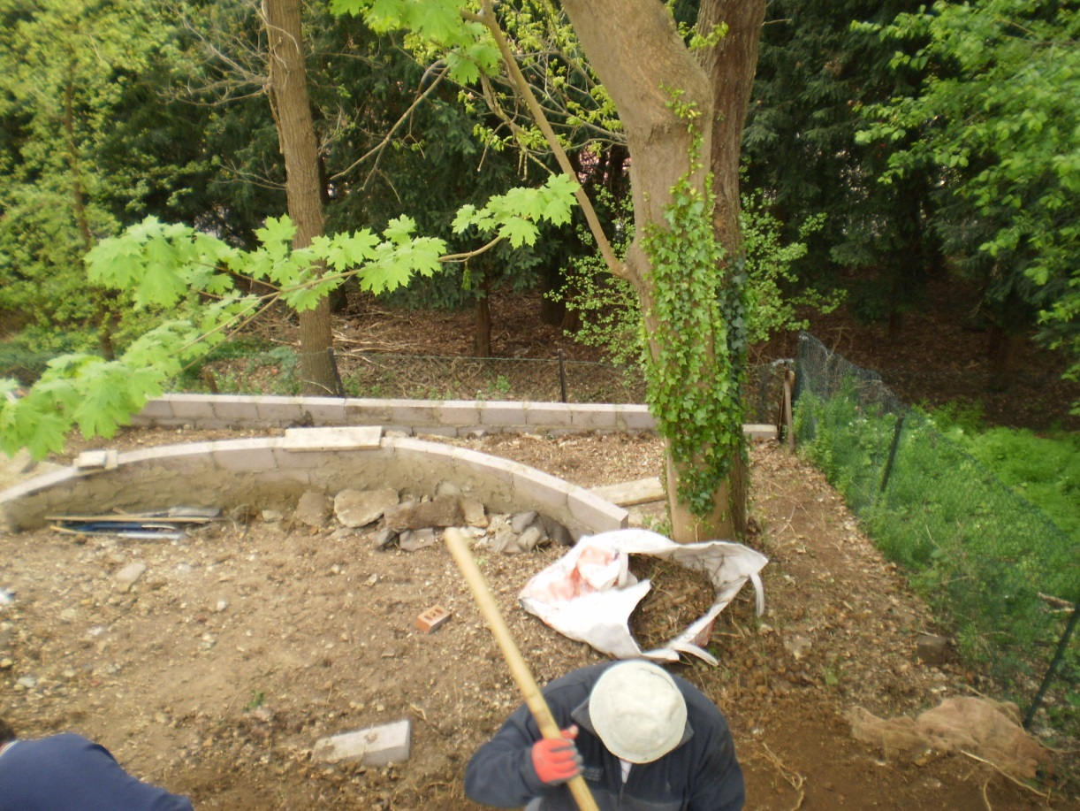
Maple – main branch overhanging garden to be removed
Maple – two main limbs to be removed
Main limb over garden that can be removed
Oak – lower, epicormic (minor) growth growing towards the garden to be removed

14 Ridge Hall Close
28/04/17

