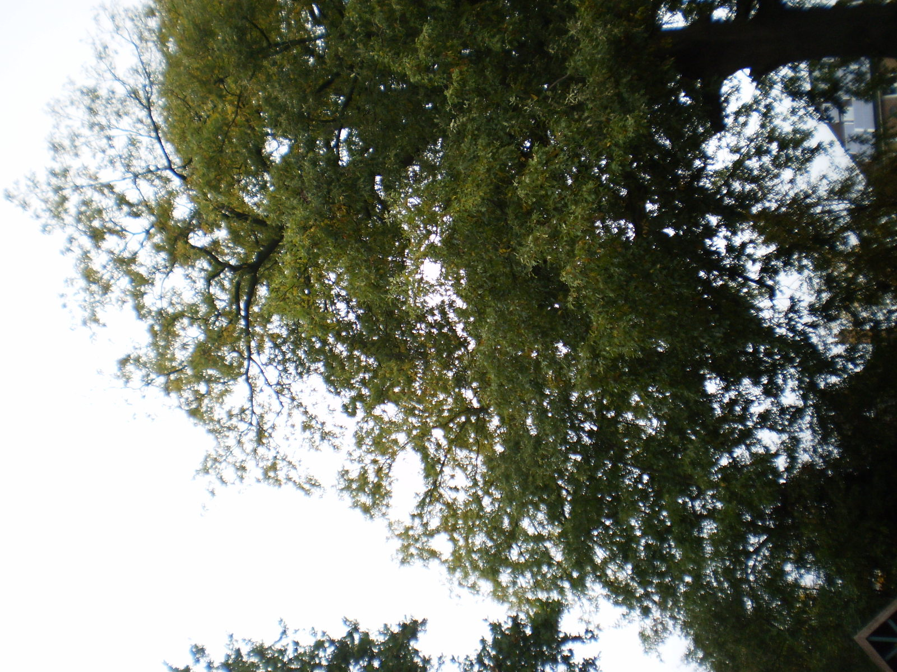
Mid-lower crown
Upper crown

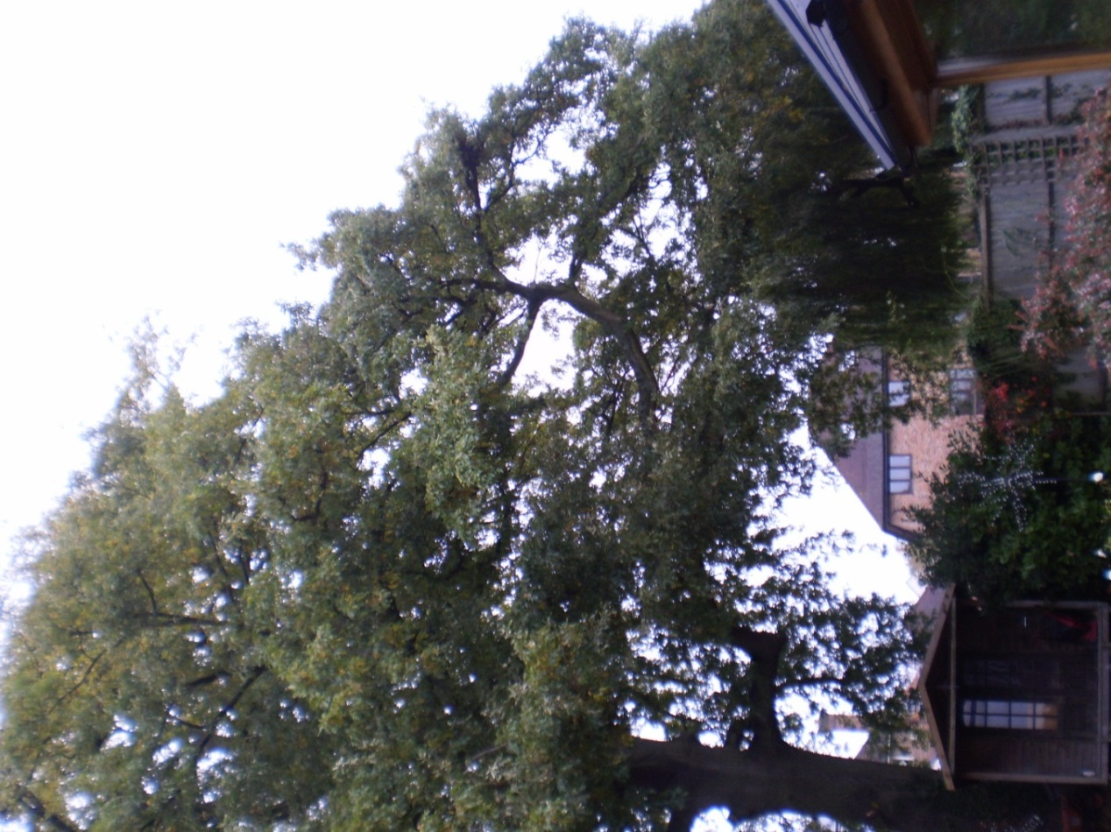
Mid-lower crown
Upper crown

Oak at 5 Chiltern Heights
19/10/17

