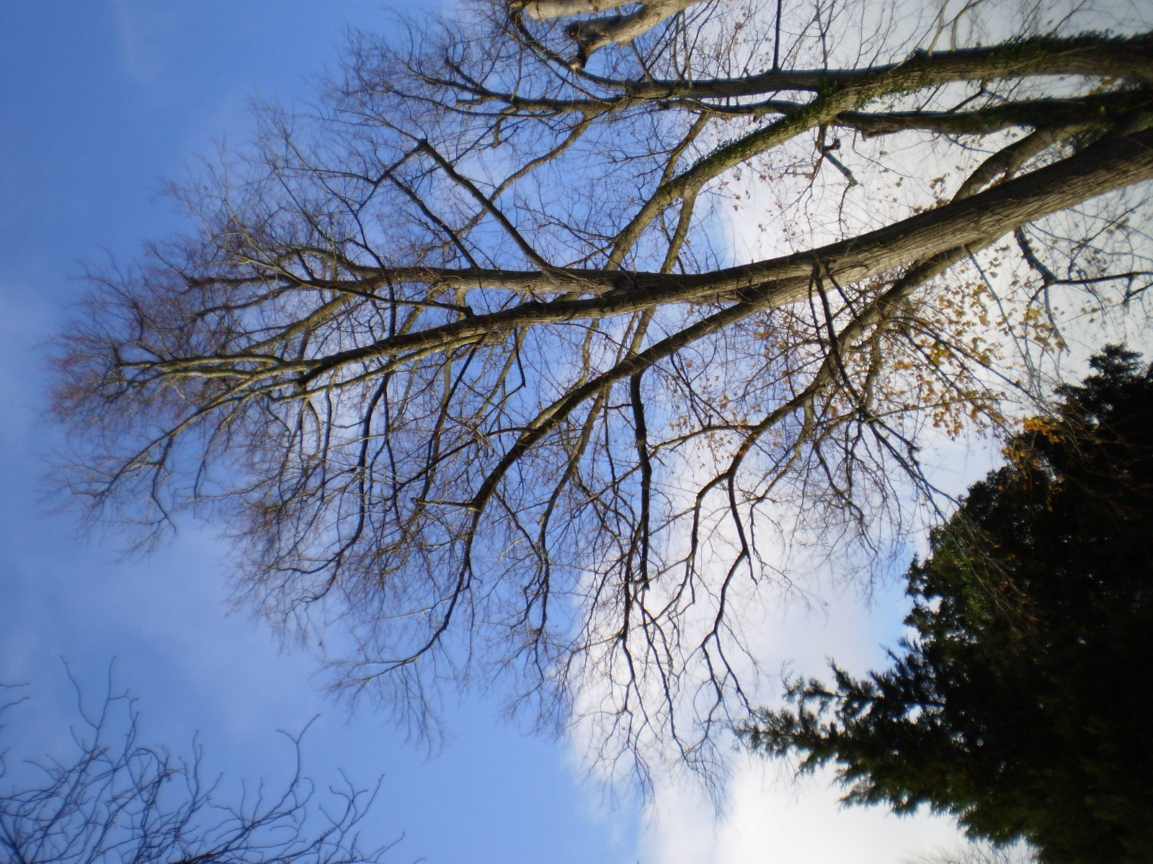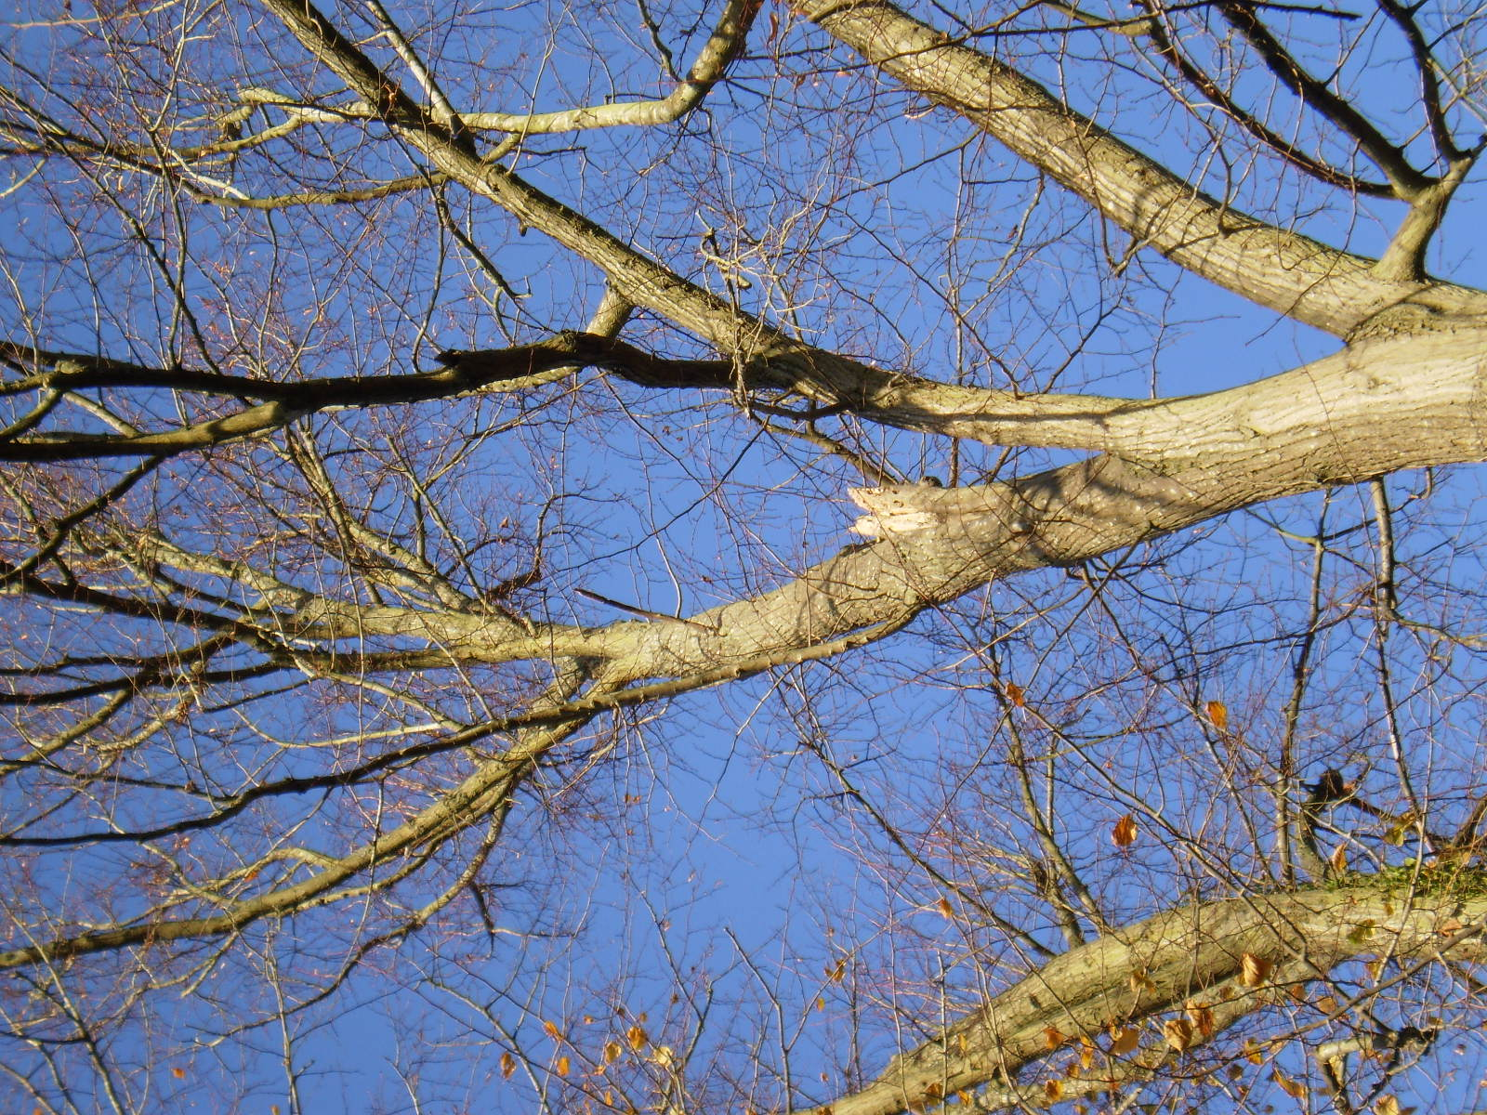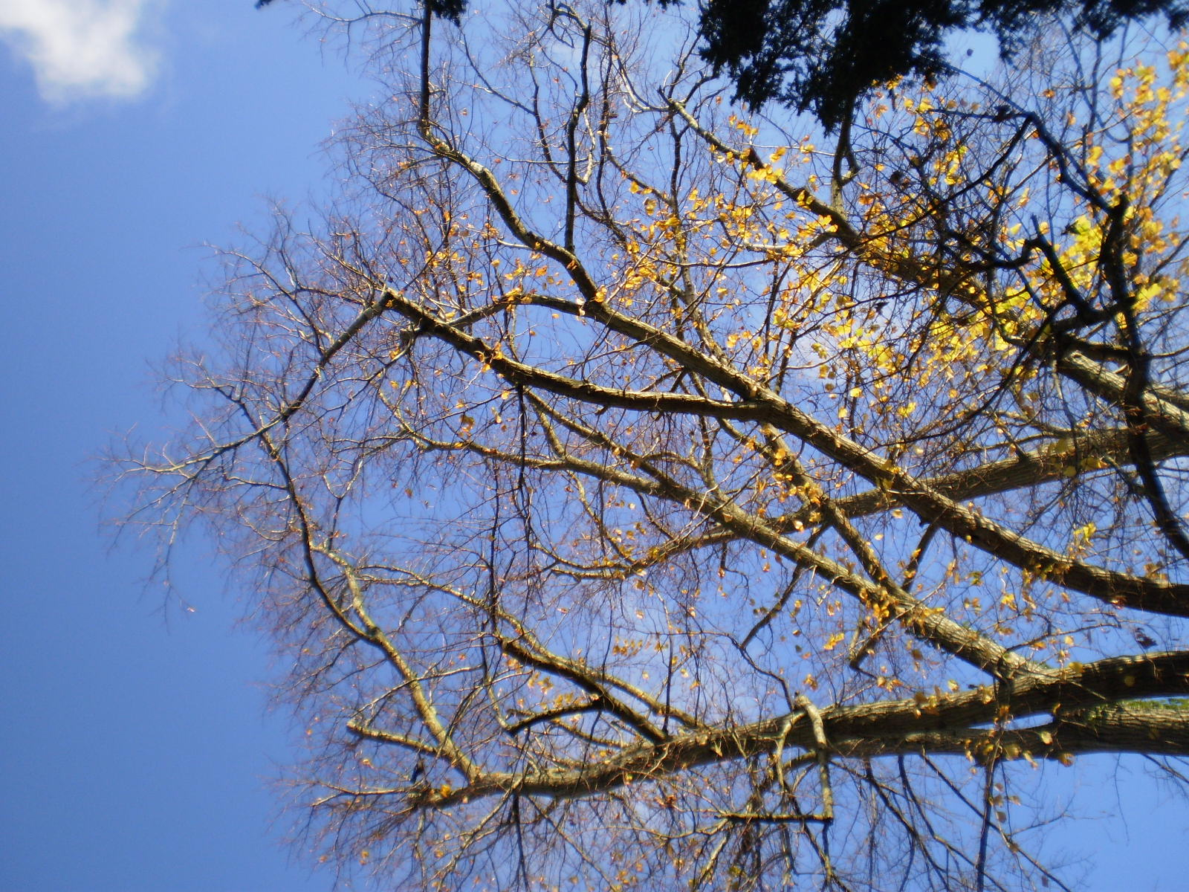
Re-growth from top previous reduction to be removed (height reduced)
Branch 1 growing toward the properties to be reduced back to a suitable growing point in line with previously reduced branches
E.g. of previous reduction points
Branch breakage point – October 2017
Example of previous reduction points
Examples of previous reduction points
Examples of upper crown reduction points
Mount Warren, Upper Warren Avenue
28/11/17

