DELEGATED APPLICATION REPORT - Application No.: 161526
Address: 51 Christchurch Road
Proposal: Proposed two storey side extension and two storey rear extension including amendments to permission 151806

Site Description and Surrounding Area:
The application site is a detached house, which has access from Christchurch Road, and its side wall faces this road. The front elevation faces towards an alley linking Christchurch Road with Lancaster Close. The site forms a small buffer between the Christchurch and the Mount Conservation Areas. The surrounding area is predominantly residential.

This site has been the subject of a number of permissions for two storey side, single storey side, rear and front, and roof height extensions (see history below). Since the 2013 permission a single storey side extension on the eastern flank has been constructed (as a prayer room and enlarged utility room), and a larger rear window and Juliet balcony have been installed in the rear elevation.
Applications 141057, and 151806 were both approved and included a number of modifications to the original 2013 permission (131719) as shown in the table below.
Proposal: The proposal is a full application which further amends the previous approved schemes. The original submission was amended following advice of the Planning Officer and this removed an additional gable to the rear, a window to the ground floor northern side, and a ground floor extension, beyond the line of the proposed chimney. The amended scheme differs from permission 151806 as follows:
- Additional front porch to access proposed family room (latter as approved through 151806) - 2.1m deep by 2.9m wide
- Open porch – roof and columns to front to access main entrance hall – 1m deep by 3m wide
- First floor side extension with hipped roof in line with width of approved ground floor extension (latter as approved under 151806)
- Full height side chimney to south-west elevation
- Flat roofed dormers to the front replaced with pitched roofs
- Rear first and second floor gable end extension to rear bedrooms 3m deep by 5.7m wide, roughly central.
- First floor gable window larger than that proposed under 151806
- Flat roofed dormers to the rear – one replaced with pitched roof the other removed (because of the proposed rear first & second floor gable extension).
- The other elements of the scheme are the same as approved under 151806

Plans considered:
Existing Elevations - Drawing no: 05-01 Rev T2, received 23rd August 2016
Existing Ground Floor Plan - Drawing no: 03-01, Rev T2, received 23rd August 2016
Existing First Floor Plan & Section - Drawing no: 03-02, Rev T2, received 23rd August 2016
Proposed Block Plan – Drawing no: 242 02-10 Rev T2, received 7th March 2017 (amended)
Proposed Ground Floor Plan – Drawing no: 03-10 Rev P4, received 15th December 2016 (amended)
Ph2. Proposed First Floor Plan – Drawing no: 03-11 Rev P4, received 1st March 2017 (amended)
Ph2. Proposed Second Floor Plan – Drawing no: 03-12 Rev P2, received 15th December 2016
Ph2. Proposed Elevations A – Drawing no: 05-10 Rev P2 received 15th December 2016 (amended)
Ph2. Proposed Elevations B – Drawing no: 05-11 Rev P3, received 15th December 2016 (amended)
Arboricultural Method Statement, received 6th October 2016
Proposed Tree Protection Plan – Drawing no: 02-11 Rev T2, received 8th March 2017 (amended)
Application | Approved/ Proposed Ground Floor Plan | Approved/ Proposed First Floor Plan | Approved/ Proposed Second Floor Plan | Approved/ Proposed Roof Plan
131719 | 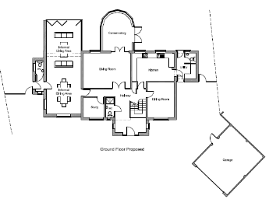 | 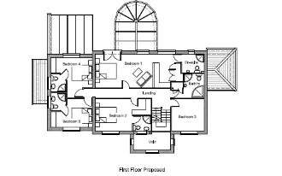 | 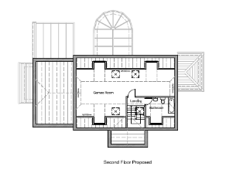 | 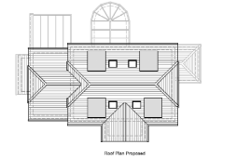
141057 | 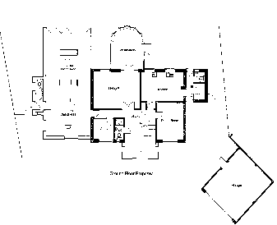 | 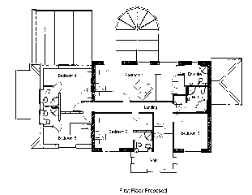
151806 | 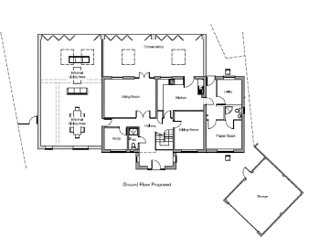 | 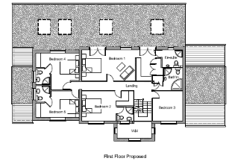
161526 | 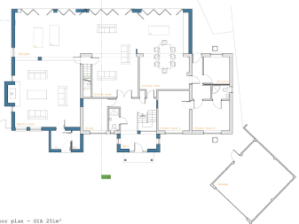 | 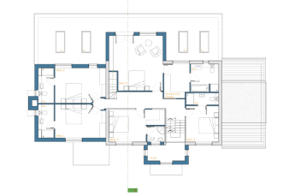 | 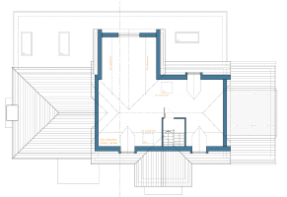
Application | Approved/ Proposed Front Elevation | Approved/ Proposed South Elevation | Approved/ Proposed Rear Elevation | Approved/ Proposed North Elevation
131719 | 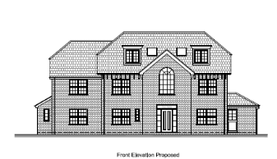 | 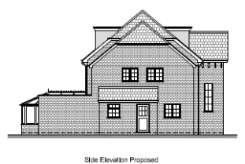 | 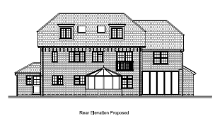 | 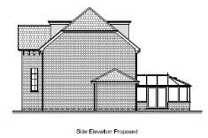
141057 | 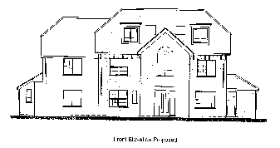 | 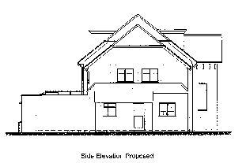 | 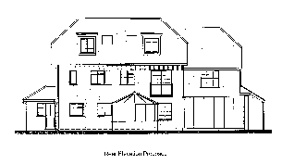 | 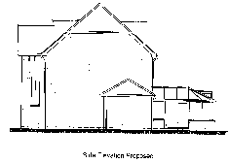
151806 | 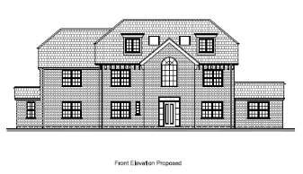 | 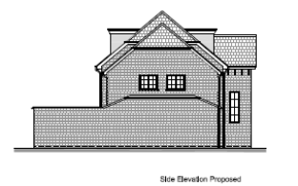 | 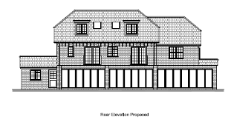 | 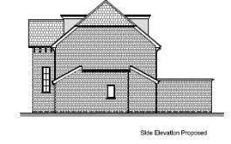
161526 | 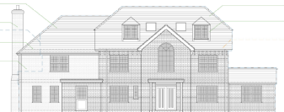 | 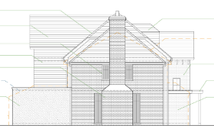 | 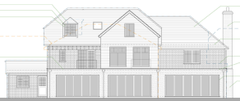 | 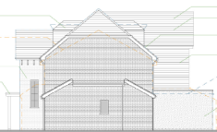
Relevant Planning History:
91-00396-FUL - Single storey extension. Granted.
06-00164-FUL - Replacement roof for a games room. Granted.
12-01492-FUL – External balcony and staircase to side of building at first floor for access to garden. Granted.
131719 - Two storey side and front extension, single storey rear conservatory and raising and extending of roof. Granted 17/4/14
141057 - Small modification of an existing approved planning application. Granted 26/9/14
150214 - Change of roof on garage from flat to pitched roof. Granted 23/4/15
151806 - Single storey side and rear extensions (changes to elements of approved scheme under planning reference 141057). Granted 3/3/16
161525 - Proposed two storey side extension, ground floor rear extension, and additional amendments to current approved scheme ref 151806 (under consideration)

Consultation Responses: Nos. 10 & 11 Lancaster Close, and 49 & 53 Christchurch Road were consulted. One response was received as follows:

It is not clear from the elevation details if the windows on the proposed rear bedroom extension will be clear glass or obscure one. Part of their first floor over looks our living room. I object to addition of windows that further intrudes on our privacy. Please add a condition to the planning approval that the window of the proposed rear bedroom extension needs to be of obscure glass and restricted on how far it can be opened.

Natural Environment – The initial comments were “Given the planning history, it is very surprising that the application form states that there are no trees on site. As you know and as the applicant knows, the site is subject to TPO 155/01 which included (when made) 10 trees. It is also surprising that none of the tree information submitted with previous applications has been submitted with the current application.

It appears from the plans submitted that the only changes (compared to 151806) to the foot print is minor extensions on the south (Christchurch Road) boundary and a minor extension on the east (towards the driveway) to the already approved extension.

These minor additions will not be detrimental to the trees on site and are therefore acceptable.

It would be preferable to obtain tree documents prior to a decision, however if these are not provided, the following conditions are required:

Conditions 4 & 5 as per 151806, plus Pre-commencement submission and approval of an Arboricultural Method Statement, including tree protection specifications, and development in accordance with the approved Arb Method Statement. Informative 3 as used on 151806 should also be attached.”

Further information was submitted by the Applicant and subsequent comments from the Natural Environment Officer are as follows: “The AMS appears to be as submitted for previous application so is likely to be acceptable. However I can’t read the annotations on the drawing at the end of the AMS.

In relation to the tree protection drawing, it is acceptable despite referring to a ‘spruce tree’ when it is a ‘Cedar’ in the back garden. For clarification we would expect the 2.4m fencing in all location shown be a red line on this plan.”

The Officer recommended conditions related to works being in accordance with the approved Arboricultural Method Statement and tree protection in accordance with the approved Tree Protection Plan.
Ecology – A preliminary bat roost assessment was undertaken and submitted with the 2013 application. The Ecologist confirmed that there were no bat related constraints to the proposal. No further bat survey was requested.

Transport - There is no transport objection subject to a recommended informative regarding damage to the highway, as the proposed extension and alterations have no transport implications. The proposal is acceptable in transport terms in that it will retain the existing parking provision on the driveway at the front of the property and a detached garage therefore there are no changes to the existing access arrangements and no impact on other road users.

Equality Act 2010:
In determining this application the Council is required to have regard to its obligations under the Equality Act 2010. However, there is no indication or evidence (including from consultation on the application) that the protected groups identified by the Act have or will have different needs, experiences, issues and priorities in relation to this particular planning application. Therefore in terms of the key equalities protected characteristics it is considered there would be no significant adverse impacts as a result of the development.

Relevant Planning Policy and Guidance
Section 38(6) of the Planning and Compulsory Purchase Act 2004 requires that proposals be determined in accordance with the development plan unless material considerations indicate otherwise. Material considerations include relevant policies in the National Planning Policy framework (NPPF) - among them the 'presumption in favour of sustainable development'.

The following local and national planning policy and guidance is relevant to this application:

Reading Borough Local Development Framework Core Strategy (2008)
CS7: Design and the Public Realm
CS33: Protection and Enhancement of the Historic Environment
CS36: Biodiversity and Geology
CS38: Trees, Hedges and Woodlands

Sites and Detailed Policies Document (2012)
DM9: House Extensions and Ancillary Accommodation
DM4: Safeguarding Amenity

Supplementary Planning Guidance/ Documents:
A Design Guide to House Extensions (2003)

Appraisal Checklist:
DM9 states: An extension to a house will be acceptable where it:

- Respects the character of the house in terms of scale, location, materials and design;

To assess this, the following has been considered – would the proposal:
- Detract from the appearance of the original building through the use of ill-matching materials and by not fitting in with the design, scale and proportions of the original building; No –The current proposal increases the overall size of the previously approved extensions and is now considered to be at the very limits of what the site can reasonably accommodate in terms of the scale of building relative to plot size, the scale of the original building and the character of the wider area. Within the context of the precedent set by the previous approved schemes, on balance the proposals are considered to be acceptable.
- Reduce the amount of usable amenity space for the property to an unacceptable degree; No.

- Require the loss of trees in the garden or put significant trees at risk; No, based on the submitted AMS and Tree Officer advice. Conditions and informative are included.

- Respects the character and pattern of neighbouring properties and the street as a whole in terms of scale, location, materials and design, and any important existing building line; Respects neighbour’s amenities and does not present a large blank façade to public areas.

To assess this, the following has been considered – would the proposal:

- Significantly reduce the amount of daylight and sunlight enjoyed by neighbouring properties; No.

- Invade the privacy of neighbouring properties through overlooking from windows or balconies; No – The neighbour raised concern over increased overlooking from the proposal. The amended scheme removed the rear first floor gable closest to no. 11 Lancaster Close. In terms of the remaining additional rear gable proposed, this is centrally located, and although it brings windows at first and second floors 3 m further back this is not considered to have a significantly detrimental effect on overlooking when compared to the existing situation and approved schemes, and therefore it is the officer’s view that a condition to make windows obscured and non-opening would not be necessary in this case. A condition preventing use of the flat roof as a terrace (etc) is recommended to protect neighbour privacy.

- Detract from the character of neighbouring properties through siting, excessive bulk, ill-matching materials or inconsistent design; No, although the proposal is at the very limit of what could reasonably be considered to be acceptable

- Detract from the appearance of the street or area by using ill-matched materials, glazing and detailing; No.

Other matters raised through consultation
A preliminary bat roost assessment was undertaken and submitted with the 2013 application. The Ecologist confirmed that there were no bat related constraints to the proposal. No further bat survey was requested and an informative regarding bats is included.

RECOMMENDATION:

APPROVE
3
- The development hereby permitted shall begin no later than three years from the date of this decision.

Reason: to prevent an accumulation of unimplemented planning permissions, and in accordance with Section 91 of the Town & Country Planning Act 1990 as amended by the Planning and Compulsory Purchase Act 2004.

- The development hereby permitted shall be carried out in accordance with the following approved plans:

Proposed Block Plan – Drawing no: 242 02-10 Rev T2, received 7th March 2017
Proposed Ground Floor Plan – Drawing no: 03-10 Rev P4, received 15th December 2016
Ph2. Proposed First Floor Plan – Drawing no: 03-11 Rev P4, received 1st March 2017
Ph2. Proposed Second Floor Plan – Drawing no: 03-12 Rev P2, received 15th December 2016
Ph2. Proposed Elevations A – Drawing no: 05-10 Rev P2 received 15th December 2016
Ph2. Proposed Elevations B – Drawing no: 05-11 Rev P3, received 15th December 2016
Arboricultural Method Statement, received 6th October 2016
Proposed Tree Protection Plan – Drawing no: 02-11 Rev T2, received 8th March 2017

Reason: because permission is only granted in respect of the development detailed in the approved plans.

3) The materials to be used in the construction of the external surfaces of the extension hereby permitted shall match those used in the existing building and as stated in the planning application dated 11th August 2016.

Reason: As no details of materials have been submitted and to ensure that the development remains in keeping with the existing building.

Core Strategy Document (Adopted 2008, altered 2015)Policy CS7: Design and the Public Realm.
Sites & Detailed Policies Document (Adopted 2012, altered 2015) Policy DM9: House Extensions and Ancillary Accommodation.

4) Development to be in accordance with the Arboricultural Method Statement with the amendment that all excavation within the Root Protection Area of the TPO Cedar tree at the rear of the site shall be carried out by hand or air spade. If any roots of 25mm diameter of above or any mass of roots are uncovered, no further works in this area shall take place until the method of proceeding is agreed with the Local Planning Authority. The works will thereafter continue only in accordance with the agreed method(s).

Reason: In the interests of protecting trees and to comply with Adopted Core Strategy (2008, altered 2015) Policies CS7: Design and the Public Realm, and CS38: Trees, Hedges and Woodlands.

5) Prior to commencement of development tree protection measures shall be implemented in accordance with Proposed Tree Protection Plan 02-11 Rev T2 and retained until completion, unless specifically allowed within the approved Arboricultural Method Statement.

Reason: In the interests of protecting trees and to comply with Adopted Core Strategy (2008, altered 2015) Policies CS7: Design and the Public Realm, and CS38: Trees, Hedges and Woodlands.

6) No use of flat roof…

Informatives:

Your attention is drawn to the terms and conditions of this permission. Any development which is carried out but which differs materially from the approved plans and details, or does not comply with any condition(s) or planning obligation(s) attached to the permission may result in the Council taking action to remedy the breach of planning control. If you are in any doubt please contact the Council.

During the course of construction, the developer should take care to ensure that no part of this development (foundations, eaves, guttering, etc.) would encroach on, under or across the boundary line with the adjoining property, as the requisite Notice has not been served on the owner of that property. This permission does not confer any right of access onto land that is not under the developer's control. The developer should also be mindful of the obligations and requirements of the Party Wall Act (1996) details of which can be found at http://www.communities.gov.uk/publications/planningandbuilding/partywall

No works to protected trees are approved by virtue of this planning consent. Any works to trees subject to Tree Preservation Order 155/01 must be formally approved by the LPA.
Work on a loft or roof may affect bats. Please be aware that bats are protected under the 1981 Wildlife and Countryside Act as amended and the European Habitats and Species Directive (92/43/C) Conservation of Habitats and Species Regulations 2010. Bats and their shelters (roosts) are protected under this legislation. It is illegal to deliberately or recklessly disturb or obstruct access to any bat roost or to disturb a bat using such a place without first obtaining the relevant licence from Natural England. The applicant will therefore need to consider protected species when planning work of this type. A survey may be needed, and if bats are using the building, a licence may be required. To view specific information regarding bats use the following link: https://www.gov.uk/wildlife-licences

The decision to grant planning permission follows the positive and proactive consideration of the issues raised by this planning application which led to amended plans.

