

METHOD STATEMENT PROJECT OVERVIEW
Project: Pink Hippo - Reading
Method Statement Prepared By: Tony Cripps

Site Address: 7 Bridgewater Close, Portman Road, Reading, RG30 1JT.
Method Statement No.: KB 297 -001
Revision: 2
Start Date: 20th November 2017

Scope of Works:

The following method statement addresses the initial site set up for the site, the internal soft strip & the internal demolition of the mezzanine structure.
The structure will then be re developed for the new pink hippo storage unit which will require a new internal steel frame & mezzanine floor with access stairs and goods lift, new floor finishes and the installation of varying sizes of secure storage units. A new office reception is to be installed with the inclusion of a toilet & a small kitchen area for staff.
Externally a new cladding is to be installed on 2 elevations with a raised profile to the existing roof line.

Access / Egress:

Site address

Leander Build Ltd / Pink Hippo
7 Bridgewater Close,
Portman Road,
Reading,
RG30 1JT

Access to the site Area will be via the security gates at the mini roundabout in Bridgewater Close turning off Portman Road. The site office and welfare area will be set up within the site fencing as shown on the logistics plan.
To the work Area: via the designated pedestrian routes as defined by LBL. Access to the work areas is to be installed and maintained by LBL.
In the work Area: via designated routes as defined by Leander, to be installed and maintained by Leander.

Parking

On site parking bays to be controlled by Leander site management, this is limited to 5 bays so operative vehicle sharing will be encouraged, Note: no site vehicles are to park on the highway at any time.

Deliveries

Deliveries to be booked in as LBL procedures 24 hrs in advance.

Delivery times between 09:15 & 17:00 Monday to Friday only to avoid peak traffic hours in the area.

Loading / unloading

No deliveries should be made to the site between 08:00 am to 09:15 am, and 05:00 pm to 06:00 pm Monday to Friday during peak traffic hours.

All loading & unloading will take place within the confines of the site hoarding under the control of a Leander Traffic Marshall and/or Banksman.
Site working Hours 7.30am - 5.30pm.

Surrounding roads

The surrounding roads will be inspected during the works to ensure the public highway remains free from dirt or debris, road sweepers will be used as and when required, a wheel wash area will be set up on site to wash down vehicles as required.

Road / Footpath closures –

No Pavement or Road closures will be required for these works.

Lighting:

General site & task lighting will be provided by Leander Build Limited (sub-contracted works packages to providing specific task lighting).
Additional Task lighting will be provided with either the use of diesel powered Telescopic floodlights or 110v Stand light if required. Care will be taken to ensure that the supplementary lighting is kept within the site confines and not directed towards train line.

Plant and Equipment used:

Herras Fencing
Pedestrian Barrier
Hooped gate access barriers
Excavators
Dumpers
MEWPS
CAT scans
Grinders
Compressors & air tools
Skill saws
Lifting equipment
Hand tools
Skips

All plant and equipment to be visually checked: All lifting plant and equipment to be tested and inspected (4 yearly; 12 monthly; 6 monthly) and have relevant certification in accordance with LOLER. Lifting Accessories 3 monthly testing
Daily and weekly checks recorded on plant inspection sheets.
Tools to be within PAT certification (3 monthly) in accordance with PUWER.
Report any damage and replace with immediate effect. Never use damaged equipment. If in doubt asked a supervisor or manager.
Any leaks to machinery, are to be captured by plant nappies, and repaired immediately, a spill kit will be positioned close to plant items.

All items of plant will have plant nappies positioned under them when stationary.

Materials used: see attached CoSHH Assessment where relevant

Structural Steel
Timber & ply
Roofing sheets
Insulation panels
Cladding
Waterproofing grouts
Concrete
Reinforcement
Drainage
Service ducts
Aggregate (sand, ballast, Type 1 c/c)
OPC
Diesel & oils

Good Practice

- A daily briefing will be held each morning by the Leander Build Limited supervisor to coordinate activities due each day, contractor interfaces and any risks associated with these, with daily signed records of the briefings. Kept on file in the site office.

- The Leander Site Manager/ Supervisor (SMSTS trained) will ensure that all operatives hold appropriate CPCS & CSCS certificates of competence for carrying out the works.

- The Leander Site Manager/ Supervisor (SMSTS trained) will ensure that all plant drivers/operators hold current and valid certificates of Training. A copy of the certificates will be kept on site.

- First Aid facilities and Emergency Procedures will be available on site in the Leander site office Sub-contractors are to have a minimum of 1 first aid trained operative on site at all times. Leander will provide the first aid facilities in the site office.

- All works will be carried out by skilled labour and will be supervised by the Leander Site Manager/supervisor with the relevant experience for carrying out the work.

- The work area will be demarked using pedestrian/ Heras barrier type fencing and signage to segregate works and personnel from other contractors. Agreed vehicle & pedestrian routes to be established to the work face.

- Leander traffic marshal to take control of the vehicles from the site gates

- HAV register and monitoring to be carried out by the site manager.

- All plant movements are to be conducted under Leander’s banksman.

- The minimum PPE Requirement for these works are Hard Hats, Boots, Hi Vis Vests, Gloves and Glasses. These items will be worn by all personnel at all times whilst carrying out these tasks.

- This section of Works will be carried out within the confines of the Site fencing so there should be no interface with the Public.

- The existing services must be identified on site. All existing service drawings will be checked for services such as Electric, Gas, Telecom & Water and the position of these will be identified by Survey Paint.

Sequence of Tasks:

Access
- Access to site will be as per the Leander pedestrian access plan and logistic plan. Fencing will be in place to establish green routes from the site access to the office / welfare area. PPE is to be worn from the welfare area to access the site red routes, signage to be maintained by Leander.

Site Mobilisation

- Materials and plant will be delivered via the approved traffic management plan in place by Leander. All deliveries are to be booked in 24 hours before arriving. A trained and competent traffic marshal will meet the delivery at the site access gate when they will walk in front of the delivery up the Leander work area (see attached logistics plan).
- To unload the delivery operatives will have to access the lorry from the rear using a lorry Pod podium. Before accessing the lorry there must be a sufficient double handrail. No operative is to go above this height. All materials will be unloaded via the excavator as laid out in the excavator lifting plan. Where handrails are not useable the fall restraint system will be used (please see fall restraint below)
- Heras fencing will be erected around the perimeter of the work area and storage area. Separate barriers will be used to enclose the storage areas and pedestrian routes with the inclusion of red gates for when crossing work areas/ traffic routes. Appropriate signage will be put in place to identify safe routes of access.

Internal Works

Isolation of services.

- Before any works commence within the existing structure all the existing services are to be isolated (see specific sub-contractor rams)
- At this point temporary site supplies will be set up to water & electricity for the site offices & welfare supply 240V & also transformers for the 110V site supply.

Soft strip / Demolition

- Pedestrian barriers will firstly be installed to the perimeter edge of the Leander work area to segregate our works from other contractors on site.
- The existing warehouse & offices are to be stripped out of all furniture / shelving / desks / tables / lights / equipment and any other shop mock ups that may remain. Some of this equipment is to be stored for removal off site for future use (Ref: list of items to be saved) all the other materials are to be placed in the skips for disposal. Waste is to be segregated on site (Metal / Wood / Plastic / Rubble / other)
- When the soft strip is complete the existing mezzanine steel frame is to be demolished, this will be carried out in the reverse order to the installation and whenever possible will be unbolted section by section whilst the steel members are supported by the excavator on site. All steel members are to be placed in the site skips for disposal.

Roof & Steelwork repairs.

- When the demolition works are complete the floor within the warehouse will be clear, at this point a MEWP will be used to carry out the repairs to the existing roof internally
- The MEWP is to be operated by trained personnel only
- There are several areas where loose material is hanging from the roof, this is to be removed and replaced with new.
- Any unwanted fittings / cables / equipment will be removed at this time.
- The existing roof lights are to be removed and replaced with similar material to match the existing roof coverings.
- Following all the roof repairs the existing steelwork structure is to be cleaned and made good where required.

Lift Pit

- Following the MEWP activity within the new entrance area, a new goods lift is to be installed and to accommodate this a recess is to be formed within the existing ground floor slab.
- The position for the lift pit will be marked on the floor.
- The area will be CAT scanned to ensure no live services are in the area
- A trial hole will be broken through the existing floor to determine if the existing floor is thick enough to accommodate the new recess.
- Following this information the floor can be either trimmed down to the required depth and made good or fully broken out and a new section of slab cast and tied into the existing floor to suit the requirements of the lift design.
- The existing concrete will be broken out using a breaker attachment on a mini excavator and trimmed by hand using compressed air tools.
- All arising’s will be disposed of into the site skips.
- Pedestrian barriers will be set up around any open excavations or steps in the floor.

Excavate & install new drainage & services
- New services & drainage runs to be marked out on the existing floor.
- The area will be CAT scanned to ensure no live services are in the area
- The trench runs in the floor will be cut using a diamond floor saw to keep the sides of the trenches tidy.
- Using the mini excavator the new underground services for the new reception area, kitchen and toilet will be broken out & excavated.
- The new services will be installed & tested before they are backfilled.
- Pipes and services will be backfilled with sand, shingle or concrete as per the details provided.
- The trenches will be topped up to the underside of the floor slab with type 1 crushed concrete and the floor slab will be reinstated and tied in as per the details.

Structural alterations

- Within the existing external envelope several new door openings are required for the new entrance into the reception area, new roller shutter for goods entrance, new openings in internal walls to the extension area and a new fire escape.
- For the new door openings in the brickwork panels the position of the new lintels will be marked out and approximately 3 courses above small pockets will be broken out for the installation of needles and acrow props to support the brick work above.
- When the needles are installed the opening below can be cut out using a petrol grinder & water bottle to suppress the dust.
- Following the cutting the brickwork inside can be broken out to form the new opening and the new lintel can be installed.
- When this has cured the head of the lintel is to be dry packed with sharp sand/cement, to support the brickwork above.
- When this has cured the needles can be removed and the brickwork can be repaired.
- Where the new shutter openings are to be installed the whole brickwork panel would be removed, the new structural opening would be formed using structural steel work and then the brickwork around the opening will be made good, further development and temporary works designs to be followed.

Removal of existing escape stairs

- There is an existing fire escape & set of concrete stairs in the corner of the ground floor, this is to be removed as it is not required in the new scheme.
- The existing door and frame is to be removed and new brickwork is to be stitched back in to close up the opening.
- When the opening is fully blocked in the set of concrete steps can be removed.
- The area will be CAT scanned to ensure no live services are in the area
- A trial hole will be broken next to the existing wall to determine if the stairs are tied into the wall & also into the existing floor.
- Once it is established that the stairs are isolated they will be broken out using a breaker attachment on a mini excavator and trimmed by hand using compressed air tools.
- All arising’s will be disposed of into the site skips.
- Pedestrian barriers will be set up around any open excavations or steps in the floor.

Waterproofing to external wall

- In the same area as the existing fire escape there is an external concrete retaining wall that is below the external ground level, once the stairs have been removed the wall is to be survey to determine if any additional water proofing is required to the wall. This will be in the form of an internally surface applied product should it be required – further development of this will be required when it is exposed.

Floor repairs

- Following all the demolition and the structural repairs the existing ground floor is to be made good to provide a smooth surface for the new storage units and access routes, this is expected to be small isolated repairs with concrete and latex but this will have to be determined following further surveys.

New Mezzanine & staircases

- The new steel frame for the mezzanine floor, additional stairs and the storage unit partitions and doors will all be installed by our specialist subcontractor Steel Storage. (please refer to their RAMS for this work activity)
- As part of these works the structure for the new reception area, kitchen and toilet will be formed. Following this these areas will be fitted out by a specialist subcontractor. (please refer to their RAMS for this work activity)

Fire proofing

- When the new steel work is installed this is to be fire proofed with intumescent paint, this will be carried out by a specialist subcontractor TBC (please refer to their RAMS for this work activity)

Electrics, Alarms, Phones & CCTV

- The installation of the new electrical systems will be by specialist subcontractor TBC (please refer to their RAMS for this work activity)

Floor finished

- The mezzanine floor is to be carpeted again this will be carried out by a specialist subcontractor TBC (please refer to their RAMS for this work activity)

External Works

Cladding & steelwork

- Two elevations of the existing building will receive new sheet cladding as per the design drawings from ……….
- The new cladding is to extend above the existing pitched roof line to form a new rectangular elevation, this will require new structural steel work to support the new cladding line between the pitched roof profiles.
- The structural steel work and cladding will all be install off MEWP’s working from the existing concrete hardstanding’s by our specialist subcontractor. (please refer to their RAMS for this work activity)

Roller shutters, Gates & Doors

- The new roller shutters, Gates & doors to the Pink hippo storage area and office will again be installed by a specialist supplier. (please refer to their RAMS for this work activity)

Hard landscaping

- The new external layout will require the adjustment of the existing kerbs and paths
- The position of the new kerbs and access ramp will be marked on the floor.
- The area will be CAT scanned to ensure no live services are in the area
- The existing surface will be broken out using a breaker attachment on a mini excavator and trimmed by hand using compressed air tools.
- The required kerbs, edgings, manhole covers & gullies etc. will be installed to the required levels. These will be laid on a bed of semi dry concrete with a supporting haunch to secure them into position, the materials will be transported to the areas with the aid of the dumper & excavator to minimise manual handling and where possible mechanical lifting equipment will be used to install kerbs & covers.
- Then the sub-structure formation will be installed as per the engineers details, the sub base will be installed for safe access for vehicles & personnel, heaps of material will be levelled into layers and it will rolled with a vibrating roller with a minimum of 6 passes. Additional PPE in the form of Ear defenders must be worn by the roller driver for these works. This will be carried out over the full Area until the required levels are achieved.
- Any new fence posts, bollards & sign posts will be installed at this time and cast into concrete foundations as required.
- The new tarmac can then be installed by hand by a specialist contractor. (Please refer to specific RAMS for this activity) as there are only a few small areas of tarmac required around the site, materials & plant will be distributed with the excavator & dumper.
- Once all the kerbs & tarmac are complete the area will be cleared of all plant & materials so the white lining can be installed to the tarmac to identify parking areas, access routes etc. This will be by a specialist contractor. (Please refer to specific RAMS for this activity)

Site Logistics Plan & Site Pedestrian Access

Site address

Leander Build Ltd / Pink Hippo
7 Bridgewater Close,
Portman Road,
Reading,
RG30 1JT

Access to the site Area will be via the security gates at the mini roundabout in Bridgewater Close turning off Portman Road. The site office and welfare area will be set up within the site fencing as shown on the logistics plan.

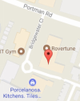
Logistics Plan : see attachment & below

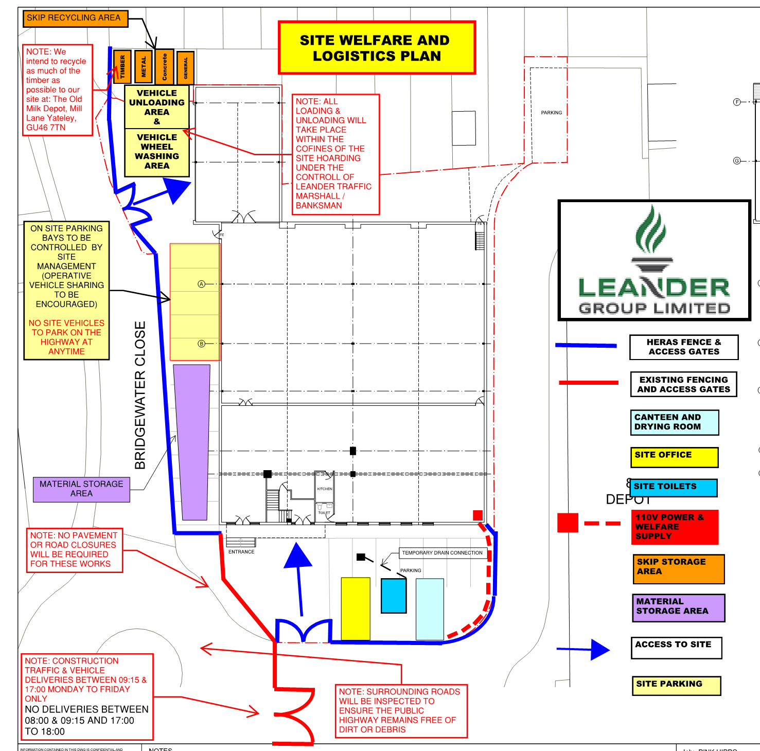

Risks and Controls:
The following risks and control measures have been identified: See Risk Assessment index for detailed assessments.

Lifting Operations RA
Loading Lorries RA
Lorry Movements on site RA
Maintaining safe separation of vehicles and pedestrians RA
Vibrating Generating Equipment RA
Leading Edge Work RA
Hand tools RA
Hop ups RA
Ladders RA
Work at height RA
Podium Steps RA
Drilling Concrete RA
Manual Handling RA
MEWPS RA
Abrasive wheels RA
Cutting – steel, wood, concrete
Dumper RA
Excavator RA
Hi-ab – Crane RA
Hoarding & fencing RA
Installing steelwork RA
Towers RA
Painting RA
Podiums RA
Rollers RA
Lighting RA
Use of pallet trucks RA
Moving waste to skips RA
Underground services RA

Please refer to RA register items 1 to 105 in the Risk assessment section of our safety file.

Technical Information:

Construction Issue Structural engineers GAs and sections
Construction Issue Specifications
Suppliers working drawings
Design information and drawings

Emergency Arrangements:

Fire Arrangements
Please see fire arrangement plan for onsite – (Leander)
The Main Contractor will brief all operatives on the site Emergency procedures at site induction.

Leander First Aiders: TBA

Nearest hospital is: A and E

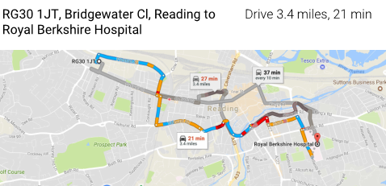

Craven Road Reading RG1 5AN
Tel: 01183 225111

Directions available on notice board situated in Welfare/office area.
Training:

- Site Induction will be carried out for all persons prior to commencing work or entering the site working area. Induction carried out by Leander
- All operatives to be briefed on this MS. Record of ‘Understanding of Method Statement’ for site-specific operations for all operatives involved and copy kept on site for record purposes. Before site inductions at 09:00am
- All Operatives will hold a current certificate of Training/competency CSCS/CPCS for the task.
- 1No Site Toolbox Talks will be carried out on a Weekly Basis on site specific subjects & sustainability.
- PASMA required for erection and use of mobile towers
- IPAF required for use of MEWPs
- Slinger Signallers to be CPCS
- Traffic Marshalls to be CPCS
- All activities will be covered by morning briefing, carried out on a daily basis, as a minimum.
- All operatives cutting steel are to be trained in the use of abrasive wheels.
PPE Requirements:
Hard hat (BSEN397)
Safety boot (BSEN345)
Hi-Viz (BSEN471 class 2)
Eye protection (BSEN166)
Gloves (BSEN388)
Ear protection (as per risk assessment) (BSEN352)
Face Fitted mask (as per risk assessment)(BSEN143) Force 8 half mask-press to check
White Disposable suits (Concreting)

Supervision:

Eddie Shepherd - Contracts manager visiting
Tony Cripps – Manager (SMSTS, CSCS, TWC)
TBA - Foreman

Housekeeping and Waste Removal Procedure:
Waste will be disposed of in the appropriate skips in accordance with waste management plan. Segregation of waste By Leander. Note: We intend to recycle as much of the timber as possible to our site at: The Old Milk Depot, Mill Lane Yateley GU46 7TN.
Hazardous liquids to be stored in a bunded area: bund to be 110% of volume stored. Area to be underlain with an impermeable layer & in a secure area a minimum of 10m from any other buildings.
Plant & equipment to have built in drip trays. In the event they are not present then a stand-alone trip tray must be used Spill kits to be provided in storage areas.
All re-fuelling will be carried out in a designated area; this will be carried out in a suitably sized drip tray.

The following Risk/COSHH/Noise/Manual Handling assessments are attached:

COSHH Assessments: See attached sheets CoSHH will be kept in lockable cage.

Risk Assessments: See attached sheets – RA 01 to 105.

Manual Handling Assessments: Manual Handling assessments will be carried out where the need is identified.

Noise Assessments: Where equipment used in this task generates a noise level above the first action level of 80db(A), a noise assessment will be carried out.

Date of compilation: 01/12/2017

REFERENCE

Regulations/ACoPs:

HSE Guidance:

Standards:

Other:

