DELEGATED APPLICATION REPORT
SITE ADDRESS: Broad St Mall
APPLICATION NUMBER: 171559
PROPOSAL: Installation of new lighting to existing car park facade

RELEVANT POLICIES AND SUPPLEMENTARY PLANNING GUIDANCE
Legal and Planning Policy Context
Section 38(6) of the Planning and Compulsory Purchase Act 2004 requires that proposals be determined in accordance with the development plan unless material considerations indicate otherwise. Material considerations include relevant policies in the National Planning Policy framework (NPPF) - among them the 'presumption in favour of sustainable development'. However the NPPF does not change the statutory status of the development plan as the starting point for decision making (NPPF paragraph 12). In this regard, the NPPF states that due weight should be given to the adopted policies of the Local Development Framework (LDF) (Core Strategy and Sites and Detailed Policies Document) according to their degree of consistency with the NPPF (the closer the policies in the plan to the policies in the NPPF, the greater the weight that may be given). The Council's adopted Supplementary Planning Guidance and Supplementary Planning Documents are also material planning considerations.

Accordingly, the National Planning Policy Framework and the following development plan policies and supplementary planning guidance are relevant:

National Planning Policy Framework (NPPF)
- Ensuring the viability of town centres
7. Requiring good design

Reading Borough LDF: Core Strategy (2008)
CS7 (Design and the Public Realm)
CS33 (Protection and Enhancement of the Historic Environment)

RCAAP
RC2 (Development in the West Side MOA)
RC5 (Design in the Centre)
RC14 (Public Realm)

Reading Borough LDF: Sites and Detailed Policies Document (2012)
SD1 (Presumption in Favour of Sustainable Development)
DM4 (Safeguarding Amenity)
DM12 (Access, Traffic and Highway-Related Matters)

SPD/SPG
None specifically relevant

CONSULTATION RESPONSES
Informal response from Transport Strategy is that no objection is raised. Agrees with case officer that cowl needed on back of lamps so as not to distract drivers within the car park.

PLANNING HISTORY
Various and extensive, but none relevant.

APPRAISAL
The application site is the edge of the BSM car park. It is a circa. 1970 concrete structure and features a series of patterned concrete tessellating slabs as an external wall to the car park above retail level.

The proposal is to integrate coloured lighting into the façade by attaching LED colour ‘light bars’ which would back-illuminate the concrete, allowing coloured light spill to penetrate to the façade. The lighting may also improve security/attractiveness of these pedestrian streets, and this is the applicant’s aim.

In terms of Highway safety, there is no external issue and as long as the cowls/protective channel is in place (needs a condition), there would be no dazzling of drivers in the cp. Complies with DM12

In terms of external appearance, the lighting would be ‘colourful’ and most noticeable at dusk/night-time. The applicant has been asked about the colour changing strategy to be used and has confirmed that there would be either a static colour or a slow colour transition only. Where static, orange/blue/cyan/green/yellow is proposed and this is to reflect the current Mall branding. Where a ‘multi-colour gradient’ is proposed, this would have no flashing lights graphics or optical effects. The colour change cycle proposed is orange-blue-cyan-green-yellow-purple-red. In terms of highway safety and impact on streetscene/heritage assets, this is considered to be acceptable (DM12, CS7, RC5, CS33).

Policy DM4 requires the amenity impact on the nearest residential units to be assessed, which is the student accommodation on Queens Walk. It is 12.5m to the flank wall to the student accommodation and this faces the proposal, but no facing rooms. The Hexagon Theatre also includes night-time ‘ambient’ lighting. The student accommodation now also includes roof extensions for further student units. There may be some ‘sky glow’ impact to the student rooms themselves, but this is not likely to be direct, given the back-lit nature of the installation. It is considered that although the colours will be noticeable, the amenity of these rooms which have south-facing windows should be significantly adversely affected.

Lighting level proposed is 50 lux maximum, which is considered to be low, but in any event, should be controlled via condition.

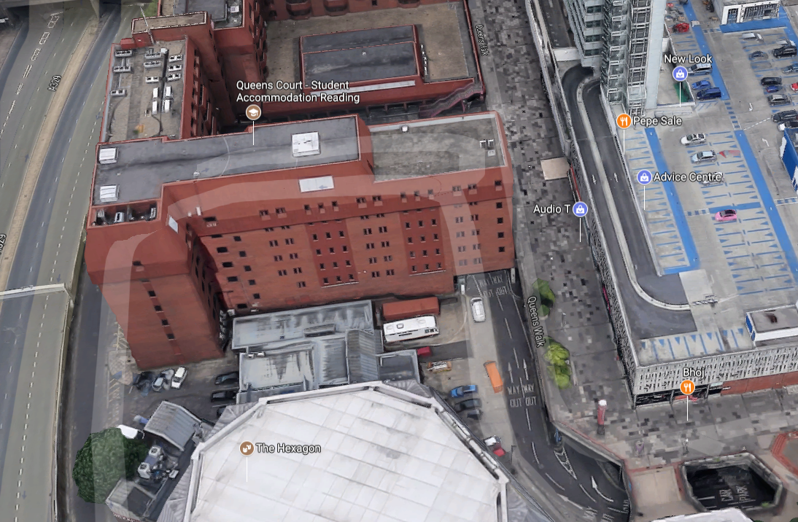

Equalities Act
In determining this application, the Council is required to have regard to its obligations under the Equality Act 2010. The key equalities protected characteristics include age, disability, gender, gender reassignment, marriage and civil partnership, pregnancy and maternity, race, religion or belief, sexual orientation. There is no indication or evidence (including from consultation on the application) that the protected groups have or will have different needs, experiences, issues and priorities in relation to the particular planning application. In terms of the key equalities protected characteristics it is considered there would be no significant adverse impacts as a result of the development.

RECOMMENDATION:
GRANT planning permission, subject to conditions.

Tl1 3 yr time limit

Approved Plans
0350 1:1250 Site location plan
0353 Proposed car park façade lighting first floor plan
0354 Proposed car park façade lighting west & south elevations
All plans were received by the Local Planning Authority on 7/9/2017

The lighting hereby approved on the plans in Condition 2 above shall be Stairville LED IP Bar 320/8 RGB DMX IP65 lamps, with a maximum lighting level of 50 lux and the cowls/shields as shown on the approved plans shall be retained at all times.
Reason: to maintain driver safety and the amenities of the area.
Policies: CS7, CS33, RC5, DM12

For the avoidance of doubt, the lighting strategy for the lighting hereby approved by this permission shall be as follows, unless otherwise approved in writing by the Local Planning Authority:
-lighting shall be either static or colour-changing;
-where colour-changing, transition from one colour to the next should take a minimum of two seconds and there shall be no strobing, flashing or instant colour changes.
Reason: to maintain driver safety and the amenities of the area.
Policies: CS7, CS33, RC5, DM12

Informatives
Pos and proactive requirement
Terms and conditions.

