Ref: 171295 – 28 St Peter’s Hill
Submitted by: Debbie Evans
Submitted to:
Property Address: 28 St Peter’s
Date of latest Submission: 2nd November 2017

Planning Application Details

A planning application for a garden building to replace the existing concrete garage located to the rear, left hand side of the property built with a mix of wood and red brick, with roof to match the existing property was submitted in January/February 2017.

A surveyor, Three County Surveyors, was used to prepare and submit the plans, however it is understood that various requests and exchanges were made to alter the plans. The information that follows includes drawings from a proposed supplier/builder of the replacement garage/garden room; updated drawings from the surveyor, amended plans by myself and photos of the existing garage for illustration purposes.

In addition amended details are included of the method for the work to address the tree preservation order as previously submitted.

Front and side aspect:

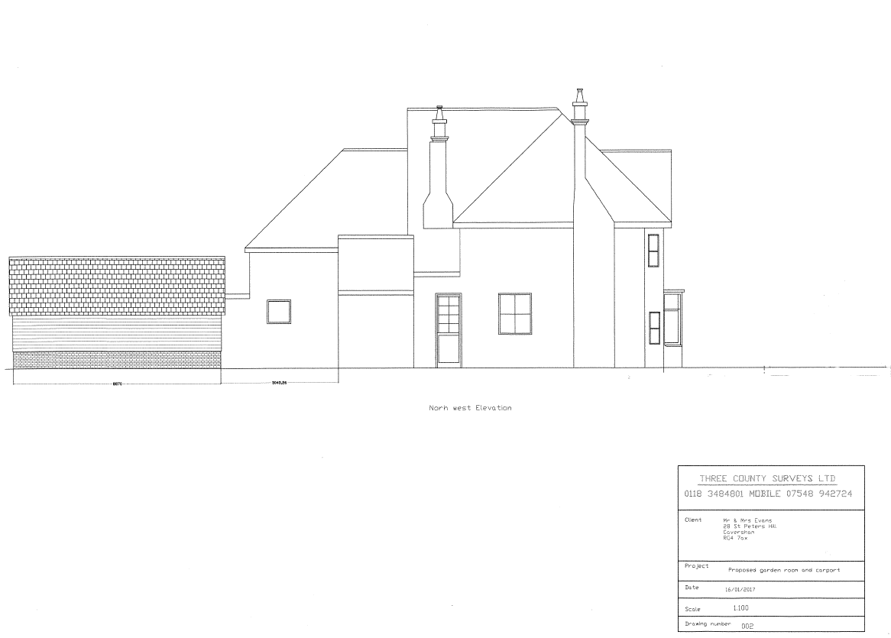
Front aspect:

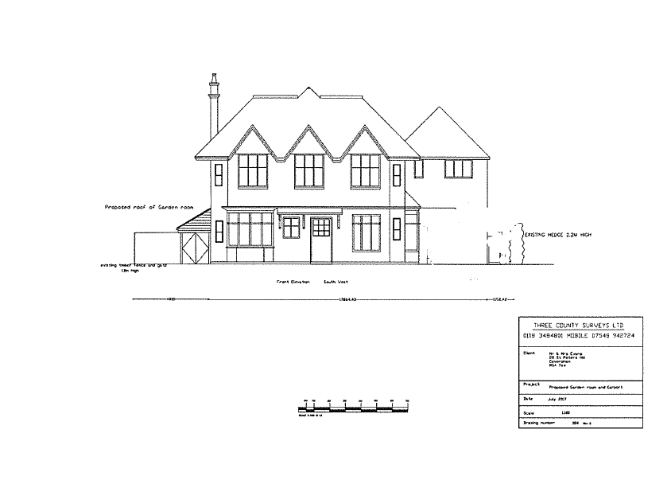

Garage/Leisure Room Details:

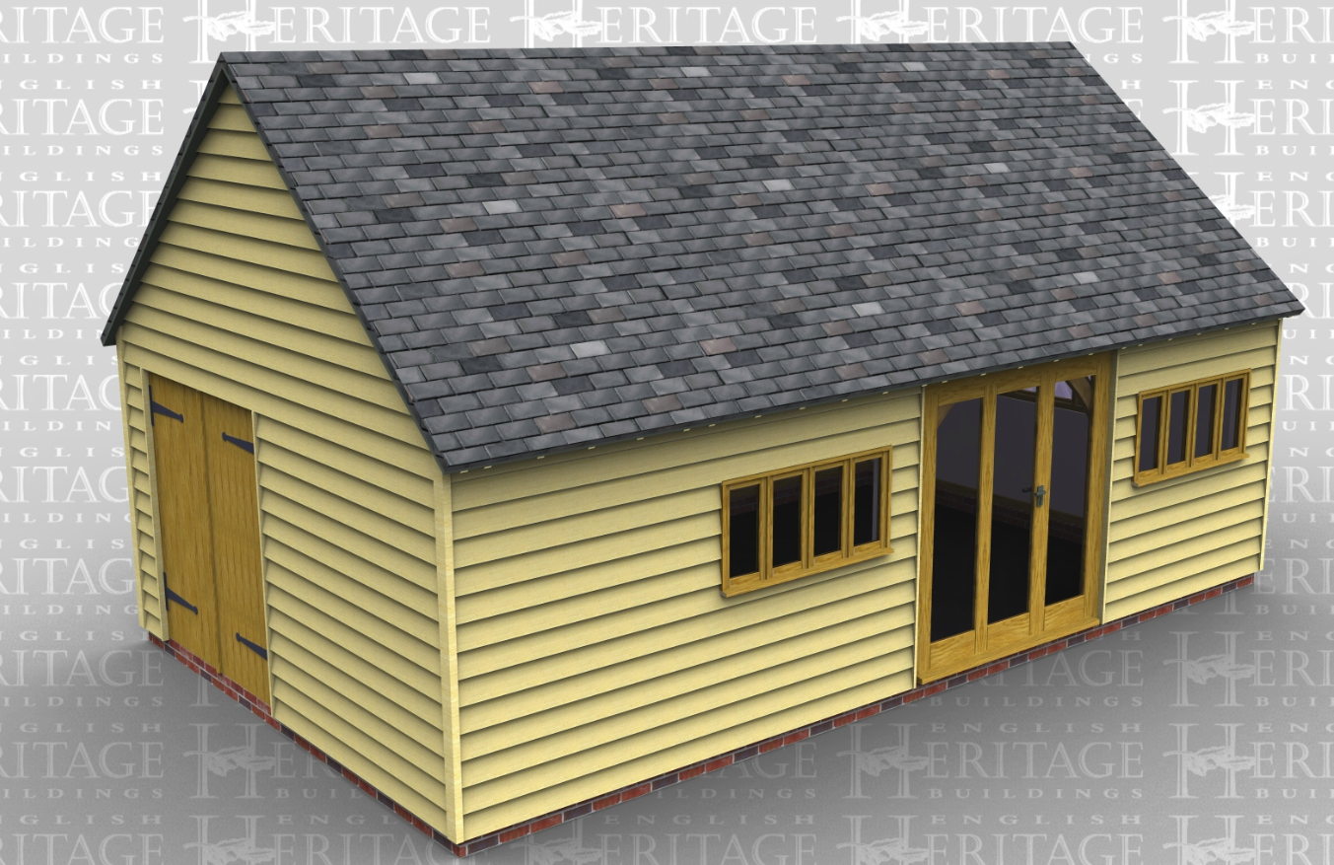
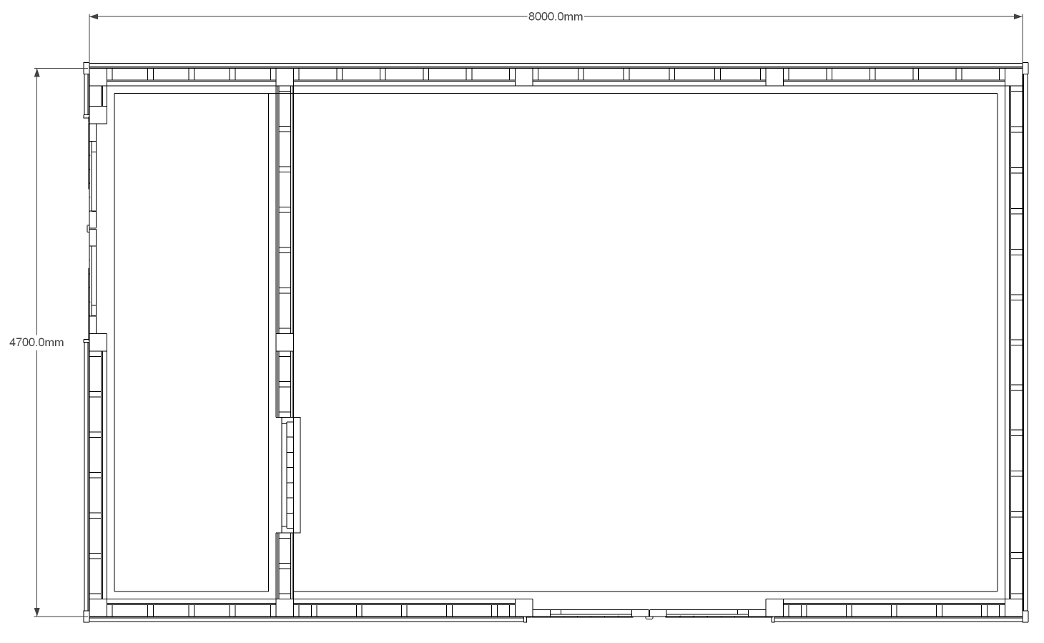

Current Dimensions.
Width: 4700mm
Height:2700mm
Length:6500mm

Proposed new dimensions:
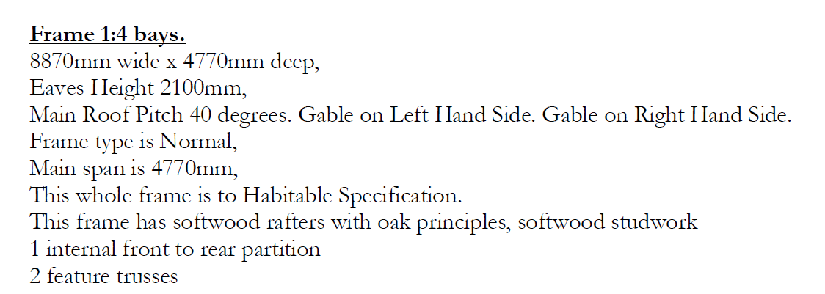

Photographs of the existing garage:

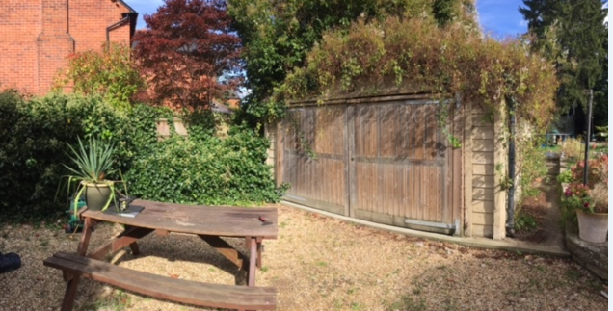

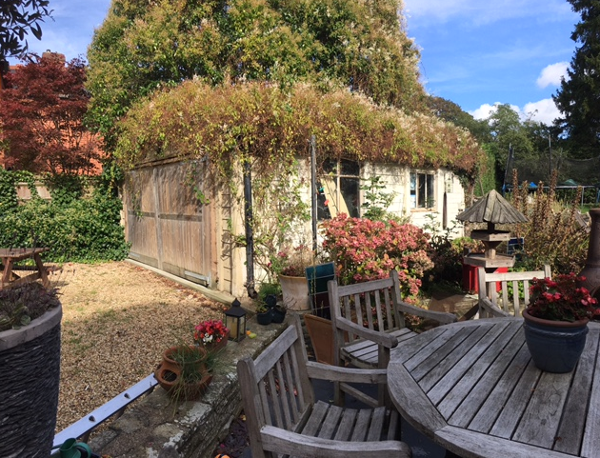

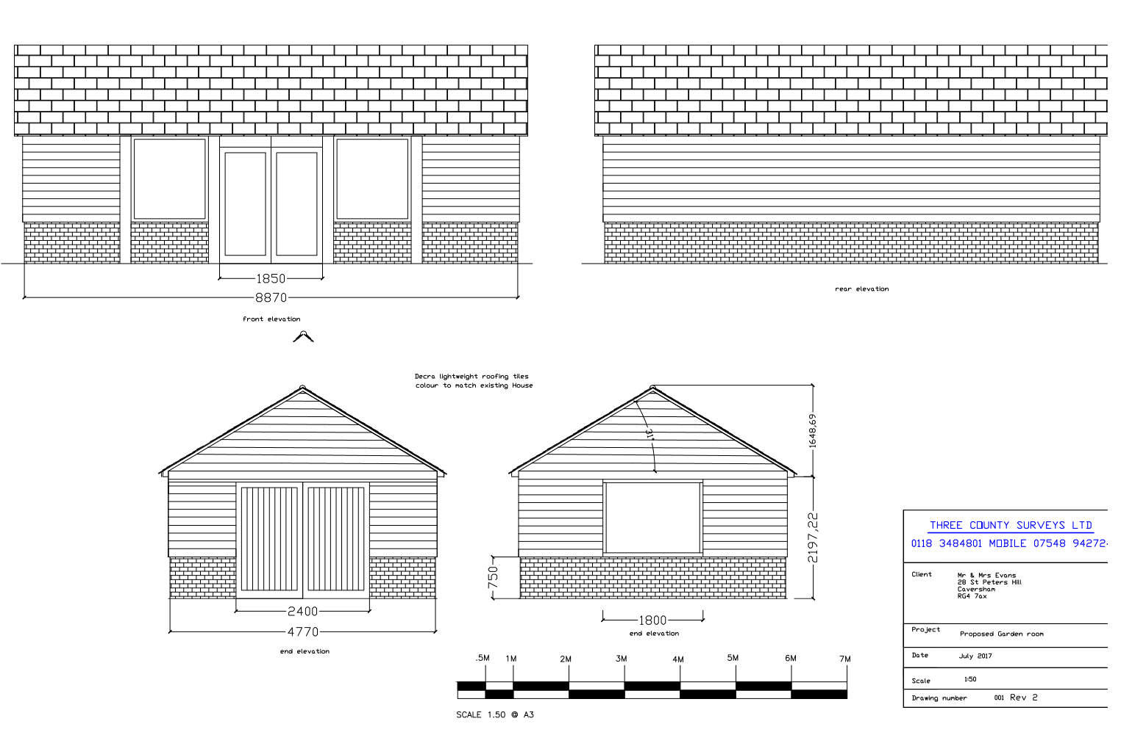

Tree Preservation Order Method

Date: 04/10/2017
Submitted by: Debbie Evans
Submitted to: Sarah Hanson
Ref: 171295 – 28 St Peter’s Hill

Tree Works Statement

As part of an application to replace the garage at 28 St Peter’s Hill, Reading, RG4 7AX it was indicated that we could include a description of how required maintenance of the trees with TPOs would be undertaken to ensure avoiding damage to the protected trees. The plan has therefore been updated and is illustrated below and appended in a larger form for ease of reference. The outline of the spread of the branches and the root spread line are presented and marked accordingly. We seek permission to remove any branches below 2.75 metres, Crown lifting, and any dead wood. It is only our intention to undertake the crown lifting from the Douglas fir, this tree trunk is indicated on the plan.

