Planning, Design and Access Statement Addendum – Open Space Statement
Land at 34 – 38 Southampton Street, Reading
15th January 2018

Introduction
  - This addendum statement has been prepared in support of the details already submitted for land at 34-38 Southampton Street, where the following development is proposed:
‘Erection of a basement and 4-storey building to provide 12 (3x studio, 6x1-bed & 3x2-bed) residential units (Class C3) and associated works following the demolition of the existing buildings (3-storey public house at No’s 34-36 Southampton Street and 2-storey residential building at No. 38)’.
  - This statement has been produced to consider the approach to Open Space in light of validation requirements and prevailing planning policy, which is as set out in the Core Strategy 2008 (as amended 2015) (CS), Reading Central Area Action Plan (RCAAP) and Sites and Detailed Policies DPD (2012, as amended 2015) (SDPDPD).

Policy Considerations
  - It is important to recognise that the site is not located within or adjacent to an area of designated open space, as highlighted in Figure 1, which reproduces the Council’s Planning Policy Proposals Map, shown overleaf. As such, consideration should be given to the provision of on-site landscaping and amenity space as a means of offsetting existing private space currently on site.
  - As demonstrated in Figure 2 overleaf, the site currently comprises nos. 34-36 Southampton Street (the former Red Lion Public House) and 38 Southampton Street, a two bedroom residential unit. Both sites have small hardscaped areas to the rear, the former Red Lion space being that related to an outside drinking area. This space leads to an external grassed space that has not been maintained and is currently overgrown and of low amenity value that extends to the west to the site boundary, where there is a landscaped space primarily designated for users of the adjacent Riverside Supported Living accommodation.

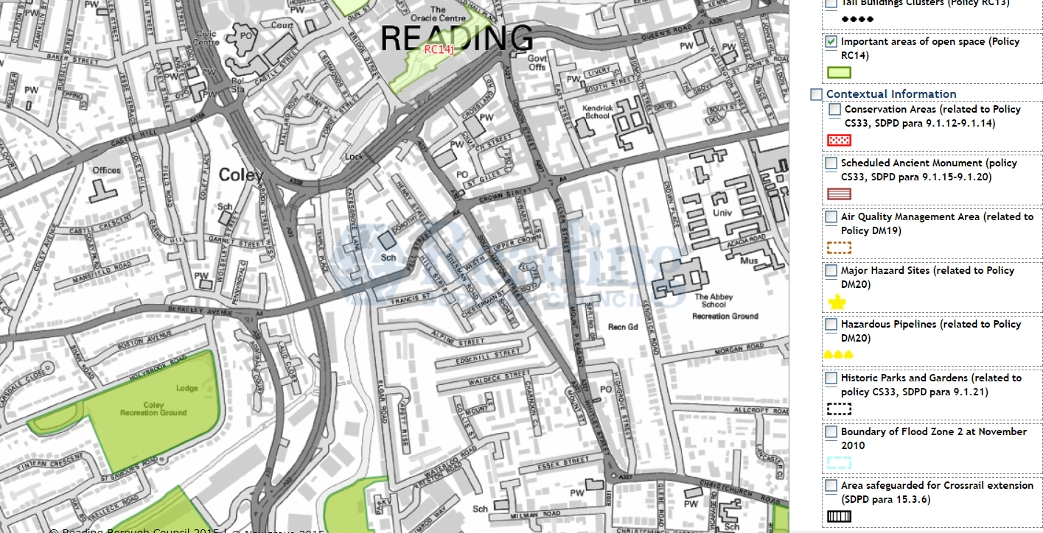
Figure 1 – Areas of Open Space, Reading Proposals Map

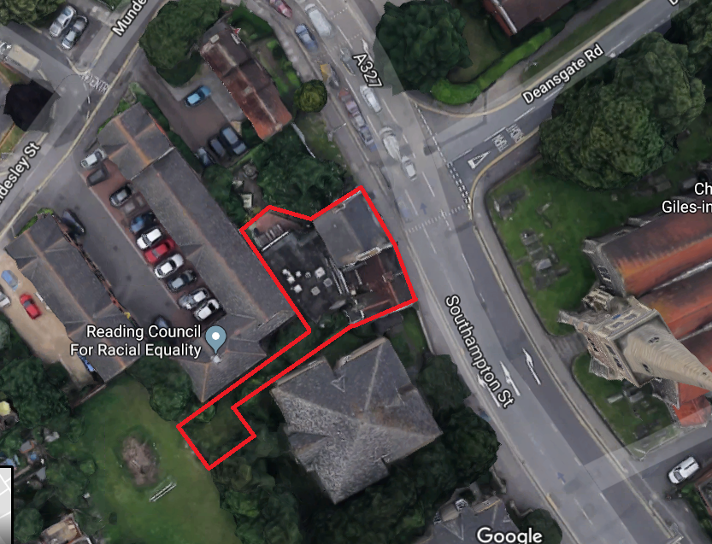
Figure 2 – Satellite Image – 34 – 38 Southampton Street, Reading

  - Policy DM10 seeks to ensure that houses are provided with a functional private and communal outdoor space. The design of such outdoor spaces should respect the size and character of other similar spaces in the vicinity, ensure spaces are appropriately related to main entrances, enhance safety and ensure that they are not compromised by the relationships of other buildings which may be detrimental in terms of overlooking, overbearing and over-shadowing.
  - In this regard, the proposals provide a range of enhanced spaces for use of residents. As highlighted on pages 28 to 31 of the submitted Design and Access Statement, private terrace, balcony and garden spaces are provided for five of the units, whilst approximately 80 sqm of communal garden space is provided to the rear of the flats. This area will be subject to significant maintenance and improvement to provide an area that is usable and high quality, representing a significant improvement over that in-situ. It is considered that the level of space provided should be considered appropriate given the site is located in a central area of Reading and as residents will have a number of open spaces within ten minutes’ walk of the site for wider amenity.
  - Policy RC14 has regard to the quality of public realm within the central area and notes that developments of under 1 hectare will not need to provide open space, but will need to contribute to improvements in the public realm. Planting and landscaping is encouraged to aid the creation of high quality spaces.
  - It is noted above, and in Section 5.8 of the submitted Design and Access Statement, that the scheme represents a significant uplift in visual aesthetic. All ‘public’ realm sits on the site frontage outside of the applicant’s ownership, but the high quality, locally appropriate design will enable a visual improvement on the London Street frontage which will complement the open space sitting outside of the site to the north. In addition, spaces within the applicant’s ownership will be subject to hard and soft landscaping to provide usable spaces that meet communal amenity requirements and enhance site perception. To provide the Council with certainty that the proposals will meet policy requirements in this regard, it is proposed that a condition requiring submission of landscaping details is attached to any consent given.

Conclusion
  - The proposals at 34-38 Southampton Street are not located on or within close proximity of designated open space. This assessment has therefore considered the approach to on-site provision of amenity and open spaces in light of relevant policy context, as well as how the proposals can contribute to the wider public realm.
  - Further to review of the proposals, it is concluded that the scheme will provide sufficient amenity spaces for residents and will contribute to the significant improvement of dilapidated, poorly maintained spaces that currently attract mis-use and anti-social behaviour. Accordingly, the proposals represent good planning: they seek to improve not only the use of this land, but through better surveillance associated with the residential properties, lighting and use, the perception of the open spaces will be altered, leading to provision of safer, more usable land to the benefit of residents and the wider locality.
Contact
Jonathan Walton
jonathan.walton@vocalism.co.uk
15th January 2018
VOC-17-13

