COMMITTEE REPORT

BY THE DIRECTOR OF ENVIRONMENT AND NEIGHBOURHOOD SERVICES
READING BOROUGH COUNCIL ITEM NO.
PLANNING APPLICATIONS COMMITTEE: 6th December 2017

Ward: Park
App No.: 171562
App Type: FULL
Address: 81 Hamilton Road, Reading, RG1 5RB
Proposal: Change of use from a C3 dwellinghouse to a 7 person large Sui Generis
HMO (amended)
Applicant: Dr. Shoba Benjamin-Philip
Date valid: 18th September 2017
Minor Application: 8 week target decision date: 13th November 2017
Extended decision date: 8th December 2017
Planning Guarantee: 26 week date: 12th February 2018

RECOMMENDATIONS

GRANT planning permission subject to conditions and informatives.

CONDITIONS TO INCLUDE:
- TL1 - Full - time limit - three years.
- Cycle storage details to be submitted and approved and retained thereafter.
- Bin storage details to be submitted and approved and retained thereafter.
- & 5. No entitlement to parking permits (2 standard conditions).
- Vehicle parking space provided in accordance with approved plans
- Communal areas marked as social rooms on the approved plans to be retained for communal use at all times.
- The HMO use at ground, and first floors hereby approved shall be restricted to seven single occupancy bedrooms.
- The coach house building shall be retained for storage, including bin and cycle storage ancillary to the use of the dwelling as a large HMO and shall not be used for further residential living accommodation.
- The area laid as garden shall be retained for private garden with existing vegetation to be retained, and shall not be converted into parking areas of areas of hardstanding.
- Prior to occupation a management agreement for all the communal areas both internally and externally to be submitted and approved and thereafter complied with.
- Removal of pd rights for extensions, including in roof, and outbuildings.

INFORMATIVES TO INCLUDE:
- Terms and Conditions
- Building Regulations
- No entitlement to parking permits
- Fire safety requirements
- Requirements of the Housing Act
- Highways
- Advice about TPO.d trees and trees in Conservation Areas
- Contact Waste Team to ensure correct number of bins is provided.
- Positive and Proactive
1. INTRODUCTION

  - The application site is a Victorian detached two storey villa in the South Park Conservation Area. It is set within a large plot with existing garden wrapping round the property and a driveway on the southern side leading to a two storey building (former coach house) and in the opposite corner a greenhouse. There are existing paths across the garden and around the perimeter of the house. There is limited existing planting and trees. It has a garden to the front enclosed with low railing and a pedestrian gate. The driveway is enclosed with double wooden gates. The front elevation includes an attractive verandah feature. It is described in the Conservation Area Appraisal as “(“Rosehill”): 2 storey detached villa. Gabled slate roof [since removed]. Projecting bracketed eaves. Decorative verandah with curved roof (part removed to accommodate later bay).” To the rear are a number of single storey extensions across the full width of the house. There is no record of any planning permission or building regulations approval for these structures.

  - The local area is characterised by a range of large detached and semi-detached properties, which, in this part of Hamilton Road are mainly in C3 residential use.

  - The application was called in by Councillor White and Councillor Page due to the number of neighbour objections.

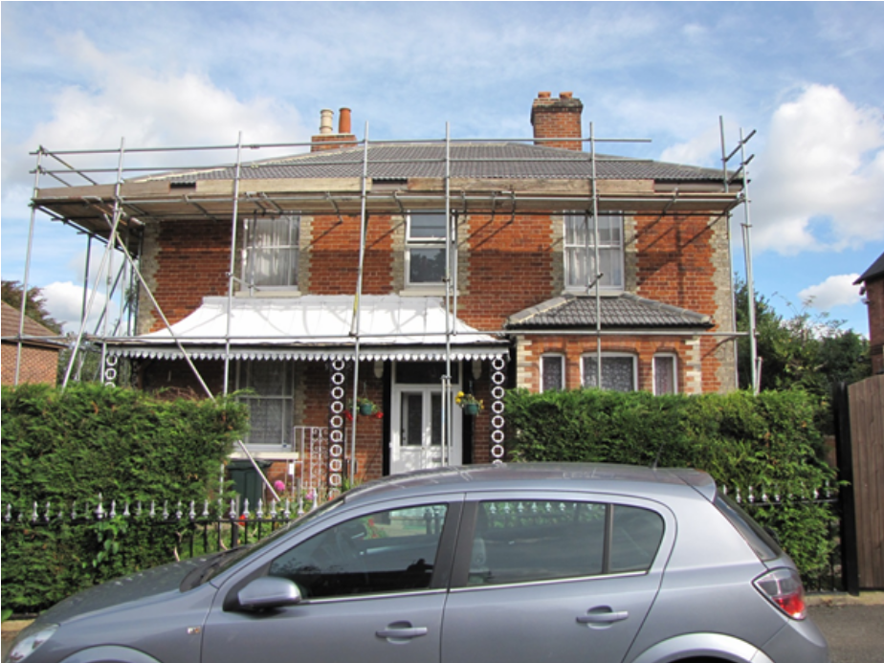

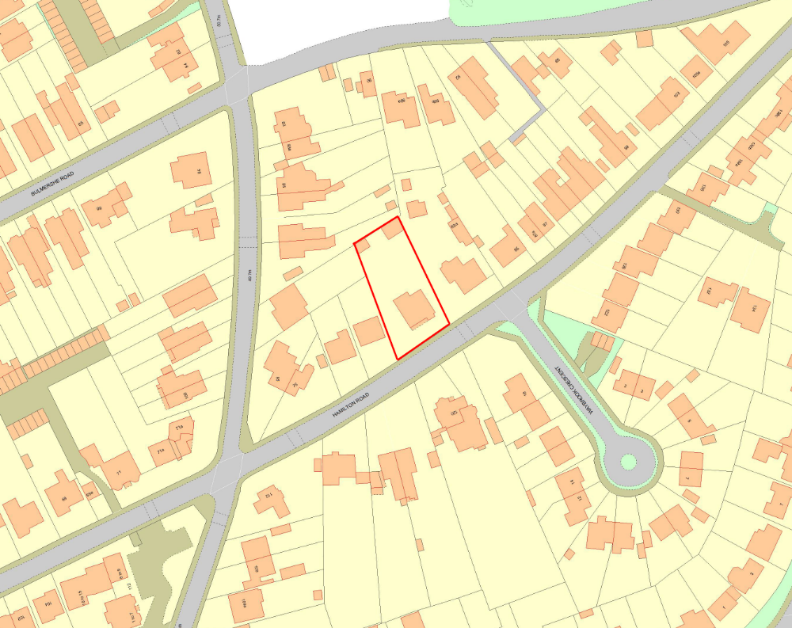

2. PROPOSAL AND SUPPORTING INFORMATION

2.1 The amended scheme is for the change of use from a four bed C3 dwelling to 7 person (in 7 beds) HMO. No extensions or changes to the external appearance are proposed. It was originally submitted as an 8 bed HMO.

2.2 The proposed bin store, cycle store and other storage would be within the two storey former coach house at the rear of the plot. Two car parking spaces are shown on a slightly widened existing driveway on the southern side of the property. A bin collection area is shown to the front of the property, i.e. where bins would be pulled to on collection day.

2.3 The application site is within the Article 4 Direction Area, which restricts the permitted change of use from C3 dwellinghouse to C4 small House in Multiple Occupation (HMO).

2.4 The following plans and supporting documents were submitted with the application:

Location Plan, received 8th September 2017
Existing Floor Plans – Drawing no: 01, received 18th September 2017
Existing Site Plan – Drawing no: 05, received 11th October 2017
Proposed Floor Plans – Drawing no: 02, received 18th September 2017
Proposed Elevations – Drawing no: 03, received 18th September 2017
Proposed Site Plan - Drawing no: 04, received 18th September 2017
Design Statement, prepared by 1Right Plan, received 8th September 2017

An amended plan was submitted on the 9th October 2017, which introduced a driveway and additional entrance to the front:

Proposed Site Plan – Drawing no: 04 Rev B, received 9th October 2017

Further to discussion with the agent further amended plans were submitted which removed the front driveway and additional entrance; removed one of the bedrooms and made this into a communal room; moved bin storage to the 2 storey former coach house; included a bin collection point to the front of the property adjacent to the driveway, and reducing the area of hardstanding for parking. These are as follows:

Proposed Floor Plans – Drawing no: 02 Rev A, received 8th November 2017
Proposed Site Plan – Drawing no: 04 Rev D, received 8th November 2017

Amended Plans to show the verandah to be retained, and correction of an error to show an existing internal door, all received 22nd November 2017:
Proposed Site Plan – Drawing no: 04 Rev E
Proposed Floor Plans – Drawing no: 02 Rev B
Existing Floor Plans – Drawing no: 01

3. RELEVANT PLANNING HISTORY

None

4. CONSULTATIONS

- Statutory

None.

- Non-statutory

Ecology - The proposals are unlikely to impact upon any protected species. As such, there are no ecology related objections to this application.

Natural Environment – The property is characterised by its large garden and green frontage, consistent with this type of property and in keeping with the conservation area. The proposal will result in the loss of a notable amount of rear garden soft landscaping and, more importantly, introduces a new access hence will result in the loss of part of the green frontage. Whilst the hedge on the frontage is not of particular merit, it does serve a function and whilst there does not appear to be any trees worthy of a TPO, the overall vegetation provides a verdant character.
Given the site’s location within a conservation area and the potential harm to amenity from the proposed increase in hard landscaping, it is important that the applicant demonstrate how mitigation could potentially be provided through landscaping prior to a decision. This acceptability of this mitigation would then be an important consideration as to the acceptability of the proposal in tree/landscape terms.

Planning officer note: The following comments were provided further to the receipt of amended plans:

Losing the in/out driveway is a definite improvement. I note the relatively minor loss of soft landscaping at the rear for parking and from a street scene point of view, the change wouldn’t make a difference. I do, however question how vehicles will move in/out of the site, i.e. there’s no room to turn on the site, it’s a long drive to reverse into and the road is normally full of parked cars. However I guess this is not different from lots of driveways and assume transport will/have commented.

I think it would be prudent for the final approved proposed site plan to indicate the retention of existing vegetation. An informative [regarding trees in Conservation Areas] would be prudent.

Transport - The site is located at the south-eastern end of Hamilton Road, in between Crescent Road and Whiteknights Road. The property benefits from an existing access situated on the right hand side of the property, directly off of Hamilton Road.

The site is located just within Zone 2, Primary Core Area, of the Revised Parking Standards and Design SPD. This zone directly surrounds the Central Core Area and extends to walking distances of 2 kilometres from the centre of Reading. A frequent service of public transport is available along Wokingham Road which provides a good frequency of services to and from the town centre. It is also part of the South Park Conservation Area.

In accordance with the adopted Parking Standards and Design SPD, the development would be required to provide a parking provision of 0.25 spaces per HMO room equating to 2 parking spaces.

Hamilton Road itself is not part of the Council’s designated Parking Permit Area; however adjacent roads are, and there is the potential of extending the permit scheme in to other roads in the area. Hamilton Road is a busy road with unrestricted parking on both sides of the carriage way. Therefore to ensure the development does not result in adding to the already high level of on street car parking in the area it is essential that adequate off road provision is in place.

The plans illustrate that the development would utilise the existing access from Hamilton Road and parking for a minimum of 2 vehicles can be accommodated on-site. A secondary access point would also be introduced onto Hamilton Road although this access is not required to facilitate the development. A large area of hardstanding at the rear of the site would enable 2/3 additional vehicles to park on-site.

It should be noted that the access road is narrow at approximately 2.9m wide which may cause disturbance to the neighbouring property when accessing the rear parking spaces. This could be overcome by having a singular access point and parking on the opposite side of the property. However, there are no transport grounds to object on the current layout.

The future occupants of the dwellings should be aware that they would not be eligible for any residents parking permits if a residents parking scheme comes forwards in the future.

In accordance with the Borough’s Parking Standards and Design SPD, a minimum provision of 0.5 cycle storage spaces should be provided per unit (0.5 spaces per flat/HMO room). Cycle storage has been proposed and is located at the rear of the property. The proposed location is acceptable but the specification is still to be solved by way of condition.

Bin storage should comply with Manual for Streets and British Standard 5906: 2005 for Waste Management in Buildings to avoid the stationing of service vehicles on the carriageway for excessive periods. Waste collection vehicles should be able to get within 10m of the storage point (15m for 240 litre wheelie bins). The bin store would be located to the rear of the property and would be maintained and operated by the management company. In principle, this is acceptable but a bin collection point should be provided with 10m of the highway. I am happy to deal with this by condition.

Planning Officer note: Further to amended plans Transport provided some additional comments as follows:

There is a large area of hardstanding (existing) at the rear of the site. The plans illustrate that the development would utilise the existing access from Hamilton Road and parking for a minimum of 2 vehicles can be accommodated on-site. Additional vehicles could be accommodated within the site if an informal parking arrangement was adopted by the future residents.

A bin collection point has been illustrated at the front of the site which will enable on-street serving to occur from Hamilton Road.

There are no transport grounds to object to this application as the development has provided on-street parking which complies with the Council’s adopted Parking Standards.

- Public/ local consultation and comments received

Nos. 75-85 (odd) and 112-120 (even) Hamilton Road, nos. 91-93 Crescent Road and 18 Waybrook Crescent were consulted. 51 objections were received with regard to the original submission, which was for 8 person HMO, and included a new access point and driveway to the front and reduction in garden area at the back for parking. In summary the issues raised are as follows (full responses are available to view online):

Parking problems/ highway safety
- Appalling parking problem and the proposal would increase the cars trying to park on the road and have a negative impact on highway safety.
- Parking on pavements is commonplace and pedestrians have been hit by motorists trying to negotiate the congestion.
- Residents in Hamilton Road are asking the council to consider a residents’ parking scheme; No current proposals to implement residents’ parking this means that the already overcrowded road will have yet more cars trying to park on street.
- Inadequate loading and turning area.
- The proposed 2-3 car parking spaces on site may be in line with recommendations, but there will be more cars for the site.
- Parking spaces will reduce the rear amenity space; how would residents be prevented from parking on the grass?
- Removal of the front fence would reduce kerbside parking.
- Recent proposal to put double yellow lines along west side of Hamilton Road received over 6 responses which indicates the strength of feeling about parking and traffic problems in this area.
- Just because the area is well served by public transport does not mean that occupants will not own a car.
- I welcome the attempt to alleviate the impact of the HMO with proposed parking to the front, but this will require removal of period railings subject to conservation area controls.
- Parking has become worse since the introduction of metered parking in University and Hospital areas.
- This is the first road out of the town centre with no parking controls.
- Proposed drive across the front would be inaccessible unless both gates open outwards and also danger to the use of the front door; Proposed front driveway would require cars to drive onto land to the north, further reducing garden space; what will prevent residents from parking on the amenity areas?
- Vehicles using the driveway would need to reverse into the road.

Traffic
- Hamilton Road is extremely congested.
- The road is used to access three schools on Crescent Road.
- Clogged up with cars of commuters, students and hospital workers.
- Lorries and ambulances sometimes cannot get up the road.

Impact on the Character and Appearance of the Property and Conservation Area
- HMOs are never maintained to a high enough standard and quickly deteriorate.
- 81 Hamilton Road is cited in the Conservation Area Appraisals Document and is therefore of special interest; the gabled slate roof [now removed] is specifically mentioned in the South Park Conservation Area Appraisal; it is one of the most distinctive architectural buildings in the South Park Conservation Area; it is a unique example of Victorian heritage and worthy of protection to preserve Reading’s heritage.
- The new owners have already substantially degraded the external appearance - changes have already been made to the external appearance – roof line, chimney, roof tiles; works already undertaken should have been subject of an application; the owners are either not aware or unwilling to abide by what is required for appropriate work.
- Alterations to the dwelling’s frontage would be out of character; removing the railings at the front of the property and turning the area into a car port would probably also lead to the destruction of the unusual and distinctive original veranda; the canopy has been vandalised by having been painted white; it should be impressed on the owners that under no circumstances should it be demolished; The Conservation Area Appraisal makes several references to brick walls and railing.
- Once the property is an HMO policy and guidance on changes to external features will be at increased risk of being ignored, the neighbouring property stands as an example of this.
- HMOS do not enhance Conservation status; the proposal would not improve the character and vitality of the area.
- Changing the usage and increasing occupancy will be likely to detract from the current appearance through increased outside amenity space for parking, bike storage, bin storage.
- Already exasperated at the Council’s failure to act as conservationists.
- Strongly oppose destruction of any of the garden which is part of the valued character of the Conservation Area.
No of HMOs
- Already a large number of HMOs on Hamilton Road.
- There are controls in place to limit the number on any one road.
- Yet another in close proximity to no. 83 will undoubtedly prove detrimental to the area.
- The whole point of the bylaw requiring planning approval for splitting a family home into HMO is to prevent the wholesale destruction of the residential area.
- Surely the fact that the house is in an Article 4 direction area is compelling grounds for refusal.
- The applicant claims precedent due to other large HMOS. There are not more than 2 in this area, the others are small house shares.
- It is important that another HMO hotspot is not created; permission of the change of use would set a precedent for South Park, which would make it difficult to resist a flood of such applications.
- Carving up a medium sized house into bedsits would not serve any pressing social need.
- Landlords also like to increase profits by converting outhouses, but this would be overdevelopment.
- The town needs good quality, affordable housing for families, not more bedsits.

Effect on character of area
- Another HMO will threaten the balance of family homes and rented and change the area.
- The effect of an absentee landlord on the upkeep, appearance and usage of the property is rarely aligned with the interests of long-term family oriented residents.
- If our local people get driven away, it could all change to a road of flats and bedsits.
- If enforcing compliance in terms of development and usage of HMOs then the emphasis needs to be placed on stopping developments which appear to be at odds with the Council’s conservation objectives.
- Transient population have no interest in taking care of their surroundings; they will contribute nothing to the community.

Effect on amenity of neighbours, future residents and the community
- Increase in noise, disturbance and nuisance from eight individuals rather than a single dwelling, including the outside space.
- At all hours of the night students can often be heard shouting and screaming, also partying [in the area].
- A change to an HMO will mean that rooms with windows on side elevation will be occupied full time and will create considerable overlooking and add to noise levels when windows are kept open.
- No noise or pollution screening is proposed for the kitchen occupants of the proposed HMO.
- Proposed driveway to be at least twice as wide as now, this would reduce the amenity space.
- The continual shunting of cars around the garden would be detrimental to quiet enjoyment of adjoining properties.
- Noise and fumes for occupants of rooms from front and rear parking areas.
- Amenity space will be severely impacted and it will fall short of guidelines.
- No provision for laundry and drying.
- All of the residents and guests will be able to look into bedroom and bathroom windows (no77) resulting in a significant loss of privacy.
- Pollution from cars would contaminate food grown in the garden.
- The elevated noise and pollution will make it impossible for neighbours to use their gardens.
- Land at 81 is slightly elevated and any person in the garden can overlook our property and garden.

HMO requirements
- Room sizes are too small to meet Council’s minimum standards.
- Insufficient communal rooms; one per 4-6 bedrooms is required.
- The layout of bedroom 7 with two doors restricts its use as a bedroom and is too small against guidelines of 7sqm.
- DM8 states that at least one unit must be provided with two separate bedrooms and separate access to the garden.
- Packing 8-16 people into a small site would meet the definition of overcrowding even in the 1930s, likely to cause substantial problems regarding waste disposal and noise.
- Number of bathrooms and toilets appears inadequate, especially given that one can only be accessed through a bedroom.
- It would be impossible to check and enforce the numbers using the HMO.
- Size of rooms and parking area are not comparable to other HMOs.
- RBC’s HMO Management Pack (section 11) states minimum requirements for shared kitchens 10m2 for 6-10 individuals, which this does not meet.
- Requirement for 2 cookers, how will this be accommodated?
- How will adequate food storage be provided?
- The ground floor WC and shower room are not suitable due to no natural light, doors opening outwards, too small to shower in without clothes getting wet.

Green Space
- Although not a designated green link the rear gardens provide a much needed wildlife corridor.
- Trees have been removed without consent.

Bin Storage
- Too far from the house and waste will accumulate. In reality they will end up outside the kitchen, how pleasant!
- Its location exceeds 9m maximum distance to the road.
- Where will bins go when put out for collection?

Cycle storage
- The entire ground floor of the coach house would have to be used for bikes and this would prohibit the possible future accommodation, which I understand from the applicant is the next step in this development.

Construction of existing extension
- Substandard construction and contains the proposed bedroom 8, kitchen and shower room. No regard to satisfy any requirements to insulation, damp proof coursing, no fire or sound insulation etc No load calculations have been submitted to Building Control for the new roof, I can only assume the same cavalier approach has been applied to meeting their obligations with regard to fire and sound. How does the building meet fire standards?;

Process & Plans
- This should be referred to committee,
- Why has the application time been changed from 6-8 weeks to 3 weeks?
- A detailed site plan is required,
- No consultation apart from with immediate neighbours
- How is the coach house to be used?; The coach house is being used for accommodation presenting a fire risk.
- We expect enforcement action to be taken on the changes to the roof, so that it is replaced with slate.
- Should permission be granted this should be conditional on detailed plans about the development of the space around the property and intentions for parking, and limited to one parking permit within any future controls; something needs to be in place that will prevent tenants parking on the grass along the side of the house.
- Veranda is not marked on the plans.

12 no. further objections were received with regard to the amended proposals which included a reduction of one bedroom to 7 rooms, an additional communal space, smaller area of hardstanding, changes to the location of storage for bins and cycles, removal of the front parking area. A summary of further additional comments, over and above those originally made is set out below:

Parking
- The Council needs to be seeking to reduce traffic and parking issues in these roads not increasing the pressure.
- The proposal is now for 2 cars, which Transport has accepted, but surely the impact on the surrounding roads must be a factor? The Transport officer states “an informal arrangement is to be adopted by future residents”. The parking standards are guidelines and clearly as Transport envisage the shunting of cars on the site these should be ignored and the application refused. Clearly after a while car parking will take place on the lawn to the detriment of residents and adjacent properties.
- People have parked in my disabled space.
- Additional vehicles will cause an unacceptable increase in the difficulty already faced by residents in finding a place to park close to their homes.
- Extreme difficulty on a daily basis getting in and out of their drives.
- Any chance of some ‘do not park’ notices to protect Waybrook’s verges – we like the grass?
- If later concreting over the grass is a likely option (which has been indicated as such) who will stand up for the overall impact to the environment and additional run off and overall blight that represents?
- The Council have already allowed desecration of this fine Victorian building by the current owners - in a supposed 'Conservation' area; it should not now allow them to inflict further misery on this long suffering street by increasing our car density.

Changes to house layout
- This does not address the problems of overcrowding, etc. The kitchen is still inadequate in size. Shared kitchens do not work; the house will become like a doss house. One group will dominate making the house like an open prison, cause friction and lead to violent behaviour. There is a fire risk from having a shared kitchen and a social room so far from the kitchen.
- The number of toilets and bathrooms is inadequate for possible 14 tenants. Downstairs shower in corridor is totally unacceptable on privacy and/or practical usability grounds. There is a bi-fold door with immediate access to the fire escape corridor.
- Suggest the number of occupants is limited to seven, but this would not solve the parking washing and kitchen facilities problems. It should be limited to four bedrooms, a family house as was originally intended, set in an exceptionally nice residential area.

Amenity
- The added pollution of having an HMO whether its extra cars, littering or noise has not and cannot be addressed by amending the plans. 7+ strangers living together will inherently cause issues to the surrounding neighbours and our community at large.

Bins
- No suitable location for further sets of landfill and recycling bins. If this ends up in the front garden this will have a significant impact on the existing appearance of this remarkable property.

Process
- No adjacent properties were made aware of the amended plans, and thereby not allowing further objections.
- I am deeply concerned that my neighbours are being targeted for voicing their opinion.

5. RELEVANT PLANNING POLICY AND GUIDANCE

5.1 Section 38 (6) of the Planning and Compulsory Purchase Act 2004 requires that proposals be determined in accordance with the development plan unless material considerations indicate otherwise. Material considerations include relevant policies in the National Planning Policy Framework (NPPF) – among them the “presumption in favour of sustainable development”

5.2 The following local and national planning policy and guidance is relevant to this application:

National Planning Policy Guidance
National Planning Policy Framework (NPPF)

Reading Borough Local Development Framework Core Strategy (2008)
CS18 (Residential Conversions)
CS24 (Car/Cycle Parking)

Reading Borough Local Development Framework Sites and Detailed Policies Document (2012)
DM4 (Safeguarding Amenity)
DM8 (Residential Conversions)
DM10 (Private and Communal Outdoor Space)

Supplementary Planning Guidance/ Documents:
Residential Conversions SPD (2013)
Revised Parking Standards and Design SPD (2011)

6. LEGAL CONTEXT

6.1 Reading Borough Council made an Article 4 Direction in May 2012, which came into force on 16th May 2013, which removes permitted development rights to convert from a dwellinghouse (C3 use) to a house in multiple occupation (C4 – small HMO for 3-6 unrelated persons sharing at least one basic amenity) in parts of Redlands, Katesgrove and Park Wards. The application site is within the Article 4 Direction Area.

7. APPRAISAL

7.1 Policy CS18 states that “Proposals to convert properties into self-contained flats or for multiple occupation will be assessed against the impact on the amenity and character of the surrounding area, particularly in terms of intensification of activity, loss of privacy, loss of external amenity space, the provision and location of adequate on-site car parking, and the treatment of bin storage areas.”

7.2 Policy DM8 provides further detail and states: “Proposals to convert properties into self-contained flats or for multiple occupation under Core Strategy Policy CS18 will only be acceptable where:
- The proposal respects the physical character of the area and additionally would not, either individually or cumulatively, unduly dilute or harm an existing mixed and sustainable community through the significant loss of single family housing;
- There are no unacceptable adverse impacts to other residential properties arising from noise and disturbance in terms of the number and layout of units proposed and the proximity to other properties;
- There is appropriate sound insulation between proposed and neighbouring units and layouts avoid inappropriate stacking and location of rooms between units;
- Bin and cycle storage is of an appropriate size and standard for the units proposed and should be located at ground floor level with easy access…………..

Additionally, in the case of sui generis houses in multiple occupation (HMOs):
- The property to be converted has four or more bedrooms or measures more than 120 square metres gross;
- There is an appropriate balance between communal and private areas for sui generis HMOs

7.3 Along with the relevant adopted local planning policies the appraisal of the application has been based on the Adopted Residential Conversions SPD (2013), which provides further detail for the adopted policies. Section A of the SPD, deals with the ‘General Assessment of all Conversions’ (i.e from C3 dwellinghouses to flats or HMOs (both small C4 use and sui generis HMOs). Section B specifically covers the assessment of applications for HMOs within the area covered by the Article 4 Direction. This application has been considered against both sections.

Main considerations:
The main issues to be considered are:
- Principle of residential development
- The impact on amenity of proposed and existing residents of nearby properties
- Effect on Conservation Area
- Car/ cycle parking
- Bin storage
- Other matters raised through consultation

- Principle of residential development: Does the conversion result in unduly diluting or harming a mixed and sustainable community

7.4 In terms of whether a property is suitable to be converted to a large HMO Policy DM8 requires a property to have four or more bedrooms (as originally built) or to have a gross floor area of 120m² or more when measured externally. The property meets this requirement and therefore the conversion into a large HMO would be acceptable in principle.

7.5 Further assessment as to whether a property is suitable for conversion is whether such a conversion would result in unduly diluting or harming a mixed and sustainable community. This is assessed using the ‘tipping point’ calculation.

7.6 The SPD identifies that the ‘tipping point is when the concentration of HMOs becomes over dominant and the community is no longer considered to be mixed and sustainable.’ The SPD defines that “planning permission will not normally be granted where the proportion of HMOs will result in HMOs representing 25% or more or the residential properties within a circle of 50m radius measured from the application site” (para. 5.43).

7.7 This calculation is to also applied to changes of use from C3 dwellinghouses to large Sui Generis HMOs. The concentration of HMOs in the area surrounding the application site has been calculated as a percentage of the total estimated number of existing HMOs (C4 or sui generis) against the total number of residential properties, i.e. those falling with C3, C4 or sui generis HMO use. Available data from Environmental Health, Council Tax, extant (unimplemented) permissions for HMOs, data on property websites, and data held by the Enforcement Team, has been used.

7.8 The total number of properties within the 50m radius, including the application site, has been calculated as 17no. The total number of properties in HMO use, using the above sources of data, is estimated to be 3no. (Including the application site) and therefore the overall percentage is calculated as 17.7% which is below the threshold of a maximum of 25%. In this regard the principle of the conversion of the application property to a C4 small HMO or Sui Generis HMO is considered acceptable.

- The impact on amenity of proposed and existing residents of nearby properties

7.9 The Residential Conversions SPD sets out a number of checklist items which provide further detail related to adopted policies DM4, DM8, DM9 and DM10 of the Sites and Detailed Policies Document.

7.10 A number of objectors have made reference to the ‘Houses in Multiple Occupation Management Pack’ (RBC Licencing, March 2017) which includes a section 11 on amenities in HMOs. This identifies those matters prescribed by law in addition to those locally identified for those HMOs that fall under mandatory licensing, which this property would not (as it would not have 5 or more occupants over 3 floors).

7.11 The Pack states that “These standards will be used as guidance for all other HMOs and may be enforced if a category 1 hazard is found.” There are clearly a number of pieces of legislation that a property owner would need to comply with regard to HMOs. Compliance with such legislation would be in addition to meeting requirements as assessed under planning policy. A scheme found to be acceptable and approved under planning legislation would not necessarily meet requirements defined and required under separate legislation; such would need to be separately sought.

7.12 The SPD (Para 2.52) is clear that the HMO team should be contacted about Environmental Health matters, which are set out in in specific legislation separate to planning legislation.

7.13 Therefore, reference below to the standards in the HMO pack has been made in the context of those which are relevant to the above planning policies.

Room Sizes
7.14 The SPD identifies minimum internal floorspace standards (Appendix 1) as 6.5sqm for a single bedroom and 7sqm for a kitchen. The kitchen is shown as 8.25sqm and the smallest bedroom (no. 7 ground floor) is 6.76sqm, with the majority of bedrooms far larger than this. All the proposed rooms and kitchen meet these sizes.

Communal Space
7.15 The SPD identifies that the amount of communal space that is considered appropriate in a large HMO would be dependent on the number and size of bedrooms. The standard set out is for one communal room for every 4-6 bedrooms (depending on the size of the bedroom). The amended scheme provides for two communal rooms on the ground floor, one adjacent to the kitchen and one to the rear of the property. They both have an acceptable outlook and can be independently accessed. They could both accommodate at least 4 people at any one time, which is considered more than sufficient for the proposed seven residents. In addition there is a kitchen, and a lean to, which could be used for some extra storage area if required.

7.16 There have been objections to the scheme based on the view that the proposed scheme includes inadequate kitchen provision. The size meets requirements and in terms of other amenity guidance set out in the HMO Pack, it would be for an owner to satisfy themselves that they have met relevant requirements within HMO related legislation.

7.17 Concern has also been raised that there is an inadequate number of bathrooms and WCs to serve the proposed number of occupants. With reference to the amenity guidance in the HMO pack it states that: for 6-10 persons using communal facilities there should be 2 bathrooms and 2 separate WC’s with wash hand basins. The proposed scheme would meet this hygiene amenity standard.

Amenity Space
7.18 The property is sited in a spacious plot with garden on 3 sides, with hardstanding driveway to the south, which leads to a former 2 storey coach house. The amended scheme reduced the amount of hardstanding to be created, and removed the proposed front access and driveway. The existing garden is in excess of the gross floor area of the dwelling, and therefore of an acceptable size for seven individuals.

External windows
7.19 All habitable rooms would benefit from external windows.

Layout/Stacking of Rooms
7.20 The Council’s SPD seeks to avoid layouts which locate living rooms, bathrooms and kitchens, next to, above, or below, proposed or neighbouring bedrooms. The layout largely achieves this with only the communal room (adjacent to the kitchen) located next to and below a bedroom. The remainder of the rooms are stacked appropriately.

Sound Insulation
7.21 Policy DM8 refers to sound insulation between proposed and neighbouring units. No sound insulation is proposed, however, as this is a detached house no insulation would be required to meet policy, and indeed this would only be a building regulations requirement where independent units were being created (Self-contained flats).

Privacy and Overlooking
7.22 A number of objectors refer to the loss of privacy and overlooking which would result from the proposed scheme. Although it is accepted that the HMO rooms would be used more intensively than their use within a C3 family dwelling the property is set with windows at a minimum of 4.7m from the boundary with no. 79, which is considered far enough for any increased use to not cause a significant detrimental effect in this regard, especially since there are no side facing windows towards the application site at no. 79.

7.23 The use of the garden space would enable residents to look across into other gardens, but this is unlikely to be so significantly different to what would occur with residents of a fully occupied family house.

7.24 The ability to look into the bedroom and bathroom windows of no.77 would be possible from the garden of no.81, but this is considered to be at a good distance, and would be comparable to what would occur from the use of no. 81 as a large family dwelling.

Noise and Disturbance and Pollution
7.25 It would not be expected that the amount of the noise from the property, housing a maximum of seven adults, nor within the garden, would be appreciably different from that generated from a fully occupied large four bedroom family house. Noise from the inside of the property, during summer months when the windows would be open would be unlikely to cause significant detriment to neighbouring properties due in part to it being detached within a good size plot, and therefore at some distance from the nearest properties.

7.26 The associated noise and disturbance and pollution created by the use of the driveway from a few cars is not considered to be significant, especially when considered in the context of the existing traffic along Hamilton Road and what would be possible with its use as a family home. Officers do not therefore agree that such would make it impossible for neighbours to use their gardens, and that the presence of a few cars would contaminate food grown to any greater extent than existing traffic using Hamilton Road.

7.27 The use of the driveway would cause some disturbance to the tenants in rooms on the southern side of the house, but this must be considered and set against noise and disturbance already evident from the road, and it is unlikely that this would be of such a level to create significant harm.

7.28 Officers do not accept that the proposed use would lead to ‘continual shunting of cars around the garden’, nor that the use of the driveway in this domestic context would necessitate screening to the proposed kitchen to protect residents.

7.29 A condition is recommended above, which requires the submission of a management agreement prior to occupation, which would deal with a number of issues including the management of noise from tenants both within the property and externally within the garden.

- Effect on Conservation Area

7.30 A number of the original objections included concern over the loss of original features including the verandah and railings which would have resulted from the proposed driveway to the front. An amended scheme was submitted which removed the driveway thereby ensuring the retention of the verandah.

7.31 Many of the comments related to the importance of the building in the Conservation Area and the special architectural features. They highlighted the changes that that have occurred, such as new roof tiles, part removal of chimney stacks, and painting of the verandah, which objectors considered to have a detrimental effect on the character and appearance of the Conservation Area. It should be noted that all the works undertaken have been investigated by the Enforcement Team and it has been confirmed, in consultation with Legal Services, that all the changes benefit from permitted development rights. In addition concern was raised that the outbuilding was being used as a self-contained flat, which was also investigated and it was found that no change of use had occurred.

7.32 An issue has been raised that the amount of space required for parking, bin and cycle storage would detract from the appearance of the Conservation Area. It is proposed that bin and cycle storage would be housed in the rear two storey former coach house. Some widening of the driveway would take place for the provision of two car parking spaces and space for bins and cycles to be moved from the front to the back of the site. This change is considered minimal and Natural Environment has confirmed that the loss of an area of soft landscaping from the rear garden would not make a difference from a street scene perspective.

7.33 A proposed bin collection point would be located to the front of the property, but this would be a temporary location for bins on collection day.

- Car/Cycle parking

7.34 The most significant objection relates to the impact of parking associated with a 7 person HMO on the road and highway safety. Concerns over the existing issues of on-street parking, illegal parking and difficulties for vehicle and pedestrians resulting in highway safety concerns were set out in detail by objectors.

7.35 The proposed scheme would meet the parking requirements as set out in the Council’s Parking Standards, i.e. 0.25 spaces per room, which would equate to 2 spaces. It is acknowledged that there are parking issues on the street, and Transport has confirmed that parking requirements are met and that additional vehicles could be accommodated within the site if an informal parking arrangement was adopted by the future residents.

7.36 The issues faced on Hamilton Road appear to be the result of recent parking restrictions which have displaced parking further out of the Centre to roads which currently have unrestricted parking. This is in addition to associated parking and traffic movements with educational developments on Crescent Road. The objectors refer to the request to the Council for double yellow lines and residents’ parking. However, the level of additional parking which might be generated from this proposal would be very small compared to its use as a family home, and the impact of which would be minimal in the context of the existing issues. There was no objection on transport grounds and a refusal on this basis would be difficult to justify within the framework of relevant planning policy.

7.37 Conditions and an informative are included in the recommendation above regarding a restriction on the entitlement to parking permits for existing and future schemes in the area.

7.38 Some objectors raised the question of control to prevent parking on the grass. A condition is recommended above regarding the retention of the garden area for that purpose and that it shall not be used for parking.

7.39 There is proposed cycle storage in the rear garden. A condition is recommended that details are to be provided which shows the layout for at least 2 ‘Sheffield’ type stands.

- Bin Storage

7.40 Objectors have raised the concern regarding the location of the proposed bin store, that pulling distances to the highway are greater than standards require and that the likelihood is that bins will be located either at the front of the property or adjacent to the kitchen.

7.41 There is a suitably sized proposed area for bin storage identified at ground floor within the right hand half of the two storey former coach house. As this is some distance from the road Transport requested that there would need to be a collection point within 10m of the highway. An amended plan was provided which shows a collection point to the front of the house, which would be a temporary location for bins on collection day. The recommended condition for the management agreement would include for management for the disposal of waste.

7.42 Even if bins were located adjacent to the rear elevation of the house it is not considered that this would have a detrimental effect on the appearance of the Conservation Area, nor raise amenity concerns for residents, subject to suitable provision.

- Other Matters Raised Through Consultation

7.43 A number of further issues were raised not addressed above and these are responded to below:

The development of the outhouse would be overdevelopment
Officer response: A condition is recommended above to remove the rights to use this for ancillary residential accommodation and that the overall number of tenants in the house is to be a maximum of seven.

The town needs good quality, affordable housing for families, not more bedsits.
Officer response: the change of use of the house would be within the percentage of HMOs allowed in accordance with the threshold target. HMOs offer one form of affordable housing provision.

Transient population have no interest in taking care of their surroundings; they will contribute nothing to the community.
Officer response: A condition is recommended regarding the submission and approval of a management agreement, which would provide a range of matters that both the landlord and tenants would have to comply with, as well as their duties under other HMO related legislation.

It would be impossible to check and enforce the numbers using the HMO
Officer response: The permission, if granted, would be for seven persons and a condition is recommended that identifies this specific number. Any breach of this could be enforced against.

Although not a designated green link the rear gardens provide a much needed wildlife corridor
Officer response: The amended scheme includes a small area of the garden for proposed hardstanding, with the remainder of the garden to be retained. A condition is recommended regarding that the garden area is retained and not used for parking. Both Natural Environment and Ecology have confirmed that the proposals are acceptable, and that the proposed area to be lost from being soft landscape would not make a difference from a street scene point of view. A condition is recommended that a final plan indicates the retention of existing vegetation.

Construction of existing extension is substandard with no requirements satisfied with regard to insulation, damp proof coursing, fire protection or sound insulation. How does it meet building regulations?
Officer response: It has come to the Council’s attention that the existing extension to the rear has no record of Planning or Building Regulations approval. Even if the extension required planning permission it is likely to be immune from planning enforcement, i.e. in place for more than 4 years. However, with regard to Building Regulations an informative is recommended to advise the applicant to contact Building Control to regularise the extension, and to ensure that it would meet current standards including for insulation and fire regulations.

Why has the application time been changed from 6-8 weeks to 3 weeks?
Officer response: The statutory consultation period is 21 days, and the application period target is 8 weeks. This has been the same for many years.

No consultation apart from with immediate neighbours
Officer response: Letters were sent to the addresses as identified above and a site notice was put up.

No adjacent properties were made aware of the amended plans, and thereby not allowing further objections.
Officer response: Letters were sent to all the objectors to inform them of the amended plans and a further period of consultation provided.

Verandah is not marked on the plans
Officer response: an amended plan has been provided (Proposed Site Plan – Drawing no: 04 rev E, received 22nd November 2017) that shows the verandah to be retained.

The proposed scheme does not include a two bed unit
Officer response: This requirement, as set out in Policy DM8, relates to conversion of properties to flats, not to large HMOs.

Equality Act and Human Rights Act

  - In determining these applications the Committee is required to have regard to its obligations under the Equality Act 2010. The key equalities protected characteristics include age, disability, gender, gender reassignment, marriage and civil partnership, pregnancy and maternity, race, religion or belief, and sexual orientation. There is no indication or evidence (including from consultation on the application) that the protected groups have or will have different needs, experiences, issues and priorities in relation to the particular planning application.

  - In terms of the key equalities protected characteristics it is considered there would be no significant adverse impacts as a result of the development.

8. CONCLUSION

8.1 The proposed development for the change of use from a C3 dwellinghouse to a large Sui Generis HMO for 7 persons is considered acceptable in planning terms and for the reasons given above.

8.2 It is recommended that the application be approved subject to conditions.

Case Officer: Alison Amoah

APPLICATION DRAWINGS

