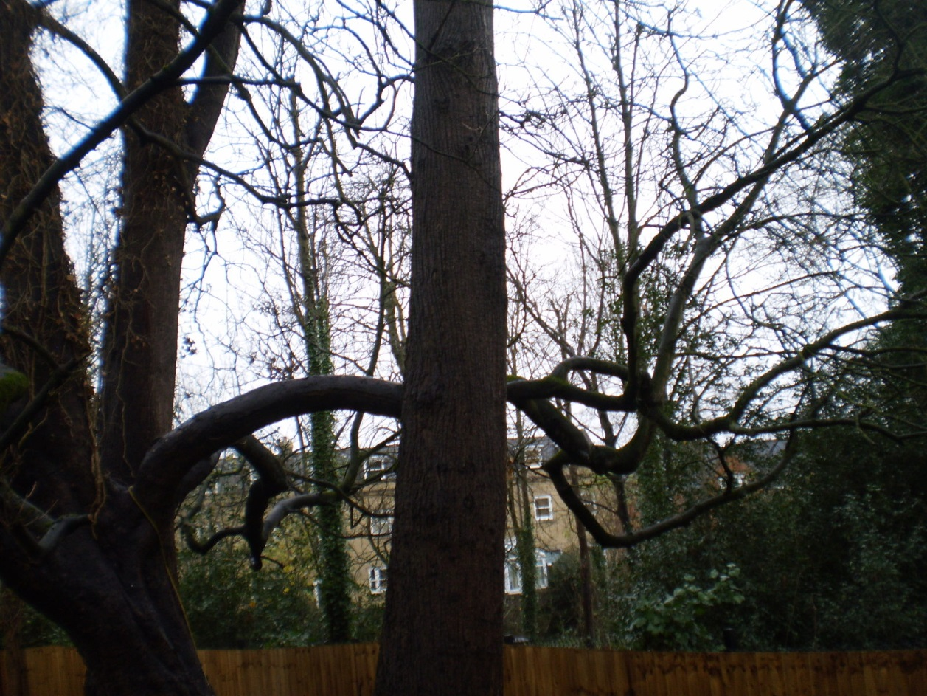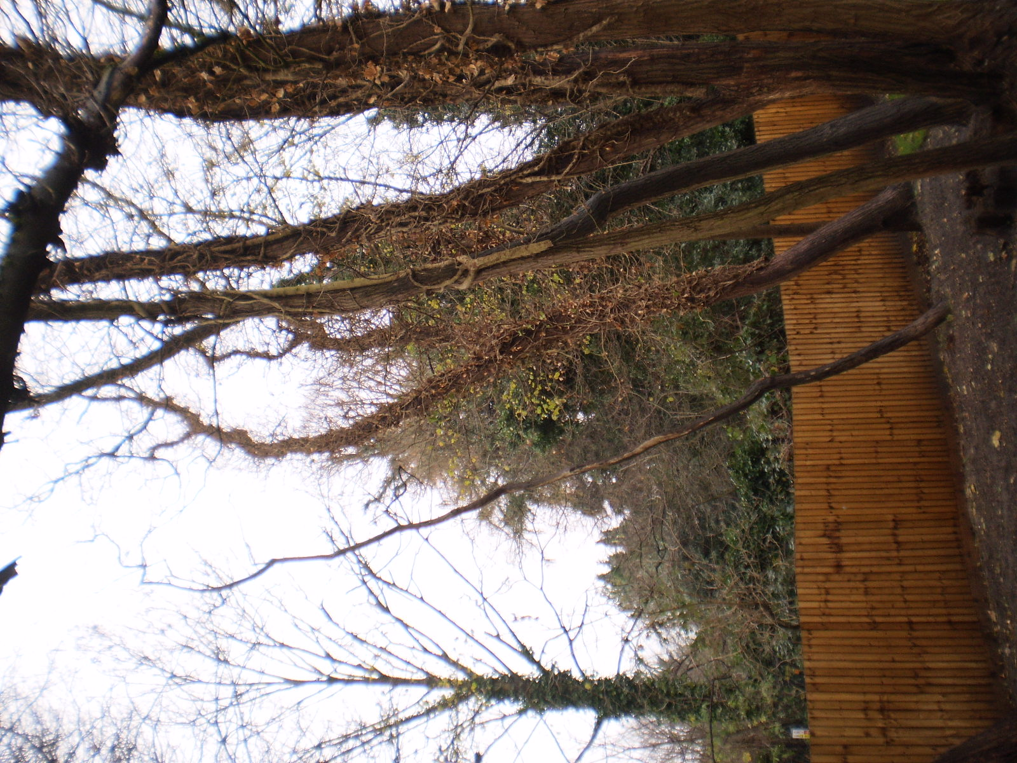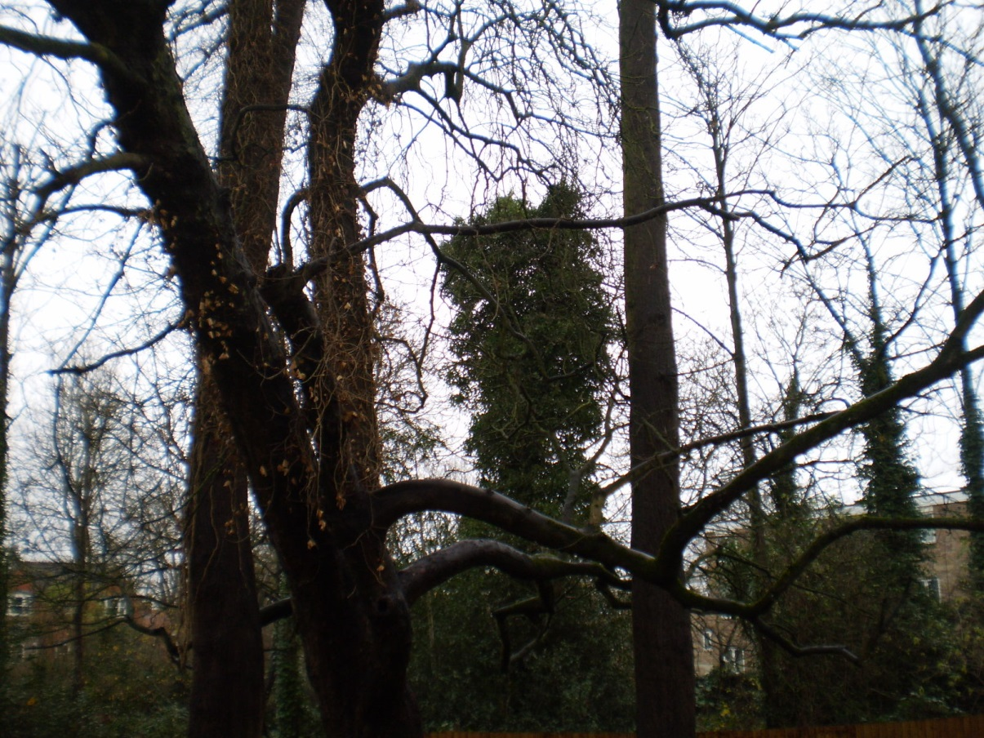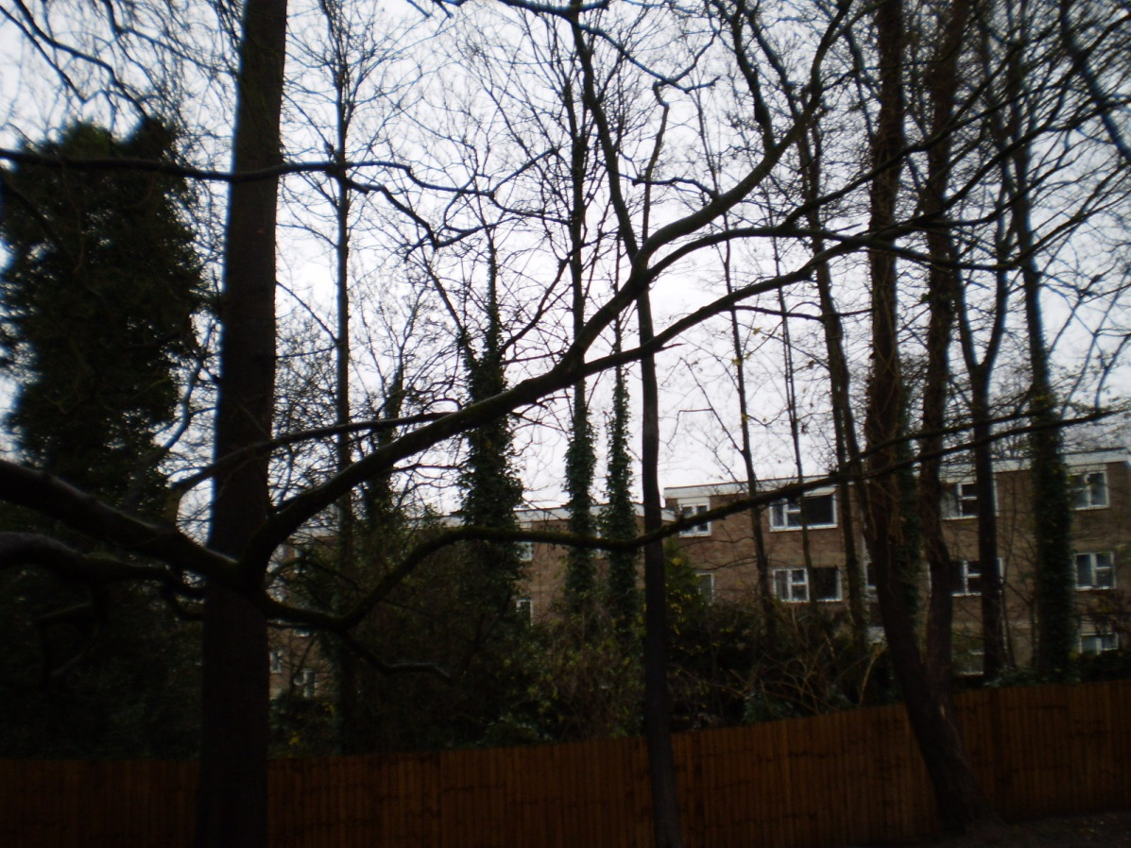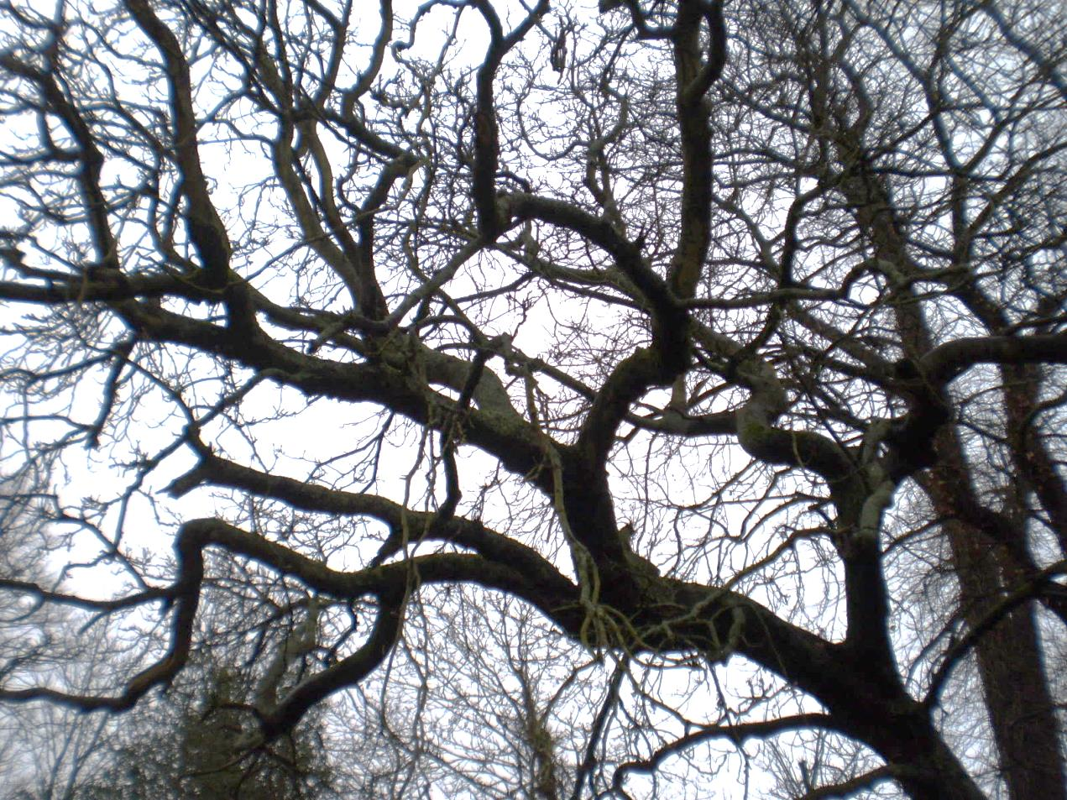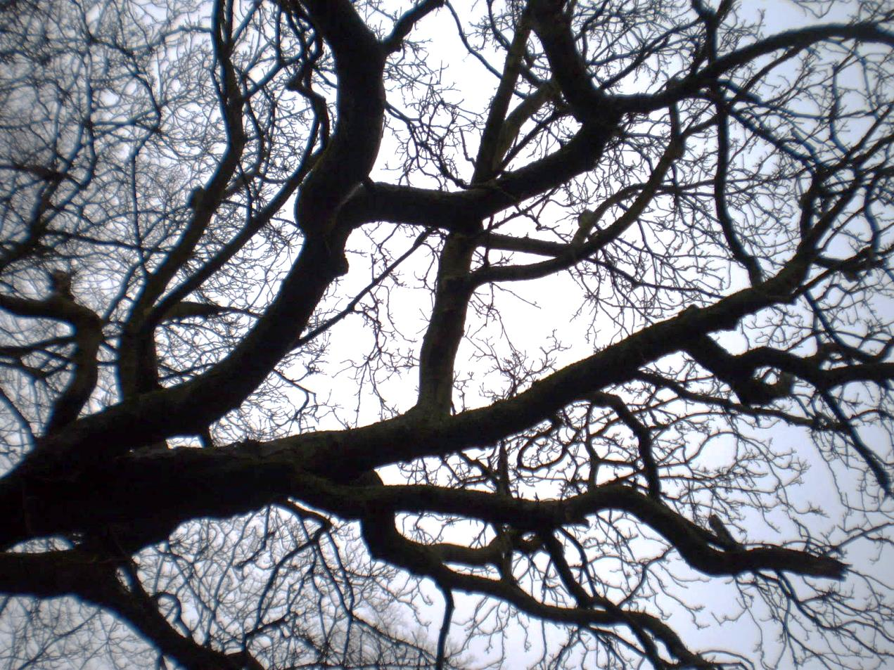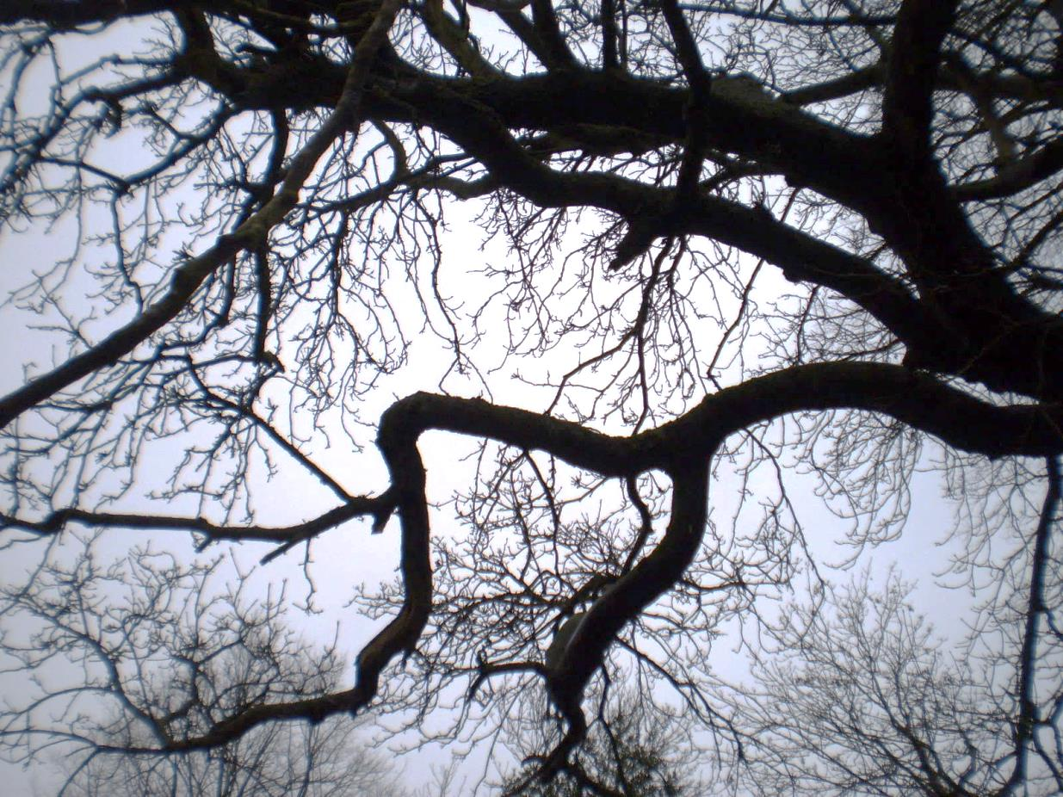
Branch 1 (left) and Branch 2 (right)
Twin branch growing to north-east (referred to in 2012 tree survey) to be reduced to points indicated in red
Small tree which could be removed due to poor condition
Branch growing low over garden – lower fork to be removed
View of southern limb branches looking north-west
Approved (indicative) reduction points in red
View of southern limb branches looking south-east
Reduction points proposed and refused in blue
View of southern limb branches looking north-west

16 Wellswood Gardens
13/12/17

