DELEGATED APPLICATION REPORT - Application No.: 171561
Address: 1 Upper Redlands Road
Proposal: Proposed single storey rear extension to 6.6M depth and side dormer extensions (Retrospective)
Case officer: Alison Amoah

Site Description and Surrounding Area:
The application property is a large traditional end of terrace house within an adjacent shared access (with the University of Reading), with residential accommodation currently being built to the rear (on the site of the former Barnat Works). The land slopes up from north-west to the south-east, with the end of garden very elevated above the house. The ground was excavated closest to the original house, so that the extension follows through at the same ground level. There is a tiered garden with trellis screening.

Proposal: Retrospective application for:

- 6.6m deep by 6.2m wide flat roofed single storey rear extension with skylight
- First floor side facing dormer extensions (see below) with side window within each dormer extension. One facing west (serving bathroom of room 6- studio) is obscure glazed, the one facing east is clear glazed (faces wooded area).

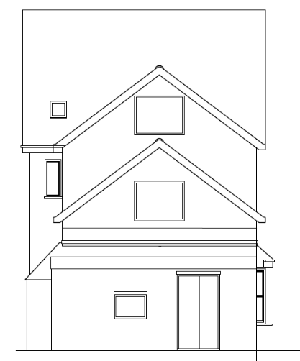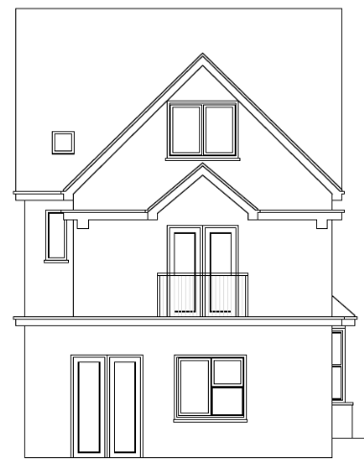
As approved under HPA 161885 Existing Rear

- First floor rear double doors and Juliet balcony
- Double doors and window to ground floor (serving communal kitchen/ dining area)

Plans considered: Amended as received 15th November 2017
Location and Block Plan – Drawing no: UR-01R
Plans - Drawing no: UR-01R1
Elevations – Drawing no: UR02R

Background:
A 6m extension was approved under a Householder Prior Approval (161885). Further to an enforcement enquiry the following was determined:

- At the time of the application the property was a large Sui Generis HMO, with a studio flat, which was not declared; an HPA is only valid for dwellinghouses, and therefore should not have been submitted for this property.

- Irrespective of no.1 above the extension was not built in accordance with HPA approved plans with respect to:
- Overall depth – increased to 6.6m (from 6m);
- Position of the ground door and window reversed and window enlarged;
- Width of extension increased by 0.2m for 3.5m length
- The window in the first floor dormer extension facing east includes clear panes and can be opened at a height below 1.7m. The window in the first floor dormer extension facing west is obscure glazed, but can also be opened at a height below 1.7m

Relevant Planning History:
91/0485/DE – Use of dwelling for six residents with communal lounge and store – confirmed that planning permission not required 11/6/1991

161885/HPA - Single storey rear extension - approved 14/11/2016

171677/FUL – Retrospective change of Use from small House in Multiple Occupation (C4) to a large Sui Generis House in Multiple Occupation comprising 8 bedrooms and one studio flat for up to a maximum of 15 persons – decision pending

Consultation Responses: No.3 Upper Redlands Road was consulted. No comments received.

Equality Act 2010:
In determining this application the Council is required to have regard to its obligations under the Equality Act 2010. However, there is no indication or evidence (including from consultation on the application) that the protected groups identified by the Act have or will have different needs, experiences, issues and priorities in relation to this particular planning application. Therefore in terms of the key equalities protected characteristics it is considered there would be no significant adverse impacts as a result of the development.

Relevant Planning Policy and Guidance
Section 38(6) of the Planning and Compulsory Purchase Act 2004 requires that proposals be determined in accordance with the development plan unless material considerations indicate otherwise. Material considerations include relevant policies in the National Planning Policy framework (NPPF) - among them the 'presumption in favour of sustainable development'.

The following local and national planning policy and guidance is relevant to this application:
Reading Borough Local Development Framework Core Strategy (2008, altered 2015)
CS7: Design and the Public Realm

Sites and Detailed Policies Document (2012, altered 2015)
DM4: Safeguarding Amenity
DM9: House Extensions and Ancillary Accommodation

Supplementary Planning Guidance/ Documents:
A Design Guide to House Extensions (2003)

Appraisal Checklist:
DM9 states: An extension to a house will be acceptable where it:

- Respects the character of the house in terms of scale, location, materials and design;

To assess this, the following has been considered – would the proposal:

- Detract from the appearance of the original building through the use of ill-matching materials and by not fitting in with the design, scale and proportions of the original building; No – the extension as built is larger than 4m guidance within the Council’s Design Guide. Although a large extension, the original house is very deep front to back and therefore it is considered that the extension fits in with the overall scale of the house. The extension is constructed of brick, which is consistent with the original house.

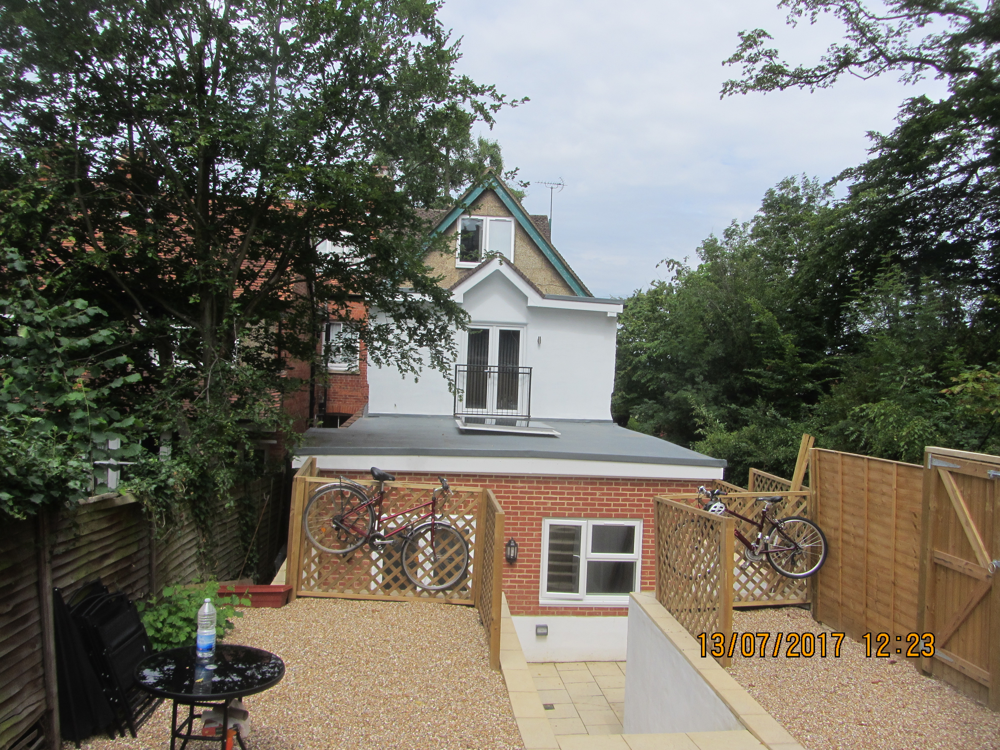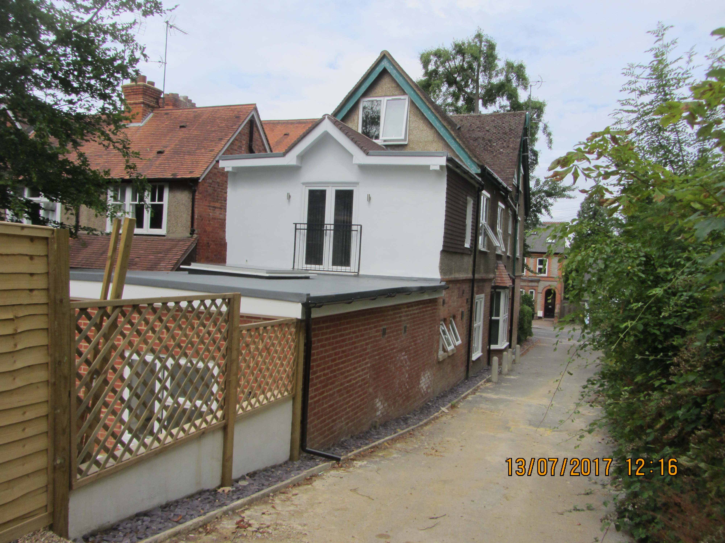

- Reduce the amount of usable amenity space for the property to an unacceptable degree; No, the remaining area is sufficient.

- Require the loss of trees in the garden or put significant trees at risk; No

Respects the character and pattern of neighbouring properties and the street as a whole in terms of scale, location, materials and design, and any important existing building line; Respects neighbour’s amenities and does not present a large blank façade to public areas.

To assess this, the following has been considered – would the proposal:

- Significantly reduce the amount of daylight and sunlight enjoyed by neighbouring properties; No.

- Invade the privacy of neighbouring properties through overlooking from windows or balconies; No – the dormer roof extension does have a side facing window towards no.3 Upper Redlands Road, but this is obscure glazed. There is also a window within the original side elevation, facing no.3, but this is also obscure glazed. A condition is recommended to ensure that these are retained as such. The window within the dormer extension facing east overlooks a wooded area, and is therefore not considered to cause any amenity issue.

There is a rear Juliet balcony with double doors. The original window was relatively large and it is therefore considered that there has not been a significant change in the level of overlooking of the rear garden of no.3. A condition is recommended regarding no use of the roof of the extension for any purpose ancillary to the use of the dwelling house.

- Detract from the character of neighbouring properties through siting, excessive bulk, ill-matching materials or inconsistent design; No – Although a large extension it is flat roofed, and 2.5m in height, which minimises the bulk. The first 3.1m of the extension depth is set off the boundary to no.3. The overall extension is not considered to be overbearing on no.3, especially in light of the large rear garden. The ground has been excavated which means the overall extension is set down within the slope, whilst the garden at no. 3 is sloping up towards the rear.
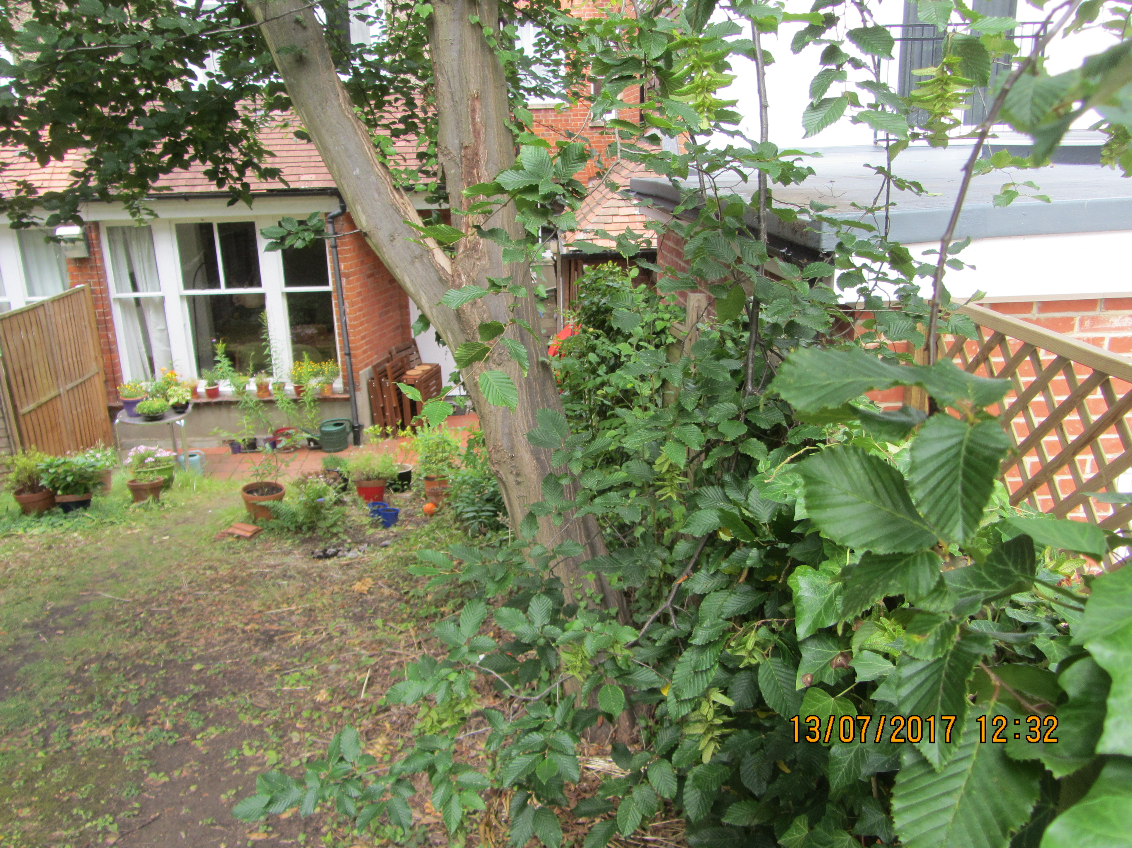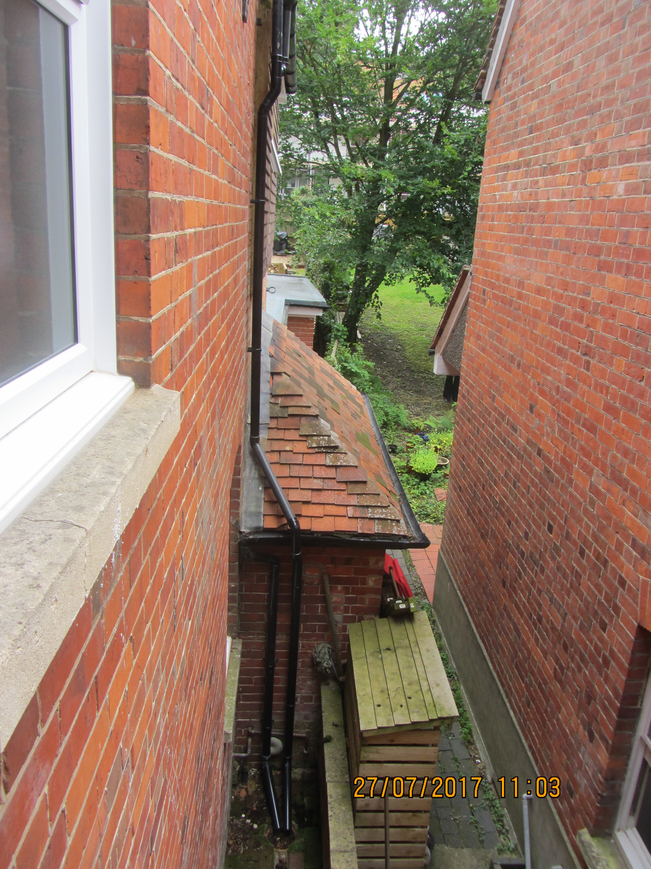

For context it should also be noted that a portion of the existing building (boiler room) encroaches over the boundary with no.3 and the extension is beyond that (see the righthand photo above).

No neighbour issues regarding the extension (apart from drainage matters) were raised through the prior approval process or through the consultation on this scheme.

The extensions are considered to be the limit of what would be acceptable for this property and conditions are recommended to restrict future development.

RECOMMENDATION:

APPROVE

1) The development hereby approved is as shown on the following plans received 15th November 2017:

Location and Block Plan – Drawing no: UR-01R
Plans - Drawing no: UR-01R1
Elevations – Drawing no: UR02R

Reason: because permission is granted in respect of the development as detailed in the approved plans only.

2) The roof area of the extension hereby permitted shall not be used as a balcony, roof garden or similar amenity area without the grant of further specific planning permission from the Local Planning Authority.

Reason: To safeguard the amenities of the adjoining premises from overlooking and loss of privacy in accordance with Policy DM4.

3) Notwithstanding the provisions of Part 1, Schedule 2, Article 3, of the Town and Country Planning (General Permitted Development) (England) Order 2015 (or any order revoking or re-enacting that Order with or without modification), no development within Class A (enlargement, improvement or other alteration), Class B (enlargement of a dwellinghouse consisting of an addition or alteration to its roof), or Class E (building or enclosure, swimming or other pool required for a purpose incidental to the enjoyment of the dwellinghouse) shall be carried out within the curtilage of the dwelling without express planning permission from the Local Planning Authority.

Reason: Due to the constrained nature of the site and as unrestricted development could harm the amenities of neighbouring properties through overlooking or being overbearing and harm the appearance of the main house and the area in general and should therefore be controlled in accordance with Policies CS7 and DM4 and DM9.

4) Notwithstanding the provisions of the Town and Country Planning (General Permitted Development) (England) Order 2015 (or any Order revoking and/or re-enacting that Order) the windows on the western elevation marked as obscure glazed (on approved plan UR02R), shall be permanently maintained thereafter as obscure glazed.

Reason: To safeguard the amenities of the adjoining premises from overlooking and loss of privacy in accordance with Policy DM4 and DM11.

Informatives:
Your attention is drawn to the terms and conditions of this permission. Any development which is carried out but which differs materially from the approved plans and details, or does not comply with any condition(s) or planning obligation(s) attached to the permission may result in the Council taking action to remedy the breach of planning control. If you are in any doubt please contact the Council.

The local planning authority has worked positively and proactively with the applicant to resolve relevant matters to allow permission to be granted within the prescribed target or agreed extended timescale for the decision to be issued.

