DELEGATED APPLICATION REPORT Target Date: 04/09/2017

Application No: 171249/HPA
Address: 260 Henley Road
Proposal: Single storey rear extension
Case officer: Heather Banks

INTRODUCTION

Under Class A(g), Part 1, of Schedule 2 to the Town and Country Planning (General Permitted Development) (England) Order 2015 (“the 2015 Order”) as amended the following is allowed:
A single storey extension, beyond the rear wall of a semi-detached house, between 3m and 6m in depth, and up to 4m in height.
provided the development is not excluded by virtue of the criteria in Paragraph A.1 of the 2015 Order.

Under Paragraph A1 (j.iii) development Permitted Development is excluded where:

the enlarged part of the dwellinghouse would extend beyond a wall forming a side elevation of the original dwellinghouse, and would— have a width greater than half the width of the original dwellinghouse;

The application site is not within a Conservation Area nor have PD rights been withdrawn or restricted by way of a direction made under Article 4 or condition attached to an express planning permission.

PROPOSAL

The proposal falls to be considered under Paragraph A.1 (g) and accordingly Condition A4 applies.

The agent has provided information on the proposed rear extension. The extension would:
- Extend beyond the rear wall of the original dwelling by 6m
- Have a maximum height of 4m
- Have an eaves height of 4m
To facilitate the proposed extension a single storey rear projection, which was original to the property, has been demolished (it was present at the time of the officer site visit for application 170234 on 06/03/17). The proposal would have glazed sliding doors across the whole rear elevation of the extension and a large glazed roof lantern on the roof. To the rear of the extension there will be steps running the full width of the extension to allow access to external ground level.

PLANS SUBMITTED

The agent submitted the following drawing received on 25th July 2017:
Drawing No: 400_P-010 – OS Site Map, Existing Block Plan
Drawing No: 400_P-011 – Existing Floor Plans and Elevations
Drawing No: 400_P-012 – OS Site Map, Proposed Block Plan
Drawing No: 400_P-013 – Proposed floor

PLANNING HISTORY
170234/HOU - Demolition of existing side garage and conservatory to be replaced by two storey side extension, loft conversion and rear dormer extension. Permitted 13/04/2017
171351/HOU – Single storey rear extension. Under consideration

RESPONSE TO PUBLICITY (REPRESENTATIONS RECEIVED)

In accordance with the relevant provision of the GPDO 2015 Order, the LPA notified on 27th July 2017 the adjoining owners and occupiers at 258 and 262 Henley Road and 2B Hawthorne Road providing a period of 21-days for representations to be made. The 21 day consultation period expired on 17th August 2017. No letters of representation have been received.

DISCUSSIONS WITH APPLICANT

The agent was emailed on the 24th August and advised that the proposed extension would not be considered to be permitted development as it does not comply with paragraph A.1 (j.iii) of Part 1, Schedule 2 of the General Permitted Development Order 2015 (as amended). The agent was advised to withdraw the application.

The agent responded to this email stating that they strongly disagreed with the Case Officer’s interpretation of paragraph A.1 (j.iii) and that given the single storey rear projection has been demolished it would not be considered as a side elevation of the original house, past which the proposal would extend. The agent stated that they would appeal a refusal of this application.

The applicant had been previously advised under the application for planning permission 170234 that a rear extension of this depth would be considered to harm the amenity of the neighbouring properties and should be reduced in size. The agent was advised that they could look into submitting a larger home extension prior approval application. The rear extension was removed from the 170234 application and permission was granted for the other works. The agent contacted the Case Officer in June regarding the potential submission of a prior approval application. After further considering the site the Case Officer advised against submitting a Prior Approval application, via email on the 21st June, as the proposal would not comply with paragraph A.1 (j.iii) of Part 1, Schedule 2 of the General Permitted Development Order 2015 (as amended) due to the original single storey projection to the rear of the property. The agent was advised to instead submit a planning application for a rear extension of reduced size.

ASSESSMENT

To facilitate the proposed extension the agent has stated that the single storey rear projection, which was original to the property and present when the Case Officer made a visit to the site on 3rd March 2017 under application 170234, has been demolished. The projection, however, is still visible on the block plan submitted with this application. This element was located to the north eastern rear corner of the original property with a width that only extended across part of the rear elevation of the property. It is considered that this element is original to the property given that it is clearly visible on the 1950 Ordnance Survey map, see below (the application property is marked with a pointer):
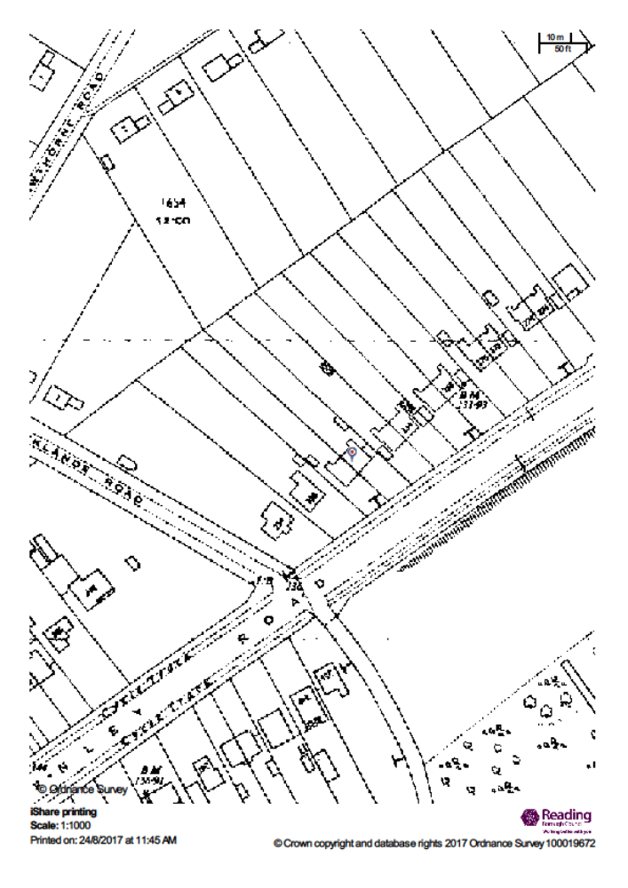
There have been a number of appeal decisions in recent years which consider what constitutes a wall forming the side elevation of the original dwelling house and whether or not the side elevation of a demolished element must also be taken into account here. The following recent appeal decision support the conclusion that the side elevations of an original part width, single storey rear projection should be considered as a side elevation of the original property:
Appeal Ref: APP/L5240/X/16/3143801
68 Hunter Road, Thornton Heath, Greater London CR78QG
Decision Made: 2nd December 2016

Appeal Ref: APP/T0355/X/15/3143755
62 Portlock Road, Maidenhead, Berkshire SL6 6DZ
Decision Made: 6th September 2016

Appeal ref: APP/B9506/X/15/3022061
Wildcroft, Badminston Drove, Fawley, Southampton SO45 1BW
Decision Made: 1st February 2016

In addition, the following recent appeal decisions (some of which are the same as stated above) support the conclusion that where an original side wall has been (entirely) removed it still constitutes “a wall forming the side elevation of the original dwellinghouse”:
Appeal Ref: APP/T0355/X/15/3143755
62 Portlock Road, Maidenhead, Berkshire SL6 6DZ
Decision Made: 6th September 2016

Appeal ref: APP/B9506/X/15/3022061
Wildcroft, Badminston Drove, Fawley, Southampton SO45 1BW
Decision Made: 1st February 2016

Appeal Ref: APP/G5180/X/14/2220683
Brickyard Farm, Jail Lane, Biggin Hill, Westerham, Kent TN16 3AU
Decision Made: 18th June 2015

Appeal Ref: APP/J0405/X/13/2206708
Coppice Cottage, Ringshall, Berkhamstead, HP4 1ND
Decision Made: 1st April 2014

The following conclusions have therefore been reached. Firstly, recent appeal decisions indicate that where an original side wall has been (entirely) removed it still constitutes “a wall forming the side elevation of the original dwellinghouse”. Secondly, recent appeal decisions also indicate that the side elevations of a part width, single storey, rear projection, original to the dwellinghouse, are considered to constitute “a wall forming the side elevation of the original dwellinghouse”. Finally the Town and Country Planning (General Permitted Development) (England) Order 2015 (“the 2015 Order”) as amended states that the term ‘original’ is interpreted as meaning:
(a) in relation to a building, other than a building which is Crown land, existing on 1st July 1948, as existing on that date;
(b) in relation to a building, other than a building which is Crown land, built on or after 1st July 1948, as so built;
(as the property in question is not Crown land points (c) and (d) are not relevant here.)

Given that the application property is shown on the 1950 Ordnance Survey as having the rear projection (see map above) and the property is not shown at all on the 1930 Ordnance Survey Map, it is considered likely that the property was constructed between 1930 and 1950 and the rear projection element would likely have been original to the property or in place by 1948. Also, given that it is proposed to have the extension span the full width of the property, it will extend past the location of the west facing side elevation of the original single storey rear projection and will be greater than half the width of the original house. It is therefore considered that the proposed development does not meet the Permitted Development criteria as stated under Class A.1(j.iii), Part 1, of Schedule 2 to the Town and Country Planning (General Permitted Development) (England) Order 2015 (“the 2015 Order”) as amended. The proposed development will extend beyond the location of a wall which formed a side elevation of the original dwellinghouse, and will have a width greater than half the width of the original dwellinghouse.

Equalities Impact
In determining this application, the Local Planning Authority has had regard to its obligations under the Equality Act 2010. The key equalities protected characteristics include age, disability, gender reassignment, marriage and civil partnership, pregnancy and maternity, race, religion or belief, gender, and sexual orientation.

In terms of the key equalities protected characteristics it is considered there would be no significant adverse impacts as a result of the development.

REASON

As Class A.1(j.iii), Part 1, of Schedule 2 to the Town and Country Planning (General Permitted Development) (England) Order 2015 (“the 2015 Order”) as amended states that development is not permitted by Class A if:

the enlarged part of the dwellinghouse would extend beyond a wall forming a side elevation of the original dwellinghouse, and would— have a width greater than half the width of the original dwellinghouse;

Prior Approval cannot be granted in this instance and is refused because the extension will extend past the side elevation of the original single storey rear projection, which has been removed to facilitate this proposal and was original to the property, and will have a width that is greater than half the width of the original property. The proposed extension therefore does not meet the Permitted Development criteria as stated under Class A.1 (j.iii), Part 1, of Schedule 2 to the Town and Country Planning (General Permitted Development) (England) Order 2015 (“the 2015 Order”) as amended.

Informatives:

- Refused Plans
- It is noted that drawing No: 400_P-010 – OS Site Map, Existing Block Plan shows a rear addition to the dwellinghouse. However, this is not shown on Drawing No: 400_P-011 – Existing Floor Plans and Elevations. The applicant has explained that the single storey rear projection has been demolished. It is confirmed that the single storey rear projection was in place at the time of a separate application at the site earlier in 2017 (Ref 170234, as shown on drawing No: 400_P-002 rev.B – Existing Floor Plans and Elevations), as witnessed during an officer site visit on 06/03/2017.

