Location plan for: 64 Portman Road, Reading, RG30 1EA
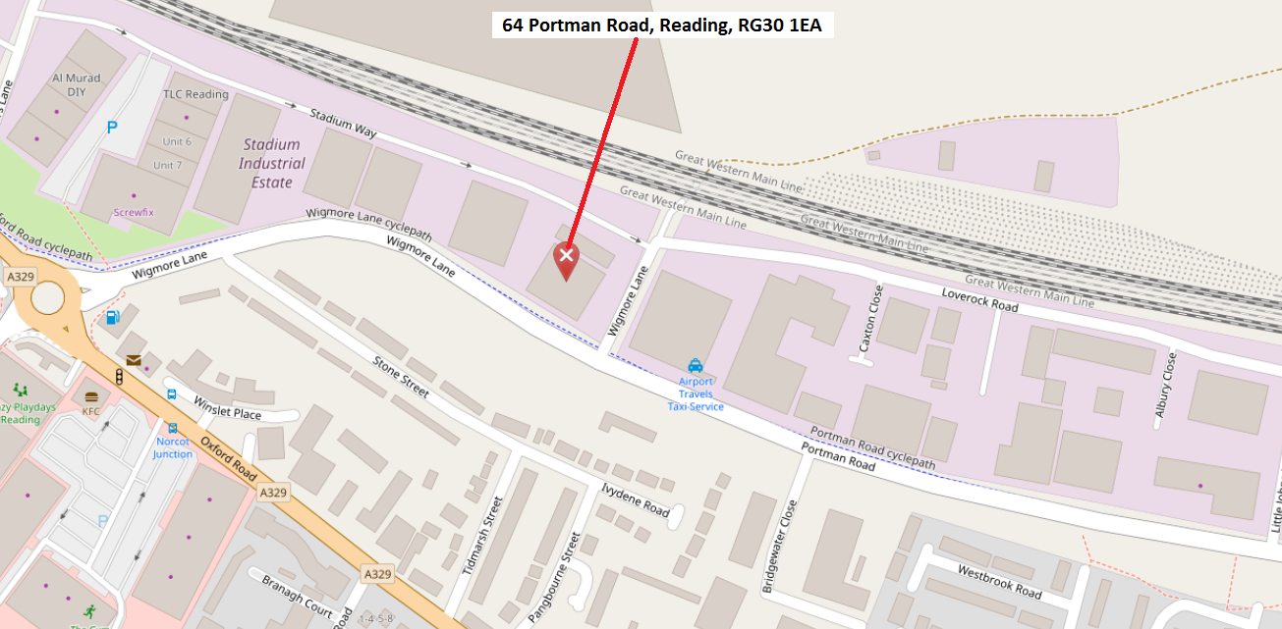

Please also see below alternative view of same property
