Heritage Statement – The Waterhouse, 7-9 Gosbrook Road
1. Introduction
This Heritage Statement supports Planning Application reference PP-06770300 relating to the erection of an internal light weight stud partition wall to form a bedroom space together with an additional doorway in the bathroom at Flat 1, 7-9 Gosbrook Road, Caversham (‘the Site’).
2. History, Character and Significance of the Building
2.1 The Waterhouse (formerly the West Memorial Hall)
Image
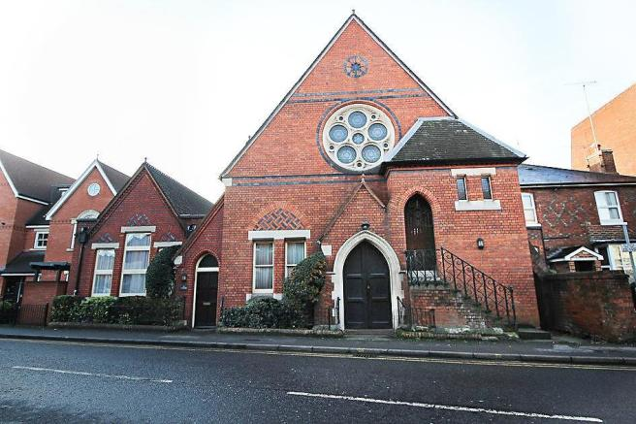
The West memorial hall was listed in 1978 as GII being considered a nationally important building of special interest. It is located to the south side of Gosbrook Road, to the east of the Site and almost opposite Caversham Baptist Free Church. The building is now identified as “The Waterhouse”.
The list entry advises:
“1865-66 by Alfred Waterhouse. Gothic. Red brick former Baptist Free Church, gable end to street. Stone plinth and dressings. Banded tile roof. Blue brick bands in gable above and below rose window. Tumbled brick in chimney to south gable. Blue and red brick herring bone work in tympanum over pair of lancets to left. The main feature is the right hand bay - this has a hipped rectangular stair turret to gallery with external stairs on quadrant wall to base. 4 bay side wall to west with arched passage below buttresses, cogged eaves cornice, paired lancets, except to 1/2 dormer to north. 1911 extension to east with central gable, echoes style of north gable. Interior rearranged. An interesting display of materials.”

The front (north) elevation is in red facing brickwork with some bands of contrasting brickwork, with a projecting, gabled entrance and arched doorway, and small hipped roofed projection to the northwest corner with high level door and external steps. There is a modest stone circular “rose” window within the elevation comprising a small circular centre light encircled by five larger circular lights. This feature was recreated with some modifications within the north elevation of the subsequent Church.
Windows are generally simple timber double hung sashes within brick reveals with stone lintels. A brick relieving arch over the two ground floor windows to the north is infilled with tumbling contrasting brickwork.
The side elevations are supported by brick buttresses designed to “fly” over a ground level access pathway with brick pointed arched heads. As recorded in the list entry the building was extended to the north in 1911 with a rectangular addition having steeply pitched roof, and matching external features.
The building is enclosed to the west by a small two storey residential building and to the east by modern residential dwellings.
GII Listed Buildings with such aesthetic qualities would be sufficient to establish an ordinary level of significance but its connection with Alfred Waterhouse increases its significance.
3. Nature and Extent of the Proposed Development
The works relate to the erection of internal light weight stud partition wall to form a bedroom space together with an additional doorway in the bathroom.
3.1 The Proposed Works
Image
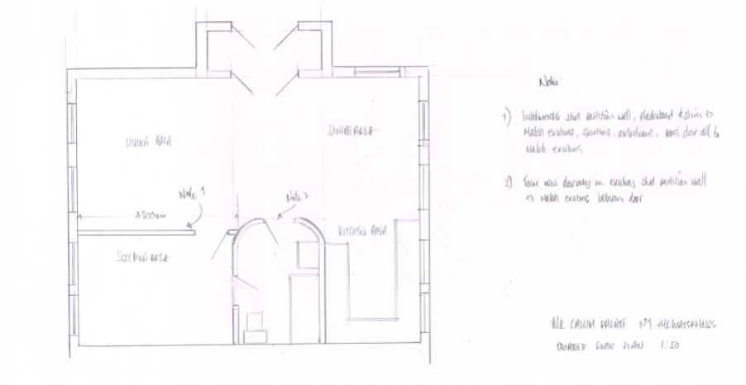
4. Impact on the Heritage Asset
The Applicant recognises the importance of the Heritage Asset and has fully taken this into account in the Design & Access Statement attached to the application to which there is no change to the existing lay-out as well as in consideration of the materials used for the Proposed Works and set out in Section 3.
The Proposed Works (above) relate exclusively to the internal parts of Flat 1 and have no impact on the appearance and architectural significance of the Heritage Asset.
The significant elements of the Waterhouse set out in section 2 will remain entirely unaltered and create no visual intrusion on the setting for the wider public.
5. Justification for the Works
5.1 Privacy
The Proposed Works will maintain the Applicants privacy in the bedroom which is currently visible from the Ground Floor windows of the North Elevation (highlighted yellow). The additional doorway to the bathroom will also allow guests to use the Bathroom without entering the Applicants bedroom.
Image
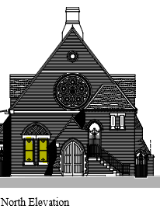
5.2 Noise
The Proposed Works will provide the Applicant with the quiet enjoyment of the bedroom of Flat 1 which is currently exposed to the noise from Gosbrook Road High-Street. There is, within 50m of the Site, a Waitrose Supermarket and the adjoining carpark, a busy roundabout connecting Prospect Street with Gosbrook Road and the Clifton Arms Pub.
Image
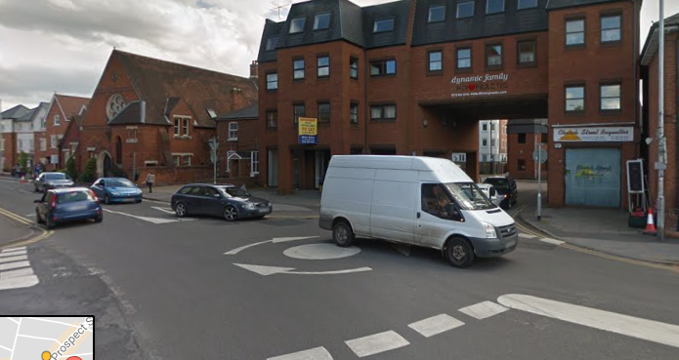
Caversham Roundabout
Image
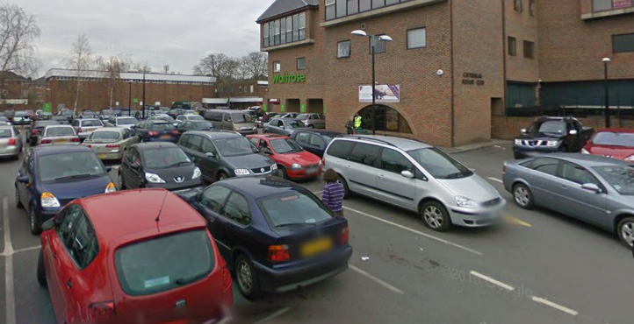
Waitrose Car Park
Image
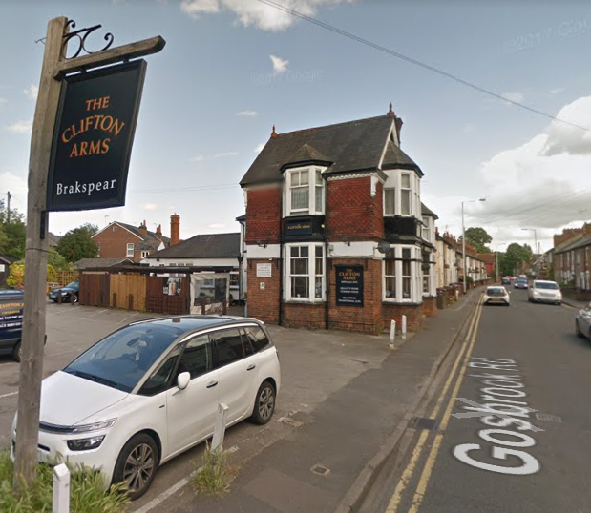The Clifton Arms Pub
5.3 Smell
The current open-plan layout of Flat 1 causes smells to travel from the Kitchen into the Bedroom after cooking reducing the sleep-quality for the Applicant.
Image
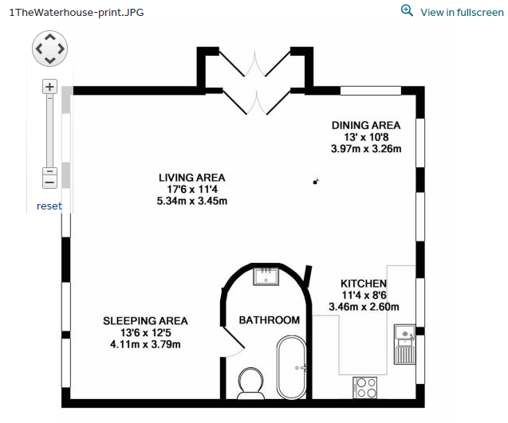
Current Floorplan
6. Conclusion
This Heritage Statement seeks to understand the historic context of the Site and to use this information to influence the design proposals. It explains how the Applicant has understood the significance of the designated heritage assets and their settings, and how this has influenced the designs for the proposed development. Having applied the results of our research to the proposed designs we have considered the impact they may have upon the designated heritage assets.
We therefore consider that the proposals will have no detrimental effect on the designated heritage assets and the designs satisfy the appropriate local and national planning policy for the setting of heritage assets.
Smells from the Kitchen

