

Construction Phase Plan

Mercedes Benz Reading
Client:
Vertu Motors PLC

Site Address:
Richfield Ave, Reading, RG1 7EQ

Principal Designer:
McBains Ltd

Principal Contractor:
PPE Group

Table of contents
1 Description Of Project 3
1.1 Project Description 3
1.2 Key Dates 3
1.3 Existing Structures 3
1.4 Ground Conditions 3
1.5 Existing Traffic Systems 3
1.6 Working Restrictions 3
2 Management Structure 4
3 Management Of The Work 6
3.1 Health & Safety Goals 6
3.2 Monitoring & Reviewing 6
3.3 Liaisons Between Parties On Site 6
3.4 Consultation With The Workforce 6
3.5 The Exchange Of Design Information 7
3.6 Handling Design Changes During The Project 7
3.7 Selection & Control Of Contractors 7
3.8 The Exchange Of Health & Safety Information Between Contractors 7
3.9 Site Security 7
3.10 Site Induction 7
3.11 On-Site Training 8
3.12 Welfare Facilities 8
3.13 The Production & Approval Of Risk Assessments & Written Systems Of Work 8
3.14 The Reporting & Investigation Of Accidents & Incidents Including Near Misses 8
3.15 First Aid 8
3.16 Site Rules 8
3.17 Fire & Emergency Procedure 8
4 Contact Names 10
5 Arrangements For Controlling Significant Safety Risks 12
5.1 Delivery & Removal Of Materials & Equipment 12
5.2 Dealing With Services 12
5.3 Adjacent Land Use 12
5.4 Stability Of Structures Whilst Carrying Out Construction Work, Including Temporary Structures & Existing Unstable Structures 12
5.5 Preventing Falls 12
5.6 Working With Or Near Fragile Materials 12
5.7 Control Of Lifting Operations 12
5.8 Maintenance Of Plant & Equipment 12
5.9 Working On Excavations & Poor Ground Conditions 13
5.10 Work On Or Near Water Where There Is A Risk Of Drowning 13
5.11 Traffic Routes & Segregation Of Vehicles & Pedestrians 13
5.12 Storage Of Materials & Work Equipment 13
5.13 Any Other Significant Safety Risks 13
6 Arrangements For Controlling Significant Health Risks 14
6.1 The Removal Of Asbestos 14
6.2 Dealing With Contaminated Land 14
6.3 Manual Handling 14
6.4 Use Of Hazardous Substances, Particularly Where There Is A Need For Health Monitoring 14
6.5 Reducing Noise & Vibration 14
6.6 Any Other Significant Health Risks 14
7 The Health & Safety File 15
7.1 Layout & Format 15
7.2 Arrangements For The Collection And Gathering Of Information 15
7.3 Storage Of Information 15

Description Of Project

Project Description & Location
The project comprises the construction of a double storey extension to the existing Mercedes-Benz Showroom for Vertu Motors Plc. In addition to the main building there is a Valet & Wash building and an MOT Building.
The work will include concrete foundations and ground floor slab; steel frame; low pitch standing seam aluminium roofs; glass curtain walling; metal external wall cladding; blockwork and metal stud partitions; and fitting out comprising services, joinery, finishes and fittings. External works include incoming services, drainage andhard & soft landscaping.
The proposed extensions and additional buildings are intended to facilitate the growth of the existing trade on site. The functions within the building are: Car showroom, workshop, parts storage, MOT, servicing, Valet and Wash, smart repair, meeting facilities, administration and welfare facilities.
More detail on the concept and approach to the building is detailed in the Design and Access Statement.

Site Address
Mercedes Benz
Richfield Ave,
Reading,
RG1 7EQ

Access to site for contractors is Milford Road only, see red arrow below

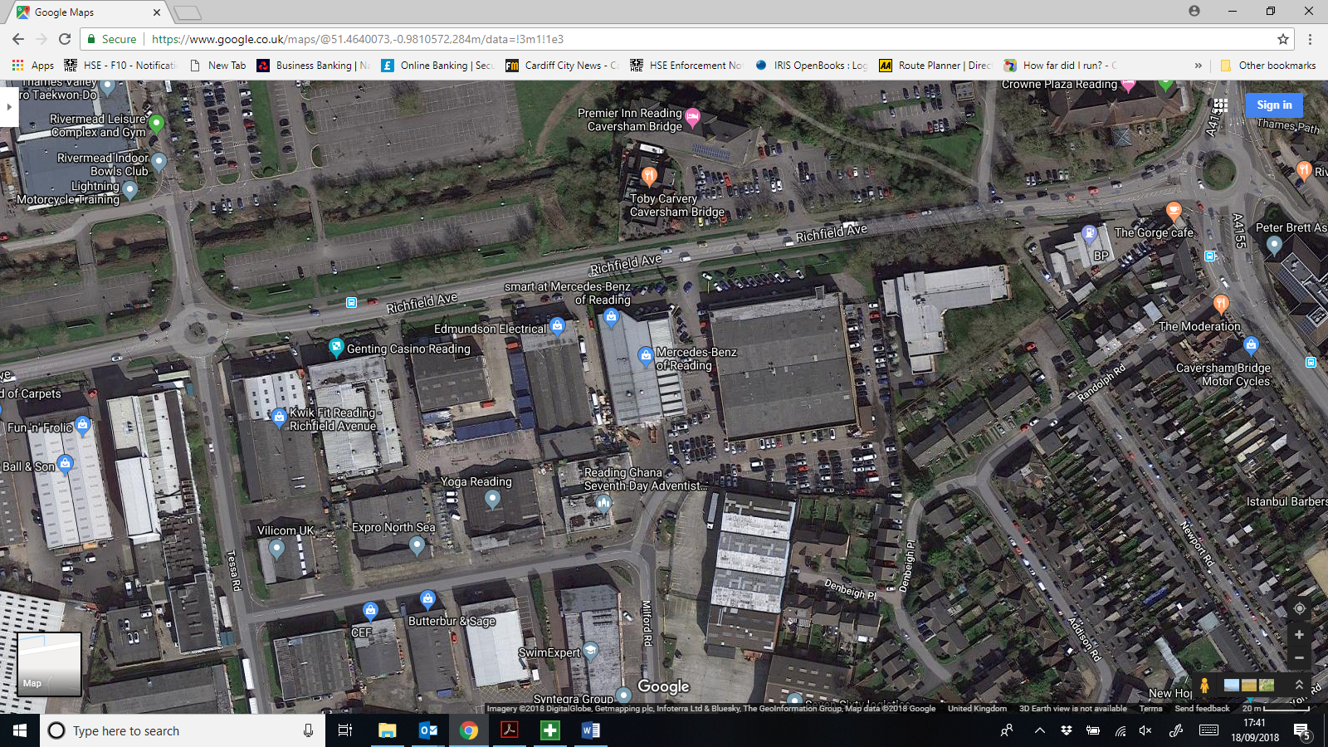

Key Dates
The works are in 3 phases – phase 1 (28 weeks) partial demo and refurbishment of the existing unit + extension & mot building.
Phase 2 (15 Weeks) valet bay area.
Phase 3 remaining externals (6 weeks)
Project programme 49 weeks(53 weeks on site including Christmas shutdown ect)
Start on Site 1st October 2018
Handover 11 October 2019

Existing Structures
The site is an existing Mercedes Benz dealership. An existing redundant building within the main body of the site will be demolished as part of a separate contract by Vertu Motors.
The site is currently a brownfield site that houses both the showroom and workshop building along with external valet
facilities.

Ground Conditions
No Ground investigation reports have been carried out but as part of the tender documents the following will be retained on site.

Topographic & Measured Building Surveys, Author: Kings Surveyors Date: August 2014.
Ref:
95751.0001 Site Survey (Aug 2014)
95751.0002 Ground Floor (Aug 2014)
95751.0003 First Floor (Aug 2014)
95751.0004 Roof Plan (Aug 2014)
95751.0005 Elevations (Aug 2014)
95751.0006 Sections (Aug 2014)

Flood Risk Assessment, Author: RPS Date: 29/11/2017, Ref: CLE30189\05\01 – Rev B (30/11/17)
Drainage Strategy, Author: OSE Consulting Date: 18.01.18, Ref: NP/1871/DS

Existing Traffic Systems
Refer to Folder 6 " Traffic Plan, Emergency Plan" in the Construction H&S Manual
Temporary access to the site for the construction phase to be from the rear site access off of Milford road. This is to avoid conflict between Vertu Motors temporary showroom facility and construction works access.

Working Restrictions
The working restrictions have been identified that the site is to remain as a fully operational business throughout the construction process and as such there is a requirement to phase the works. All details of this can be seen on McBains Architects Drawings MER 01-MCB-SL-SL-DR-A 202, 203 &204 - Site Phasing Plans 1-3 inclusive.
PPE Construction Group will liaise daily with the clients management team
Site may have to operate out of hours as well as during the day times of 0730 - 1800

Management Structure

Managing Director – David Chinijani
The Managing Director has overall responsibility for the health, safety and welfare of employees (via delegation) by:

- Ensuring that health and safety policies and procedures are developed, widely communicated and implemented
- Ensuring that health and safety is monitored and reported on and that policies are reviewed and updated as necessary
- Ensuring site safety and that everyone (employees and contractors) is fully aware of their health and safety responsibilities
- Ensuring that suitably competent and trained persons are appointed and that good working practices are adhered to
- Ensuring training is available for all staff
- Encouraging health and safety communications across the organisation

Contracts Manager – Chris Greenall
The Contracts Manager is responsible to, and shall report to the Managing Director and is responsible for:

- Site safety and shall ensure that everyone is aware of their safety responsibilities, are working to safe systems of work and are competent for the work activities undertaken
- Ensuring that necessary method statements are written for site work, and that the degree of supervision, safe systems of work and competencies are available to ensure that staff maintain a high degree of site health and safety
- Carrying out the necessary preliminary and specific risk and COSHH assessments and ensuring that they are distributed to the project team and all site staff
- Monitoring adherence to the Health & Safety Plan and the Organisation’s Health & Safety Policy
- Ensuring site inductions are carried out in accordance with the Organisation’s standards
- Encouraging health and safety communications throughout the duration of the works between him/herself the, the Site Manager, project team and subcontractors
- Ensuring that good site housekeeping discipline, which shall include correct disposal of all waste material at the end of each working shift
- Ensuring that adequate first aid and fire fighting equipment is available at all times
- Prompt investigation, recording and reporting of accidents, incidents and safety defects
- Ensuring that (or undertaking) the necessary Site Safety Inspections and Audits are conducted and that the findings are acted upon
- Ensuring that any work being carried out does not hinder any other contractors by blocking escape routes, fire equipment, pedestrian routes and traffic routes or jeopardise the health and safety of other contractors in any way
- Liaising with the Health & Safety Executive, Environmental Health Department and other external agencies

Site Manager – Bill Anderson
The Site Manager is responsible to, and shall report to the Contracts Manager and is responsible for:

- Ensuring adherence to Method Statements, the Health & Safety Plan and the Organisation’s Health & Safety Policy
- Implementing the health and safety induction, which all site personnel and visitors must attend. A record of this must be retained
- Ensuring that staff are given site briefings covering detail of fire escape routes, fire drills and assembly points on site
- Encouraging health and safety communications throughout the duration of the works between him/herself the project team and subcontractors
- Ensuring that good site housekeeping discipline, which shall include correct disposal of all waste material at the end of each working shift
- Ensuring that adequate first aid and fire fighting equipment is available at all times
- Recording and reporting of accidents, incidents and safety defects and reporting of these to the Contracts Manager
- Informing the Contracts Manager of specific risk management issues such as COSHH, noise, work equipment, method statements etc.
- Carrying out as necessary Site Safety Inspections and ensuring that the findings are made known to Contracts Manager
- Ensuring that all site plant, tools and equipment are of the appropriate type, adequately maintained and operators are competent
- Ensuring that all plant, tools and equipment and materials is delivered and handled in a safe manner from delivery to installation
- Ensuring, with respective line managers, that any work being carried out does not hinder any other contractors by blocking escape routes, fire equipment, pedestrian routes and traffic routes or jeopardise the health and safety of other contractors in any way
- Encouraging Employees and Contractors to make suggestions to improve health and safety on site

Contractors
The responsibilities on contractor personnel are the same as the Organisation’s employees. The Organisation’s management will seek to ensure compliance to any policy, procedure and standards as outlined during induction.

Employees
All employees (permanent & contract) shall:

- Ensure familiarity and adherence to the Organisation’s Health & Safety Policy
- Observe all safety rules and codes of practice
- Ensure the appropriate safety equipment (PPE) is worn and appropriate safety devices are used where there is risk of injury
- Conform to appropriate instructions from those with responsibility for health and safety
- Report to Contracts Manager/Site Manager any observed accidents and damage to property or equipment irrespective of whether persons are injured, using the appropriate Accident and Incident Form
- Report to Contracts Manager/Site Manager all accidents to themselves whilst at work
- Be encouraged to make suggestions to improve company health and safety on site to the Contracts Manager/Site Manager
- Report all hazards to Contracts Manager/Site Manager
- When on customer/client site/premises, conform to the required signing on/off procedures and safety rules
- When on customer/client site/premises, conform to the required accident or near miss procedures
- Make themselves familiar with the fire and evacuation procedures
- Exercise strict housekeeping discipline and not cause fire or trip hazards by inconsiderate disposal of rubbish
- Assist the Safety and Fire representatives in the carrying out of their duties

Management Of The Work

Health & Safety Goals
The works shall be carried out at all times in accordance with the Company Health and Safety Policy, and amongst others, the following legislation:
- Health and Safety at Work etc. Act 1974
- CDM Regulations 2015
- Management of Health and Safety at Work Regulations 1999
- Provision and use of Work Equipment Regulations 1998
- Manual Handling Operations Regulations 1992
- Workplace (Health, Safety and Welfare) Regulations 1992
- Personnel Protective Equipment at Work [PPE] Regulations 1992
- Health and Safety [Display Screen Equipment] Regulations 1992
- Control of Substances Hazardous to Health (COSHH) Regulations 2002
- Health and Safety [First Aid] Regulations 1981
- R.I.D.D.O.R. 2013
- Electricity at Work Regulations 1989
- Lifting Operation and Lifting Equipment Regulations 1998
- BS 7121 Lifting Operations
- The Control of Noise at Work Regulations 2005
- The Dangerous Substances and Explosive Atmospheres Regulations 2002 (DSEAR)
- Chapter 8 Traffic Signs Manual 1991 (& Traffic Signing Regulations and General Directions)
- Control of Asbestos Regulations 2012
- Deposit of Poisonous Waste Act 1972
- Environmental Protection Act 1991
- Safety Signs and Signals Regulations 1996
- The Health and Safety (Consultation with Employees) Regulations 1996
- Control of Pollution (Amendment) Act 1989
- Controlled Waste (Registration of Carriers and Seizure of Vehicles) Regulations 1991
- Work at Height Regulations 2005

The Client, Vertu, have specified the following HS Goals:-
The project should maintain compliance with CDM Regulations 2015 as a minimum standard for this project. There are no other specific health and safety goals have been set by the Client for this project.
The contractor is required to provide details of his Health and Safety Reporting procedures. As a minimum a full report shall be submitted to each monthly Client Meeting.

Monitoring & Reviewing

The Site Manager or Site Foreman as part of their line management responsibilities will inspect the site on a daily basis. All other site employees will be briefed to show vigilance with regard to general health and safety issues through the Induction Procedures.
Daily liaison will take place with the client's management to discuss both parties requirements
In addition to the above, this site will be visited by the Company Health and Safety Advisor or representatives appointed on their behalf, on a regular basis. Reports of these visits will be left on site for information and action.

Liaisons Between Parties On Site
Any site liaison will be consistent with normal line management and contractual procedures. All parties will be advised of management structure and contact telephone numbers etc. Any queries relating to programme constraints, design problems will be communicated through client Project/Contract team.
Co-ordination of contractors will be achieved through the normal line management process for controlling the contract. Additionally all contractors are to work within the site's build programme and where unexpected site conditions are likely to adversely affect the programme and interfere with various contractors, meetings will be held with the respective contractors to determine a revised programme as appropriate.

As the site will be operational by the clients undertakings then our site manager will liaise with the clients management on a daily basis as described above

Consultation With The Workforce
Any site liaison will be consistent with normal line management and contractual procedures. All parties will be advised of management structure and contact telephone numbers etc. Any queries relating to programme constraints, design problems will be communicated through client Project/Contract team.
Co-ordination of contractors will be achieved through the normal line management process for controlling the contract. Additionally all contractors are to work within the site's build programme and where unexpected site conditions are likely to adversely affect the programme and interfere with various contractors, meetings will be held with the respective contractors to determine a revised programme as appropriate.

The Exchange Of Design Information
It is essential that any design information is provided both in the initial contract documents and any subsequent changes to design of the structure etc. The Organisation will co-operate fully with the Client to ensure such information is properly integrated into the works. Similarly, where the Company is required to carry out design work (this may also include temporary works) then this information will be communicated to the Client for approval as necessary.

Handling Design Changes During The Project
Under the current CDM requirements, it is required that any design change, which ultimately has the potential to impact on the health and safety of those completing works or end users of the completed scheme, should be communicated and managed through the Principal Designer.

Selection & Control Of Contractors
This will be provided through the usual management regime on site viz.: direct communication between contractor representative and Contract Manager. This process will be aided by regular on site progress meetings to ensure works are being carried as per agreed programme and to address any health and safety issues that may arise from time to time.
Representatives from relevant contractors would attend the site progress meetings with attendance by client representative as appropriate.
Additionally all contractor employees are required to attend a site induction before commencement of work when the detailed site rules will be communicated in writing and any significant risk issue will be addressed.

The Exchange Of Health & Safety Information Between Contractors
The exchange of health and safety information between contractors will take place during pre-start meetings, and throughout the duration of the project by the use of on-site meetings, letters and electronic means.
The Construction Phase Manual is established to ensure information is provided, reviewed and communicated and is set up as detailed below.
S1. Construction Phase Plan
S2. Risk Assessments & Method Statements
S3. CoSHH Assessments
S4. Permits & Registers
S5. Management Documents
S6. Traffic Management Plan
S7. Programme
S8. Asbestos
S9. Pre Tender Information
S10. Underground Services
S11. Sub Contractors HS Information
S12. Reports & Surveys
S13. Other information

Site Security
Access to the site is via the existing site access points on Richfield Ave to suit the work sections as noted on drawings by McBain's Architects. All details of this can be seen on McBains Architects Drawings MER 01-MCB-SL-SL-DR-A 202, 203 &204 - Site Phasing Plans 1-3 inclusive.
Clear access/egress to the site and adjacent properties is to be maintained at all times, PPE Construction Group will provide all necessary protection/security measures as required.This will include a protected site compound area along with internally floor to ceiling partitions to allow the client and their staff and their customers to undertake their works. All pedestrian traffic management and segregation will be managed by PPE Construction Group, refer to Folder 6 for the site logistics plan and phasing drawing
Daily discussions will take place between PPE site management team and Veru's management so that deliveries, working practices can be discussed and action plans put in place to suit all parties.

Site Induction
All personnel arriving on site will be required to attend a site induction session before starting work.
The induction (Form HS05:Site Induction) (with signed attendance Form HS06:Site Induction Register) will revolve mainly around the Site Rules (Form HS17:Site Rules), a copy of which will be given to each individual. Records of these inductions will be retained.
There are site rules as set out by the client and these include
All personnel will receive induction training prior to commencing any works on site
• All works are to be carried out in accordance with a task specific risk assessment and method statement that has been approved by the contractor and communicated to the operatives via a toolbox talk
• Prior to any woks commencing the appropriate permit(s) should be in place
• No smoking and no consumption of any drugs or alcohol
• All works to be clearly delineated
• At the end of each shift the work areas are to be left in a safe, clean and tidy condition
• All works will be covered by the document entitled ’12 ESSENTIAL RULES TO MAINTAIN SAFE WORKING’. This document should be provided to all operatives during the site induction. See Folder 9 Pre Construction Information
• All personnel will hold a valid CSCS competence skills card.
• A copy of the Vertu Motors Plc Standard Conditions of Business

On-Site Training
All Company operatives will have received health and safety training commensurate with their site roles and responsibilities.
Where specific skills are required to carry out certain works e.g. electrical work, scaffolding etc evidence will be sought from respective contractor and details recorded in the induction. Where any additional training need becomes apparent within the duration of the contract, then suitable arrangements will be made for that training as soon as reasonably practicable. If that training is critical to the task in hand then a replacement operative will be provided unless respective operative can continue the task with sufficient on site instruction and supervision

Welfare Facilities
All is detailed in Folder 6 Site Logistics Plan.
Suitable and sufficient welfare facilities will be provided to reflect the requirements of Schedule 2 of the CDM Regs 2015. These will include sanitary conveniences, washing facilities, including hot and cold water, drying area, rest room, drinking water and arrangement for the preparation and eating of meals.
This will include a toilet block, office, canteen and storage containers as per the Site Logistics Plan These will be kept clean at all times

The Production & Approval Of Risk Assessments & Written Systems Of Work
Risk assessments and written systems of work will be produced and approved well in advance of the operation being carried out.

The Reporting & Investigation Of Accidents & Incidents Including Near Misses
All accidents and near misses will be entered in the site accident book and fully investigated. Accidents and incidents within the scope of R.I.D.D.O.R. 2013 will be immediately reported to the enforcing authority by the quickest available means.

First Aid
On-site first aid arrangements will be commensurate with the operations being carried out.

Bill Anderson as Site Manager and Chris Greenall as visiting Project Manager will be PPE Group's First aiders and this will be complemented by trained oe Emergency first aiders from our Sub-Contractors

Chris Greenall - Project manager - 07896 504 763
Bill Anderson - Site Manager - 07973 737254

First Aid posters will be displayed around site with photos of all site first aiders.
A first Aid box will be kept in the site office at all times

Site Rules
All site personnel must report to the site office every day and sign in
All site personnel attending site must receive a site induction from Oaktree Developments and provide and adhere to their specific RAMS.
No smoking or eating is permitted on site. A smoking designated area is externally adjacent to the site. Please ensure when you use the facilities that they are kept clean.
The daily hazard board is located in the main site office, please ensure that you make yourself aware of any issues and highlight any issues that require addressing.
Mobile phones must only be used in emergencies or on official Company Business.
All site staff must be in possession of CSCS cards

Fire & Emergency Procedure
Fire Plan to be completed by site manager with consultation with client once on site.
PPE Group will comply with the Joint Code of Practice ‘Fire Prevention on Construction Sites’. In liaison with the Principal Designer and Contract Administrator, PPE Group will prepare a fire and emergency action plan, (identifying fire detection and alarm provisions during the construction phase, fire escape routes, assembly/muster points, fire drill details, fire marshal details and emergency procedures).
Provisions and procedures for raising the alarm, for the emergency evacuation of the site, for communication with occupiers of adjoining and adjacent buildings in the event of an emergency and for the call–out of emergency services will be drawn up in liaison with the Principal Designer and Contract Administrator and will be detailed in the site induction

Assembly/muster points are to be indicated on the site set-up plan

PPE will liaise with Vertu's management to integrate with the integral Emergency procedures

Nearest A&E Hospital Address

Royal Berkshire Hospital
London Rd/Craven Rd
Reading
RG1 5AN

Tel :- 0118 322 5111 or 999

Hospital is approx. 1.5 miles from site

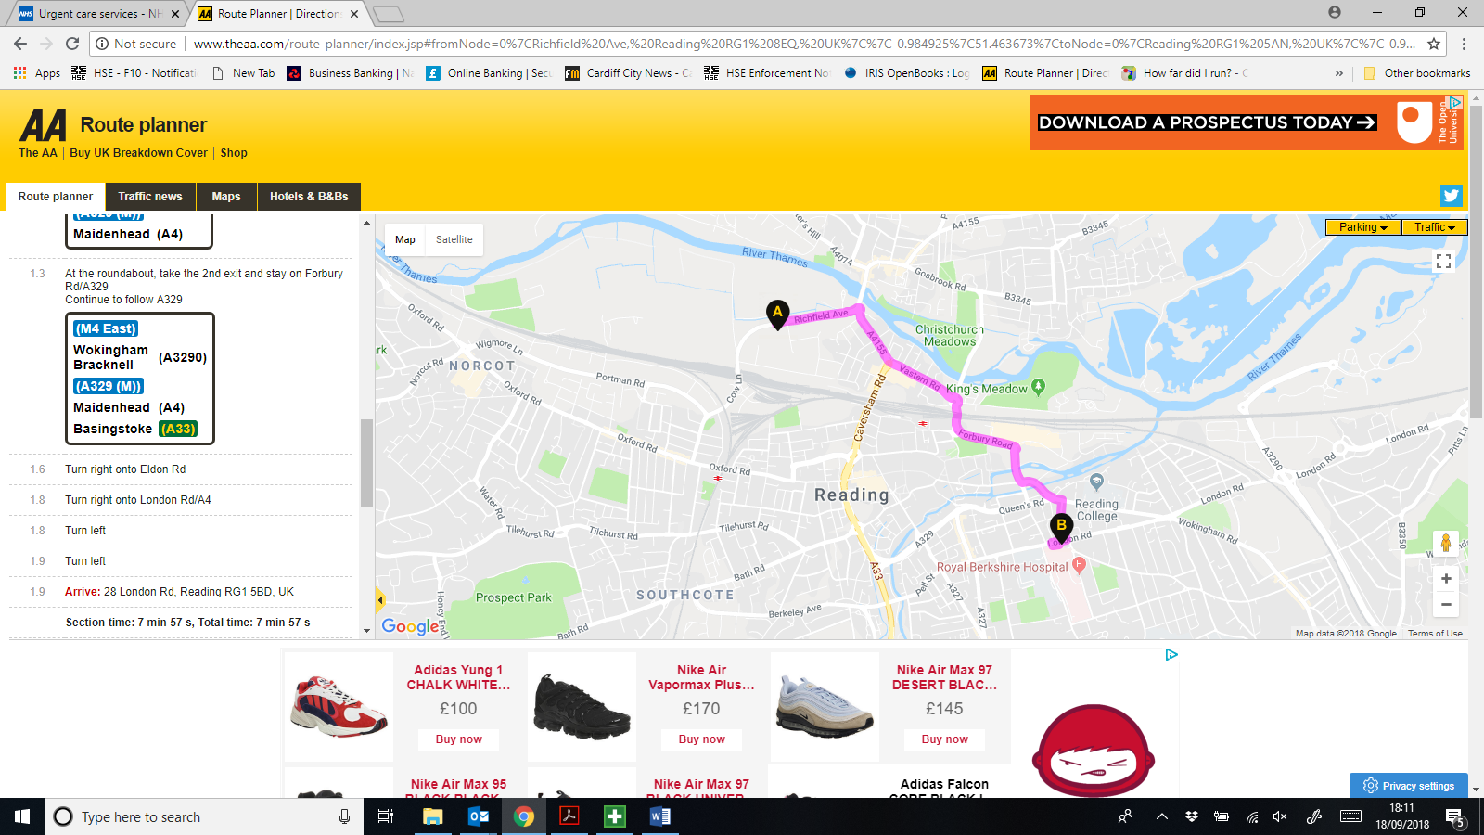

Contact Names
Involvement | Name | Address | Contact
Client (Employer) | Vertu Motors PLC | Vertu House  5th Avenue Business Park  Team Valley  Gateshead  NE11 0XA | Tel: 0191 491 2161  Mob:  Fax:  Email: gbovill@vertumotors.com
Principal Designer | McBains Ltd | 26 Finsbury Sq  London  EC2A 1DS | Tel: 0207 786 7900  Mob:  Fax:  Email: m.baseby@mcbains.co.uk
Principal Contractor | PPE Construction | Crown House  22 Walmersley Rd  Leigh  WN7 1YE | Tel: 01942 261059  Mob:  Fax:  Email: cf@ppeconstruction.com
Local Authority | Reading Borough Council | Civic Centre  Reading  Berkshire  RG1 7AE | Tel: 0118 939 0900  Mob:  Fax:  Email:
HSE Local Office | HSE Hampshire, Berkshire, Isle of Wight, Oxfordshire | Priestley House  Priestley Road  Basingstoke  Hampshire  RG24 9NW | Tel: 0845 345 0055  Mob:  Fax: 01256 404100  Email:
Environment Agency | Environment Agency Thames Regional Office | Kings Meadow House  Kings Meadow Road  Reading  Berkshire  RG1 8DQ | Tel: 08708 506 506  Mob:  Fax:  Email:
Gas | Cadent |  | Tel: 0800 111999  Mob:  Fax:  Email:
Electricity | SSE Power Distribution |  | Tel: 0345 026 2658  Mob:  Fax:  Email:
Water | Thames Water |  | Tel: 0800 980 8800  Mob:  Fax:  Email:
Fire | Royal Berkshire Fire & Rescue | Caversham Rd  Reading  RG1 8AA | Tel: 0118 945 2888 or 999  Mob:  Fax:  Email:
Hospital | Royal Berkshire Hospital | London Rd/Craven Rd  Reading  RG1 5AN | Tel: 0118 322 5111 or 999  Mob:  Fax:  Email:
Police | Thames Valley Police | Castle St  Reading  RG1 7TH | Tel: 999 or 101  Mob:  Fax:  Email:
Designer | McBains Ltd | 26 Finsbury Sq  London  EC2A 1DS | Tel: 0207 786 7900  Mob:  Fax:  Email: m.baseby@mcbains.co.uk
Designer | OSE Consulting Ltd | Quantum House  3-5 College St  Nottingham  NG1 5AQ | Tel: 0115 943 7969  Mob:  Fax:  Email: keith.clamp@oseconsulting.co.uk
Designer | Humphrey M&E Consultants | Prosperous House  Eccleston Close  Backworth  Newcastle-upon-Tyne  NE27 0RX | Tel: 0191 268 1332  Mob:  Fax:  Email: m.simmons@jhumphrey.co.uk

Arrangements For Controlling Significant Safety Risks

Delivery & Removal Of Materials & Equipment
Refer to site Logistics plan in appendix 6

Temporary access to the site for the construction phase to be from the rear site access off of Milford road. This is to avoid conflict between Vertu Motors temporary showroom facility and construction works access.
All waste materials will be removed from site on a daily basis and put into the skips provided in the compoud area.

Materials will be delivered wherever possible to location to be used immediately. Where unable to use immediately, materials will be placed/stored in locations so as not to interfere with works operations. Deliveries will be subject to a “call-off” system wherever practicable and suppliers advised of most appropriate access to the site.

The Contractor shall ensure that all construction vehicles will have an unobstructed safe access/egress to and from the site, together with good all round visibility. The Contractor shall ensure that the site operatives,
site visitors and the general public are adequately protected from being struck by moving plant machinery.
PPE Construction Group will only have the use of designated area of the site for parking, unloading and storage purposes. Delivery and unloading/removal of materials must be strictly confined to this area and NO other parts of the existing site must be used.

Dealing With Services
Refer to folder 10 for existing mains services. No internal services drawings have been provided and PPE Construction Group will employ competent contractors to carry out isolation works and we will work closely with the clients team to prevent any disruptions.
All internal works for services will be dealt with by using a Permit System

PPE will obtain copies of all existing service drawings as none have been provided at tender stage.
No wortks will be carried out until areas have been CAT scanned and the Permit to Dig is in place and all RAMS have been received from the contractor

Adjacent Land Use
Currently the land is a car dealership. An existing building within the site will be demolished prior to the appointment of the
Principal Contractor for this project.

Stability Of Structures Whilst Carrying Out Construction Work, Including Temporary Structures & Existing Unstable Structures
All practicable steps will be taken to ensure that any new or existing structure shall not become unstable due to the carrying out of the construction work. All temporary supports and structures shall be designed and installed so that they can withstand foreseeable loads. See site Specific risk assessment.

Preventing Falls
All work at height will be properly planned, supervised and carried out in a manner which is so far as is reasonably practicable safe. Such work will be risk assessed using the hierarchy of controls detailed in the Work at Height Regulations 2005. See site Specific risk assessments.

Working With Or Near Fragile Materials
All practicable steps will be taken to ensure that any new or existing structure shall not become unstable due to the carrying out of the construction work. All temporary supports and structures shall be designed and installed so that they can withstand foreseeable loads. See site Specific risk assessment.
A temporary works designer will be employed to ensure all demolitions are carried out as per the requirements of the design

Control Of Lifting Operations
All lifting operations will be properly planned and managed using trained and competent operatives and well maintained equipment. See site Specific risk assessment.

Maintenance Of Plant & Equipment
All work equipment will be properly maintained, serviced, regularly inspected with documentary evidence to support.

Working On Excavations & Poor Ground Conditions
All practicable steps will be taken to prevent danger to any person, including where necessary the provision of supports, steps or battering. An inspection will be carried out by a competent person before each shift is commenced. See site Specific risk assessment.

Work On Or Near Water Where There Is A Risk Of Drowning
NA

Traffic Routes & Segregation Of Vehicles & Pedestrians
Refer to site logistics plan in folder 6 as well as the architects phased drawing.
Temporary access to the site for the construction phase to be from the rear site access off of Milford road. This is to avoid conflict between Vertu Motors temporary showroom facility and construction works access.
Access is required to the site at all times for emergency vehicles.
Appropriate systems must be agreed with the Employer prior to any works starting.
PPE Construction Group will ensure that deliveries are well managed and all appropriate licences if required are obtained prior to a start on site.
All vehicular routes shall be clearly marked to avoid narrow gaps, places with limited headroom, overhead cables, etc.
The Contractor shall ensure that all construction vehicles will have an unobstructed safe access/egress to and from the site, together with good all round visibility. The Contractor shall ensure that the site operatives, site visitors and the general public are adequately protected from being struck by moving plant machinery.
The Contractor shall only have the use of designated area of the site for parking, unloading and storage purposes. Delivery and unloading/removal of materials must be strictly confined to this area and NO other parts of the existing site must be used.
Daily liaison will take place by our site manager and the management staff at the dealership to discuss the next days deliveries, changes to routes etc

Storage Of Materials & Work Equipment
Aggregate type materials will be stored on site wherever it is practical to do so without adversely affecting the works operation notwithstanding that the materials will be delivered to a suitable programme of frequency and quantity to avoid stockpiles wherever possible. No materials will be allowed to be stored in emergency lanes (where provided), live carriageway or safety zones. Other materials and products such as street furniture, cabling, appliances, consumables will be stored off site and delivered as required to minimise disruption to site operations.

Any Other Significant Safety Risks
Particular attention is drawn to the potential for visitors and pedestrians using the site during construction. The CMP should
cover hoarding and site signage arrangements.
The potential for plant, delivery and skip vehicle impacts / RTA’s;
Excavations – underground services
Manual handling - numerous heavy, large and/or awkward components involved – risk of musculoskeletal injuries.
Works to roofs: falls from height, dangers from falling objects.
Works to services – contacts with live electrical services; fire.
See also the Hazard Identification and Risk Registers included at
Appendix A of PTP and Folder 9 - Pretender Information

Arrangements For Controlling Significant Health Risks

The Removal Of Asbestos
At tender stage no asbestos surveys have been carried out. Prior to any works commencinn, PPE Group will get a specialist Asbestos Contractor to undertake an R&D asbestos Survey. Results are awaited and once known an action plan will be implemented

Dealing With Contaminated Land
NA
Taken from PTP - "No significant hazards identified. A geo-environmental survey has not taken place, current ground conditions are not known."

Manual Handling
Large / heavy / difficult-to-handle components presenting risks of musculoskeletal injuries – e.g.:- steel structural members; glazingand curtaining wall items; items of plant.
Manual handling will only be undertaken when mechanical handling is not reasonably practicable. A full assessment of the task will be carried out incorporating the whole task, individual, load and the environment in which the lift is to be carried out. Reference will be made to the Manual Handling Assessment Charts. See site Specific risk assessment

Use Of Hazardous Substances, Particularly Where There Is A Need For Health Monitoring
All products of a potentially hazardous nature will be the subject of a full COSHH assessment prior to being taken into use. Such an assessment will also determine the need for health surveillance and monitoring. See product specific COSHH assessments.

Reducing Noise & Vibration
Noise and vibration will be reduced to the lowest practicable level. Where possible the lowest noise and vibration producing plant and equipment will be used. The noise and vibration levels of all equipment will be documented and used to establish optimum exposure levels for operatives. See site Specific risk assessment.

Any Other Significant Health Risks
None identified

The Health & Safety File

Layout & Format
This must be agreed between the client and the principal designer at the start of the project and will include:
- A brief description of the work carried out
- Any hazards that have not been eliminated through the design and construction processes, and how they have been addressed (for example, surveys or other information concerning asbestos, contaminated land, water-bearing strata, buried services and so on)
- Key structural principles (for example, bracing or sources of substantial stored energy including pre- or post-tensioned members) and safe working loads for floors and roofs
- Hazardous materials used (for example, lead paints and special coatings)
- Information regarding the removal or dismantling of installed plant and equipment (for example, any special arrangements for lifting such equipment)
- Health and safety information about equipment provided for cleaning or maintaining the structure
- The nature, location and markings of significant services, including underground cables, gas supply equipment and fire-fighting services
- Information and as-built drawings of the building, its plant and equipment (for example, the means of safe access to and from service voids, and the position of fire doors)
There should be enough detail to allow the likely risks to be identified and addressed by those carrying out the work and be proportionate to those risks.

Arrangements For The Collection And Gathering Of Information
The principal designer will prepare, review amend or add to the file and give it to the client at the end of the project. If his duties terminate prior to the end of the construction phase then the principal contractor will carry out these duties.
Clients, designers and contractors will supply the information necessary for compilation and updating the file.
Everyone providing information will ensure it is accurate and provided promptly.

Storage Of Information
The information will be stored in a dedicated file, and in such a way as to be easily retrievable and understandable

