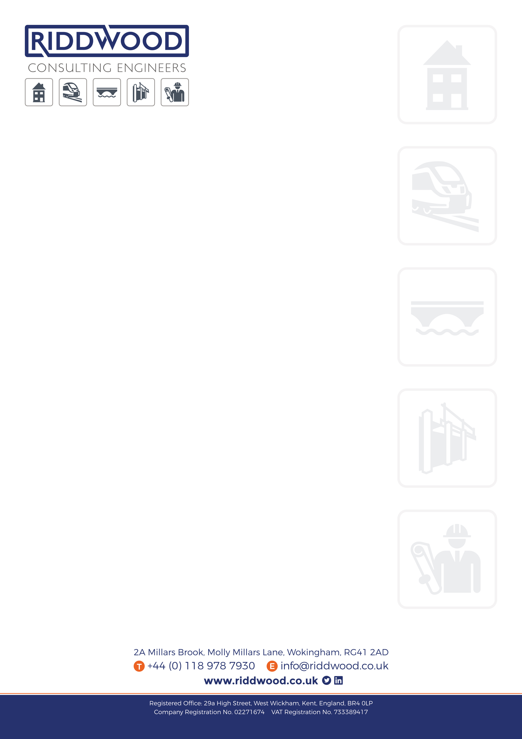
Thursday, January 18, 2018

Mr. Saqib Bhatti,
Platinum SA,
The Red Cow Pub,
50 Crown Street,
Reading RG1 2SE

By Email; platinumsa@hotmail.com

RE: RL17562 – The Red Cow Pub, 50 Crown Street, Reading

Dear Saqib,

As per your recent request, I confirm the following in connection with the above:-

- The existing first floor of the building is clearly inadequate as it is to support the loads which will result from the proposed alterations without modification. We do not consider it safe for any use at all in its present state. We therefore recommend the addition of new floor joists as shown on our drawing RL17562/02 P1.
- The roof of the existing “Barn” requires additional support in order to reduce the possibility of further wall-spread and deflection of the ridge. We have therefore indicated a steel ridge beam on drawing RL17562/02 P1.

We have explored alternatives and consider the current proposals offer the most effective and economical way of putting the building back into use.

We trust the foregoing is satisfactory for your current requirements, but please feel free to call in the event of further queries.

Yours Sincerely,

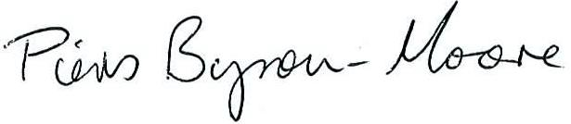

Piers Byron-Moore | Principal Engineer
for and on behalf of Riddwood Consulting Engineers

