Dear Sir/Madame
We attach our Application submission for Listed Building Consent with regard to proposed minor Works to the Basement of 65 Baker Street.

Background

We are the owners of 65, Baker Street, Reading, RG1 7XY. Our property is listed Grade II, No 1113394 and for the text SU 7073 12/13.
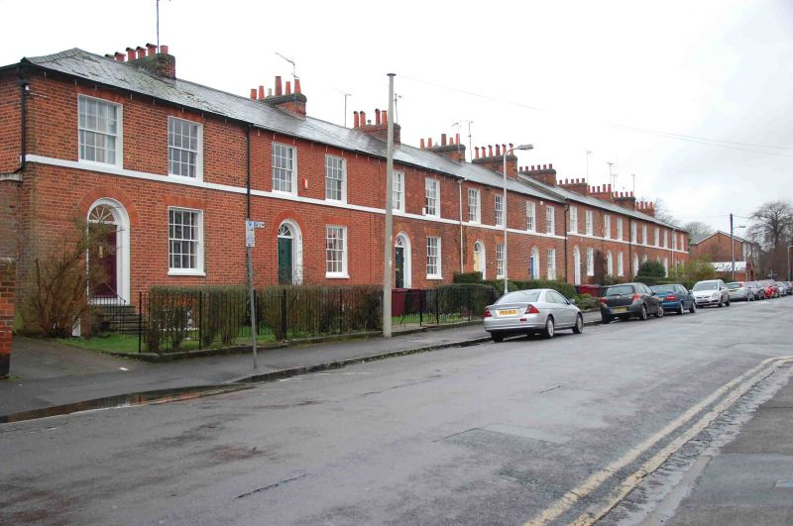
Photo of the terrace from no 61.
Credit British Listed Buildings http://www.britishlistedbuildings.co.uk/101113394-61-79-baker-street-abbey-ward/photos#.WY30CIWcGUl

The details of the listing are: “Before 1840. A formal terrace of small red brick houses set back from road. 2 storeys and basement. Stucco string under 1st floor windows. Slate roof, hipped at each end, brick ridge chimneys. 2 windows each on 1st floor, 1 on ground floor, glazing bar sashes. 4 panel door with radiating fanlight on ground floor. 1 window and door to basement.”

Proposal and the reason for the Application Submission
In the basement we propose to:
- widen the existing doorway between the kitchen and the dining room to provide more light. It will also provide easier access for one of our parents who sometimes needs to use a wheel chair. It will mimic the double door opening directly above on the first floor.
- close off the doorway between the kitchen and the hallway as this is both redundant and reduces the best use of space in the kitchen.
- Remove the plaster board cover over the fireplace in the kitchen.

We do not plan to change any of the current room configuration.

Detailed Proposal

In the basement we propose to:
- widen the existing doorway between the kitchen and the dining room (doorway A on the Floor Plan),:

  - It will mimic the double door opening directly above on the first floor.
  - The opening will increase from the current 74cm to 270cm.
  - We will need to remove 196cm of the current wall, we believe this is currently made up from a square timber frame with a brick infill, finished with plaster. The section of wall to be removed does not contain any features such as coving on either the kitchen or dining room side, see the attached photograph of the dining room face.
  - Following consultation and a site visit on 05/10/2017 from planning officer, Heather Banks of Reading Borough Council, we will ensure that, as specified, the new opening has an architrave, the profile of which will match the architrave of the existing opening, reusing as much of the existing architrave as possible.
  - Recognising this is a supporting wall (to others above it) after consultation with our builder we plan to support the wider door opening by installing timber joists attached to the current timber joists using joist hangers.
  - Our neighbour a 67 Baker Street RG17XY, Caroline Hewson, was granted listed building consent in 1990 to undertake a number of works to her property, including widening the same doorway. The photograph of the doorway at 67 is shown below and also on the Proposed Plan.

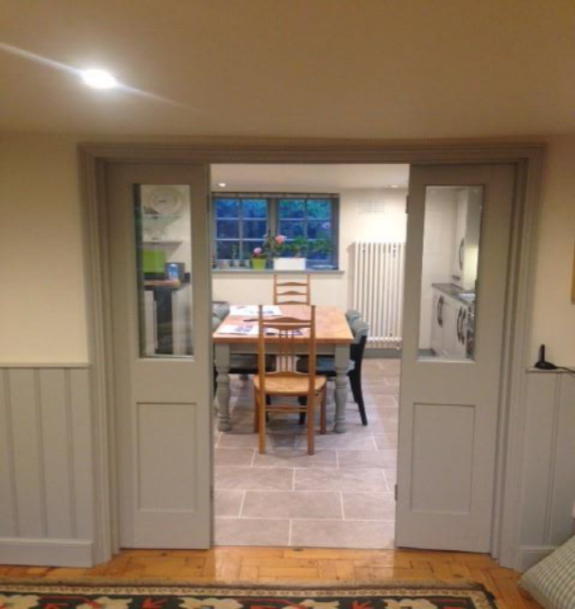
  - A door frame and doors was inserted at No 67 Baker Street, consequentially additional joists were not installed as it was judged the support of the door frame was adequate, as has proved to be the case.
  - However as we plan to have a door opening, rather than double doors, we propose to include additional supportive timber joists and timber posts.

- close off the doorway between the kitchen and the hallway ( doorway B on the Floor Plan) as this is both redundant and reduces the best use of space in the kitchen.
  - This will be achieved by creating a timber frame and plasterboard as directed by the Heritage Officer officer during Heather Bank’s site visit in October 2017.

- In the kitchen remove the plaster board cover over the original fire place. This was inserted by the Developer of the property, it appears to be exacerbating a damp problem. We wish to open up this area to increase the air movement to this areas as part of our renovation of the kitchen.
An application will be made to RBC Building Control and we will take on board any advice they provide.

The full schedule of works is attached as appendix A.

Justification for the Work
Our rationale for doing this is for a number of reasons.

- By widening the existing doorway between the 2 rooms it provides more light through the entire basement floor which is naturally dark because it is a lower ground floor. The doorway from the hall to the kitchen does not aid this purpose.
- Currently (if you include the pantry) the kitchen has 3 doors leading on to it, which isn’t the best use of the space because of the required space behind each door for the opening.
- We have large amounts of time where my mother stays at the house she has mobility issues and often uses a wheel chair, by widening the doorway we can ensure she can easily travel between each room in her wheelchair.

Timing

- Subject to approvals we wish to undertake the work in July 2018.
- The proposal is to be timed with upgrading the kitchen. The house was previously owned by a developer, who installed a basic kitchen, which isn't in keeping with the attractive nature of the property.

Summary

We hope that it is clear that we intend to carry out this work sympathetically to the style of the property and the historic fabric of the building. We will ensure that the work will enhance the property, whilst retaining the existing floor plan and compartmentalisation as it currently is.

Please see the attached plans for our application.

Yours sincerely

Thomas and Catherine Walter
65 Baker Street
Reading

Thomaswalter10@gmail.com, 07825 650378
Cathy_Westcott@hotmail.com, 07900 606260

