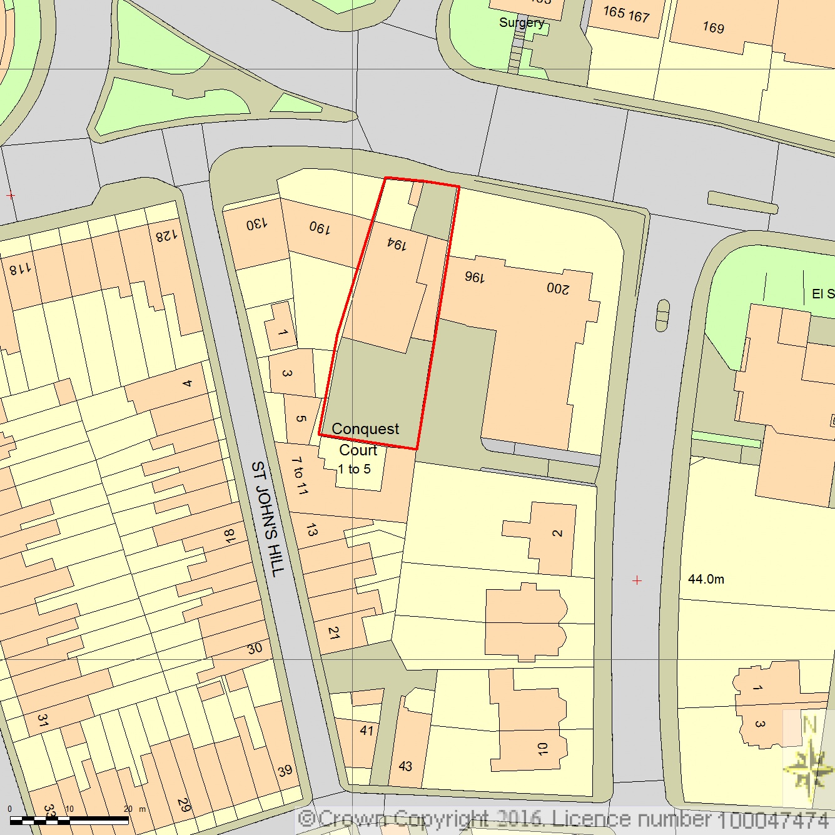SITE LOCATION PLAN
194 Kings Road, Reading
AREA 2 HA
SCALE 1:1250 on A4
CENTRE COORDINATES: 472411, 173241



Supplied by Streetwise Maps Ltd
www.streetwise.net
Licence No: 100047474
24/08/2016 17:56

