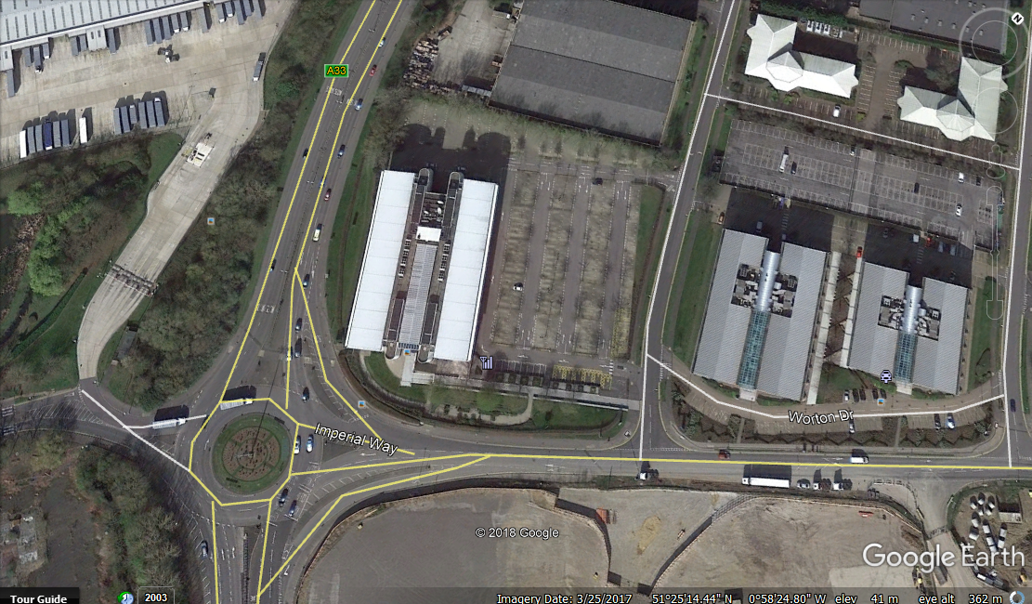
Imperium Building, RG2 OTG
G2
1x dead tree.
1x small dead tree.
G1- 7x dead Alder (Pictures are available to send if required.)

