COMMITTEE REPORT

BY THE DIRECTOR OF ENVIRONMENT AND NEIGHBOURHOOD SERVICES
READING BOROUGH COUNCIL ITEM NO.
PLANNING APPLICATIONS COMMITTEE: 6th September 2017

Ward: Out of Borough
App No.: 171202 (West Berkshire Council ref 17/0180/RESMAJ)
Address: Land opposite", Hall Place Farm Stables, Sulham Hill, Tilehurst, Reading
Proposal: Approval of reserved matters following outline permission 16/01034/OUTMAJ. Matters seeking consent: Access, Appearance, Landscaping, Layout and Scale.
Applicant: Darcliffe Homes Ltd
Date received: 5th July 2017 (by West Berkshire Council)
Major Application: West Berkshire 13 week target decision date: 4th October 2017

RECOMMENDATION:
That West Berkshire Council be informed that Reading Borough Council raise NO OBJECTION to the proposal.

That West Berkshire Council is sent a copy of this report for their information and use.

- INTRODUCTION

1.1 Reading Borough Council (RBC) has been consulted on the proposal by West Berkshire Council (WBC). The application site is wholly within West Berkshire; however the site is very close to the boundary with Reading with a traffic route into Reading, Chapel Hill, adjoining the southern boundary of the site.

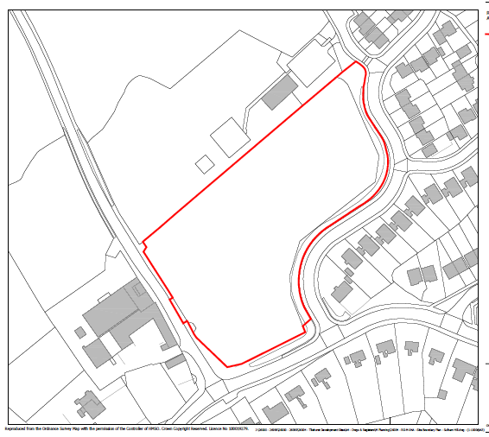
Location Map (not to scale).

- RELEVANT PLANNING HISTORY

2.1 160796ADJ - Outline application for residential development for up to 39 new dwellings with reserved matters. Permitted December 2016

2.2 Reading Borough Council did not object to the site being allocated for residential development in terms of the emerging West Berkshire Housing Site Allocations Development Plan Document.

- CONSULTATIONS

3.1 West Berkshire Council has carried out their consultations. RBC’s consultation responses are outlined below:

3.2 RBC Development Control (Transport) - The site is located approximately 70m west of the Reading boundary and will be accessed directly from Sulham Hill which is within West Berkshire’s administrative area. Given that the internal layout of the site is located solely within West Berkshire, the transport development control engineers at Newbury will assess its design and the car parking arrangements but in principle the layout appears acceptable.

Therefore, there are no transport objections to the reserved matters application.

3.3 RBC Natural Environment - No objections to the landscaping proposed. It is assumed West Berkshire will secure details of landscape maintenance and ensure implementation via conditions.

- RELEVANT PLANNING POLICY AND GUIDANCE

4.1 National Planning Policy Framework (March 2012)

- APPRAISAL
- The main considerations are:
- Legal context
- Transport considerations
- Landscaping
- Visual Impact

Legal Context

5.1 Section 38(6) of the Planning and Compulsory Purchase Act 2004 requires that considerations indicate otherwise.
Whilst it does not fall to RBC to determine this planning application, the Council may make comments as a consultee.

Transport Considerations
5.2 As set out in the RBC Transport consultation response above, the proposed development will be accessed directly from Sulham Hill which is within West Berkshire’s administrative area. The proposed layout is acceptable in principle and given that the internal layout of the site is located solely within West Berkshire, the transport development control engineers at West Berkshire will assess its design and the car parking arrangements.

5.3 To improve pedestrian access, a new 2m wide section of foot-way will be provided from the proposed site access along Sulham Hill, connecting with the existing foot- way on Chapel Hill. This is to ensure a continuous pedestrian link to the existing east-bound bus stop on Chapel Hill.

Landscaping Considerations
5.4 The Council’s Natural Environment Officer has assessed the submitted landscaping details and concluded that the proposals would not have an adverse effect onto Reading Borough. Subject to conditions by West Berkshire to secure details of landscape maintenance and ensure implementation, Reading Borough raises no objection to the development’s landscaping proposals.

Visual impact
5.5 The site adjoins residential development within the borough and continuation of residential development in this locality comprising two-storey dwellings of similar size and scale to the dwellings within Reading Borough is not considered to have an adverse effect onto the visual amenities of Reading Borough.

- CONCLUSION

6.1 It is recommended that:

- West Berkshire be informed that Reading Borough Council raise no objection to the proposed amendments.

- West Berkshire is sent a copy of this report and all comments received for their information and use.

- Case Officer: Ralph Chakadya

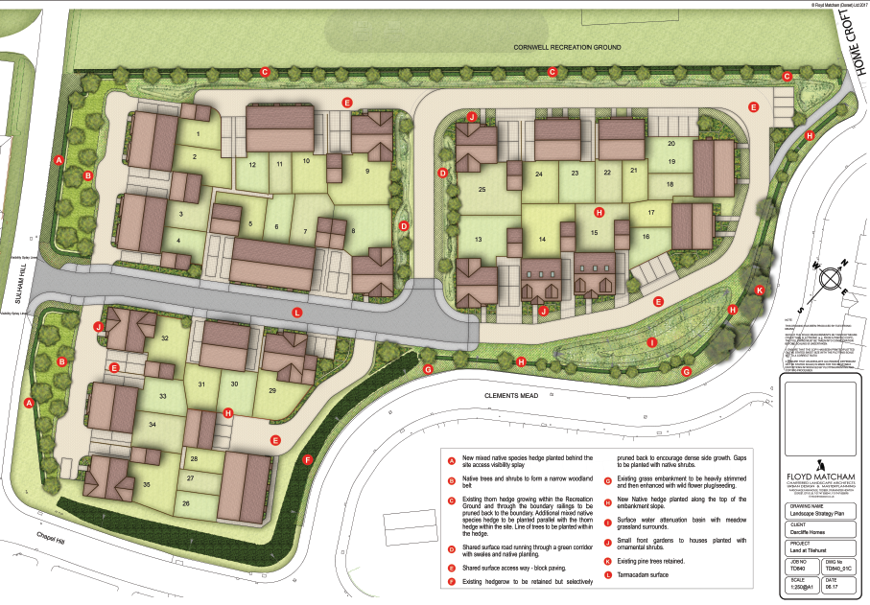

Layout Proposals Plan (not to scale)

