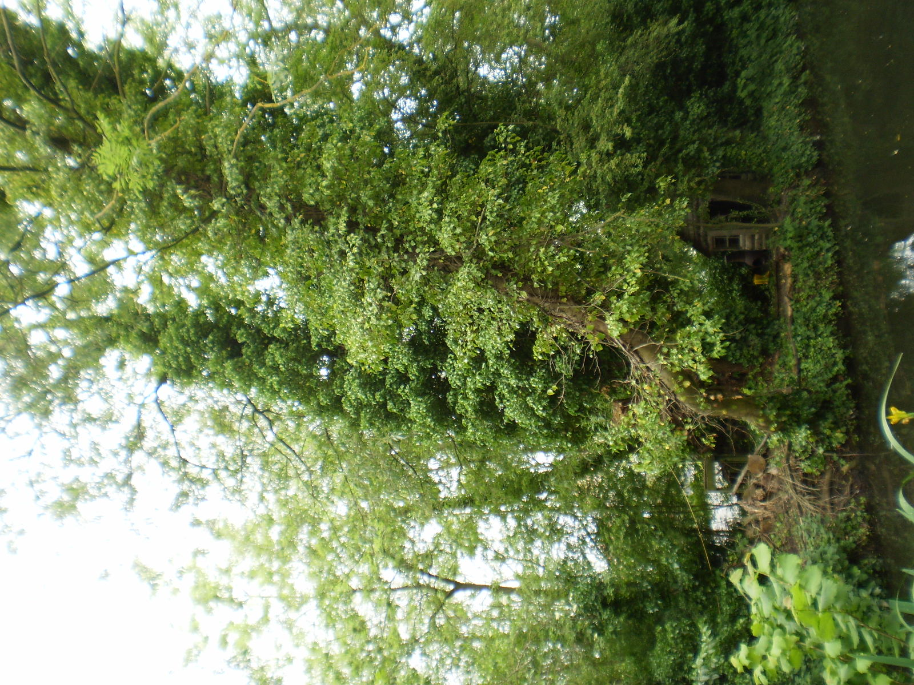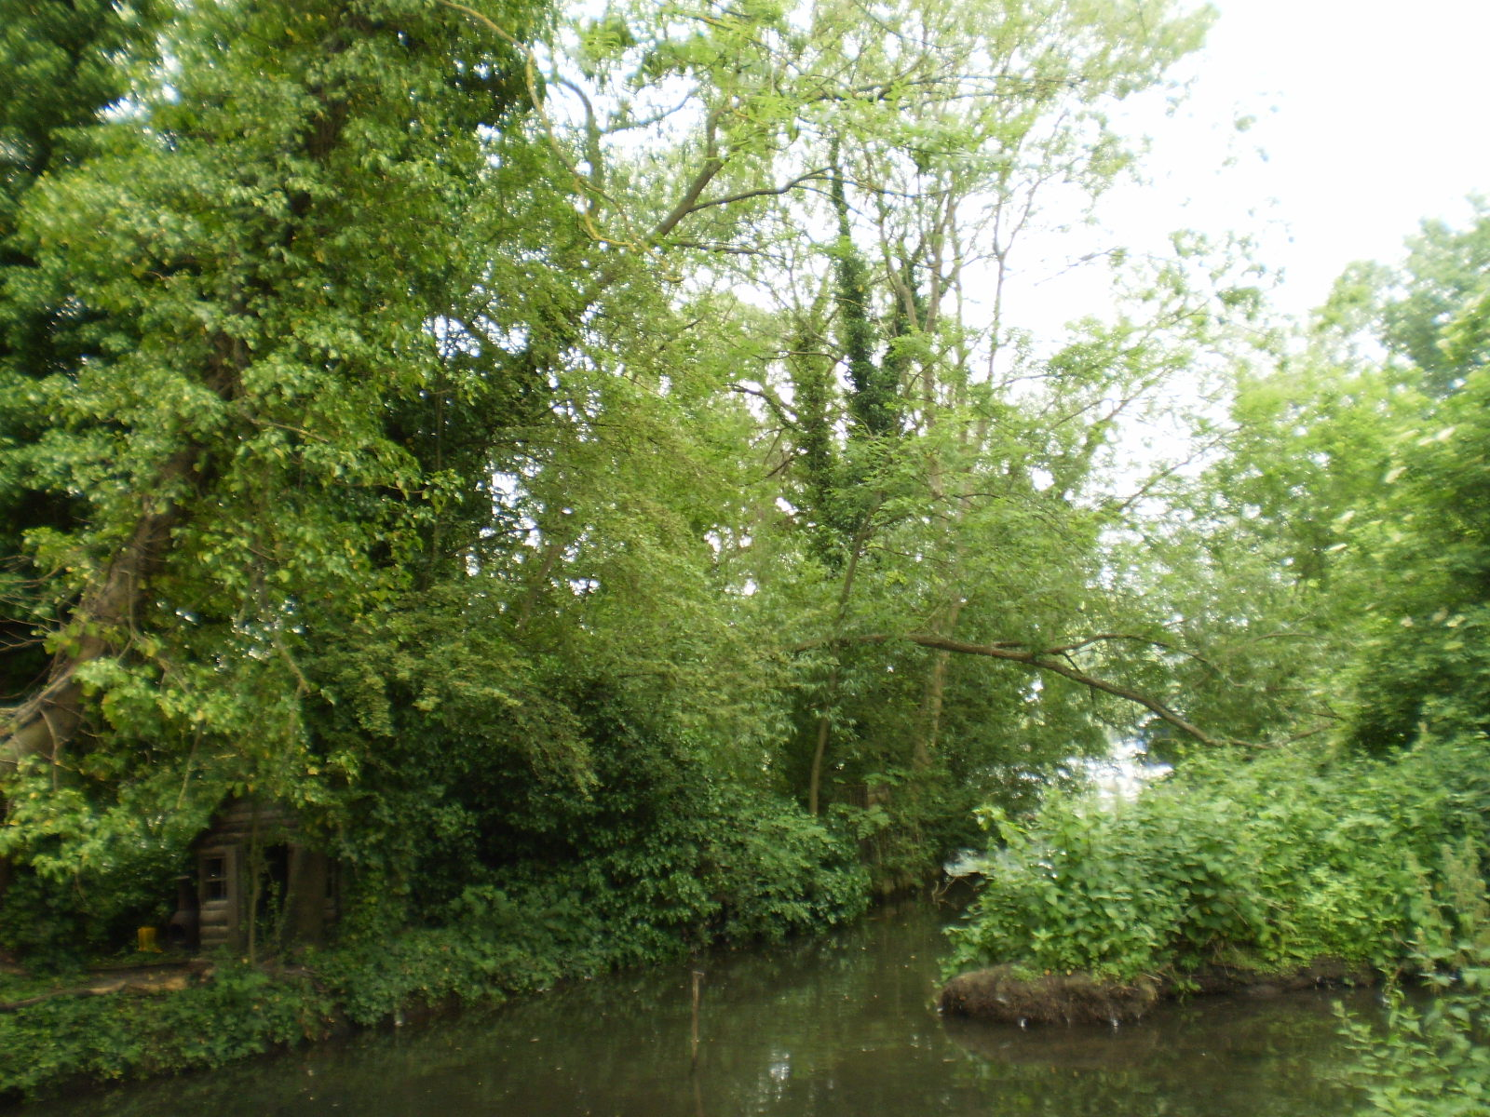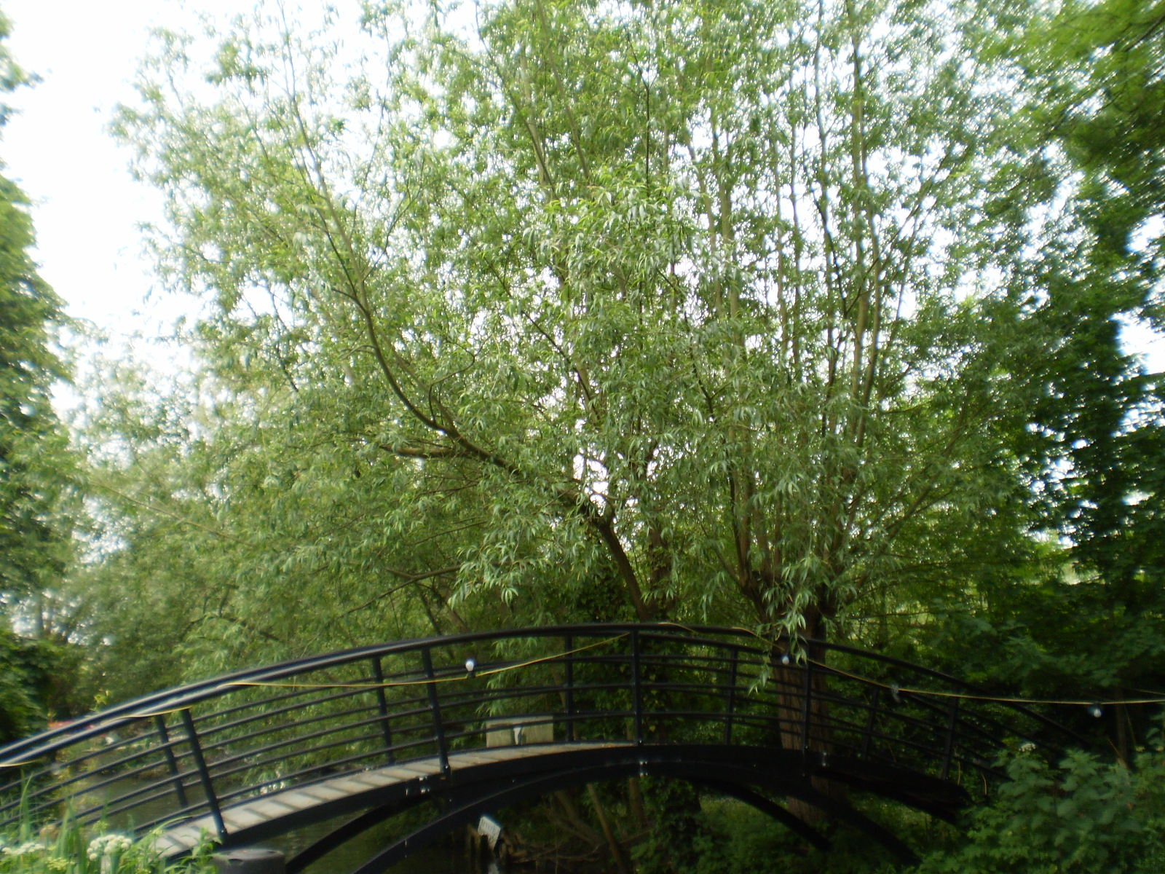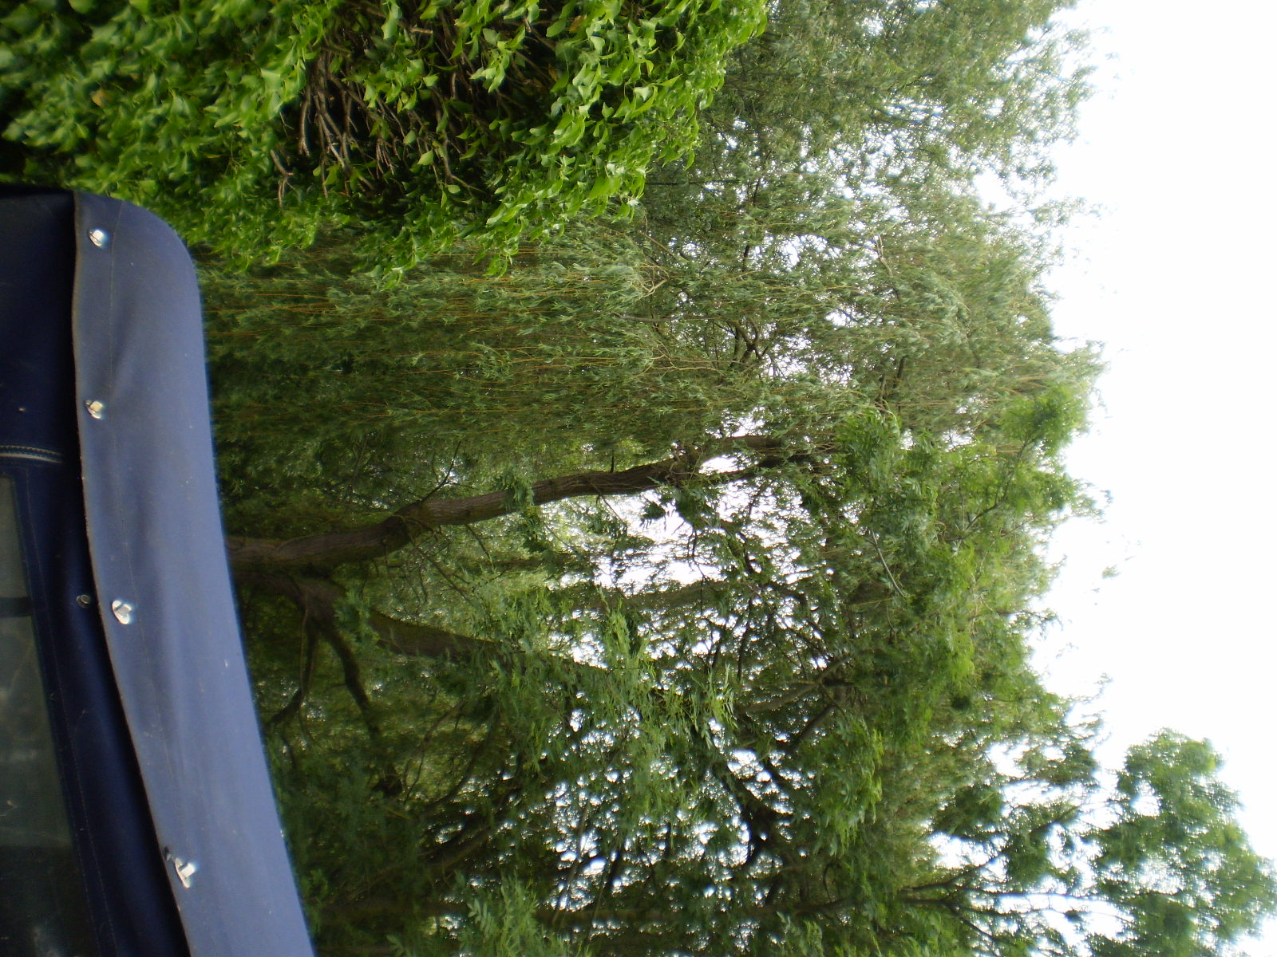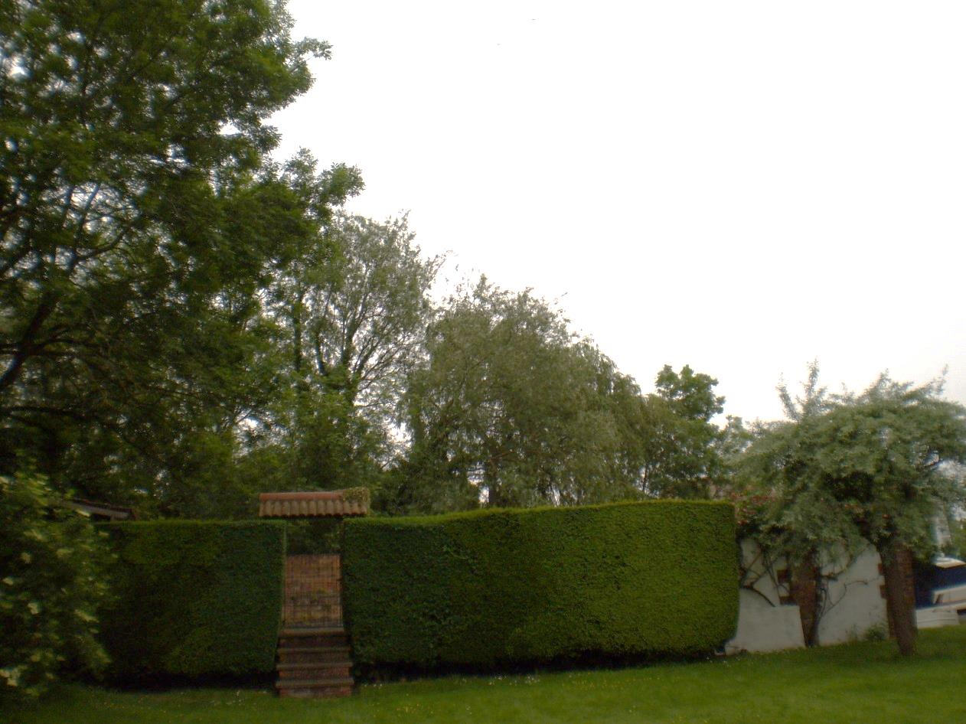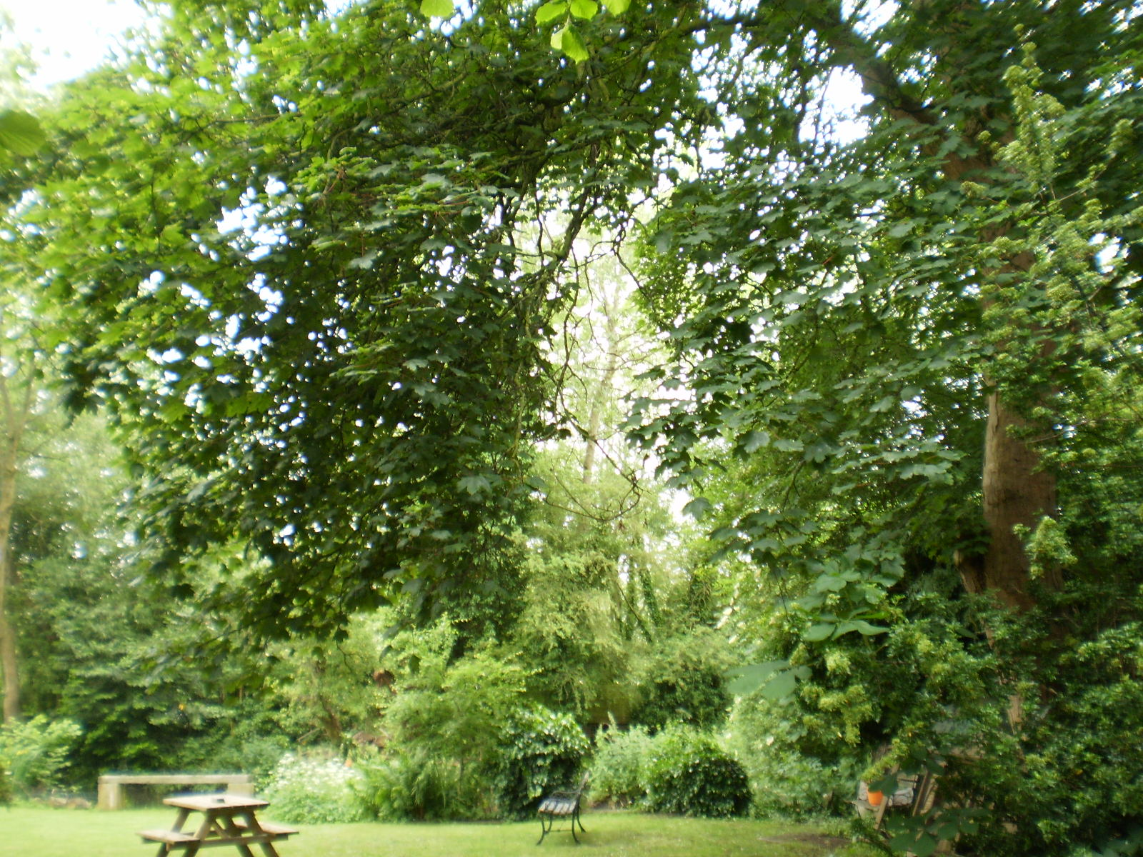
Ash - coppice
Willow branch to be removed
Willow x 2 – re-pollard
Willow on Buckside Cottage island (T1 of TPO 212/07) – create high pollard
Willow on larger island – remove leaning stem
Sycamore (T2 of TPO 16/04) – crown lift to 4m
Trees at 14-16 Church Road & Buckside Cottage
31/5/18

