DELEGATED APPLICATION REPORT
SITE ADDRESS: 3 station rd
APPLICATION NUMBER: 171138/ful
PROPOSAL: Install a door and glazing to enclose a current undercroft area.

RELEVANT POLICIES AND SUPPLEMENTARY PLANNING GUIDANCE
Legal and Planning Policy Context
Section 38(6) of the Planning and Compulsory Purchase Act 2004 requires that proposals be determined in accordance with the development plan unless material considerations indicate otherwise. Material considerations include relevant policies in the National Planning Policy framework (NPPF) - among them the 'presumption in favour of sustainable development'. However the NPPF does not change the statutory status of the development plan as the starting point for decision making (NPPF paragraph 12). In this regard, the NPPF states that due weight should be given to the adopted policies of the Local Development Framework (LDF) (Core Strategy and Sites and Detailed Policies Document) according to their degree of consistency with the NPPF (the closer the policies in the plan to the policies in the NPPF, the greater the weight that may be given). The Council's adopted Supplementary Planning Guidance and Supplementary Planning Documents are also material planning considerations.

Accordingly, the National Planning Policy Framework and the following development plan policies and supplementary planning guidance are relevant:

National Planning Policy Framework (NPPF)
Nothing relevant at this scale of development.

Reading Borough LDF: Core Strategy (2008)
CS7

RCAAP
RC1 area, RC5, RC10, RC14

Reading Borough LDF: Sites and Detailed Policies Document (2012)
SD1 (Presumption in Favour of Sustainable Development)
DM4 (Safeguarding Amenity)

SPD/SPG
Is within the Station Hill South Planning and Urban Design Brief (2007) area

CONSULTATION RESPONSES
CPDA: no response
No neighbours consulted, site notice erected. No representations.

PLANNING HISTORY
020090 Change of use of first, second and third floors from A2/A1 to form six
1 bedroom flats, rear extensions to second and third floors. PERMISSION 11/10/02 and implemented.
030802 Proposed enclosed entrance to serve flats. PERMISSION 15/1/2004. Not implemented. Similar proposal, but was for only half the area.
170815/PREAPP: Pre-application advice for installation of outer door at street level obs given 23/6/17

SUMMARY OF DISCUSSIONS WITH APPLICANT/AGENT (pro-active approach to the application) None required.

APPRAISAL

The application site is a small undercroft area to an upper floors residential block on Station Road. Area is approx. 5 sq.m. and used for storage of waste and appears to also be used for rough sleeping.

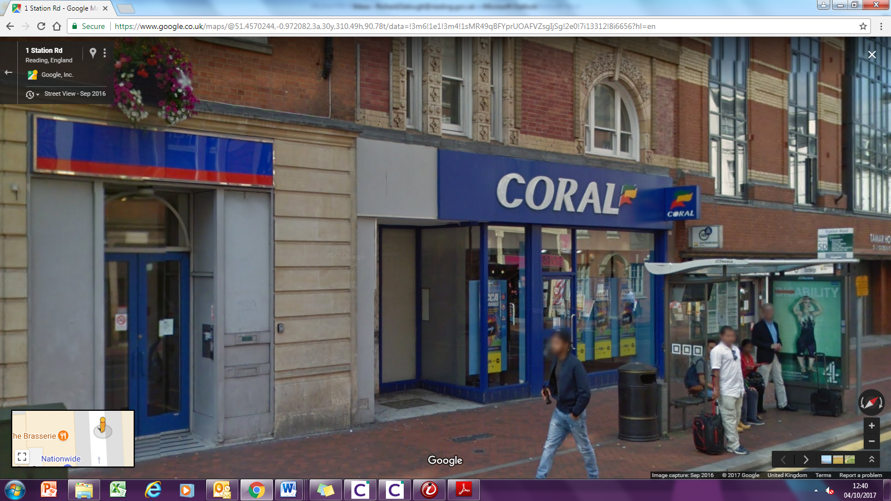
Proposal is to enclose this area. No identified harm to amenity or public safety, maintains an active frontage. Waste area unchanged, now out of sight. Simple material finish proposed (aluminium glazing sysem).

Regarding equalities, there may be a loss of area for those rough sleeping, however, this is an issue to be addressed by other LA functions and is not considered material to the consideration of this planning application.

Equalities Act
In determining this application, the Council is required to have regard to its obligations under the Equality Act 2010. The key equalities protected characteristics include age, disability, gender, gender reassignment, marriage and civil partnership, pregnancy and maternity, race, religion or belief, sexual orientation. There is no indication or evidence (including from consultation on the application) that the protected groups have or will have different needs, experiences, issues and priorities in relation to the particular planning application. In terms of the key equalities protected characteristics it is considered there would be no significant adverse impacts as a result of the development.

RECOMMENDATION: GRANT planning permission.

