Delegated Application Report Target Date: 15/02/18
Address: Unit 2 64 Portman Road
Application No: 172315/CLP
Proposal: Certificate of lawfulness for proposed installation of a glass curtain wall (with integrated double door set) into the existing roller shutter opening in the front elevation of Unit 2

Case Officer: Julie Williams

Introduction and Proposal
The application site is an industrial unit in the core employment area of Portland Road. It is current in use as light industrial.
Confirmation is sought that planning permission would not be required for the proposed installation of a glass curtain wall with a set of double doors in the place of an existing opening which is currently screened by a full height roller shutter. It is intended that this unit will be used by staff in association with the workshop and production processes being carried out at the adjacent units 3, 4 & 5.
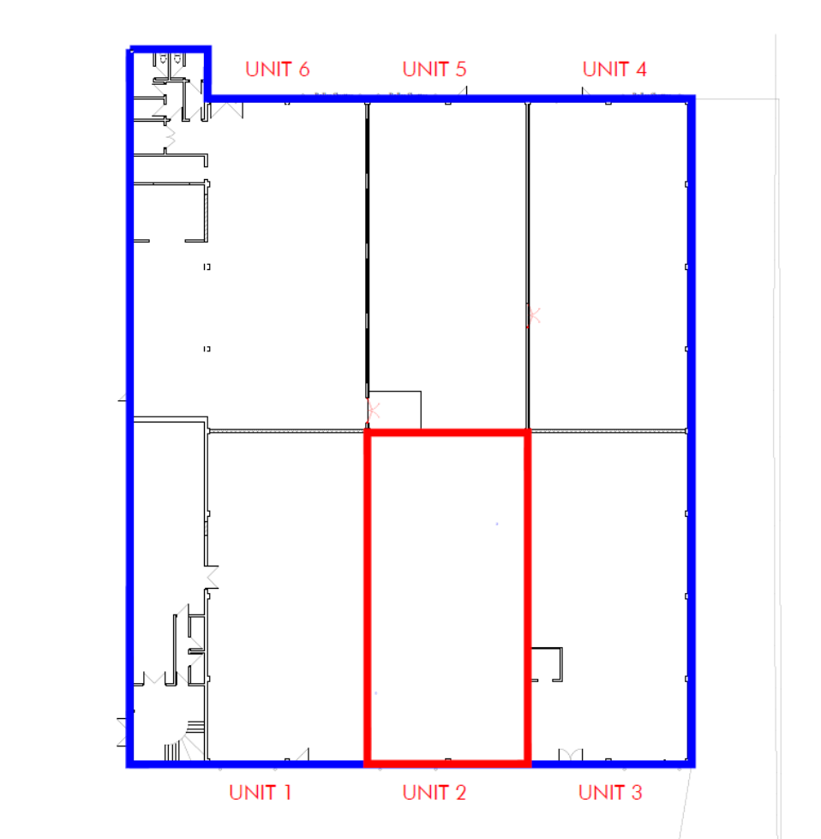

Plans Submitted
The agent supplied the following, received on 21 December 2017:
Location plan showing site and where the curtain wall will go
Photographs and a written statement showing the existing roller shutter opening and an image of what it could look like with the curtain wall and door.
The following were also received on 22 January 2018.
Drawing 51220-GA-03 Rev A to show the internal layout.
Additional illustration of all units at 64 Portman Road and proposed location of the alteration.
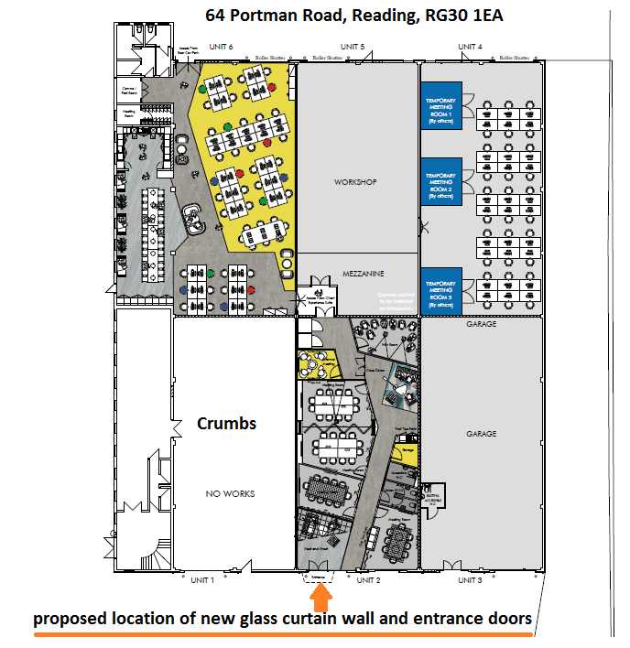

Relevant Planning History
11/00956/FUL - Demolition of existing house and erection of two 4-bed detached houses and 1 detached garage with new access from highway. Application withdrawn 01.09.2011.
11/01496/FUL - Demolish existing detached dwelling and garage and construct two 4-bed detached dwellings and one detached garage and provide one new access from highway (resubmission of 11/00956/FUL). Permitted
11/01906/NMC to above application - Agreed

Summary of Consultations
No consultations are required for an application of this type.
Relevant Planning Policy and Guidance
National Planning Practice Guidance
The Town and Country Planning (General Permitted Development) (England) Order 2015 (GPDO)

Assessment
A Certificate of Lawfulness for a proposed development has been submitted as the applicant considers the proposal falls within the permitted development rights of the property.
The proposed change would fall within the definition or being an alteration to an existing warehouse or industrial building. Class H of Part 7 of the GPDO 2015 applies.
Class H of Part 7 of the GPDO 2015 permits the erection, extension or alteration of an industrial building or a warehouse. However, an alteration is not permitted by Class H if (parts a, b & c are not applicable) -
(d) the height of the building as extended or altered would exceed—
(i) if within 10 metres of a boundary of the curtilage of the premises, 5 metres;
(ii) in all other cases, the height of the building being extended or altered;
This part is relevant to alterations but not applicable in this case.

(e) any part of the development would be within 5 metres of any boundary of the curtilage of the premises; The wall in question is over 5 metres from the boundary of the site.

(f) the development would lead to a reduction in the space available for the parking or turning of vehicles; It does not, or

(g) the development would be within the curtilage of a listed building. Does not apply.

Development is permitted by Class H subject to the following conditions—
(a) the development is within the curtilage of an existing industrial building or warehouse; It is.

(b) any building as erected, extended or altered is only to be used—
(i) in the case of an industrial building, for the carrying out of an industrial process for the purposes of the undertaking, for research and development of products or processes, or the provision of employee facilities ancillary to the undertaking; The application submission confirms that this is the case.
(ii) in the case of a warehouse, for storage or distribution for the purposes of the undertaking or the provision of employee facilities ancillary to the undertaking; Not applicable,

(c) no building as erected, extended or altered is used to provide employee facilities—
(i) between 7.00pm and 6.30am, for employees other than those present at the premises of the undertaking for the purpose of their employment; or
(ii) at all, if a quantity of a dangerous substance is present at the premises of the undertaking in a quantity equal to or exceeding the quantity listed in the entry for for that substance in Parts 2 or 3 of Schedule 1 to the Control of Major Accident Hazards Regulations 1999; Complies
(d) any new building erected shall, in the case of article 2(3) land, be constructed using materials which have a similar external appearance to those used for the existing industrial building or warehouse; This site is not article 2(3) land.
(e) any extension or alteration shall, in the case of article 2(3) land, be constructed using materials which have a similar external appearance to those used for the building being extended or altered. This site is not article 2(3) land.

Recommendation
A Certificate of Lawfulness should be granted for the proposed alteration to the existing light industrial building known as Unit 2 64 Portman Road with the replacement of an existing roller shutter opening with a glazed curtain wall with double doors.
The proposal has been assessed against Class H, Part 7, Schedule 2 of the Town and Country Planning (General Permitted Development) (England) Order 2015. It can be confirmed that the proposed alteration would be lawful for planning purposes on the basis of the information received on 21st December 2017.
Informatives
Add conditions a – c from above.

