DELEGATED APPLICATION REPORT - CERTIFICATE OF LAWFULNESS
Target Date: 15/03/2018
APPLICATION NUMBER: 180011/CLE
SITE ADDRESS: 34 Basingstoke Road, Reading
PROPOSAL: Certificate of lawfulness of existing use of dwelling as 3 residential flats.
CASE OFFICER: Ralph Chakadya

SITE DESCRIPTION & PROPOSAL
The site is an end-terrace three-storey building on the corner of Basingstoke Road and Swainstone Road.

At ground floor is a 2-bed flat, first floor contains a 1-bed unit and the roofspace a bedsit.

PLANS SUBMITTED
The agent provided the following drawings:
No. EX001 Location, Block and Existing Floor Plans received 2 January 2018

RELEVANT PLANNING HISTORY OF THE SITE
040968 – Certificate of Existing Lawful Use for 6 self-contained bed-sits. Granted 29/ 6/2004

RELEVANT PLANNING POLICY AND GUIDANCE
Section 10 of the Planning and Compensation Act 1991 established a procedure that enables anyone who wishes to do so, to apply to the local planning authority to determine whether a proposed use or operation, or an existing operational development or an existing use of land, or any other matter constituting a failure to comply with any condition or limitation subject to which planning permission has been granted, is lawful, and if so, be granted a certificate to that effect.

A Lawful Development Certificate is a legal document stating the lawfulness of past, present or future development. If granted by the local planning authority, the certificate means that enforcement action cannot be carried out to the development referred to in the certificate. However, the certificate will not protect from enforcement action by the planning authority if the specified use or development is then changed 'materially' without a planning application for it.

The certificate is not a planning permission. The planning merits of the use, operation or activity in the application are not relevant. The issue of a certificate depends entirely on factual evidence about the history and planning status of the building or other land and the interpretation of any relevant planning law or judicial authority. The responsibility is on the applicant to provide evidence to support the application.

In determining an application for a Certificate of Existing Use or Development under Section 191 of the Town & Country Planning Act a local planning authority must be satisfied of the lawfulness at the time of the application of the use and if so they shall issue a certificate to that effect.

RESPONSE TO CONSULTATIONS

RBC Enforcement – no enforcement record for the property

RBC Legal – On the evidence set out in this report it appears that the use of the site as 3 residential flats has become lawful over time and a Certificate of Lawfulness may be issued.

RBC Electoral Services – The Electoral Services Department have supplied details of the Electoral Register for this property showing the property as 3 flats from 2008.

RBC Council Tax - Council tax records show there are 3 separate flats registered at this property and these flats have been banded for council tax purposes since January 2005.

EVIDENCE SUBMITTED
The following documents were submitted:
Drawing No. EX001 Location, Block and Existing Floor Plans received 2 January 2018
Tenancy Estate Agency Invoices 2005-2006
Statutory Declaration by applicant
Valuation Office Listings for the 3 flats from 2005 to present
British Gas invoice dated 30/09/2004 (installation of mains and services to the 3 flats)

ANALYSIS OF EVIDENCE (ASSESSMENT)
The applicant has submitted a signed Statutory Declaration confirming that the property was converted to 3 flats since 2005 and has remained as such to present day.
Council tax records show there are 3 separate flats registered at this property and the Council Tax department has confirmed that these 3 flats have been banded for council tax purposes since January 2005 to present. In addition submitted screenshots from the Valuation Office Listings by the applicant confirms the 3 flats were registered for council tax since 2005. A British Gas invoice dated 30/09/2004 for the installation of mains and services to the 3 flats has also been submitted. The Council’s Electoral Services Department have supplied details of the Electoral Register for this property showing the property as 3 flats since 2008 to present.

The submitted existing floor plans (Drawing No. EX001) show the property as 3 flats, a situation confirmed by officers upon site visit on 05/03/2018. All 3 flats are currently occupied. The applicant has provided Estate Agency Invoices for tenancy payments dated 2005 and 2006.

Having reviewed the information submitted as outlined above, it has been concluded that on the balance of probability, the property known as 34 Basingstoke Road Reading, RG2 0EL has been in use as 3 flats for a period in excess of 4 years with no enforcement action having been taken on the property in connection with the use. It should be noted that whilst the relevant 4 year period is 18/01/2014 to 18/01/2018, evidence submitted confirm that the property has been in use as 3 flats from 2005 to present. In these circumstances, it is considered appropriate to grant a certificate of Lawfulness to that effect.

Conclusion
Sufficient evidence has been provided to demonstrate that a Certificate of Lawfulness for the use of 34 Basingstoke Road Reading as 3 flats should be granted on the basis that a period of 4 years has lapsed since the conversion of the property and is now therefore immune to enforcement action and is now lawful.

Submitted drawings:
Drawing No. EX001 Location, Block and Existing Floor Plans received 2 January 2018
Therefore the Local Planning Authority will, on this occasion, issue the applicant with a Certificate of Lawfulness for the existing 3 flats.

Recommendation:
GRANT Certificate
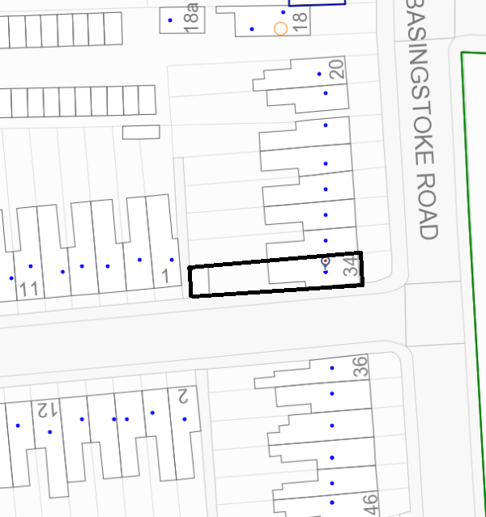
Location/Block Plan (not to scale)

