Delegated Application Report Target Date: 01/08/2017

Address: 22 Henry Street, Reading
Application No: 170923/CLP
Proposal: Certificate of Lawfulness for Loft conversion consisting of flat roof dormer to rear elevation and two rooflights to front elevation.
Case Officer: Ralph Chakadya

Introduction & Proposal
The application site is a mid-terrace two-storey dwelling on a residential street. The house is not listed or in a conservation area.

Plans Submitted:
The agent supplied the following drawings, received on 6th June 2017:
Unnumbered Location Plan
No.1 Proposed Ground Floor Plan
No.2 Proposed First Floor Plan
No.3 Proposed Loft Plan
No.4 Proposed Elevation Plan
No.6 Proposed Section Plan

Relevant Planning History:
None

Summary of Consultations:
No consultations were undertaken as it is not required for an application of this type.

Relevant Planning Policy & Guidance:
Section 10 of the Planning and Compensation Act 1991 established a procedure that enables anyone who wishes to do so, to apply to the local planning authority to determine whether a proposed use or operation, or an existing operational development or an existing use of land, or any other matter constituting a failure to comply with any condition or limitation subject to which planning permission has been granted, is lawful, and is so, be granted a certificate to that effect.

A Lawful Development Certificate is a legal document stating the lawfulness of past, present or future development. If granted by the local planning authority, the certificate means that enforcement action cannot be carried out to the development referred to in the certificate. However, the certificate will not protect from enforcement action by the planning authority if the specified use or development is then changed ‘materially’ without a planning application for it.

The certificate is not planning permission. The planning merits of use, operation or activity in the application are not relevant. The issue of a certificate depends entirely on factual evidence about the history and planning status of the building or other land and the interpretation of any relevant planning law or judicial authority. The responsibility is on the applicant to provide evidence to support the application.

The NPPG states that ‘The applicant is responsible for providing sufficient information to support an application. In the case of applications for existing use (section 191 of the Town and Country Planning Act 1990), if a local planning authority has no evidence itself, nor any from others, to contradict or otherwise make the applicants version of events less than probable, there is no good reason to refuse the application, provided the applicants evidence alone is sufficiently precise and unambiguous to justify the grant of a certificate on the balance of probability’.

Assessment:
A Certificate of Lawfulness for a Proposed Development has been submitted as the applicant considers the proposal falls within the permitted development rights of the property.

The proposal must be assessed to ensure that it complies with the conditions set out in Class B & Class C, Part 1, Schedule 2 of the Town and Country Planning (General Permitted Development) (England) Order 2015 (as amended), which relates to ‘the enlargement of a dwellinghouse consisting of an addition or alteration to its roof’ and ‘any other alteration to the roof of a dwellinghouse’.

Development is not permitted by Class B if:
B.1 (a) permission to use the dwellinghouse as a dwellinghouse has been granted only by virtue of Class M, N, P or Q of Part 3 of this Schedule (changes of use); COMPLIES.
B.1 (b) any part of the dwellinghouse would, as a result of the works, exceed the height of the highest part of the existing roof; COMPLIES.
B.1 (c) any part of the dwellinghouse would, as a result of the works, extend beyond the plane of any existing roof slope which forms the principal elevation of the dwellinghouse and fronts a highway; COMPLIES.
B.1 (d) the cubic content of the resulting roof space would exceed the cubic content of the original roof space by more than 40 cubic metres in the case of a terraced house; COMPLIES, the calculated volume is 14.5 cubic metres.
B.1 (e) it would consist of or include (i) the construction or provision of a veranda, balcony or raised platform, or (ii) the installation, alteration or replacement of a chimney, flue or soil and vent pipe; NOT APPLICABLE IN THIS INSTANCE or
B.1 (f) the dwellinghouse is on article 2(3) land. COMPLIES

Development is permitted by Class B subject to the following conditions:

- B.2 (a) the materials used in any exterior work shall be of similar appearance to those used in the construction of the exterior of the existing dwellinghouse; COMPLIES.
- B.2 (b) the enlargement must be constructed so that –
(i) other than in the case of a hip-to-gable enlargement or an enlargement which joins the original roof to the roof of a rear or side extension – (aa) the eaves of the original roof are maintained or reinstated; and (bb) the edge of the enlargement closest to the eaves of the original roof is, so far as practicable, not less than 0.2 metres from the eaves, measured along the roof slope from the outside edge of the eaves; COMPLIES, and;
(ii) Other than in the case of an enlargement which joins the original roof to the roof of a rear or side extension, no part of the enlargement extends beyond the outside face of any external wall of the original dwellinghouse; COMPLIES.

• B.2 (c) any window inserted on a wall or roof slope forming a side elevation of the dwellinghouse must be (i) obscure-glazed, and (ii) non-opening unless the parts of the windows which can be opened are more than 1.7 metres above the floor of the room in which the window is installed; NOT APPLICABLE IN THIS INSTANCE.

Development is not permitted by Class C if:
C.1 (a) permission to use the dwellinghouse as a dwellinghouse has been granted only by virtue of Class M, N, P or Q of Part 3 of this Schedule (changes of use); COMPLIES
C.1 (b) the alteration would protrude more than 0.15m beyond the plane of the slope of the original roof; COMPLIES
C.1 (c) it would result in the highest part of the alteration being higher than the highest part of the original roof; COMPLIES or
C.1 (d) it would consist of or include (i) the installation, alteration or replacement of a chimney, flue or soil and vent pipe, or (ii) the installation, alteration or replacement of solar photovoltaics or solar thermal equipment. COMPLIES

Development is permitted by Class C subject to the condition that any window located on a roof slope forming a side elevation of a dwellinghouse shall be:

• C.2 (a) Obscure glazed; and (b) non-opening unless the parts of the window which can be opened are more than 1.7 metres above the floor of the room in which the window is installed; NOT APPLICABLE IN THIS INSTANCE.

Conclusion
The proposal has been assessed against the Town and Country Planning Act 1990 (as amended) and Class B and Class C, Part 1, Schedule 2 of the Town and Country Planning (General Permitted Development) (England) Order 2015 (as amended), and it has been confirmed that the proposal would be lawful, on the basis of the following submitted drawings received on 6th June 2017:

Unnumbered Location Plan
No.1 Proposed Ground Floor Plan
No.2 Proposed First Floor Plan
No.3 Proposed Loft Plan
No.4 Proposed Elevation Plan
No.6 Proposed Section Plan
Therefore the Local Planning Authority will, on this occasion, issue the applicant with a Certificate of Lawfulness for the proposed development.

Recommendation:
GRANT Certificate

Informatives
Building Regulations
Encroachment and Party Wall
Construction and demolition
Bats
GPDO 2015

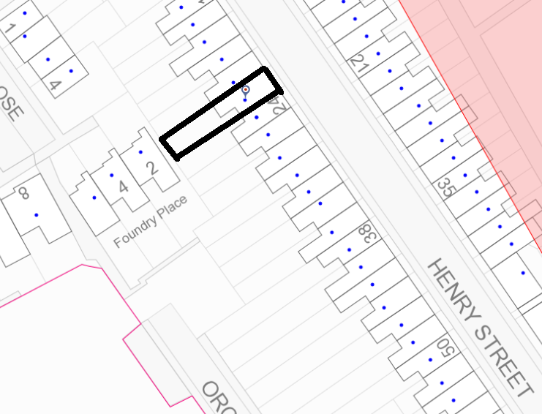

Location plan (Not to scale)

