Flood Risk Assessment for 57 South View Avenue, Caversham, RG4 5AJ
Version 1
Site Address: 57 South View Avenue, Caversham, RG4 5AJ
Description of development: minor addition of approx. 8 sq. metre extension to ground floor
The flood zone your property is in: Flood Zone 2. (Source Environmental Agency report – attached)
The estimated 1 in 100-year river flood level for your development site: The Reading Borough Council, Strategic Flood Risk Assessment (2009) shows, in figure 8, that the driveway has a 1 in 100-year floor depth of between 0m and 0.3m. The actual property sits outside the flood risk zone.
The risk of flooding from surface water: HIGH (Although no flooding of the property has ever occurred)
Reservoir failure: The area is not at risk of flooding from reservoir failure
Is the site protected by flood defences –if so state what standard of protection they provide: The property does not have its own protection, however its slightly elevated position from South View Avenue does provide it with more protection than other properties on the opposite side of the street.
An assessment of the flood risk for your site: See environmental agency maps in this document.
Due to the property’s elevated position and being on the outer edge of the flood risk zone it has never flooded even in the historic events recorded of 1947, 2003 and 2014. Although the precise existing flood levels have not been obtained and we cannot therefore verify that the floor levels will be 300mm above existing, given the 1 in 100-year flood depth given in the RBC Strategic Flood Risk Assessment, it is likely that floor levels will not be 300mm above this level. However, as this is a minor extension to an existing room, setting floor levels at this height would not be practicable, the proposed floor levels will be no lower than the existing floor levels.
To mitigate flooding the proposed development will incorporate flood resilience where appropriate:
- using materials with low permeability to at least 0.3m
- using flood resilient materials (e.g. lime plaster) and design (raised electrical sockets).
- making sure there’s access to all spaces to enable drying and cleaning.
Details in your plan and statement should demonstrate how surface water will be drained:
Existing building drains in to mains drainage the proposed extensions would also drain into the mains drainage system.
Additional Information – Source 2017 RBC Strategic Flood Risk Assessment
Reference to the EA Historic Flood Maps indicates that Lower Caversham is particularly susceptible to fluvial flooding from the River Thames, with a significant area impacted in the severe flood of 1947, approximately centred on Gosbrook Road and extending as far north as South View Avenue.
Since 1894 there have been significant improvements in the flow capacity of the River Thames weirs and, following the 1947 floods, a further significant programme of weir improvements and channel dredging was carried out with the effect that for repeats of such floods as 1894 and 1947, the resultant flood levels would be much reduced by comparison. Subsequent River Thames flooding has been less severe but notable fluvial flood events occurred in 1971, 1992, 1993, 2003 and 2014.

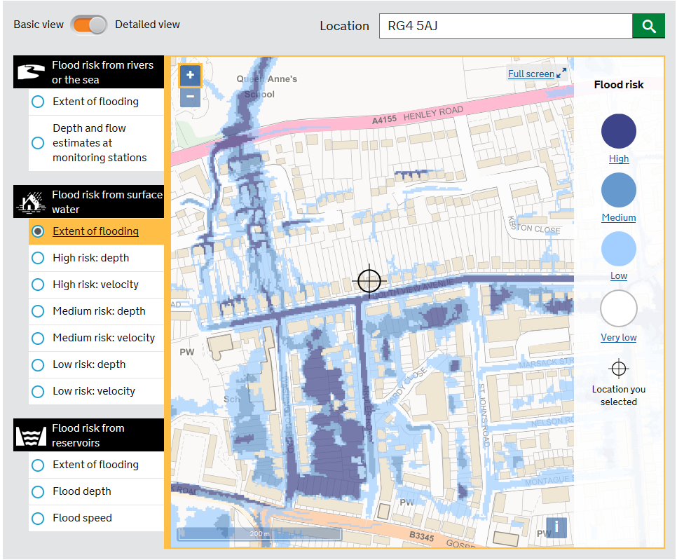
The flood risk from rivers or the sea is LOW (between 0.1% and 1%) – Source – Environment Agency

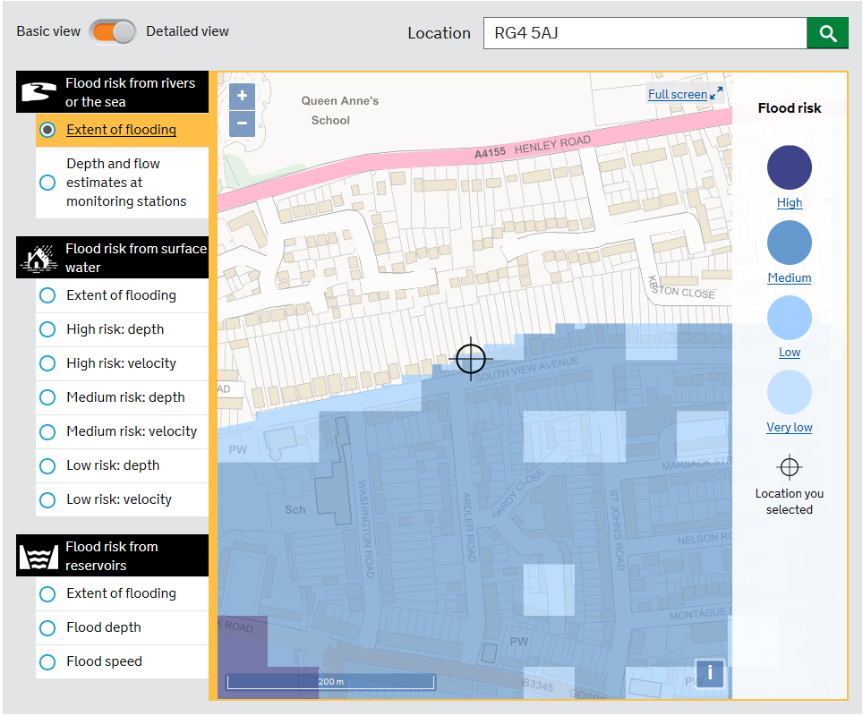
The flood risk from surface water is HIGH (over 3.3%) Source – Environment Agency

