DELEGATED APPLICATION REPORT - Application Nos.: 180497/ADV Target Expiry:
Address: Motorline Nissan, Imperial Way
Proposal: External illuminated signs and totems
Case officer: Alison Amoah

Site Description and Surrounding Area:
The application site forms part of the overall mixed use scheme at the former Worton Grange (‘The Gateway’). The car showroom is located at the north-eastern corner of the commercial half of the development, facing Imperial Way.

Proposal:
- Signs B, D, & H - 'Nissan' signs – individual 3D letters in red. 1m high letters and total length of 6.62m. 5.3m from ground to the base of the sign. 0.12m max projection. Internally illuminated to 400 cd/m. Made from aluminium, acrylic and vinyl.
- Signs C & G – ‘Motorline’ – individual 3D letters in white. 0.75m high letters and total length of 4.96m. 5.3m from ground to the base of the sign. 0.12m max projection. Internally illuminated to 400 cd/m. Made from aluminium, acrylic and vinyl.
- Sign A – Red ‘Nissan’ 3D tablet sign. 4m wide by 4.56m high at 3.76 m above the ground to bottom of sign. Internally illuminated to 400 cd/m. Aluminium, acrylic and vinyl on a steel frame.
- Sign I – Directional sign with list of services. 1.44m high by 0.95m width and 0.21 m deep. Non illuminated. Made from aluminium, acrylic and vinyl.
- Totem J – ‘Nissan’ 6.1 m tall, 1.95m wide by 0.585m deep. Internally illuminated to 400 cd/m. Aluminium, acrylic and vinyl on a steel frame.
- Totem K – ‘Nissan’ 4.3m high, 1.38m wide by 0.41m deep. Internally illuminated to 400 cd/m. Aluminium, acrylic and vinyl on a steel frame.

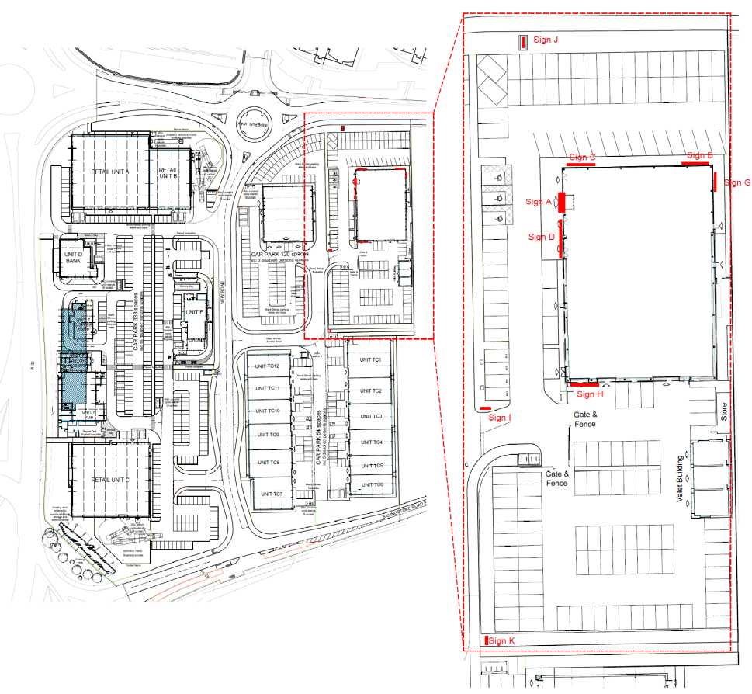
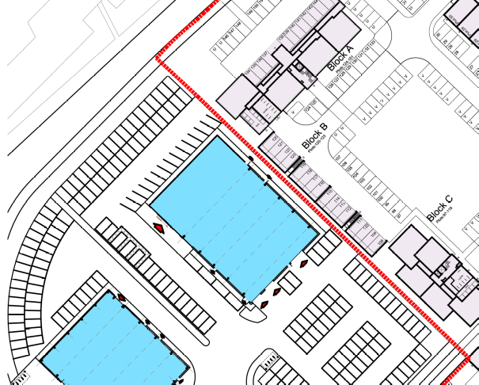

Car showroom in context with residential blocks to the east/ north-east

Plans considered:
- Location Plan, received 8th February 2018
- Plans and Elevations – Drawing no: 1894-Issue D (page 1-5), received 9th April 2018

Amended received 11th May 2018:
- Plans and Elevations – Drawing no: 1894-Issue E (page 1-5)

Amended received 24th May 2018:
- Plans and Elevations – Drawing no: 1894-Issue F (page 1-5)

Amended received 14th June 2018:
- Plans and Elevations – Drawing no: 1894-Issue G (page 1-5)

Relevant Planning History:
151944/FUL – A Hybrid application seeking outline planning permission for the development of up to 175 new homes, including affordable housing(with all matters reserved apart from access), and full planning permission for the development of 12 commercial units in flexible use within Classes B1(c),B2 and B8,two car showrooms with MOT and servicing(Sui Generis), three retail warehouse units (Class A1),120 bed hotel (Class C1),pub with restaurant facility (Class A4),coffee shop (Class A1), restaurant (Class A3), and bank (Class A2). New vehicular access from Basingstoke Road and Imperial Way. Bus stop facilities, hard and soft landscaping and other ancillary development (Summarised Description). Permitted 14/ 4/2016.

171498/ADV - No.8 internally illuminated fascia signs, no.1 internally illuminated
projecting sign, no.1 internally illuminated hoarding sign and no.1 – Consent 20/10/17

180161/ADV - No.22 non-illuminated 'To Let' fascia signs and No.12 non-illuminated number signs – Consent 13/3/18

180262/ADV - No. 1 7m high non-illuminated totem sign – Consent 13/3/18

180416/ADV - Consent to display 8No. Internally illuminated fascia signs to North East, South East, South West and North West Elevations (Wren Kitchens)– Consent 30/4/18

Consultation Responses: Bewley Homes. No comments were received.

Environmental Protection & Nuisance: I have no objections to the proposals as the light levels will not result in light levels into windows above the guideline limits due to the nature of the lighting proposed.

Natural Environment: The proposed positions of Signs I & K are in direct conflict with approved trees (Condition 63 Hard and Soft Landscaping of permission 151944 as discharged by application 172245) and are therefore not acceptable. The signs should be slightly repositioned to avoid conflict with the important tree planting.

Planning Officer note: Further to amended plans Natural Environment confirmed that the position of the signs were acceptable.

Transport: No objection subject to condition on restriction on illumination.

Equality Act 2010:
In determining this application the Council is required to have regard to its obligations under the Equality Act 2010. However, there is no indication or evidence (including from consultation on the application) that the protected groups identified by the Act have or will have different needs, experiences, issues and priorities in relation to this particular planning application. Therefore in terms of the key equalities protected characteristics it is considered there would be no significant adverse impacts as a result of the development.

Relevant Planning Policy and Guidance
Section 38(6) of the Planning and Compulsory Purchase Act 2004 requires that proposals be determined in accordance with the development plan unless material considerations indicate otherwise. Material considerations include relevant policies in the National Planning Policy framework (NPPF) - among them the 'presumption in favour of sustainable development'.

The following local and national planning policy and guidance is relevant to these applications:

Reading Borough Local Development Framework Core Strategy (2008):
CS7 (Design and the Public Realm)

Reading Borough Local Development Framework Sites and Detailed Policies Document (2012):
DM4: Safeguarding Amenity
DM12: Access, Traffic and Highway-Related Matters
DM22: Advertisements

Legal context:
Regulation 3 of the Town and Country Planning (Control of Advertisements) (England) Regulations 2007 requires the Local Planning Authority to exercise its powers under these regulations in the interests of amenity and public safety taking into account the provisions of the development plan, so far as they are material; and any other relevant factors. Regulation 3 states that factors relevant to amenity include the general characteristics of the locality, including the presence of any feature of historic, architectural, cultural, or similar interest.

Factors relevant to public safety include highway safety and whether the advert would hinder security or surveillance devices, including speed cameras.

Appraisal:
Main Issues: The main issues are considered to be:

(a) Amenity
- Safety

(a) Amenity
All of the signs, except for the directional sign (I) would be internally illuminated to a lux level of maximum 400 cd/m2. The majority of these are set well back from the highway, and/ or would only be visible once inside the development itself. Proposed totem J, to the Imperial Road frontage, was relocated further westwards following issues raised by the Natural Environment Officer, and the conflict with trees as part of the approved landscaping in this area. An issue was also raised by the Planning officer regarding the effect of a 6.1m high totem on residential amenity. However, now the sign has been relocated westwards, this is further from the residential part of the overall ‘Gateway’ scheme (located to the east of the Nissan car showroom – see plan extract above) and is considered acceptable.

It is considered that the material, colour and luminance are appropriate to the building and the surrounding area, which includes existing businesses on Imperial Way. Although there is a residential area to the east of the site it is considered that the signs would not cause a significant amenity issue.

It is not considered that there would be harm to the appearance of the building or the wider area and therefore there would be no detrimental effects on visual amenity.

On the above basis, the proposed signs are considered to comply with Reading Borough Local Development Framework Core Strategy (2008) and CS7 (Design and the Public Realm), and Reading Borough Local Development Framework Sites and Detailed Policies Document (2012) DM4: Amenity and DM22: Advertisements.

(b) Safety
The majority of the proposed signs would be visible by road users, in particular the totem J, although the majority would be set well back from the highway. The illuminance level of the signs would not distract drivers so as to have an effect on safety. None of the signs would obscure any existing traffic signs, reduce visibility for road users, or sight lines of cameras. Transport has no objection subject to a luminance condition. The advertisements are therefore considered to accord with Reading Borough Local Development Framework Sites and Detailed Policies Document (2012) DM12: Access, Traffic and Highway-Related Matters and DM22 (Advertisements).

RECOMMENDATION:

GRANT

Proposed conditions:

- Standard advert conditions
- Approved plans
- Maximum luminance should not exceed 400 cd/m2.

Informatives:
T&Cs
Positive and proactive

