Delegated Application Report Target Date: 28/08/17
Address: 24 Callington Road, Reading
Application No: 171049/CLP
Proposal: Erect an outbuilding (summer house)
Case Officer: Ralph Chakadya
Introduction and Proposal
The application site contains a semi-detached two storey property dwelling house. The surrounding area is predominantly residential.
The proposal is for an outbuilding to provide a summer house. The outbuilding would be 6m deep by 4.65m wide being a maximum 2.5m high with a flat roof. The outbuilding would be located at the bottom corner of the rear garden adjoining number 22 Callington Road and 23 Helston Gardens
Plans Submitted
Drawing No.02 Location plan
Drawing No.01 Proposed Block, Floor and Elevation Plans

Relevant Planning History
None relevant
Summary of Consultations
No consultations were undertaken as it is not required for an application of this type.
Relevant Planning Policy and Guidance
National Planning Practice Guidance
The Town and Country Planning (General Permitted Development) (England) Order 2015 (GPDO)
Permitted development rights for householders – Technical Guidance April 2017
Assessment
A Certificate of Lawfulness for a proposed development has been submitted as the applicant considers the proposal falls within the permitted development rights of the property.
The proposed outbuilding must be assessed to ensure that it complies with the conditions of Class E, Part 1, Schedule 2 of the Town and Country Planning (General Permitted Development) (England) Order 2015, which relates to ‘buildings etc incidental to the enjoyment of a dwellinghouse’.
The relevant conditions of the GPDO for an outbuilding, which is not listed or in a conservation area, are as follows:
E.1 Development is not permitted by Class E if:
E.1 (a) permission to use the dwellinghouse as a dwellinghouse has been granted only by virtue of Class M, N, P or Q of Part 3 of this Schedule (changes of use); complies
E.1 (b) the total area of ground covered by buildings, enclosures and containers within the curtilage (other than the original dwellinghouse) would exceed 50% of the total area of the curtilage (excluding the ground area of the original dwellinghouse); complies
E.1 (c) any part of the building, enclosure, pool or container would be situated on land forward of a wall forming the principal elevation of the original dwellinghouse; complies
E.1 (d) the building would have more than a single storey; complies
E.1 (e) the height of the building, enclosure or container would exceed (i) 4 metres in the case of a building with a dual-pitched roof, n/a (ii) 2.5 metres in the case of a building, enclosure or container within 2 metres of the boundary of the curtilage of the dwellinghouse, complies or (iii) 3 metres in any other case; n/a
E.1 (f) the height of the eaves of the building would exceed 2.5 metres; complies
E.1 (g) the building, enclosure, pool or container would be situated within the curtilage of a listed building; complies
E.1 (h) it would include the construction or provision of a verandah, balcony or raised platform; complies
E.1 (i) it relates to a dwelling or a microwave antenna; complies or
E.1 (j) the capacity of the container would exceed 3,500 litres. complies
E.2 In the case of any land within the curtilage of the dwellinghouse which is within:
(a) an area of outstanding natural beauty;
(b) the Broads;
(c) a National Park; or
(d) a World Heritage Site,
development is not permitted by Class E if the total area of ground covered by buildings, enclosures, pools and containers situated more than 20 metres from any wall of the dwellinghouse would exceed 10 square metres. complies
E.3 In the case of any land within the curtilage of the dwellinghouse which is article 2(3) land, development is not permitted by Class E if any part of the building, enclosure, pool or container would be situated on land between a wall forming a side elevation of the dwellinghouse and the boundary of the curtilage of the dwellinghouse. complies
Recommendation
Sufficient evidence has been provided to demonstrate that a Certificate of Lawfulness should be granted for the proposed outbuilding.
The proposal has been assessed against the Town and Country Planning Act 1990 (as amended) and Class E, Part 1, Schedule 2 of the Town and Country Planning (General Permitted Development) (England) Order 2015. It can be confirmed that the proposed operation would be lawful for planning purposes on the basis of the drawings received on 27th June 2017:
Drawing No.02 Location plan
Drawing No.01 Proposed Block, Floor and Elevation Plans
Therefore the Local Planning Authority can issue the applicant with a Certificate of Lawfulness for the proposed development.
Informatives
Building Regulations
Encroachment and Party Wall Act
Construction and Demolition
Materials

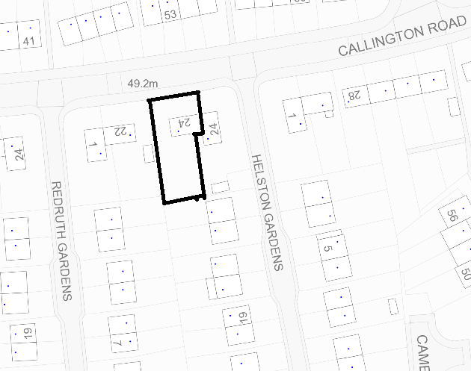
Location plan (not to scale)

