
Mr. David Moro
JSA Architects,
Tavistock House,
Waltham Road,
Maidenhead SL6 3NH

By Email; david@jsaarchitects.com

RE: RL17562 – The Red Cow Pub, 50 Crown Street, Reading

Dear David,

Following our recent conversation in connection with the above, we note the following points concerning the proposed alterations.

- The existing first floor joists of the building measure approximately 50mm x 50mm and are clearly inadequate to support the floor loads which will result from the proposed alterations without modification.
The fact that they have been notched previously, for the facilitation of services, greater than is recommended by NICEIC, has weakened them and reduced their integrity further.
Their spacing is uneven, which makes it more difficult to assess the strength of the floor.
The area of floor in question relies on an original downstand beam for support which itself is supported at one end by a post at ground floor and at the opposite end by a second downstand beam spanning front to back midspan. It is not possible to assess the integrity of these beams to the satisfaction of today’s BS EN 1912:2004 to meet with Building Regulations requirements.
We do not consider it safe for any use at all in its present state.
The only suitable support for floor joists is the existing loadbearing masonry walls at the front, down the centre and to the rear of the building, which requires joists to span over 4m, requiring a minimum depth of 220mm.
We feel that a new floor should effectively be independent of the existing structure, as to do otherwise might tend to compromise the structural integrity of the building in any future use and this should be avoided. This would bring the first floor to one uniform level to meet the new staircase.
We therefore recommend the addition of new floor joists as shown on our drawing RL17562/02 P1.

- The roof of the existing “Barn” shows signs of sagging at the ridge and requires additional support in order to reduce the possibility of further wall-spread and deflection of the ridge. We have therefore indicated a steel ridge beam on drawing RL17562/02 P1.

We have explored alternatives and consider the current proposals offer the least invasive and most effective, sympathetic long-term way of putting the whole building back into use.

Friday, February 09, 2018
We are happy for our design and calculations to be scrutinized by an independent engineer if required.

We trust the foregoing is satisfactory for your current requirements, but please feel free to call in the event of further queries.

Yours Sincerely,

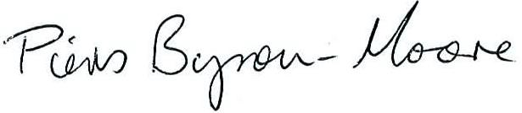

Piers Byron-Moore | Principal Engineer
for and on behalf of Riddwood Consulting Engineers

