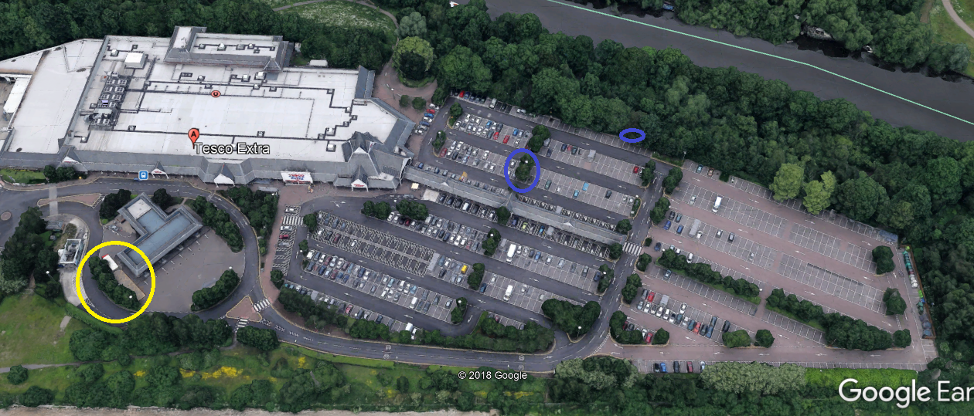

- In yellow - trees that we needs to slightly prune in orderly to allow more light from lamp posts
- In blue - 3no trees that are dead and need to be felled as can cause H&S risk. If possible please submit TPO application for these trees as well

