DELEGATED APPLICATION REPORT - Application No.: 180874 Target Expiry: 20/8/2018
Address: 28-30 New Road
Proposal: Subdivision of dwelling to create two separate dwellings (28 & 30 New Road) and single storey rear extensions to proposed no.28
Case officer: Alison Amoah

Site Description and Surrounding Area:
The property is currently a single terraced property, formerly 28 and no.30 New Road. It has retained two front doors, with the door to the original no.30 being the main access point used. Limited internal changes took place to make this into a single dwelling. To the rear is a shared hipped and pitched gable projection. To the rear of original no.28 is an existing flat Single storey extension (garden room) with mon-pitched roof and roof light and beyond this a flat roof providing covering to an outside patio. The boundary wall between no. 26 & no. 28 is very high (ca 3.5m – higher than the bottom of the first floor windows of the application site), which provides enclosure to this outside space.

There is a good sized rear garden.

It is located in the Redlands Conservation Area.

Proposal: The proposal is to return the house to two houses, creating two terraced properties. This would result in the closing up of an internal door between the dwellings to reinstate the original layout. The frontage would not change. There would be amendments to the layout to the rear, i.e. new wall to split the existing kitchen. The proposal also includes a flat roofed single storey extension replacing the roof of the existing garden room (of no.28 - to become the kitchen) and providing an enclosed garden room in the place of the existing covered external patio, the latter measuring 3.2m wide by 4.1m wide. This would link up with part of the existing kitchen. In addition a porch is proposed to the rear of no. 28 measuring 2.1m wide, by 2.5m deep, with height to eaves of 2.3 and to ridge of pitched roof 3.1m. A roof lantern is proposed over the garden room. The roof of the porch would be glazed. The roof of the kitchen for no.30 would be flat and tie up with the roof of the proposed roof of the garden room for no.28.

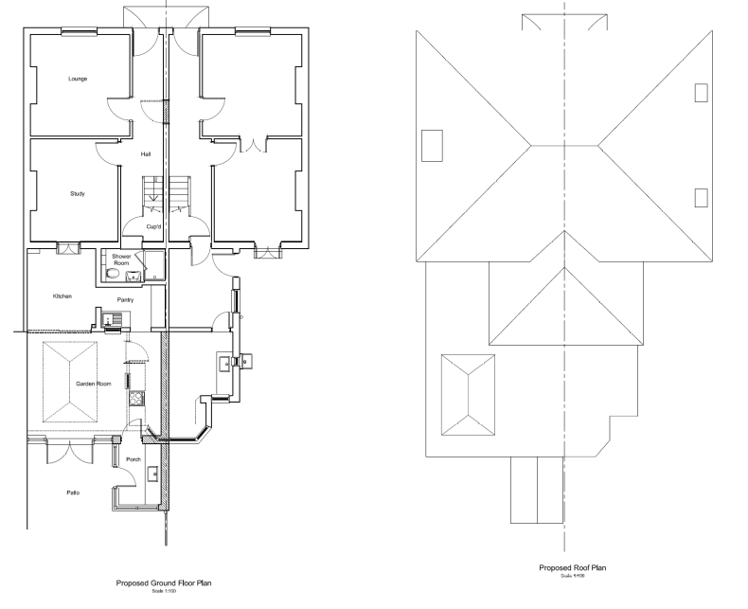

The proposed materials would be to match the existing house.

Plans considered: As received 29th May 2018:
Location and Block Plan – Drawing no: 001
Existing Ground Floor and Roof Plans – Drawing no: 002
Existing Elevations - Drawing no: 003
Proposed Ground Floor and Roof Plans – Drawing no: 004
Proposed Elevations – Drawing no: 005

Received 26th July 2018:
Proposed Elevations – Drawing no: 005 Rev A

Received 30th July 2018:
Existing and Proposed First Floor Plans – Drawing no: 006

Relevant Planning History: None

Consultation Responses: Nos. 21-25 (odd) and 26 & 32 New Road were consulted. No responses were received. A site notice was displayed.

Transport: The site is located in Zone 2, Primary Core Area, of the Revised Parking Standards and Design SPD. This zone directly surrounds the Central Core Area and extends to walking distances of 2 kilometres from the centre of Reading. A frequent service of public transport is available which provides a good frequency of services to and from the town centre. The site is within cycling distance of Reading town centre, and walking distance of local services.

In accordance with the adopted Parking Standards and Design SPD, the new dwelling would be required to provide parking provision of 1 space for 2 bedroom dwelling or 2 for a 3+ bedroom dwelling. It would appear that there is no off road parking associated with the existing property.

The development site is located in an area designated as a Residents Parking Permit Area; Zone 15R. Under the Borough’s current parking standards, this proposal would generate additional pressure for parking in the area which is not acceptable. Therefore, there should be an assumption that any future occupants of the proposed new dwelling will not be issued with resident parking or visitor permits which would be covered by condition and an informative applied. This will ensure that the development does not harm the existing amenities of the neighbouring residential properties by adding to the already high level of on street car parking in the area.

In accordance with the Borough’s Parking Standards and Design SPD, a minimum provision of 2.0 cycle storage spaces should be provided for a 2/3 bedroom dwelling. No details of cycle storage have been provided; In a development of this nature a secure garden shed would be acceptable.

Bin storage should comply with Manual for Streets and British Standard 5906: 2005 for Waste Management in Buildings to avoid the stationing of service vehicles on the carriageway for excessive periods. It is assumed that the bin storage and collection will be the same as is for the existing dwelling and other householders.

In principle Transport do not have any objections to this application as on street parking can be managed through the administration of the Residents Permit Scheme.

Recommended conditions – DC7 - parking permits 1; DC8 - Parking permits 2; DC5 Bicycle parking – plans to be approved. Informatives – Highways and parking permits.

CAAC: consulted – no response received.

Equality Act 2010:
In determining this application the Council is required to have regard to its obligations under the Equality Act 2010. However, there is no indication or evidence (including from consultation on the application) that the protected groups identified by the Act have or will have different needs, experiences, issues and priorities in relation to this particular planning application. Therefore in terms of the key equalities protected characteristics it is considered there would be no significant adverse impacts as a result of the development.

Relevant Planning Policy and Guidance
Section 38(6) of the Planning and Compulsory Purchase Act 2004 requires that proposals be determined in accordance with the development plan unless material considerations indicate otherwise. Material considerations include relevant policies in the National Planning Policy framework (NPPF) - among them the 'presumption in favour of sustainable development'.

The following local and national planning policy and guidance is relevant to this application:

Reading Borough Local Development Framework Core Strategy (2008, altered 2015)
CS7: Design and the Public Realm
CS14: Provision of Housing
CS33: Protection and Enhancement of the Historic Environment

Sites and Detailed Policies Document (2012, altered 2015)
DM4: Safeguarding Amenity
DM5: Housing Mix
DM9: House Extensions and Ancillary Accommodation;

Other Guidance
Supplementary Planning Guidance: A Design Guide to House Extensions (2003)
Redlands Conservation Area Appraisal, March 2008

Appraisal

- Principle
The subdivision of the house to revert it to the original two dwellings would comply with policy CS14 in contributing to the provision of housing and would provide family housing in accordance with Policy DM5. The principle of the proposed scheme would therefore be acceptable.

- Extension
DM Checklist:
DM9 states: An extension to a house will be acceptable where it:

- Respects the character of the house in terms of scale, location, materials and design;

To assess this, the following has been considered – would the proposal:

- Detract from the appearance of the original building through the use of ill-matching materials and by not fitting in with the design, scale and proportions of the original building; No. The property is in the Redlands Conservation Area, however the proposal does not include for any works to the front elevation. The proposed changes are either internal or are to the rear within a very enclosed garden, and in any case are considered to be of a suitable and sympathetic design considered to provide enhancements as compared to the existing rear configuration.

- Reduce the amount of usable amenity space for the property to an unacceptable degree; No

- Require the loss of trees in the garden or put significant trees at risk; No.

- Respects the character and pattern of neighbouring properties and the street as a whole in terms of scale, location, materials and design, and any important existing building line; Respects neighbour’s amenities and does not present a large blank façade to public areas.

To assess this, the following has been considered – would the proposal:

- Significantly reduce the amount of daylight and sunlight enjoyed by neighbouring properties; No

- Invade the privacy of neighbouring properties through overlooking from windows or balconies; No

- Detract from the character of neighbouring properties through siting, excessive bulk, ill-matching materials or inconsistent design; No

- Detract from the appearance of the street or area by using ill-matched materials, glazing and detailing; No

DM4 states: Development will not cause a significant detrimental impact to the living environment of existing or new residential properties, in terms of:
• Privacy and overlooking; NO
• Access to sunlight and daylight; NO
• Visual dominance and overbearing effects of a development; NO
• Noise and disturbance; NO
• Artificial lighting; NO
• Vibration; NO
• Dust and fumes; NO
• Smell; or NO
• Crime and safety. NO

Other matters: Transport has recommended that conditions restricting access to parking permits are attached to any permission. It is not considered that 2no, two bedroom houses would generate such a significant parking requirement as compared to the one larger house, therefore these conditions have not been included.

As family dwellings no condition has been attached regarding bicycle storage, because it is considered that this would be accommodated within a shed in the rear garden.

RECOMMENDATION

APPROVE subject to conditions and informatives.

Proposed Conditions:

- Standard Time limit TL1

- The development hereby permitted shall be carried out in accordance with the following approved plans received 29th May 2018 (unless otherwise stated):

Location and Block Plan – Drawing no: 001
Proposed Ground Floor and Roof Plans – Drawing no: 004
Proposed Elevations – Drawing no: 005 Rev A, received 26th July 2018
Existing and Proposed First Floor Plans – Drawing no: 006, received 30th July 2018

- Matching materials

Informatives:

Terms and conditions
Building regulations
Encroachment
Complaints re noise during construction
Positive and proactive
Boundary fences

